<< The layout and format of the guide is subject to change; the text will remain the same>>

PAPrKA Study Oura Ring Guide
<<content table>>

Welcome
Welcome to the PAPrKA study Oura guide. This guide provides step-by-step guidance on how to share your Oura physical activity information with the PAPrKA study team.

Quick take: how to share your Oura Ring data
Step 1: Go to Oura’s website by clicking ‘Link Oura’.
Step 2: Login to your Oura account.
Step 3: Select the data you want to share and click “Accept” to share them
Step 4: Add another device or finish.

Connect your Oura Ring: what you will see when you click into it
The page details each step, providing images of what you will see as you go through steps 1-4.
<<Screenshot of front page of Oura Ring>>

Let us take you through the four steps

Step 1: Go to Oura’s website by clicking the "Link Oura" button
- This will redirect you away from this page to Garmin's website.
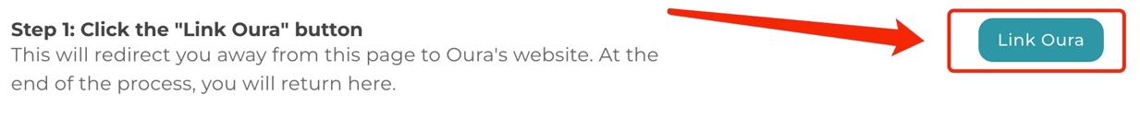

Step 2: Log in
  - If you are not already logged in to your Oura account, you will be redirected to a sign in page. Please log in with your Oura account details: your Oura account’s username and password.

Step 3: Select the data you want to share and click “Accept” to share them
  - Once you have logged in to your account you will see a screen called “Connect with Oura”. Tick all 3 boxes, and then click “Accept” at the bottom to share your physical activity information with the study team. This includes:
    - Sleep, Readiness and Activity Data [includes physical activity measures such as distance travelled, step count, time doing activities]
    - Heart Rate Data [needed because it indicates how intense the activities were performed]
    - Workout Data [includes physical activity measures such as Activity, distance, intensity]
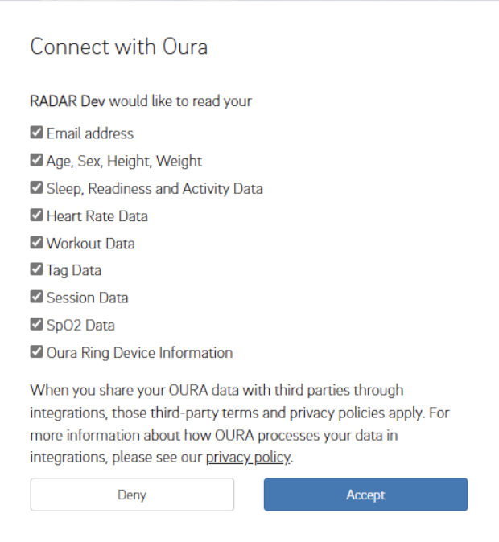
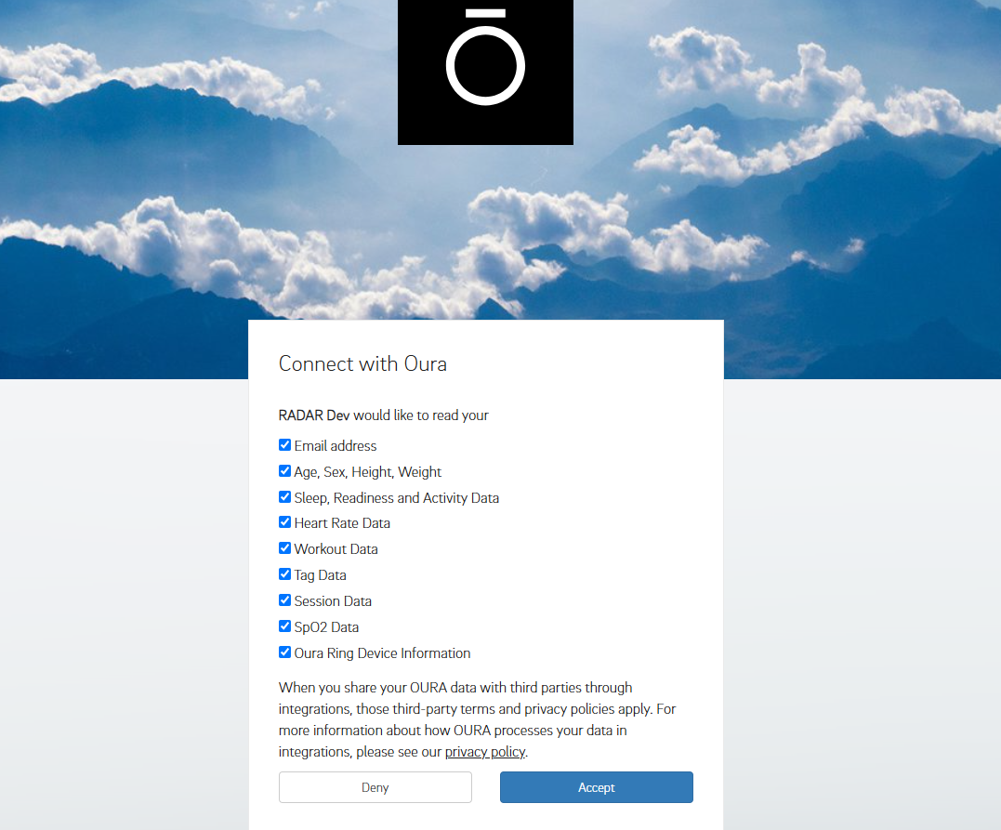

Step 4: Add another device or Finish
You will receive a ‘thank you’ message once you have completed all three steps. The message will ask you if you want to ‘link another device’, or if you are ‘done’.

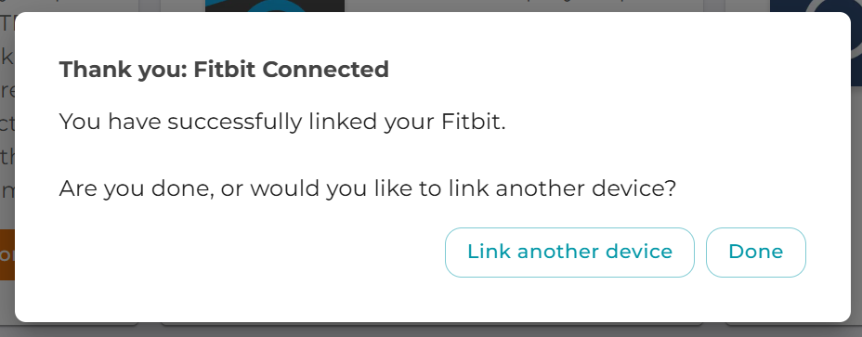

If you want to share data from another device, click the “link another device” button, this will take you to the Connect Device page. From there you can chose which other device you want to share ‘iPhone or Apple Watch’, ‘Garmin’ or ‘Fitbit. Please remember you need to have used that device to track your activities within the study’s time-period of the 1st July 2016 - 31st December 2024.
<<Screenshot connect device page>>

If you do not want to share data from another device, click the “Done” button. You will be taken to the Portal page where you can complete any outstanding tasks.
<<Screenshot portal page>>

PAPrKA study guides
- PAPrKA study iPhone and Apple watch guide <<hyper link on the underlined text>>
- PAPrKA study Garmin guide<<hyper link on the underlined text>>
- PAPrKA study Fitbit guide<<hyper link on the underlined text>>

Thank you for taking part in the PAPrKA study

Troubleshooting
If you are having trouble sharing your Oura data, try the following solutions:
- I can’t access the Oura Ring website
  - Make sure you have a stable internet connection
  - Try using a different browser (e.g. Chrome, Safari, Firefox)
  - Disable any browser extensions that may block pop-ups or redirects
- I can’t log in to my Oura Ring account
  - Double-check your email and password
  - If you’ve forgotten your login details, use the "Forgot Password?" option on the Oura Ring login page
- I don’t see the screen to allow data sharing
  - Make sure you’ve followed the link from the PAPrKA study portal
  - If the page doesn’t load correctly, try refreshing or restarting your browser

Still having issues? Please contact the PAPrKA study team at paprka@manchester.ac.uk and we’ll be happy to help.

