Welcome to the PAPrKA Study

Thank you for your interest in helping us learn how people recover from knee replacement surgery. The PAPrKA study looks at activity data from fitness trackers and smartphones to understand how mobility changes over time.

Website Overview
In order to participate, you will need to progress successfully through each of the following four stages of the website:
- Homepage – General information about the study including who can join, and why it matters.
- Join Study – The starting point to begin your participation if you meet the eligibility requirements.
- Consent & Registration – Where you give permission for your data to be used and create a personal account.
- Participant Portal – Your own dashboard with tasks to complete, including providing surgery details, your NHS number, and connecting your devices.

1. Home Page: Starting Your Journey
- Navigate to the PAPrKA Website: https://dev.radarbasedev.co.uk/kratos-ui/paprka
  - When you arrive at the homepage, you’ll see the title: “PAPrKA: How Active Are People After Knee Surgery?”
  - Skim through the brief overview that explains how activity data from fitness trackers can help us understand changes in mobility after surgery.
- Cookies
  - The PAPrKA website uses cookies not just to enhance your browsing but primarily to collect data for our research. These cookies help us see how participants progress through the study and which steps may be more or less clear.
  - By selecting “Accept All”, you allow us to gather the analytics needed for this research, giving us meaningful insights into user navigation and participant engagement.
  - If you choose to reject or customize your cookie settings, you can still proceed with the study. However, certain functionalities or the completeness of our research data may be limited.
- Participant Information Sheet
  - You’ll find the link for Participant Information Sheet – A detailed document outlining your rights, data usage, and study goals.
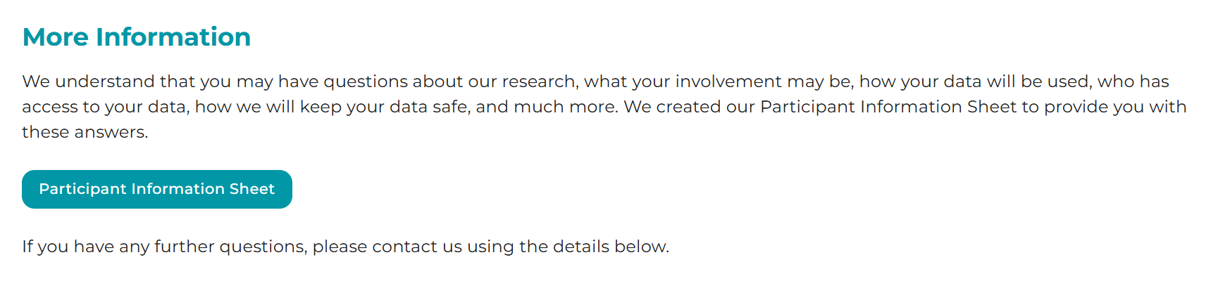
- Click “Join Study”
  - If you’re ready to proceed, click the Join Study button. This will take you to the eligibility check.
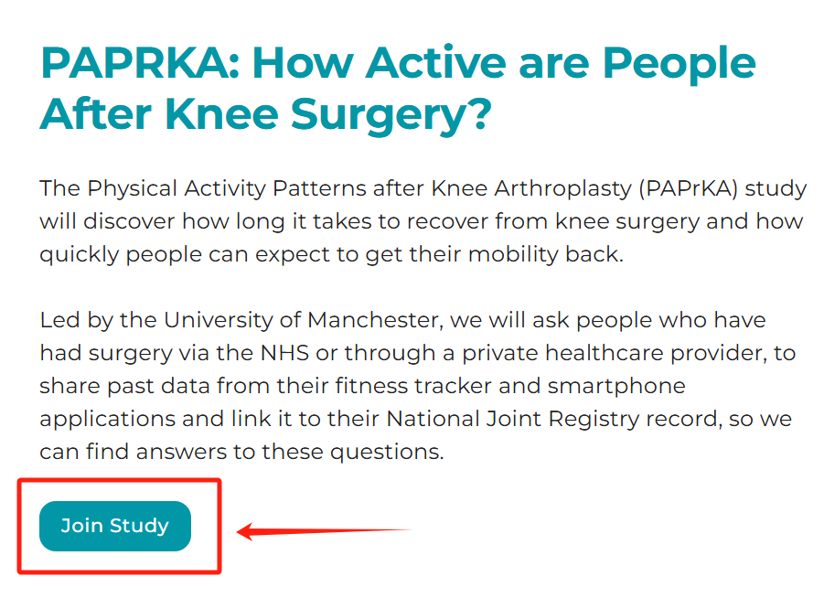
Tip: If you have any doubts, the Participant Information Sheet covers what happens to your data, how long it’s stored, and any other questions you may have.

2. Eligibility Check: Confirm You Can Take Part
- Answer the Questions
  - The website will ask four questions, one at a time:
    - Are you over 18 years of age?
    - Have you had total, or partial, knee replacement surgery, either through the NHS or a private healthcare provider, between January 2017 and December 2023?
    - Did you use a smartphone app or fitness tracker to track your activity six months before your surgery? An iPhone automatically collects activity data.
    - Did you use a smartphone app or fitness tracker to track your activity one year after your surgery? An iPhone automatically collects activity data.
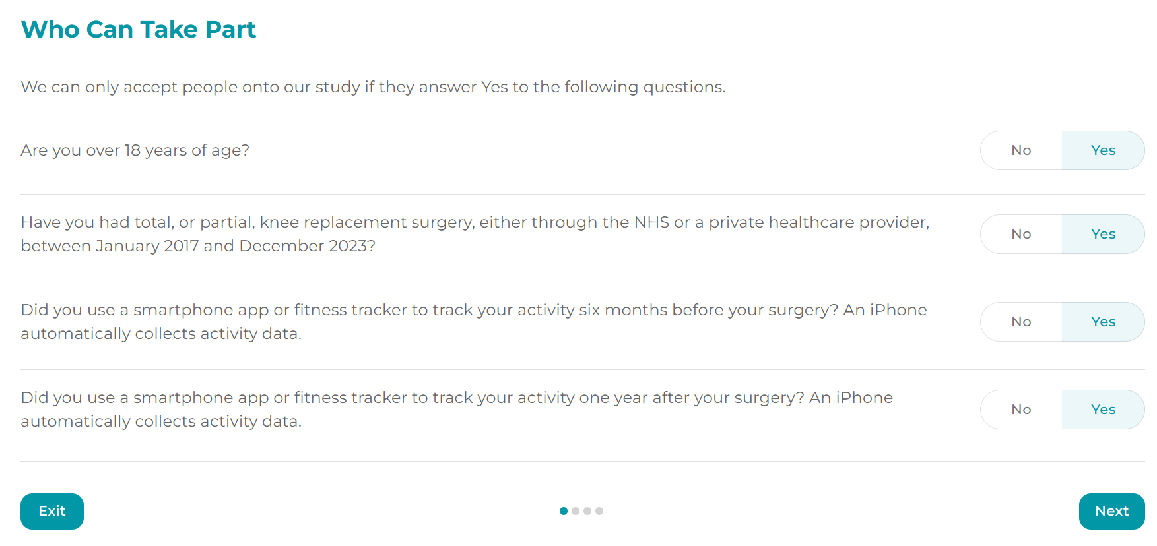
- Proceed if Eligible
  - You must select Yes to each question to continue.
  - If you answer “No” to any question, the system will let you know that you’re not currently eligible.
- Click “Next”
  - If all answers are “Yes,” click Next to move on to the consent page.

3. Consent Page: Understanding and Agreeing to the Study
- Required Consent Items
  - You’ll see several statements explaining what data will be collected (e.g., your fitness tracker data, knee surgery information from the National Joint Registry).
  - You must select “Yes” for all required items to join.
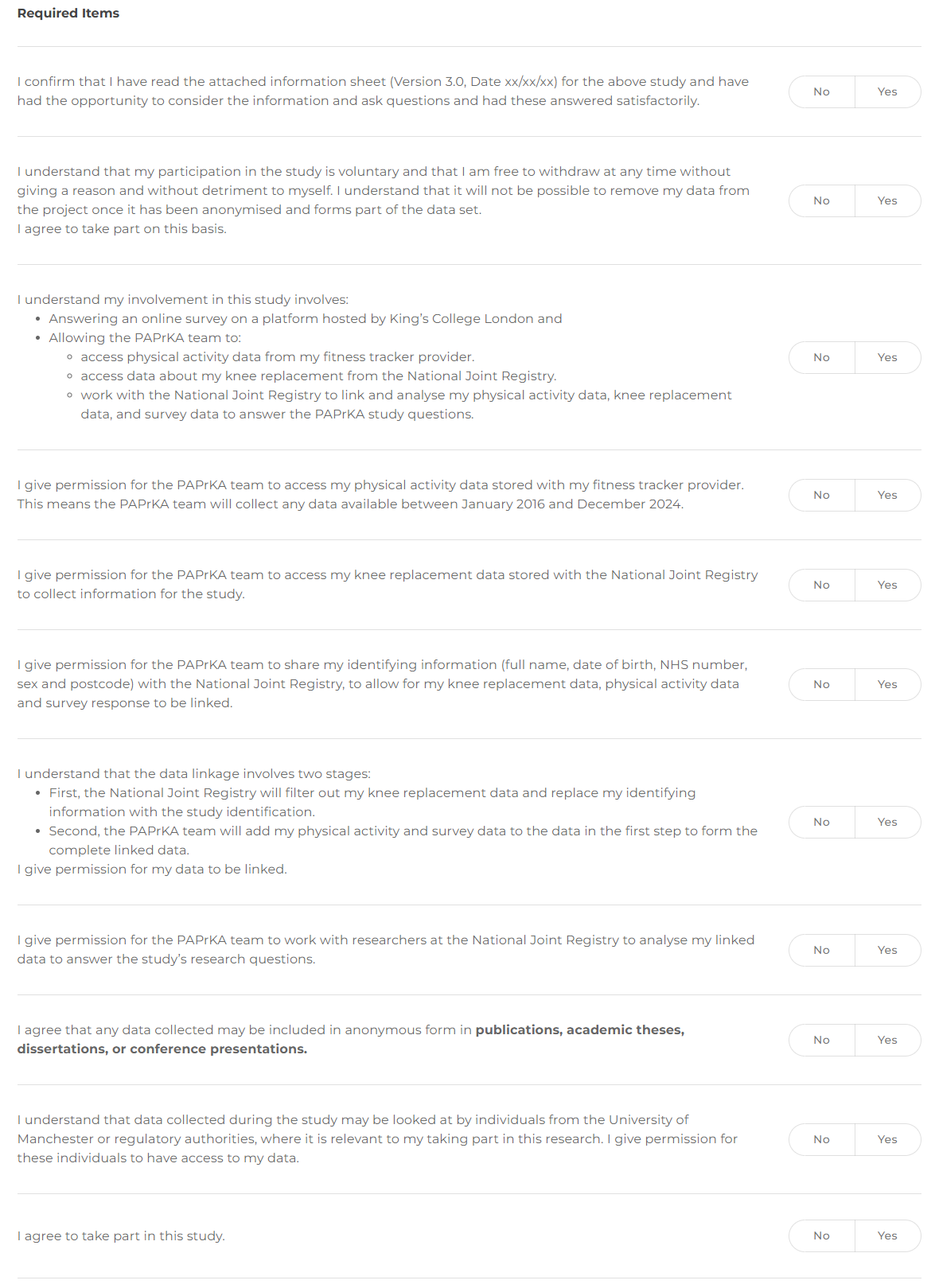
- Optional Consent Items
  - These items cover things like entering a prize draw or being contacted for future research.
  - You can choose Yes or No without affecting your participation.
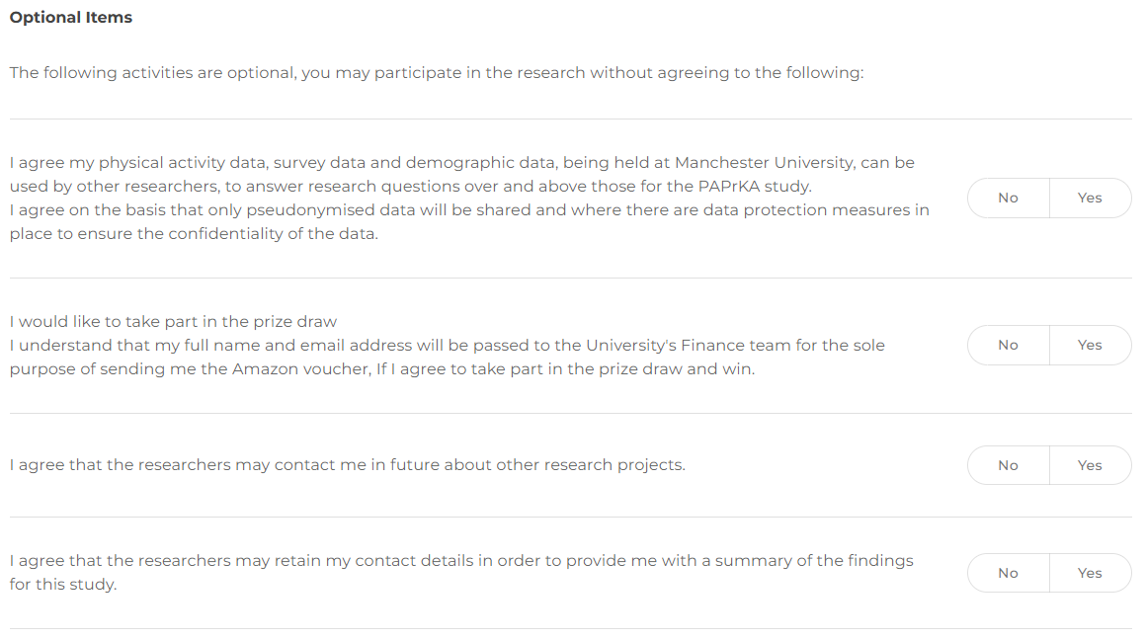
- Electronic Signature
  - Scroll to the bottom where you see “Click to sign.”
    - First, you may need to type your name in the provided text field.
    - Next, use your mouse, finger, or trackpad to draw your e-signature in the signature box.
  - Click Next to confirm you agree.
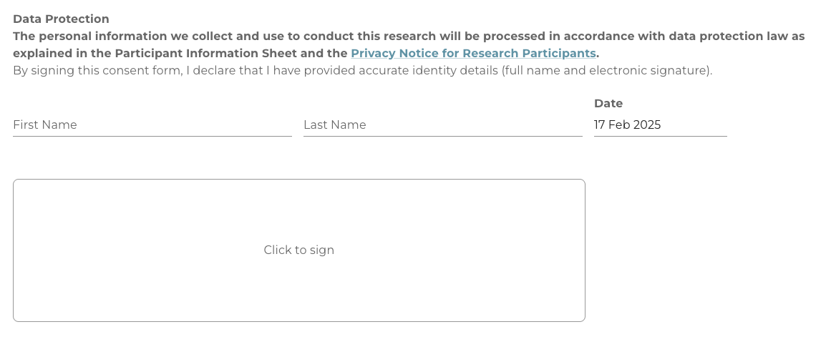

4. Register Your Account: Personal Details
After giving consent, you’ll be asked to create an account. Please ensure this information is accurate as it will enable the linkage of your activity data to your surgical data
This happens in two parts:
Part A: Basic Information
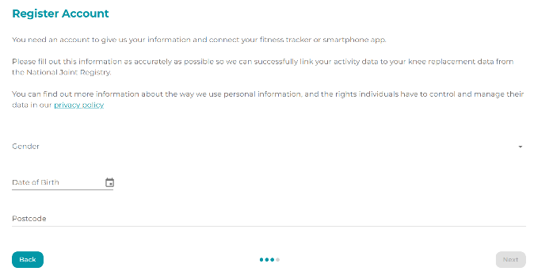
- Fill Out the Form
  - Gender (choose from the dropdown)
  - Date of Birth (use the date picker)
  - Postcode
- Click “Next”
  - Confirm the details you entered are correct.

Part B: Login Credentials
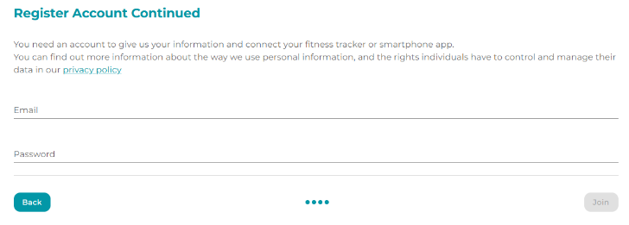
- Enter Your Email and Password
  - Email: Please use a valid, active email address.
  - Password: Choose a password that has at least 12 characters, ensuring it’s long enough to keep your account secure.
- Click “Join”
  - This completes the registration process.
  - You’ll be taken to your personal portal.
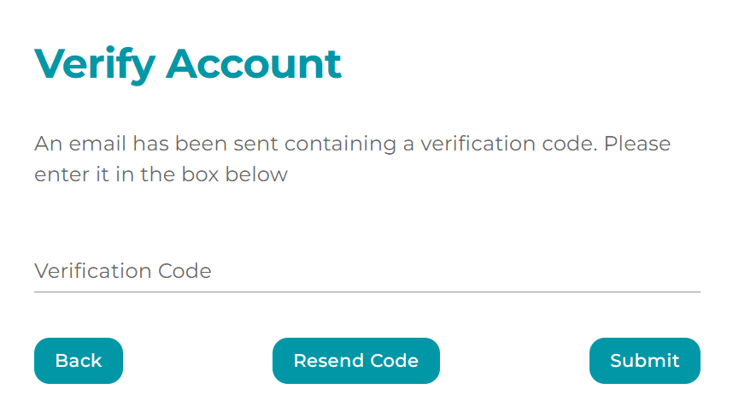
- Verify Account
  - You will receive an email containing a verification code.
  - Type or paste the code into the field provided on the website.
  - Click “Submit”
- Forgot Your Password
  - If you need to reset your password, go to the homepage and click the Sign In button in the top-right corner.
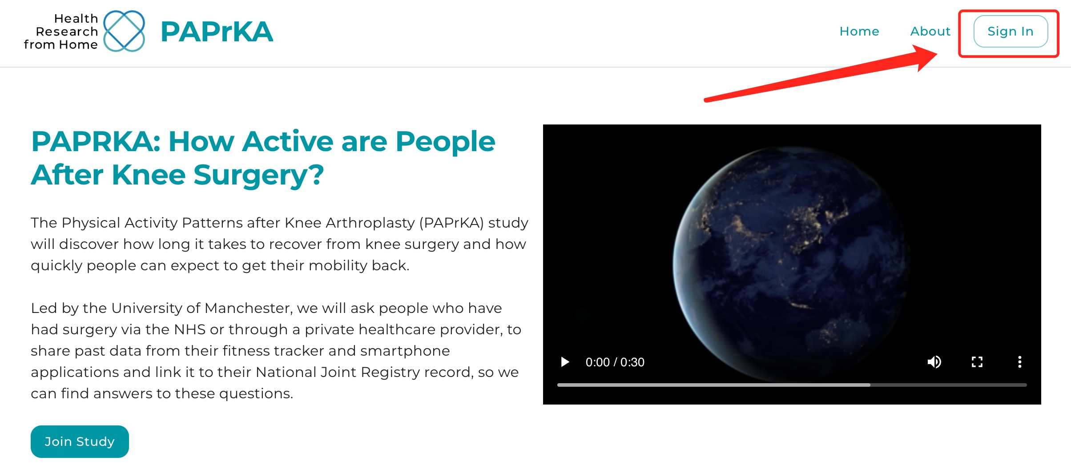
  - On the sign-in page, select “Forgot Your Password?”, then enter the email address you used to create your account. Click Submit, and you’ll receive an email with a reset link to set a new password.
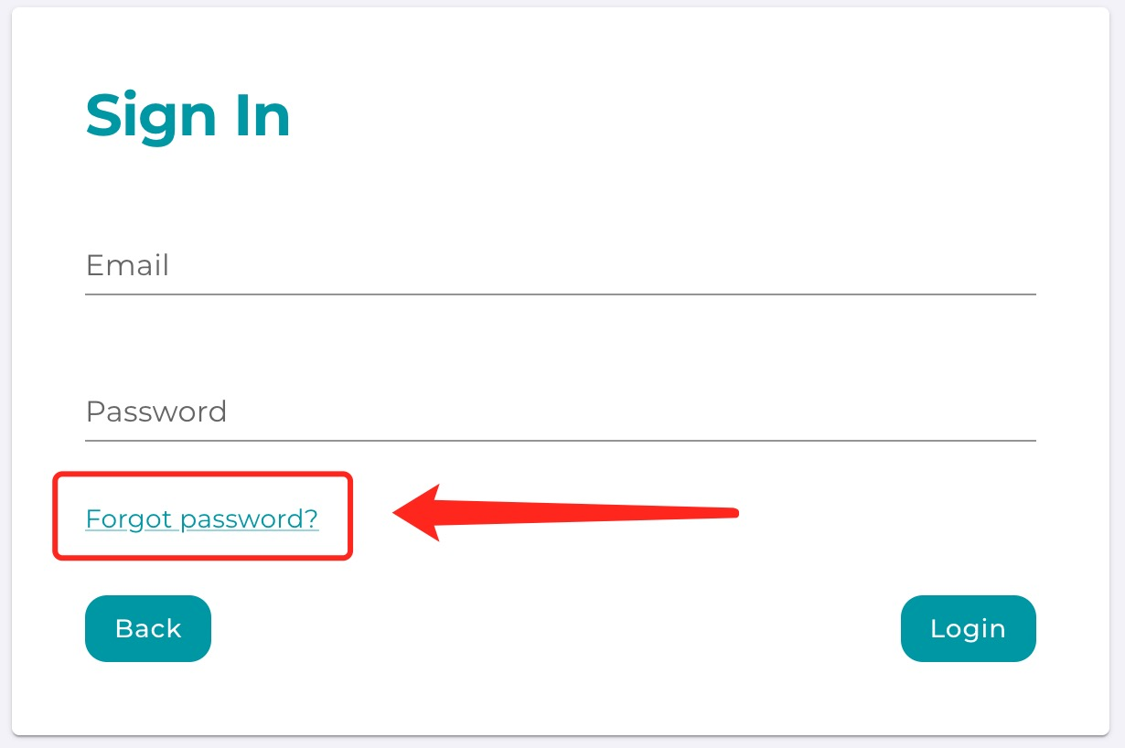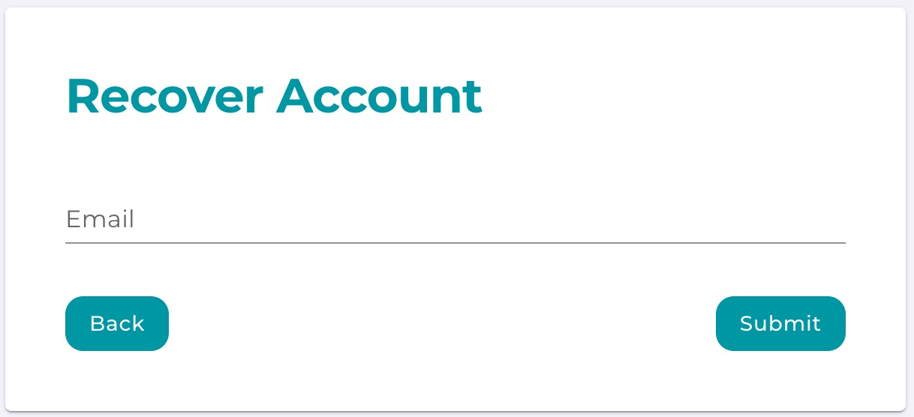
Tip: Your account lets you pause and return later. If you need a break, simply log out and come back whenever you want.

5. Using the Participant Portal
You’ll arrive at a dashboard showing four tasks. Three are essential (required), and one is optional:
- Surgery Information (Required)
- NHS Number (Required)
- Connect Devices (Required)
- Feedback (Optional)
Each task has a “ToDo” label if it’s not done yet, and “Done” once you complete it. A counter at the top (e.g., 0/3) tracks your progress on the required tasks.
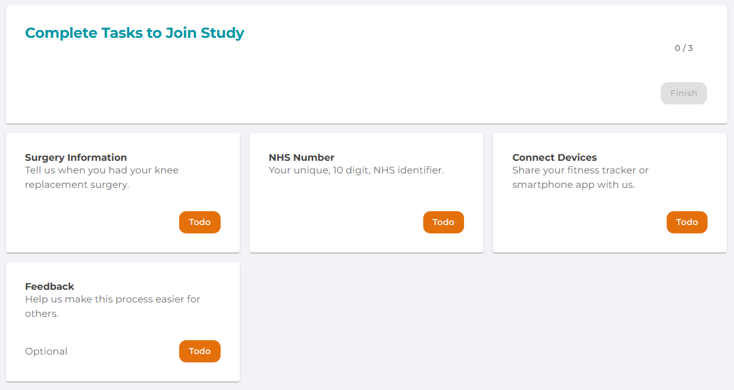
Task 1: Surgery Information
- Open the Surgery Information Card
  - Click the “ToDo” button under “Surgery Information.”
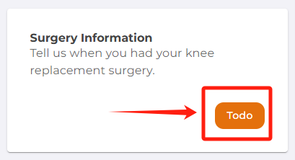
- Provide Surgery Details
  - Surgery Date: Use the calendar to select your most recent surgery date. Month and year are required, but the day of the month is optional.
  - Side of Knee: Choose what side knee was the surgery performed on.
  - Satisfaction Level: Choose your satisfaction rating (e.g., Very Satisfied, Somewhat Satisfied).
  - Education Level: Select from the list (no formal qualifications, GCSEs, degree, etc.).
  - Work Status: Indicate whether you are employed, retired, or out of work.
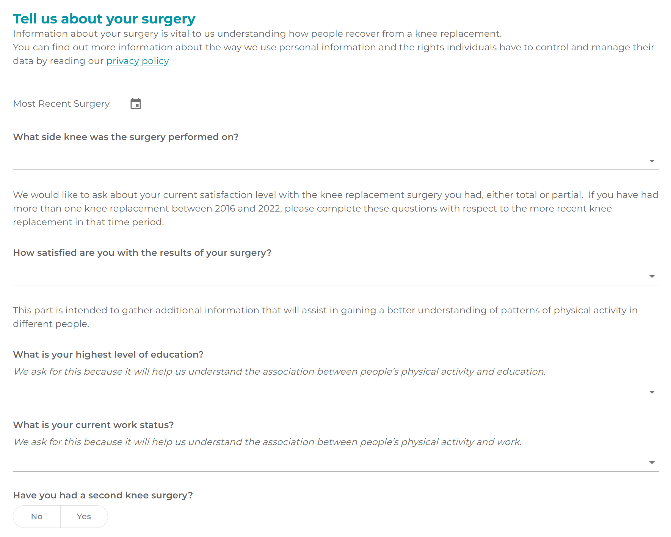
  - Second Knee Surgery: If you’ve had more than one knee replacement, please select ‘Yes’ and provide the details of your second surgery—this includes the date and which knee was operated on.
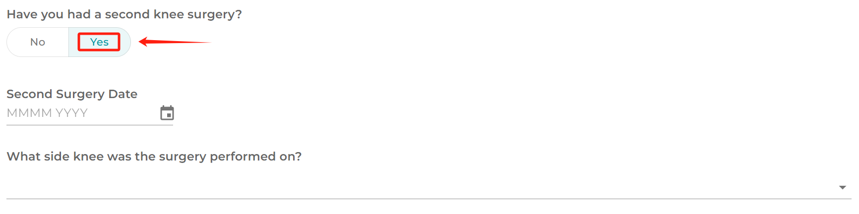
- Click “Submit”
  - This saves your surgery information and changes this task to “Done.”

Task 2: NHS Number
- Open the NHS Number Card
  - Click “ToDo” under “NHS Number.”
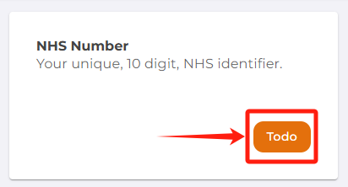
- Enter Your 10-Digit NHS Number
  - If you don’t know it, the page provides tips (e.g., the NHS website, your GP surgery, NHS app, or documents).
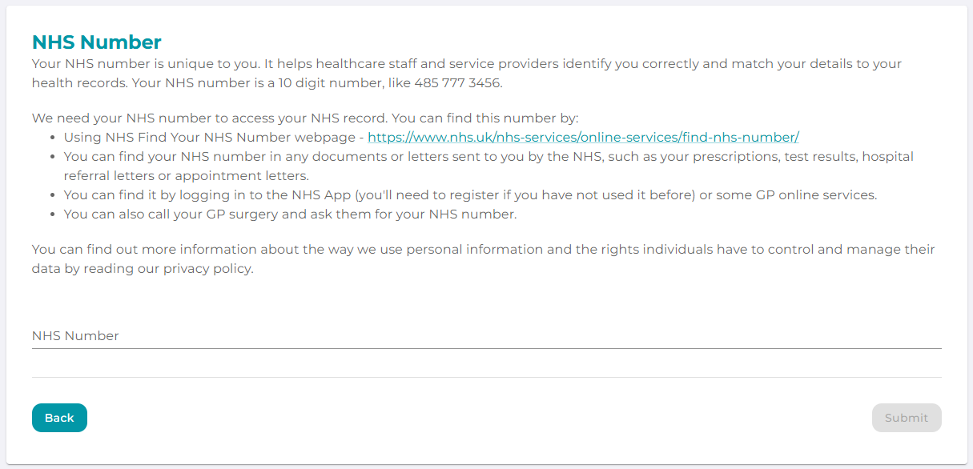
- Click “Submit”
  - Once submitted, the task becomes “Done.”

Task 3: Connect Devices
- Open the Connect Devices Card
  - Click “ToDo” under “Connect Devices.”
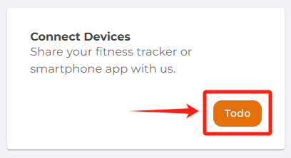
- Choose a Device
  - Options might include Fitbit, Apple Health, Garmin, or Oura.
  - Click the Connect button for the device you use.
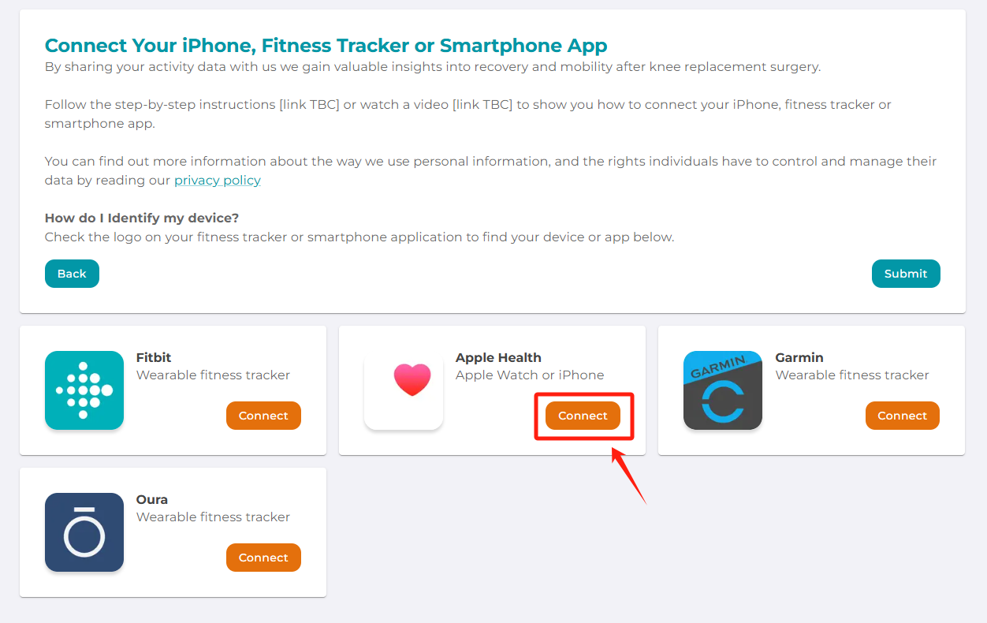
- Follow the Instructions
  - Fitbit: A new window will open; log in to Fitbit and allow data sharing.
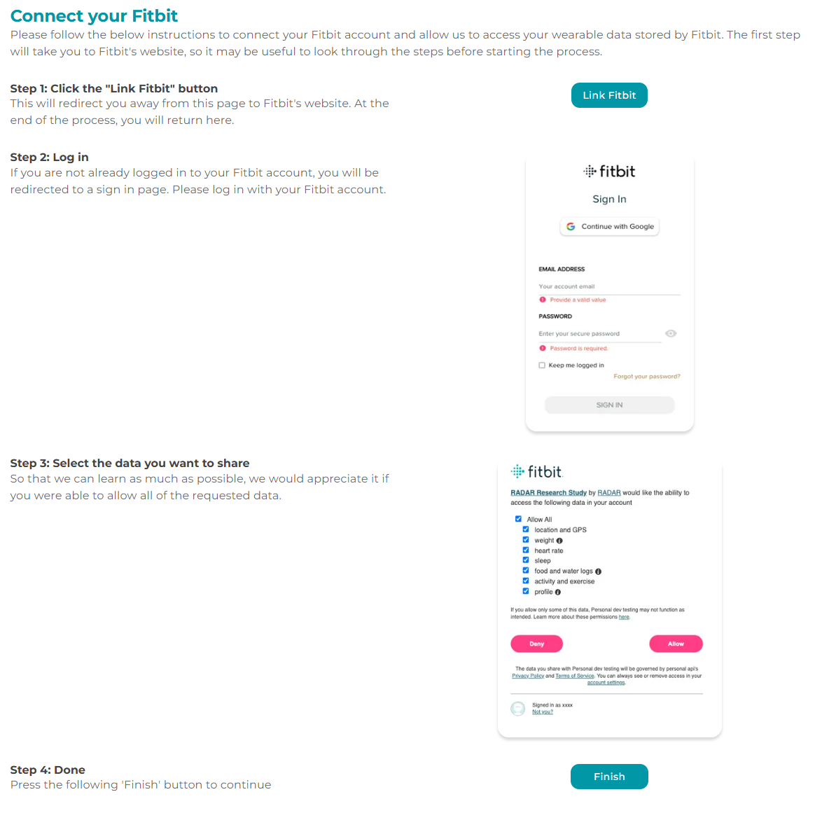
  - Please give permission for your health data, including:
    - Heart Rate
    - Activities and Exercise
    - Sleep
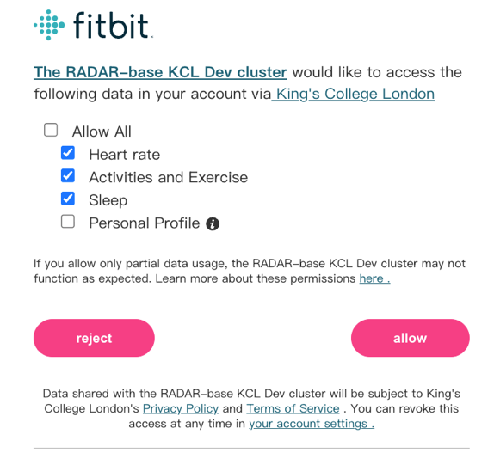

  - Apple Health: Follow these steps to link your Apple Health data so the research team can access your data and better understand your activity levels.
    - Download the RADAR Active RMT App
      - Open the App Store on your iPhone.
      - Search for “RADAR Active RMT” (it may be listed under “RADAR-base”).
      - Install the app onto your iPhone
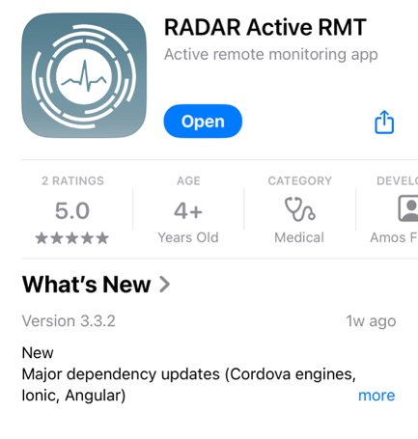
    - Open the App
      - Locate the RADAR Active RMT app on your home screen.
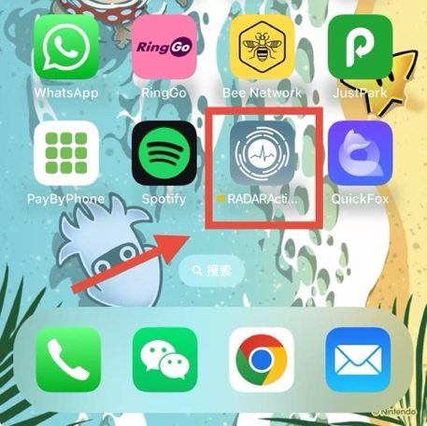
      - Tap it to launch the app.
      - You should see a welcome screen with a “Start” button.
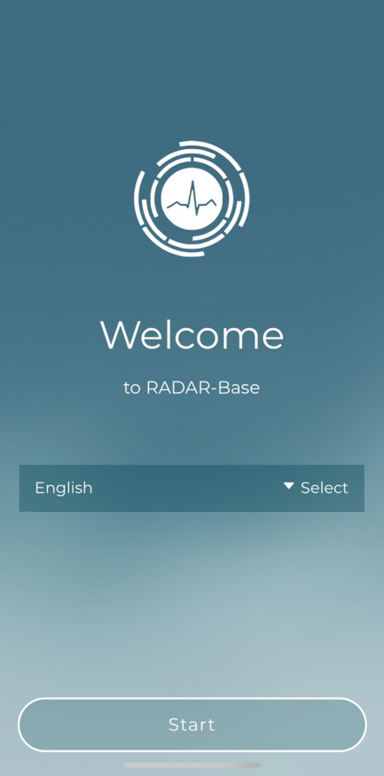
    - Registration
      - After tapping “Start,” click on ‘Enrol’ button to allow the registration.
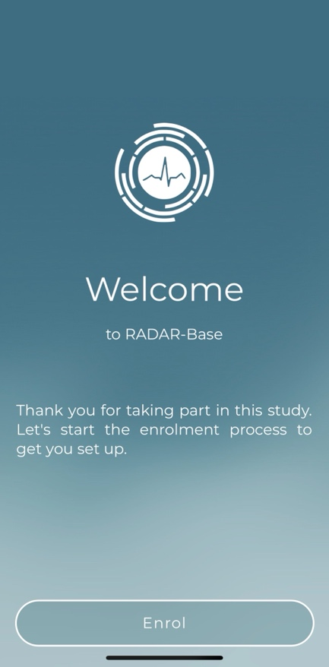
      - Select “Scan” to enable your phone’s camera for scanning a QR code.
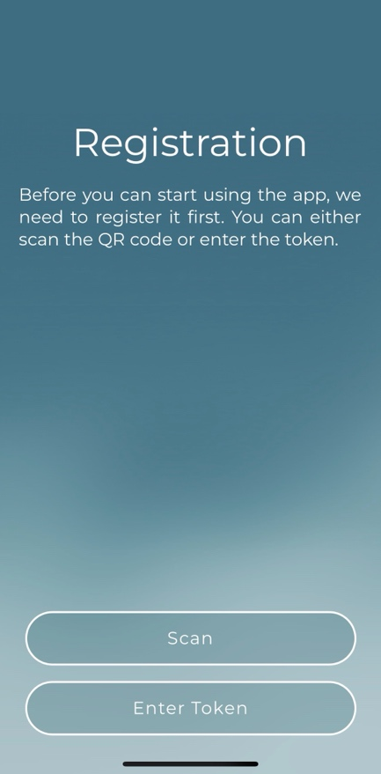
      - Scan the QR code for connecting Apple Health. The QR code can be found in the Connect to Apple Health task. Each participant has a unique code, so please locate yours on PAPrKA webpage.
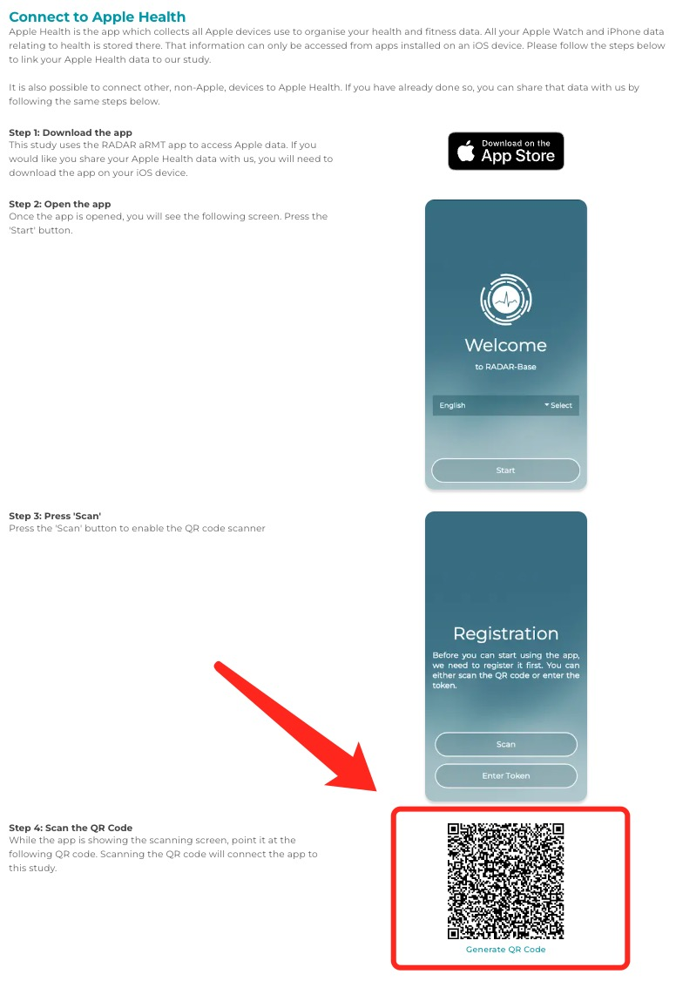
      - Point your phone’s camera at the QR code until it’s recognized. Then you can click the ‘Next’ button to finish the registration and continue for data sharing.
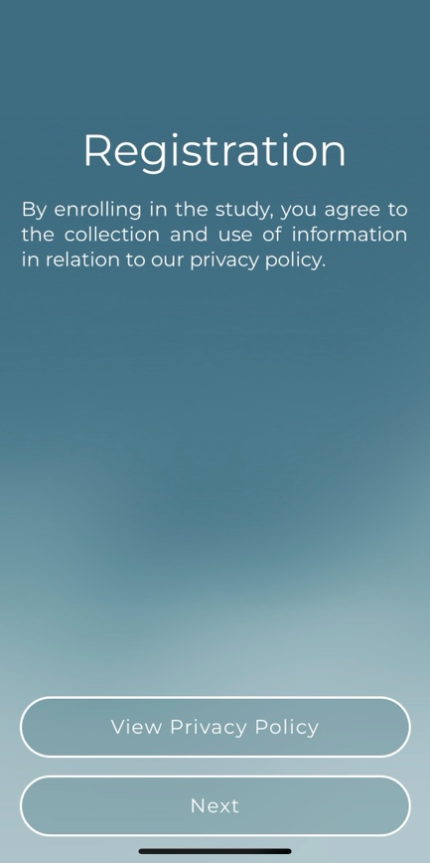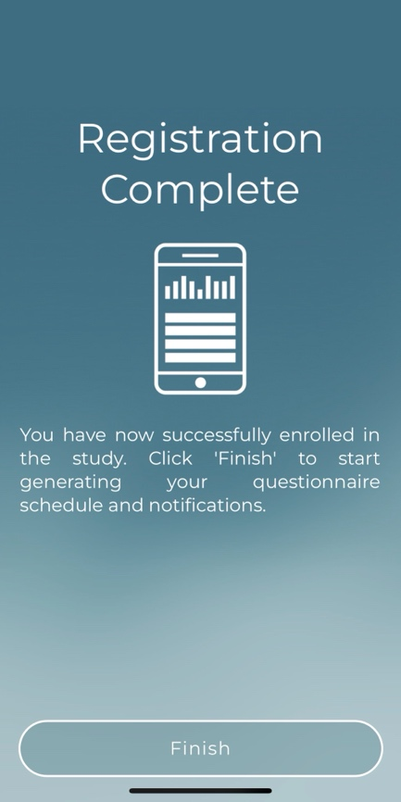

    - Allow Apple Health Sharing
      - Click the ‘Start’ button to share your health data.
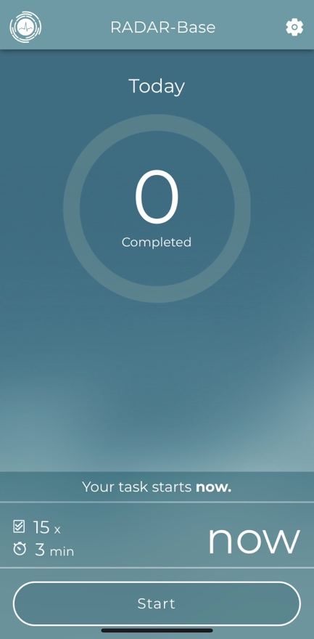

      - You may see prompts to allow data sharing from Apple Health to the RADAR rMT app.
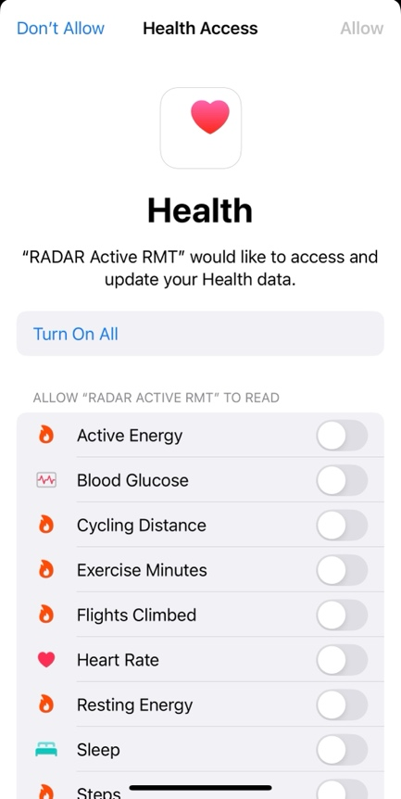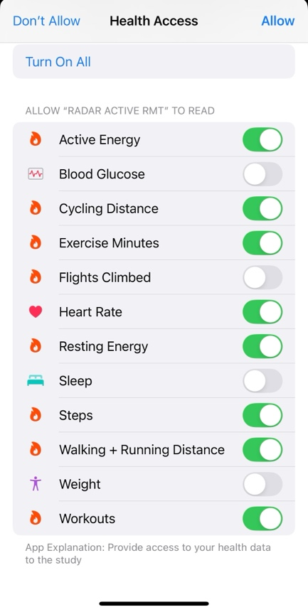
      - Follow these prompts to give permission for your health data, including:
        - Active Energy
        - Cycling Distance
        - Exercise Minutes
        - Heart Rate
        - Resting Energy
        - Steps
        - Walking + Running Distance
        - Workouts
    - Complete the Apple Health Task
      - Click “Next” to allow the data sharing.
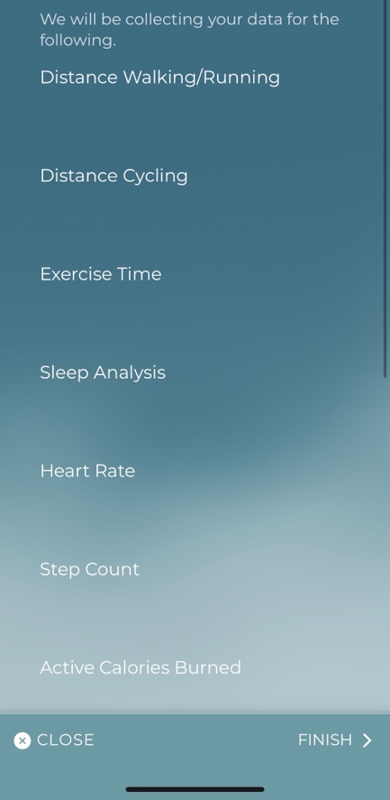
      - Wait while the app finishes setting up your connection.
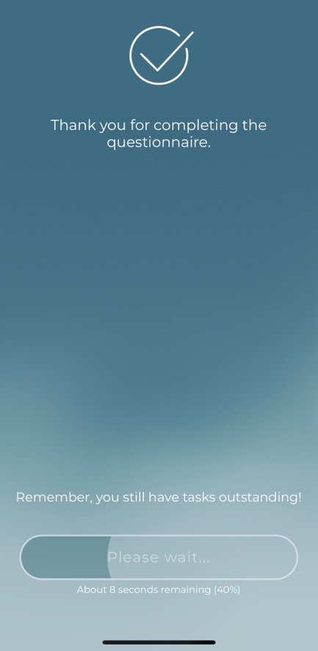

      - Once you finished all the tasks, you can go back to the PAPrKA website to finish other tasks.
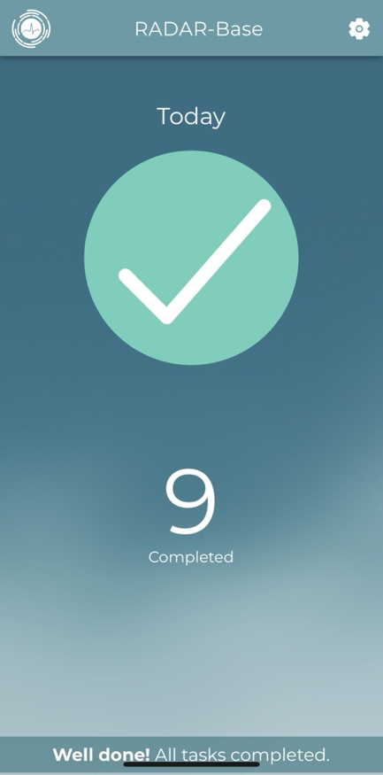

  - Garmin or Oura: Sign in or authorize data sharing.
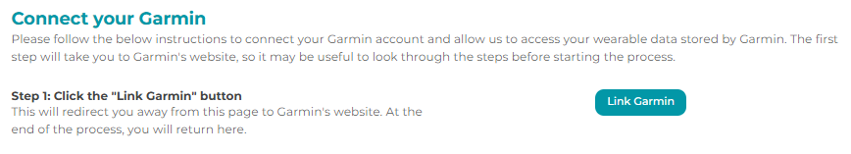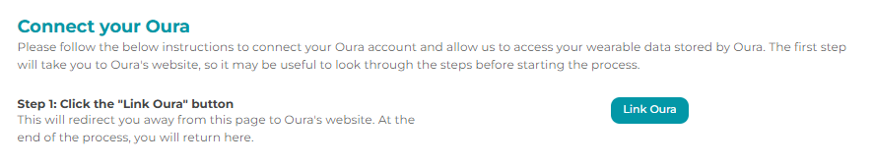
- Finish or Add More Devices
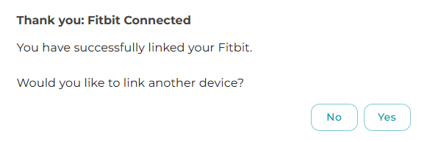
  - After you connect one device, you can connect another if you use more than one.
  - When done, click Submit to complete the task.

Optional: Feedback
- Open the Feedback Card (If You Wish)
  - Click “ToDo” under “Feedback,” if you want to share your thoughts.
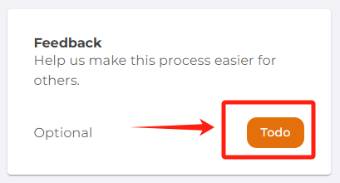
- Answer a Few Questions
  - How easy was the data collection process? (choose from a dropdown)
  - Where did you hear about this study? (another dropdown)
  - Provide any extra comments or suggestions in the text box.
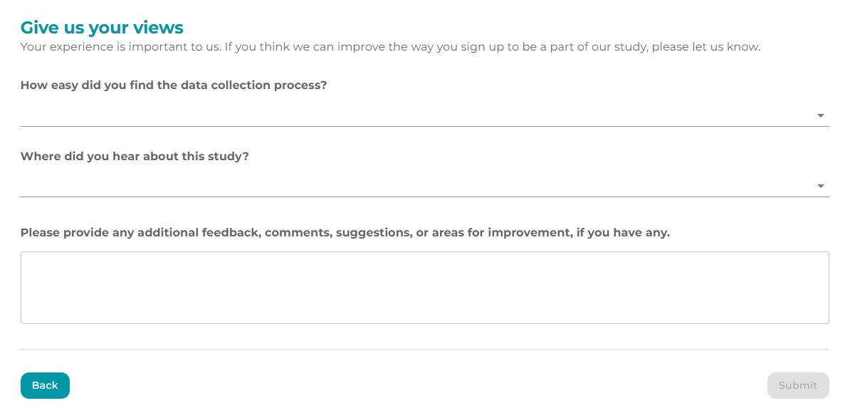
- Click “Submit”
  - This step is completely optional but helpful to improve future participant experiences.

6. Finishing Up
- Check Your Progress
  - Each completed required task will say “Done” instead of “ToDo.”
  - The counter (e.g., 3/3) tells you how many essential tasks you’ve finished.
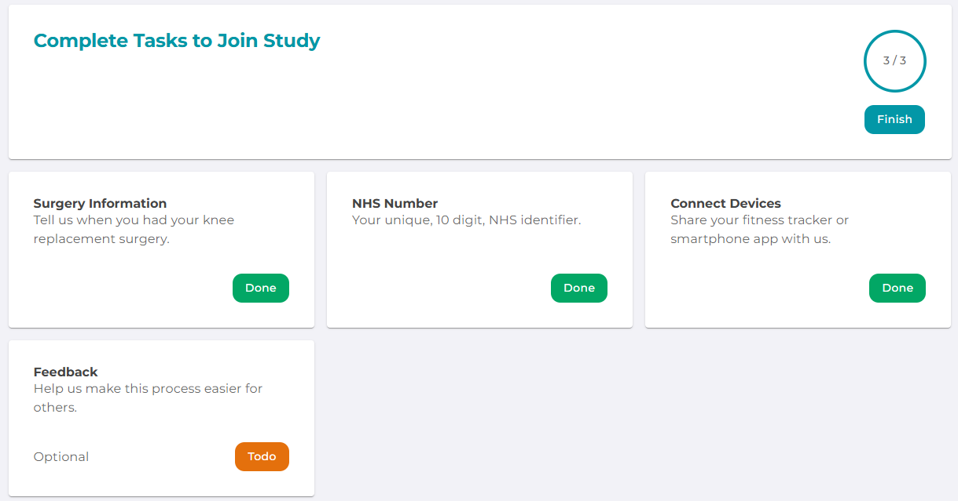
- Click “Finish”
  - Once you have all three required tasks marked as Done, a Finish button becomes active.
  - Click it to finalize your participation.
- Study Complete
  - You’ll see a message that says you’ve successfully joined the PAPrKA study.
  - You can still do the optional Feedback task if you haven’t already. Otherwise, you’re all set!
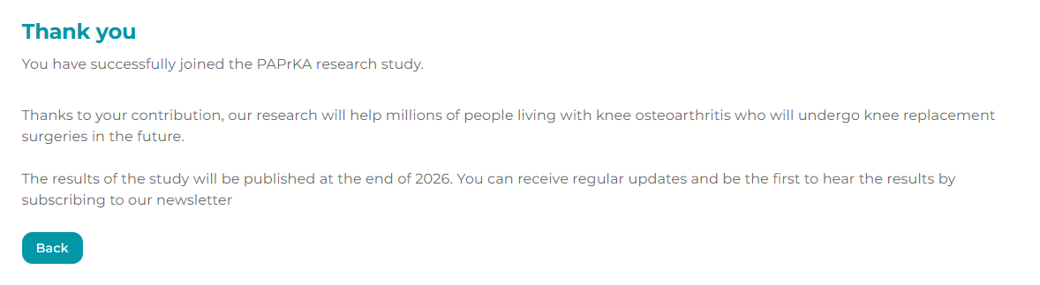
Tip: Even after finishing, you can return to the portal with your login details if you need to update anything.

7. Need Help? We’re Here to Support You
- If you encounter any issues during the process, please email the PAPrKA study team: PAPrKA@manchester.ac.uk for assistance. We’re here to help you troubleshoot and get back on track as quickly as possible.
- Data Privacy and Questions
  - Detailed information on how your data is handled can be found under the Privacy Policy and Participant Information Sheet. If you still have questions, please contact the PAPrKA study team: PAPrKA@manchester.ac.uk

