Q59: Count even and odd numbers in an array.
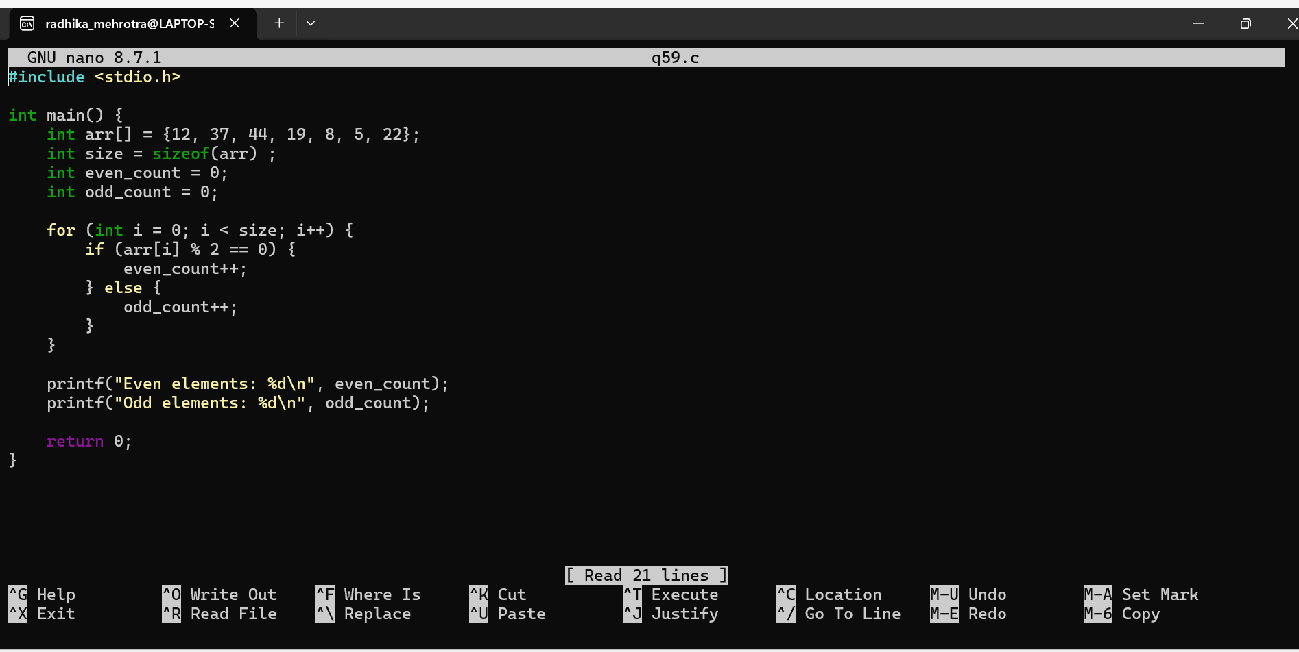Q60: Count positive, negative, and zero elements in an array.
