Q61: Search for an element in an array using linear search.
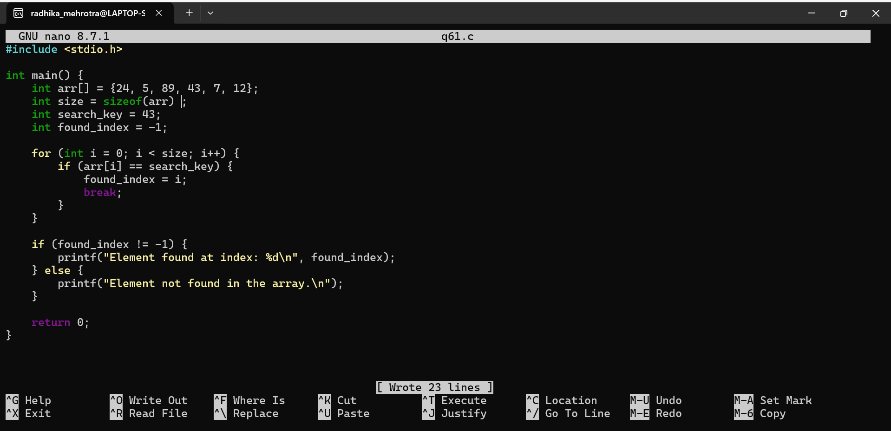
Q62: Reverse an array without taking extra space.
