Q63: Merge two arrays.
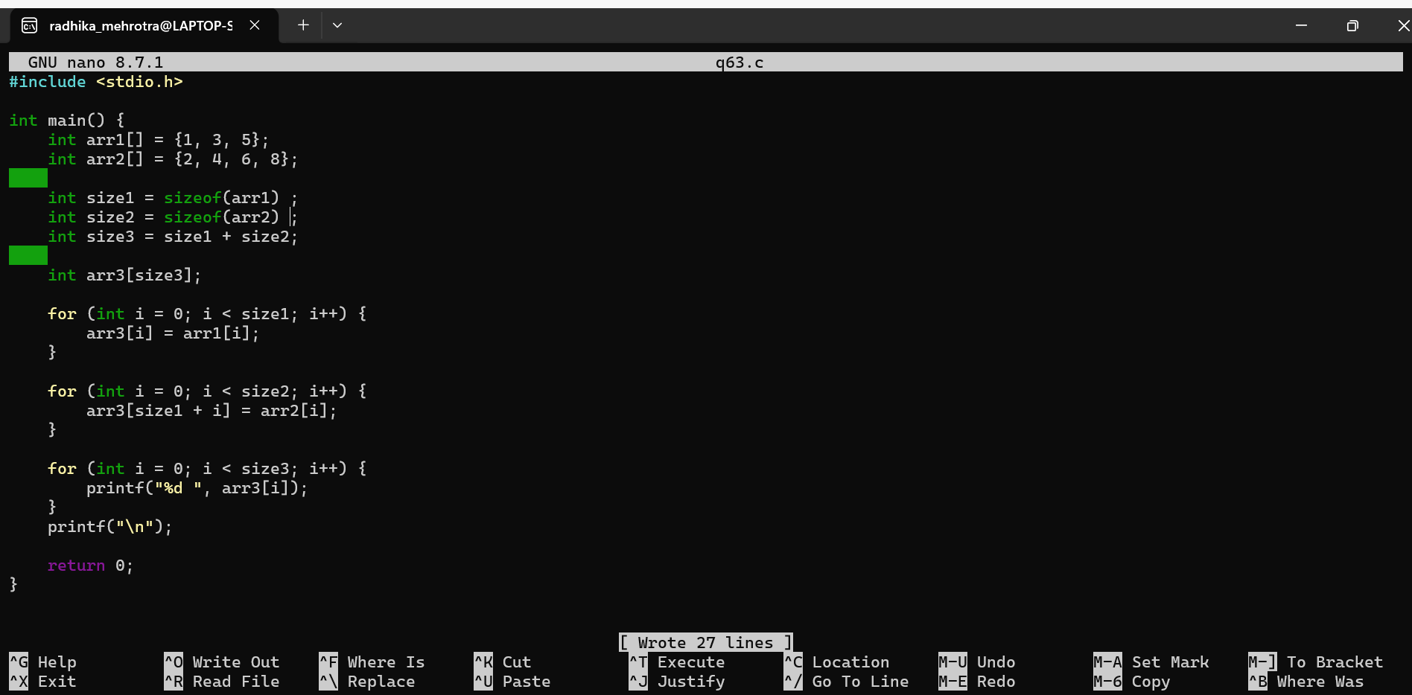
Q64: Find the digit that occurs the most times in an integer number.
