Q65: Search in a sorted array using binary search.
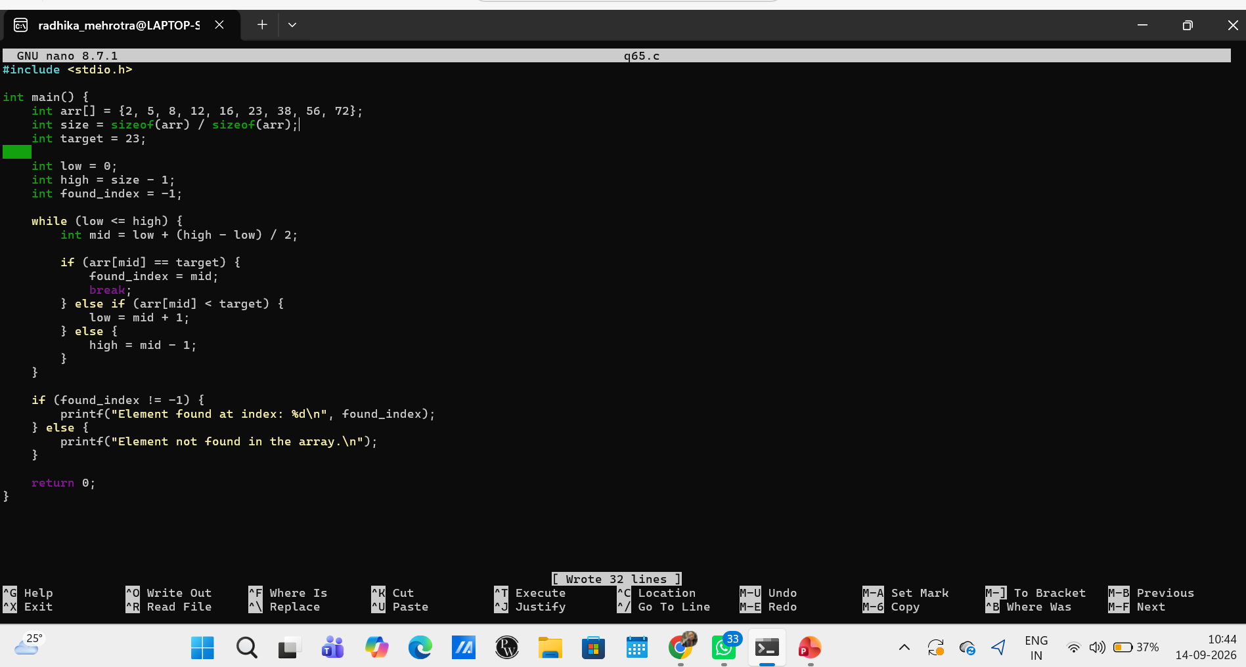Q66: Insert an element in a sorted array at the appropriate position.
