Q67: Insert an element in an array at a given position.
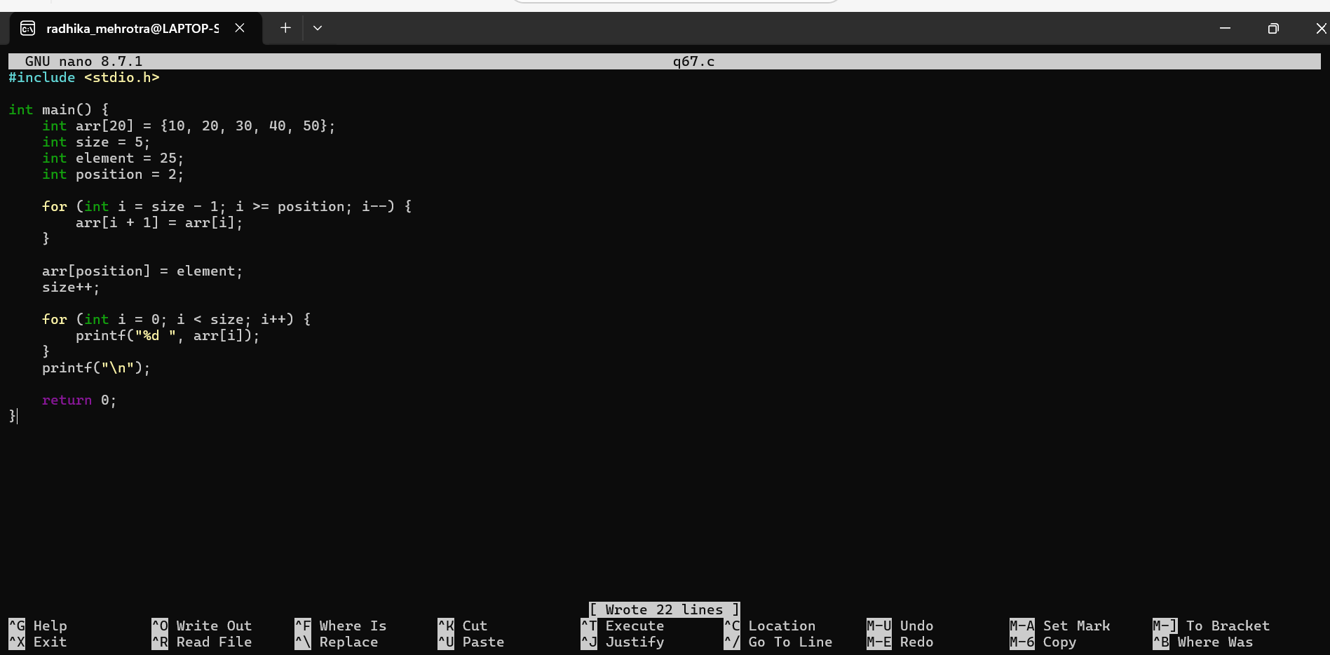
Q68: Delete an element from an array.
