Q69: Find the second largest element in an array.
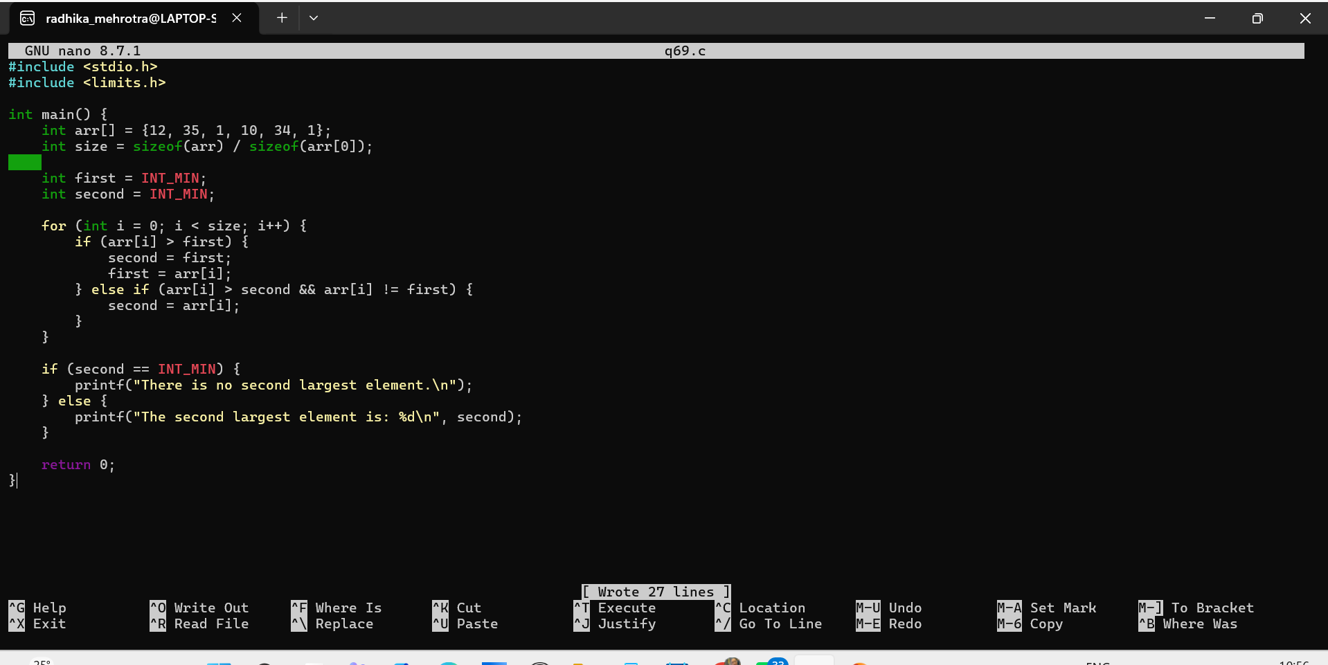Q70: Rotate an array to the right by k positions.
