Q71: Read and print a matrix.
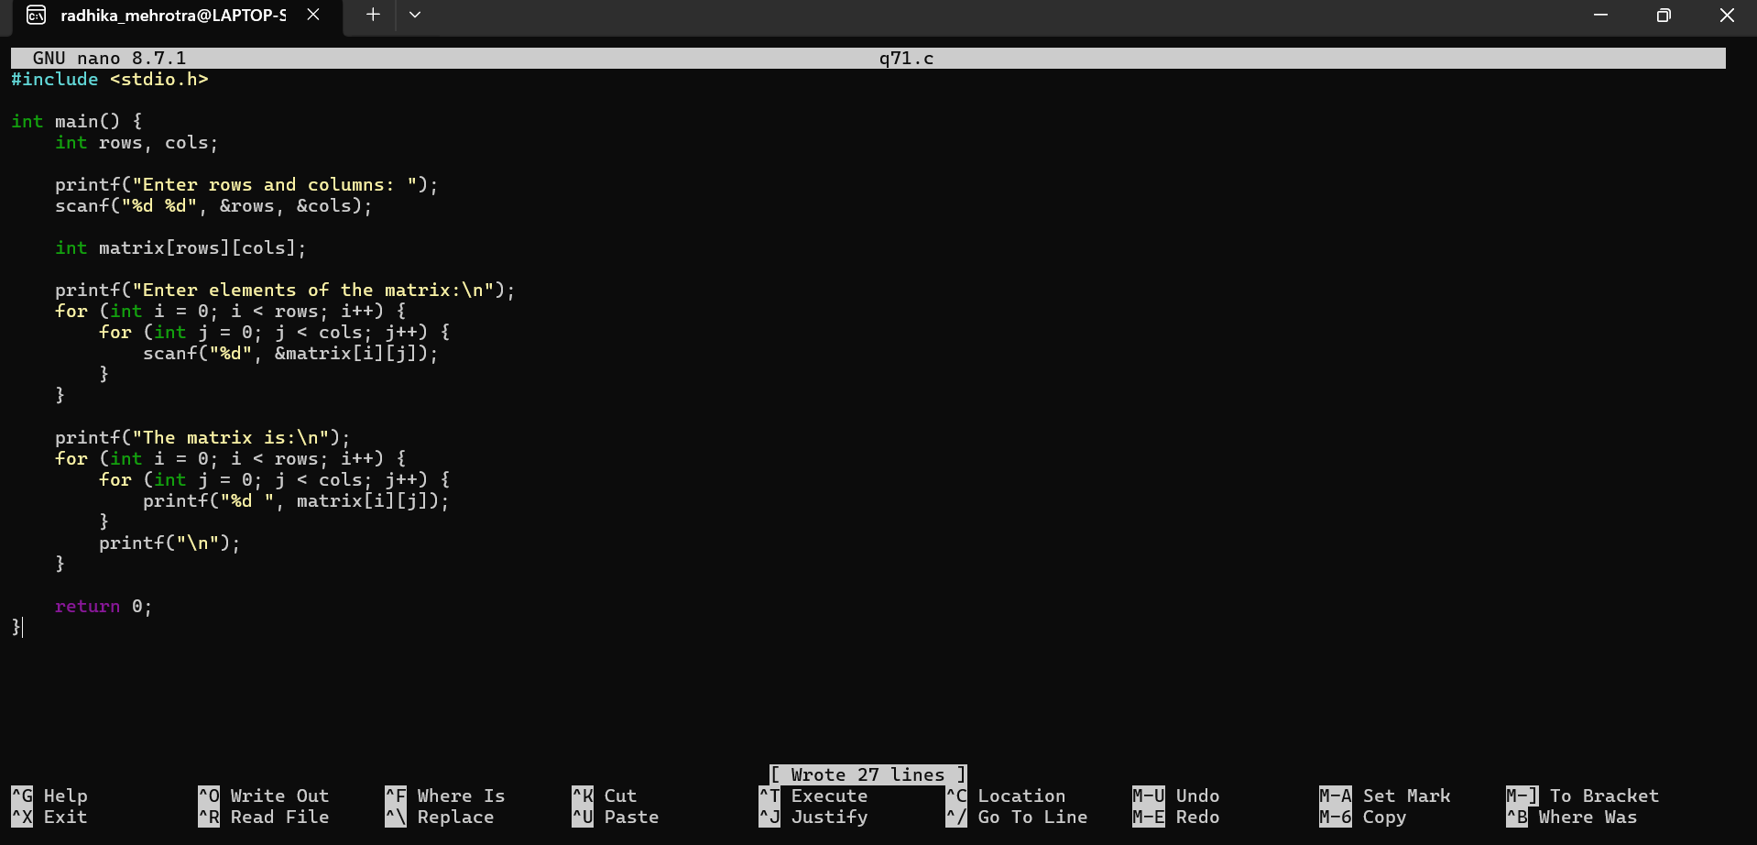Q72: Find the sum of all elements in a matrix.
