Q43: Write a program to check if a number is a strong number.
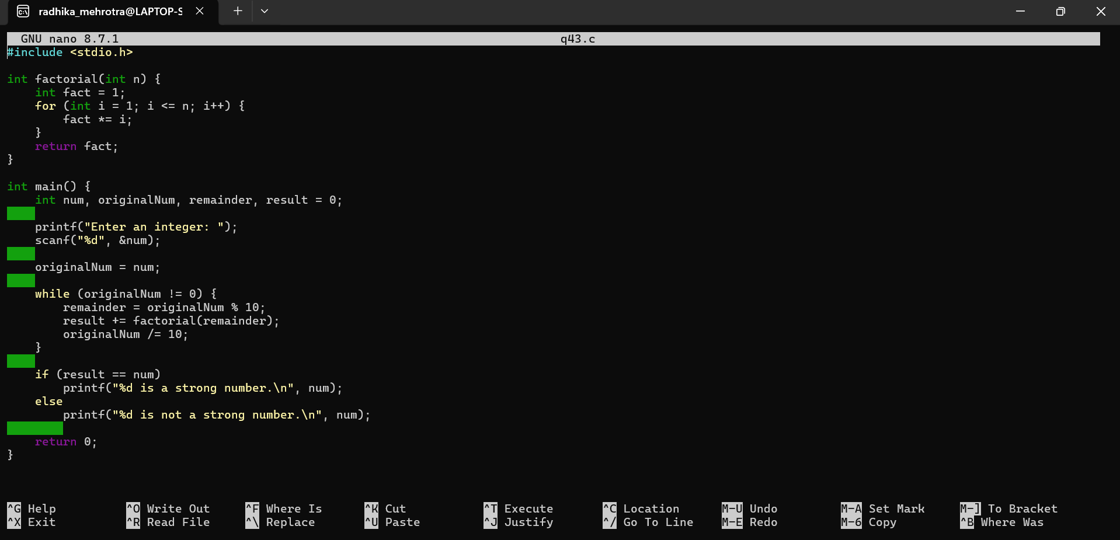Q44: Write a program to find the sum of the series: 1 + 3/4 + 5/6 + 7/8 + … up to n terms.
