Q45: Write a program to find the sum of the series: 2/3 + 4/7 + 6/11 + 8/15 + ... up to n terms.

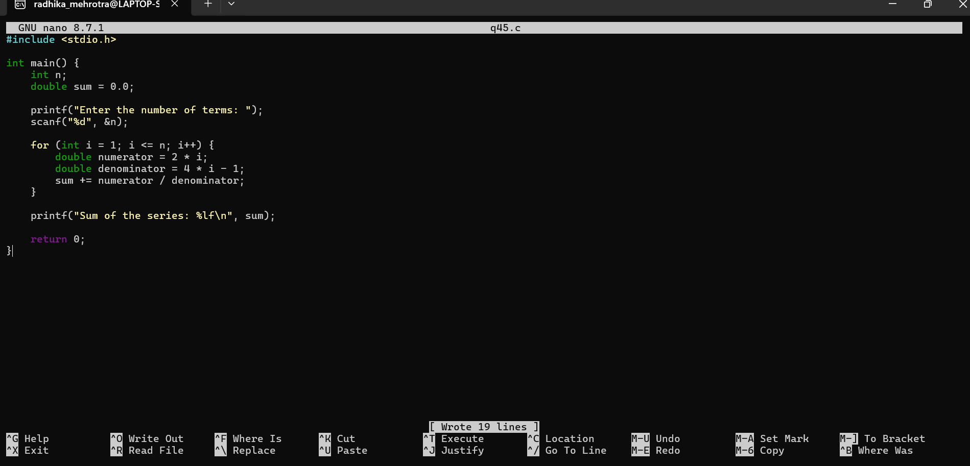
Q.46 Write a program to print the following pattern:
*****
*****
*****
*****
*****
