Q47 (Nested Loops without Arrays/Strings)📋
Write a program to print the following pattern:
*
**
***
****
*****
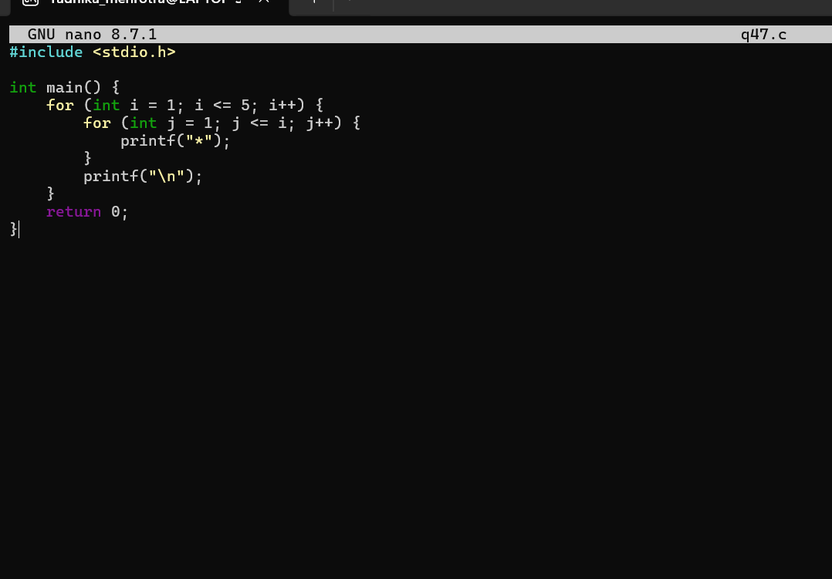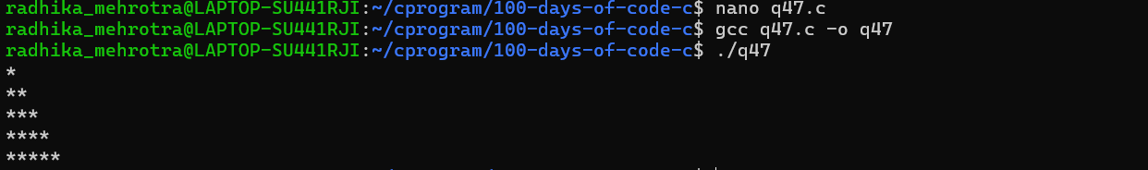Q48 (Nested Loops without Arrays/Strings)📋
Write a program to print the following pattern:
1
12
123
1234
12345
