Q51 (Nested Loops without Arrays/Strings)📋
Write a program to print the following pattern:
5
45
345
2345
12345
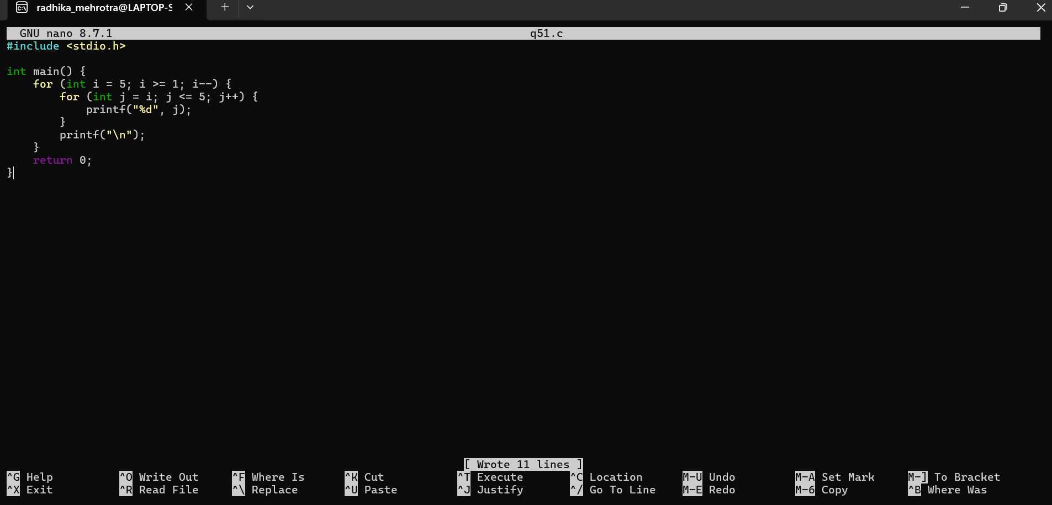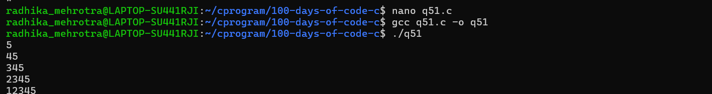Q52 (Nested Loops without Arrays/Strings)📋
Write a program to print the following pattern:
*
*
*
*
*
*
*
*
*
*
*
*
*
