Q53 (Nested Loops without Arrays/Strings)📋
Write a program to print the following pattern:
*
***
*****
*******
*********
*******
*****
***
*
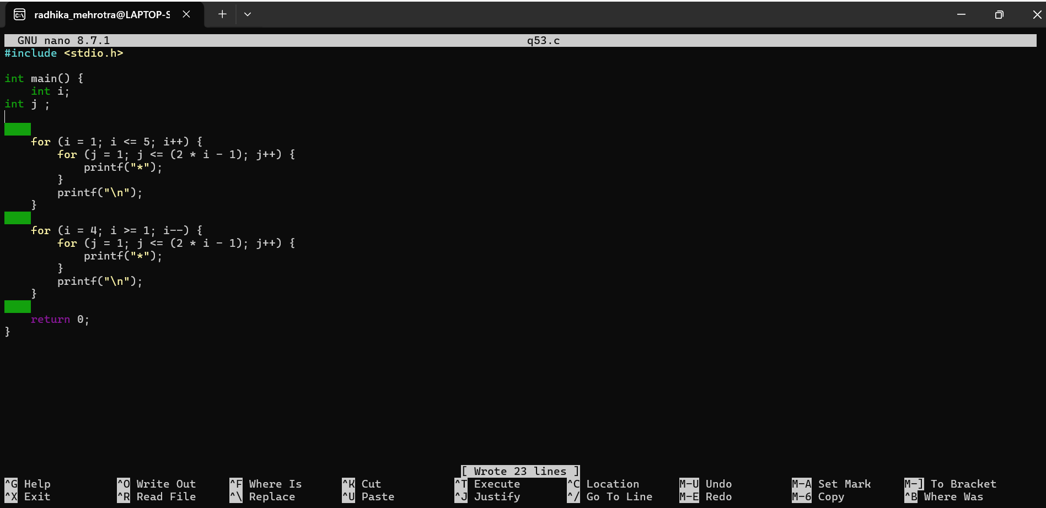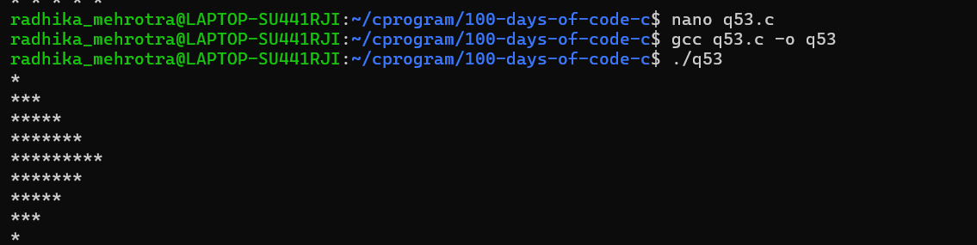
Q54 (Nested Loops without Arrays/Strings)✅
Write a program to print the following pattern:
*
***
*****
*******
*****
***
*
