Q55. (Nested Loops without Arrays/Strings)📋
Write a program to print all the prime numbers from 1 to n.
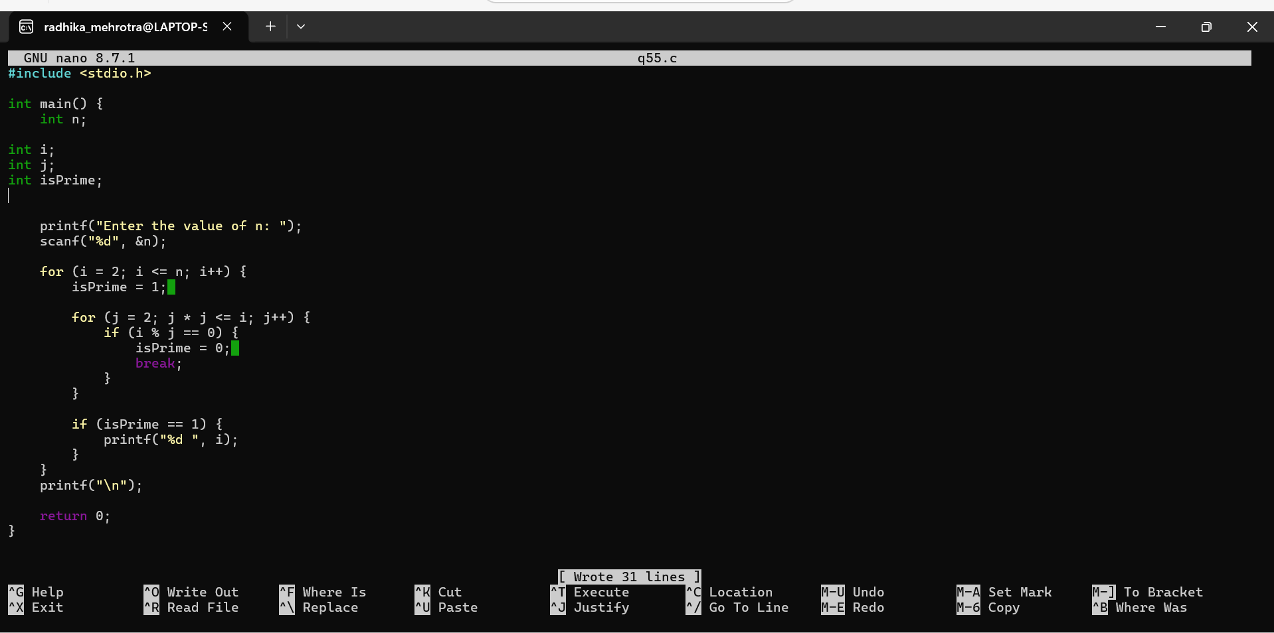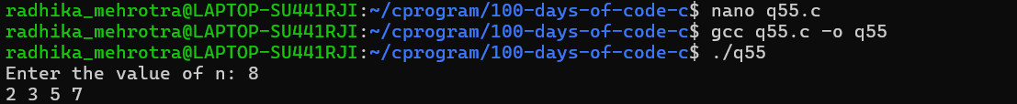Q56 (Arrays (1D))📋
Read and print elements of a one-dimensional array.
