Q57. (Arrays (1D))📋
Find the sum of array elements.
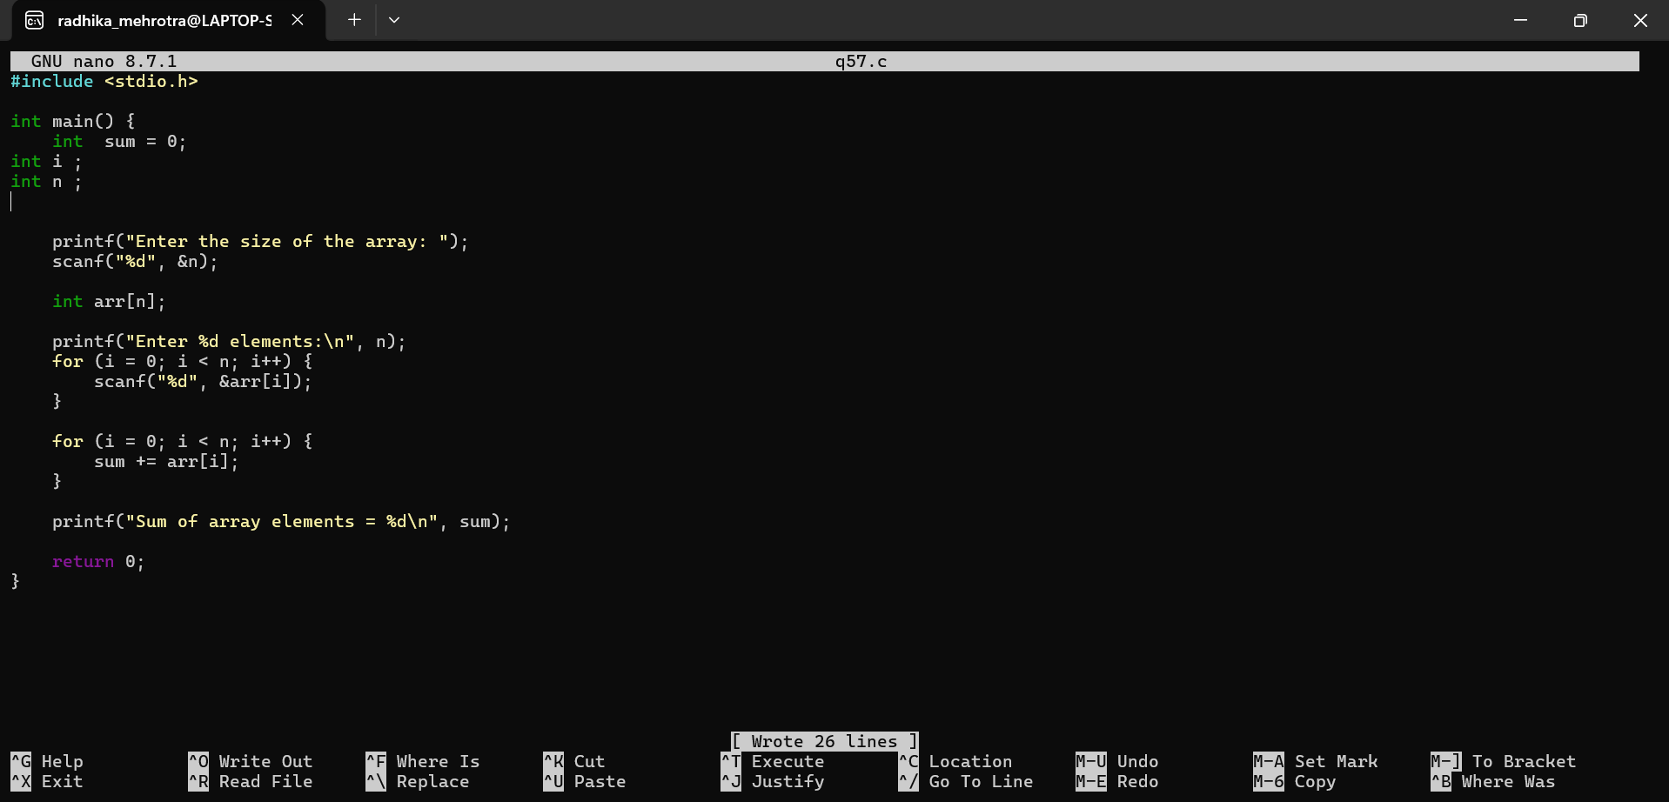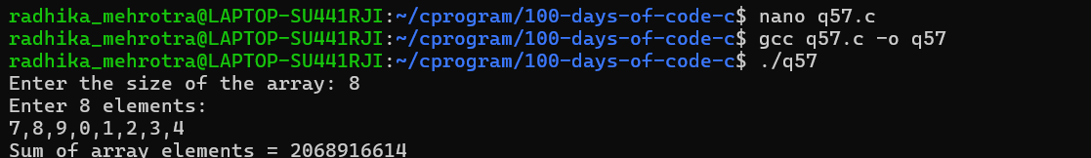Q58 (Arrays (1D))✅
Find the maximum and minimum element in an array.
