Q23: Write a program to calculate library fine based on late days as follows:
First 5 days late: ₹2/day
Next 5 days late: ₹4/day
Next 20 days days late: ₹6/day
More than 30 days: Membership Cancelled.
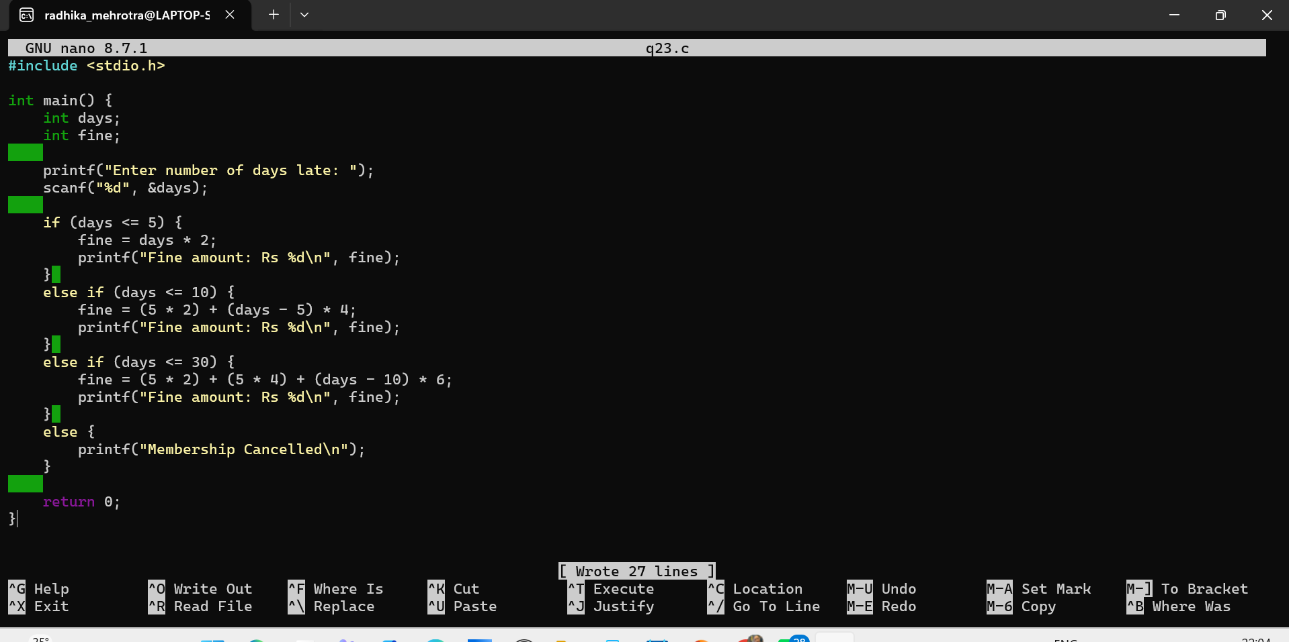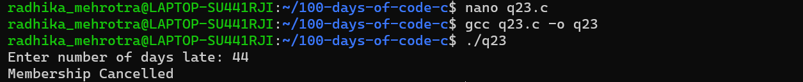
Q24: Write a program to calculate electricity bill based on units consumed with these rates:
First 100 units at ₹5/unit
Next 100 units at ₹7/unit
Next 100 units at ₹10/unit .
