Q31: Write a program to take a number as input and print its equivalent binary representation.
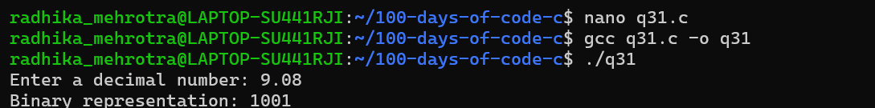
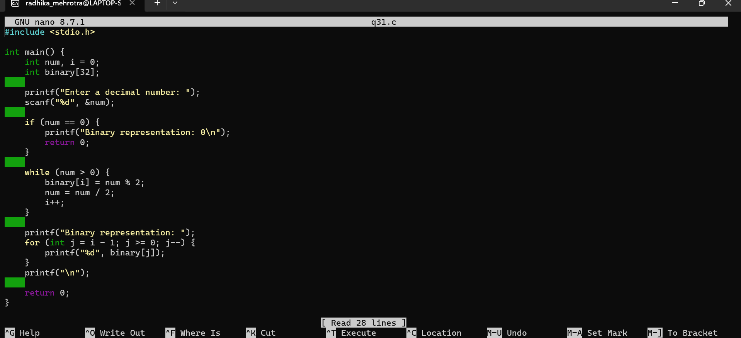
Q32: Write a program to check if a number is a palindrome.
