Q33: Write a program to check if a number is an Armstrong number.
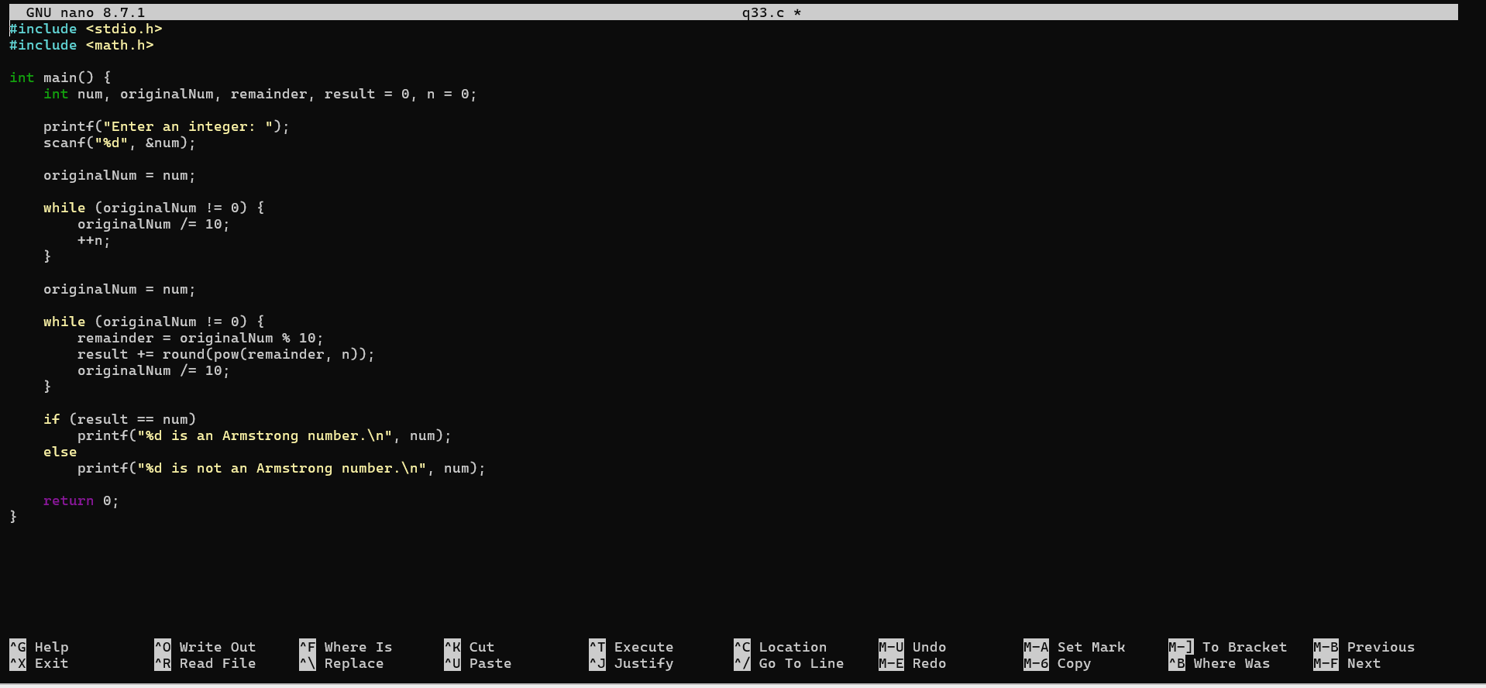
Q34: Write a program to check if a number is prime.
