Q35: Write a program to print all factors of a given number.
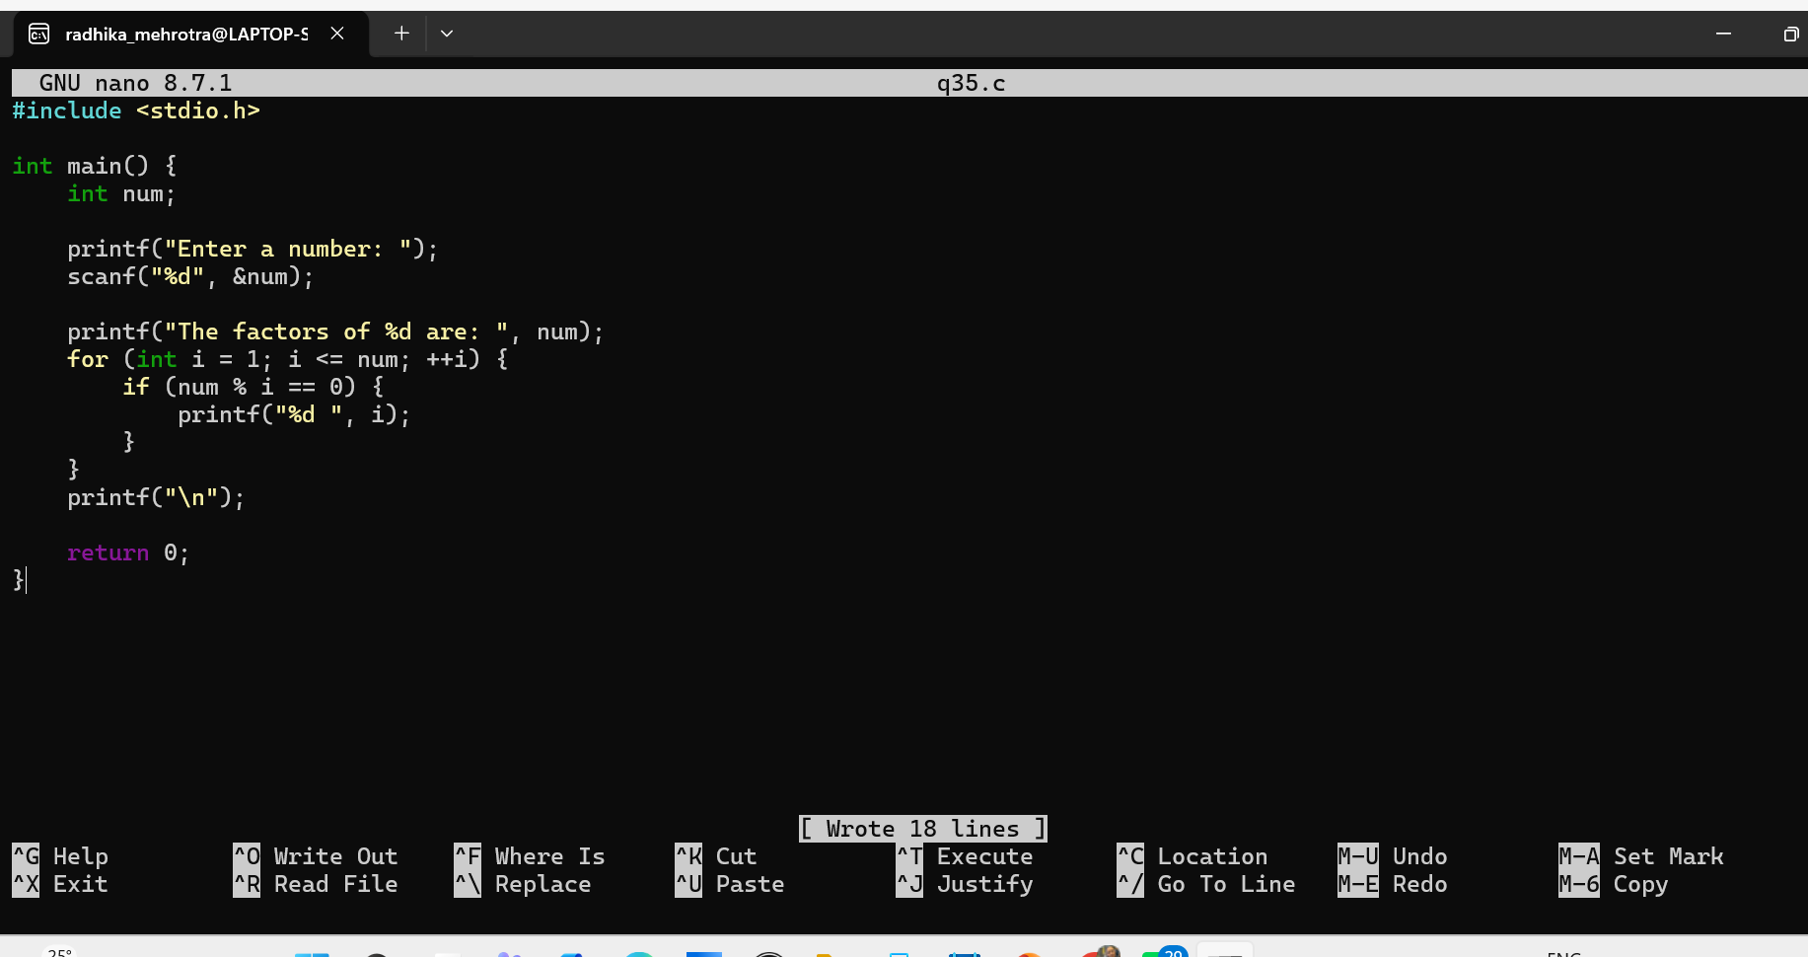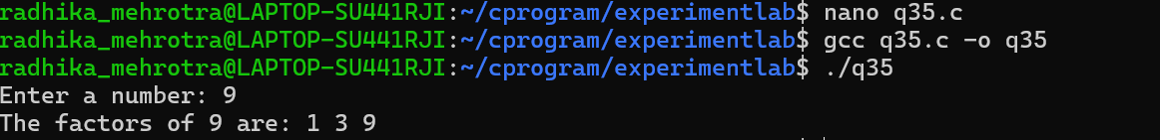Q36: Write a program to find the HCF (GCD) of two numbers.
