Q37: Write a program to find the LCM of two numbers.

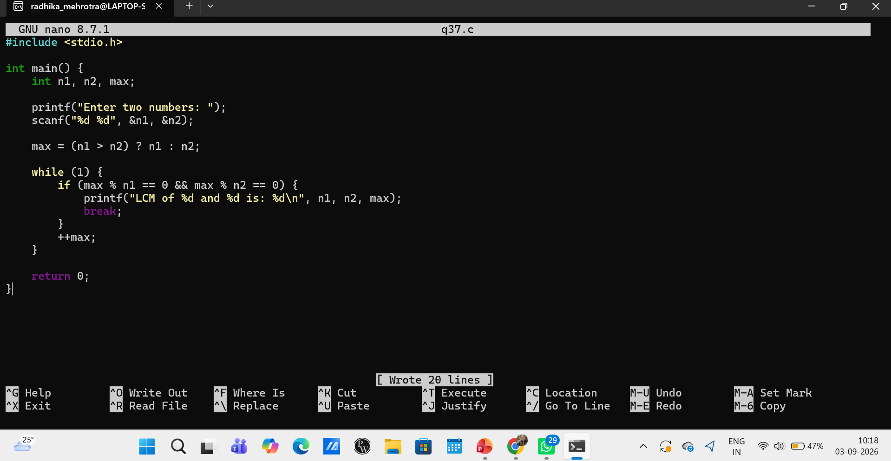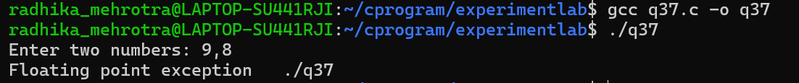Q38: Write a program to find the sum of digits of a number.

