Q39: Write a program to find the product of odd digits of a number.
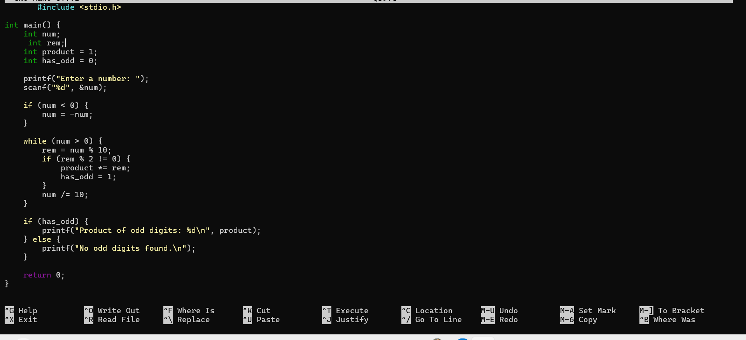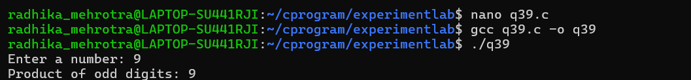
Q40: Write a program to find the 1’s complement of a binary number and print it.