Q41: Write a program to swap the first and last digit of a number.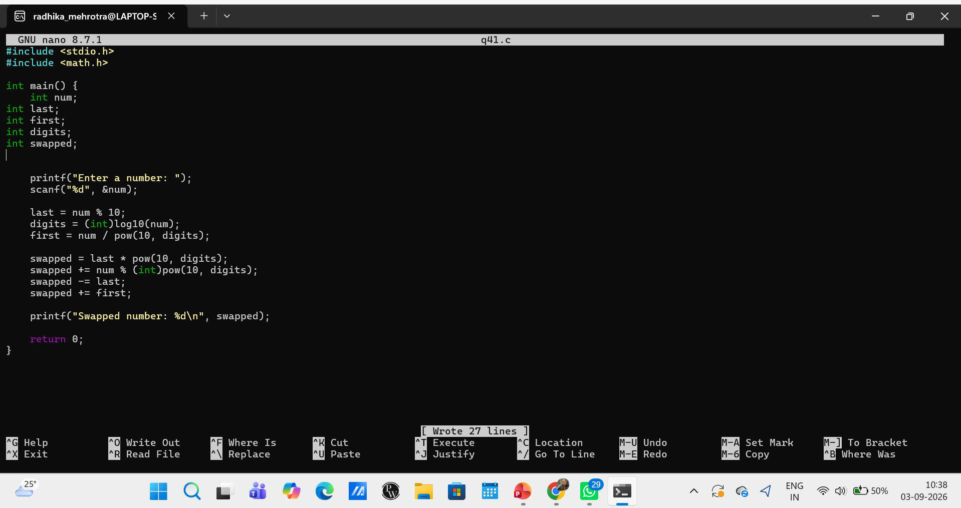Q42: Write a program to check if a number is a perfect number.
