Q19: Write a program to classify a triangle as Equilateral, Isosceles, or Scalene based on its side length.
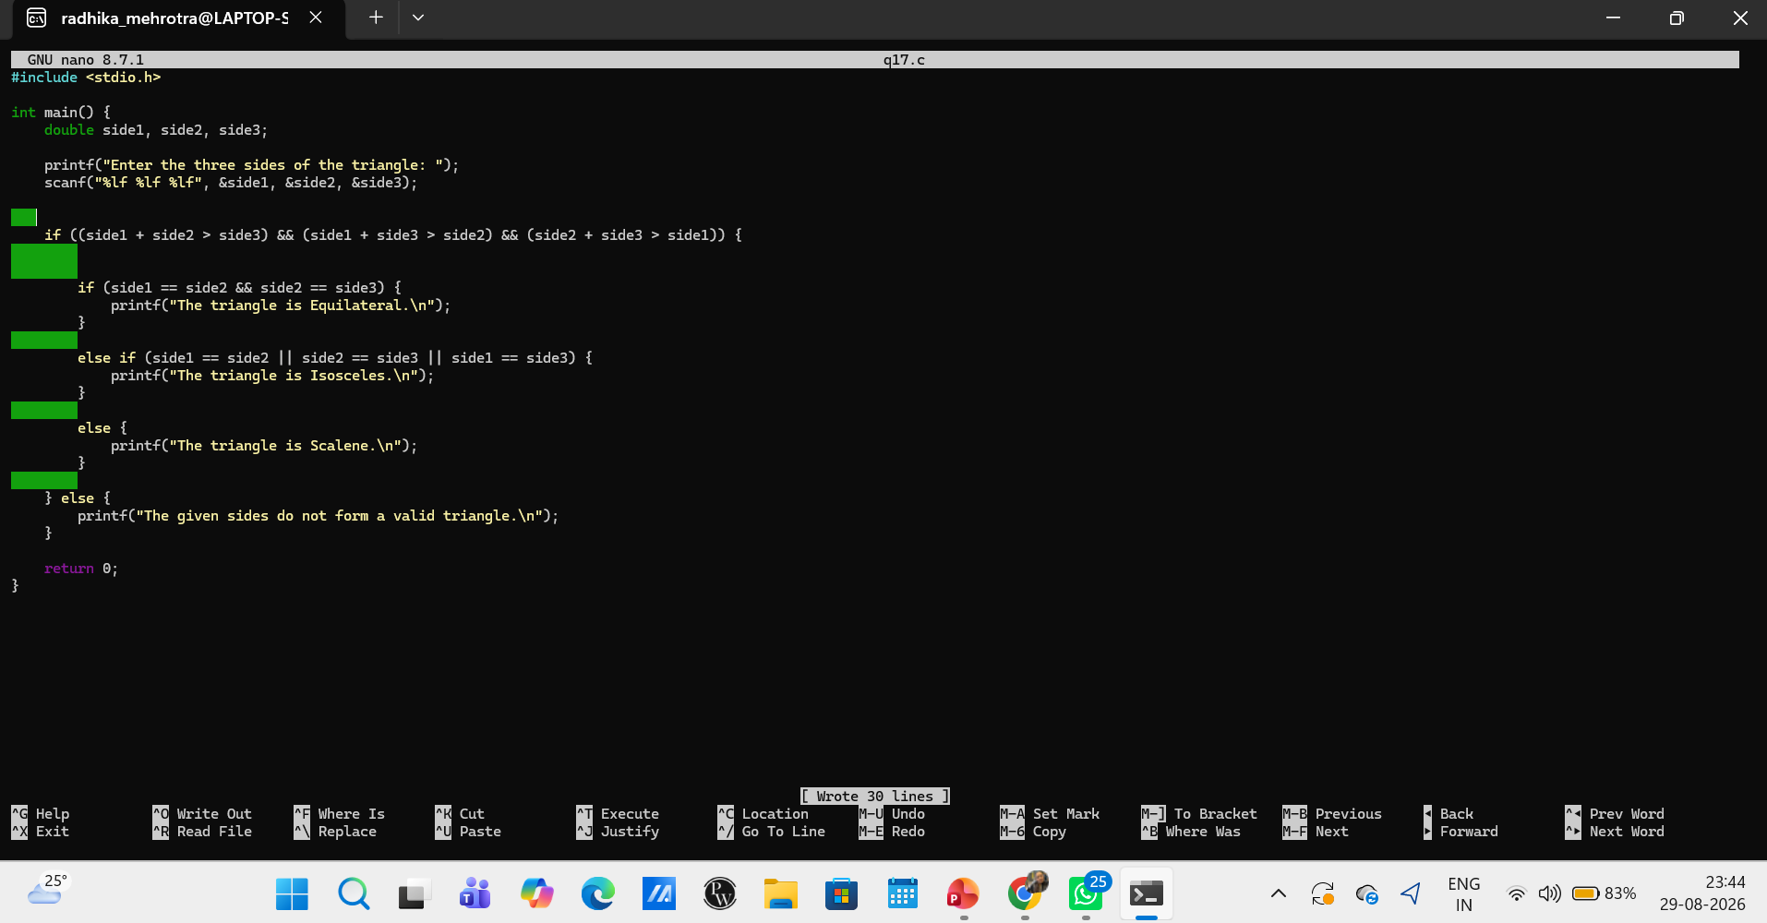Q20: Write a program to display the day of the week based on a number (1–7) using switch case.

