Q13. Write a program to input a year and check whether it is a leap year or not using conditional statements.
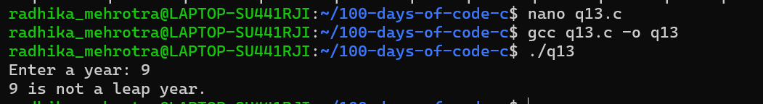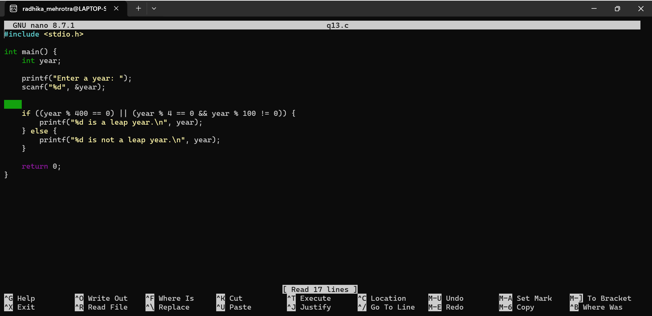Q14: Write a program to input a character and check whether it is a vowel or consonant using if–else