Q17: Write a program to find the roots of a quadratic equation and categorize them.
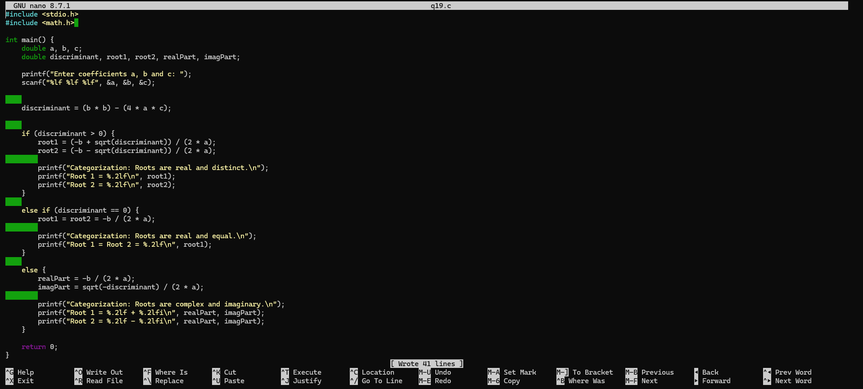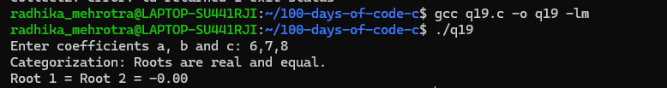

Q18: Write a program that accepts a percentage (0-100) and assigns a grade based on the following criteria:
90-100: Grade A
80-89: Grade B
70-79: Grade C
60-69: Grade D
below 60: Grade F.
