Decryption Report

encrypted_1234.png
Encrypted Image | Decrypted Image
 | 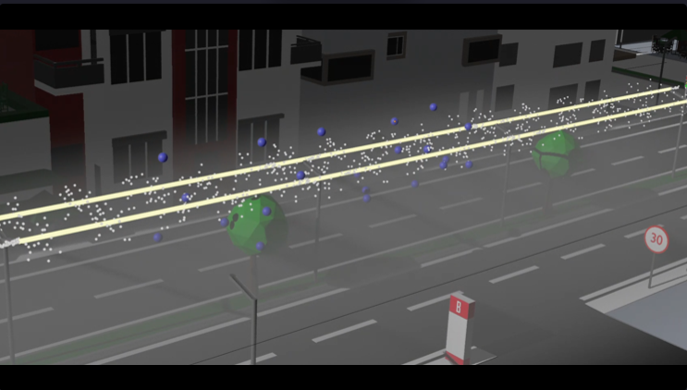
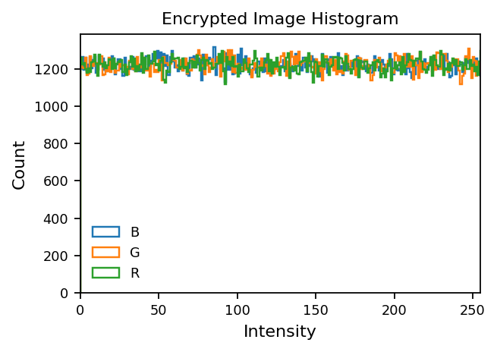 | 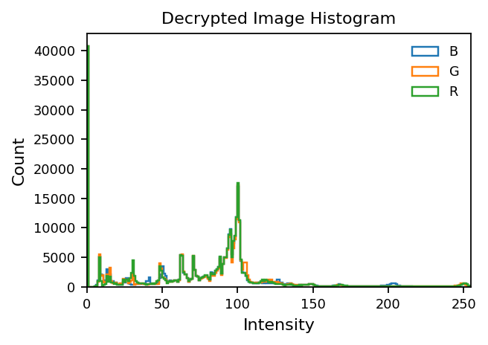

Entropy: 7.9994  Corr H: 0.0001  Corr V: -0.0006  Corr D: 0.0012 | Entropy: 6.2795  Corr H: 0.9876  Corr V: 0.9638  Corr D: 0.9463
Decryption check: PASS
Mode: DECRYPT
Use the encrypted file generated by the encrypt mode.

