Encryption Report

1234.png
Original Image | Encrypted Image
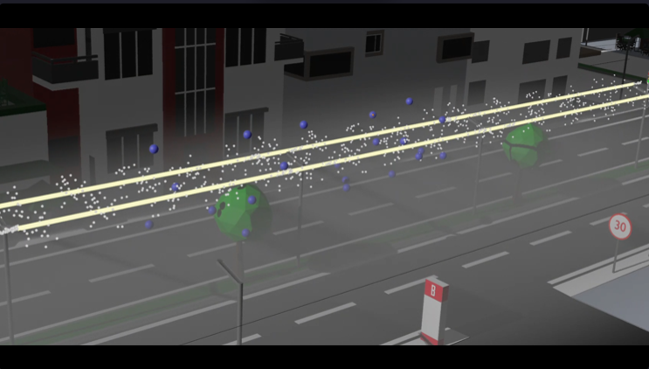 | 
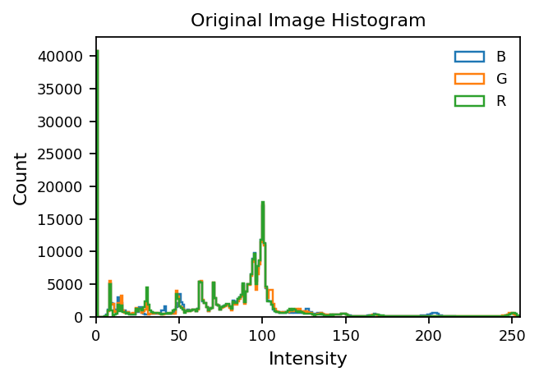 | 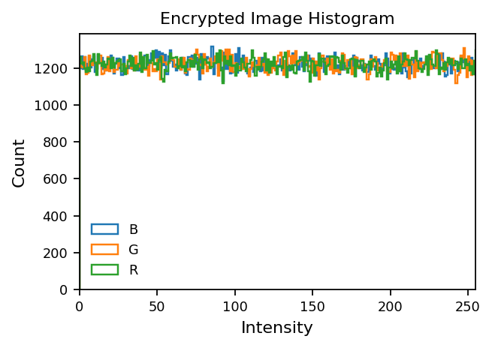

Entropy: 6.2795  Corr H: 0.9876  Corr V: 0.9638  Corr D: 0.9463 | Entropy: 7.9994  Corr H: 0.0001  Corr V: -0.0006  Corr D: 0.0012
NPCR (Original vs Encrypted): 99.60%
UACI (Original vs Encrypted): 32.81%
Mode: ENCRYPT

