|  |  |
| --- | --- |
| Gerb-BMSTU_01 | **Министерство науки и высшего образования Российской Федерации**  **Федеральное государственное бюджетное образовательное учреждение**  **высшего образования**  **«Московский государственный технический университет**  **имени Н.Э. Баумана**  **(национальный исследовательский университет)»**  **(МГТУ им. Н.Э. Баумана)** |

ФАКУЛЬТЕТ **Информатика и системы управления**

КАФЕДРА **Компьютерные системы и сети (ИУ6)**

НАПРАВЛЕНИЕ ПОДГОТОВКИ **09.03.03 Прикладная информатика**

**Отчет**

|  |  |
| --- | --- |
| **по лабораторной работе №** | 1 |

**Название:**

Создание простейших HTML-страниц.

**Дисциплина:** Языки Интернет-программирования

|  |  |  |  |  |
| --- | --- | --- | --- | --- |
| Студент | ИУ6-25Б |  | 05.09.2022 | В.К.Полубояров |
|  | (Группа) |  | (Подпись, дата) | (И.О. Фамилия) |
|  |  |  |  |  |
| Преподаватель |  |  |  |  |
|  |  |  | (Подпись, дата) | (И.О. Фамилия) |

Москва, 2022

**Задание 1. Разметка HTML-страницы с использованием элементов семантической разметки текста.**

Выполните разметку HTML-страницы с использованием элементов семантической разметки текста (см. таблицу 6). Напишите не менее 10 строк произвольного текста. Выделите в каждой строке несколько слов как более важные, значительно важные, добавьте математические формулы и пр. Также, с использованием семантической разметки, добавьте к тексту произвольные строки кода на любом языке программирования.

Подготовьте второй вариант разметки, отличающийся выделенными словами. Замените фрагменты, которые ранее отображались курсивом на фрагменты, отображаемые жирным шрифтом.

**Вариант 1**

<!DOCTYPE html 5>

<html>

<head>

<meta charset="utf-8">

<title>L1.1</title>

</head>

<body>

<p>

When <em> Naughty Dog </em>revealed <strong>The Last of Us Part 1</strong> earlier this year,

a complete visual remake of the original <strong>The Last of Us</strong> from <mark>2013</mark>,

we were a little surprised.

There's always a debate to be had about the timing of a re-release,

and we wondered whether the new version would be different enough from the <mark>2014</mark> <em>PS4</em> remaster

and <mark>2016</mark> <em>PS4 Pro</em> patch to justify a purchase from newcomers to the seasons and series veterans alike.

After spending some time with the final release,

we have some answers - including comparisons between the new <em>PS5</em> release and the prior <em>PS3</em> and <em>PS4</em> versions,

the video modes available and the gameplay changes included.

</p>

<p>

First, let's rewind.

The Last of Us was the PS3's <strong>swan song</strong>,

a showpiece title released just months before the arrival of the <em>PS4</em>.

The mix of storytelling, survival horror and action resonated with fans,

becoming one of <em>Naughty Dog's</em> most successful games ever.

The technical challenge <em>Naughty Dog's</em> created for itself was the creation of a world

almost entirely devoid of electric lights(<small>The Last of Us relies heavily on indirect lighting which,

in <mark>2013</mark>, was still very difficult to achieve even when leaning on pre-calculated techniques).</small>

Against the odds,

Naughty Dog did manage to come up with a suitable solution to this problem - it's far from perfect,

mind you, but the world was convincingly lit and designed.

The problem was that on <em>PS3</em>, the performance just didn't hold up and many larger areas exhibited severe frame-rate issues that detracted from the experience.

</p>

<p>

<var> x <sup>2</sup> </var> + <var> y <sup>2</sup> </var> = 25

</p>

<p>

H<sub>2</sub>O

</p>

<p>

<code> #include &lt;iostream&gt; <br>

int main{<br>

cout &lt&lt "Hello, world!"; <br>

return 0; <br>

}

</code>

</p>

</body>

</html>

****

**Вариант 2**

<!DOCTYPE html 5>

<html>

<head>

<meta charset="utf-8">

<title>L1.1(2)</title>

</head>

<body>

<p>

When <b> Naughty Dog </b>revealed <strong>The Last of Us Part 1</strong> earlier this year,

a complete visual remake of the original <strong>The Last of Us</strong> from <mark>2013</mark>,

we were a little surprised.

There's always a debate to be had about the timing of a re-release,

and we wondered whether the new version would be different enough from the <mark>2014</mark> <b>PS4</b> remaster

and <mark>2016</mark> <b>PS4 Pro</b> patch to justify a purchase from newcomers to the seasons and series veterans alike.

After spending some time with the final release,

we have some answers - including comparisons between the new <b>PS5</b> release and the prior <b>PS3</b> and <b>PS4</b> versions,

the video modes available and the gameplay changes included.

</p>

<p>

First, let's rewind.

The Last of Us was the PS3's <strong>swan song</strong>,

a showpiece title released just months before the arrival of the <b>PS4</b>.

The mix of storytelling, survival horror and action resonated with fans,

becoming one of <b>Naughty Dog's</b> most successful games ever.

The technical challenge <b>Naughty Dog's</b> created for itself was the creation of a world

almost entirely devoid of electric lights(<small>The Last of Us relies heavily on indirect lighting which,

in <mark>2013</mark>, was still very difficult to achieve even when leaning on pre-calculated techniques).</small>

Against the odds,

Naughty Dog did manage to come up with a suitable solution to this problem - it's far from perfect,

mind you, but the world was convincingly lit and designed.

The problem was that on <b>PS3</b>, the performance just didn't hold up and many larger areas exhibited severe frame-rate issues that detracted from the experience.

</p>

<p>

<var> x <sup>2</sup> </var> + <var> y <sup>2</sup> </var> = 25

</p>

<p>

H<sub>2</sub>O

</p>

<p>

<code> #include &lt;iostream&gt; <br>

int main{<br>

cout &lt&lt "Hello, world!"; <br>

return 0; <br>

}

</code>

</p>

</body>

</html>

****

**Задание 2. Табличная верстка.**

<!DOCTYPE html 5>

<html>

<head>

<title>L1-2</title>

<meta charset="utf-8">

</head>

<body>

<p><strong>Расписание ИУ6-35Б</strong></p>

<table border="1", allign = "center">

<tr>

<th rowspan="8">ВТ</th>

<th>Время</th>

<th width = "200px">ЧС</th>

<th width = "200px">ЗН</th>

</tr>

<tr>

<td>8:30-10:15</td>

<td></td>

<td></td>

</tr>

<tr>

<td>10:15-11:50</td>

<td></td>

<td></td>

</tr>

<tr>

<td>12:00-13:35</td>

<td colspan="2">(лек) Языки интернет-программирования 501ю Самарев Р. С.</td>

</tr>

<tr>

<td>13:50-15:25</td>

<td colspan="2">(лек) Базы данных 501ю Фомин М. М.</td>

</tr>

<tr>

<td>15:40-17:15</td>

<td>(сем) Физика 323</td>

<td></td>

</tr>

<tr>

<td>17:25-19:00</td>

<td></td>

<td></td>

</tr>

<tr>

<td>19:00-20:45</td>

<td></td>

<td></td>

</tr>

</table>

</body>

</html>

**Задание 3. Создание формы**

<!DOCTYPE html>

<html lang ="en">

<head>

<title>L1-3</title>

<meta charset="utf-8">

</head>

<body>

<div>

<h1>Регистрация</h1>

<table>

<form>

<tr>

<th>Логин</th>

<td> <input type="text"> </td>

</tr>

<tr>

<th>Почта</th>

<td> <input type="text"> </td>

</tr>

<tr>

<th>Пароль</th>

<td> <input type="password"> </td>

</tr>

<tr>

<td сolspan="2">Больше 16 лет?</td>

<td> <input type ="checkbox"></td>

</tr>

<tr>

<th colspan="2"> <input type="submit"></th>

</tr>

</form>

</table>

</div>

</body>

</html>

**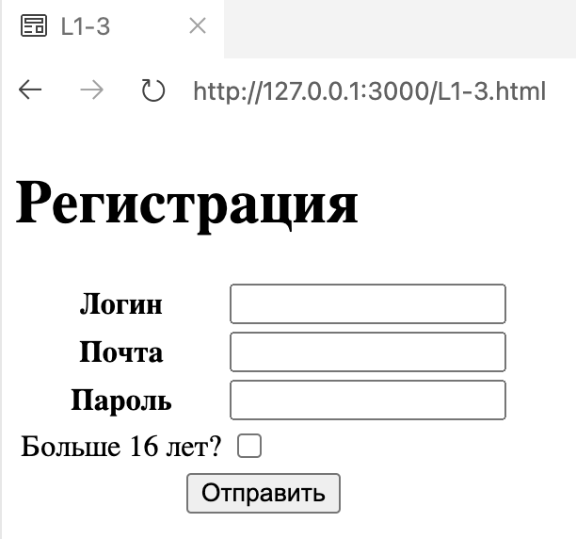**

**Задание 4. Проверка валидатором**

|  |  |
| --- | --- |
| **Ошибки** | **Их проявление в браузере** |
| Named character reference was not terminated by a semicolon. (Or & should have been escaped as &amp;.) | Никак не проявляется |
| This document appears to be written in English. Consider adding lang="en" (or variant) to the html start tag. | Никак не проявляется |