|  |  |
| --- | --- |
| Gerb-BMSTU_01 | **Министерство науки и высшего образования Российской Федерации**  **Федеральное государственное бюджетное образовательное учреждение**  **высшего образования**  **«Московский государственный технический университет**  **имени Н.Э. Баумана**  **(национальный исследовательский университет)»**  **(МГТУ им. Н.Э. Баумана)** |

ФАКУЛЬТЕТ **Информатика и системы управления**

КАФЕДРА **Компьютерные системы и сети (ИУ6)**

НАПРАВЛЕНИЕ ПОДГОТОВКИ **09.03.03 Прикладная информатика**

**Отчет**

|  |  |
| --- | --- |
| **по лабораторной работе №** | 2 |

**Название:**

Таблицы стилей, селекторы, блочная модель разметки, страница с кнопками и ссылками, Bootstrap.

**Дисциплина:** Языки Интернет-программирования

|  |  |  |  |  |
| --- | --- | --- | --- | --- |
| Студент | ИУ6-35Б |  | 07.09.2022 | В.К.Полубояров |
|  | (Группа) |  | (Подпись, дата) | (И.О. Фамилия) |
|  |  |  |  |  |
| Преподаватель |  |  |  |  |
|  |  |  | (Подпись, дата) | (И.О. Фамилия) |

Москва, 2022

**Задание 1. Разметка текста с помощью таблицы стилей.**

**HTML**

<!DOCTYPE html>

<html>

<head>

<link rel="stylesheet" href="L2-1.css" type="text/css">

</head>

<body>

<p>

When <span class="name"> Naughty Dog </span>revealed <span class="TLOU">The Last of Us Part 1</span> earlier this year,

a complete visual remake of the original <span class="TLOU">The Last of Us</span> from <span class="date">2013</span>,

we were a little surprised.

There's always a debate to be had about the timing of a re-release,

and we wondered whether the new version would be different enough from the <span class="date">2014</span> <span class="name">PS4</span> remaster

and <span class="date">2016</span> <span class="name">PS4 Pro</span> patch to justify a purchase from newcomers to the seasons and series veterans alike.

After spending some time with the final release,

we have some answers - including comparisons between the new <span class="name">PS5</span> release and the prior <span class="name">PS3</span> and <span class="name">PS4</span> versions,

the video modes available and the gameplay changes included.

</p>

<p>

First, let's rewind.

The Last of Us was the PS3's <span class="TLOU">swan song</span>,

a showpiece title released just months before the arrival of the <span class="name">PS4</span>.

The mix of storytelling, survival horror and action resonated with fans,

becoming one of <span class="name">Naughty Dog's</span> most successful games ever.

The technical challenge <span class="name">Naughty Dog's</span> created for itself was the creation of a world

almost entirely devoid of electric lights(<small>The Last of Us relies heavily on indirect lighting which,

in <span class="date">2013</span>, was still very difficult to achieve even when leaning on pre-calculated techniques).</small>

Against the odds,

Naughty Dog did manage to come up with a suitable solution to this problem - it's far from perfect,

mind you, but the world was convincingly lit and designed.

The problem was that on <span class="name">PS3</span>, the performance just didn't hold up and many larger areas exhibited severe frame-rate issues that detracted from the experience.

</p>

<p class="formula">

<var> x <sup>2</sup> </var> + <var> y <sup>2</sup> </var> = 25

</p>

<p class="formula">

H<sub>2</sub>O

</p>

</body>

</html>

**CSS**

p{

font-size:18px;

font-family: "Times New Roman";

}

.name{

font-style:italic;

color:blue;

}

.date{

color:red;

font-stretch: ultra-expanded;

}

.TLOU{

font-weight: 800;

}

.formula{

color:yellowgreen;

font-family: "Comic Sans MS";

}

**Демонстрация**

****

**Задание 2. Разметка таблицы.**

**HTML**

<!DOCTYPE html>

<html>

<head>

<link rel="stylesheet" href="L2-2.css" type="text/css">

<meta charset="utf-8">

</head>

<body>

<div class="tbl">

<div class="tbl-name">Расписание</div>

<div class="tbl-row">

<div class="tbl-col time">Время</div>

<div class="tbl-col green content">ЧС</div>

<div class="tbl-col blue content">ЗН</div>

</div>

<div class="tbl-row">

<div class="tbl-col time">08:30 - 10:05 </div>

<div class="tbl-col content"></div>

<div class="tbl-col content"></div>

</div>

<div class="tbl-row">

<div class="tbl-col time">10:15 - 11:50</div>

<div class="tbl-col content">(сем) Электротехника 739л Ибрагимов С. В.</div>

<div class="tbl-col content"></div>

</div>

<div class="tbl-row">

<div class="tbl-col time">12:00 - 13:35</div>

<div class="tbl-col content">(сем) Языки интернет-программирования 619л</div>

<div class="tbl-col content"></div>

</div>

<div class="tbl-row">

<div class="tbl-col time">13:50 - 15:25</div>

<div class="tbl-col content"></div>

<div class="tbl-col content"></div>

</div>

<div class="tbl-row">

<div class="tbl-col time">15:40 - 17:15</div>

<div class="tbl-col content"></div>

<div class="tbl-col content"></div>

</div>

<div class="tbl-row">

<div class="tbl-col time">17:25 - 19:00</div>

<div class="tbl-col content"></div>

<div class="tbl-col content"></div>

</div>

<div class="tbl-row">

<div class="tbl-col time">19:10 - 20:45</div>

<div class="tbl-col content"></div>

<div class="tbl-col content"></div>

</div>

</div>

</body>

</html>

**CSS**

.tbl{

display:table;

margin-left: auto;

margin-right: auto;

border: 5px solid black;

font-family: "Times New Roman";

font-size:16px;

}

.tbl-name{

display: table-caption;

color:#00bfff;

text-align: center;

font-size: 28px;

}

.tbl-row{

display: table-row;

}

.tbl-col{

display: table-cell;

border:1px solid black;

text-align: center;

padding-top: 5px;

padding-bottom: 5px;

}

.time{

padding-left: 25px;

padding-right: 25px;

}

.content{

padding-left: 100px;

padding-right: 100px;

}

.dat{

font-weight: 800;

padding-left: 3px;

padding-right: 3px;

}

.green{

background-color: aquamarine;

}

.blue{

background-color: #00bfff;

}

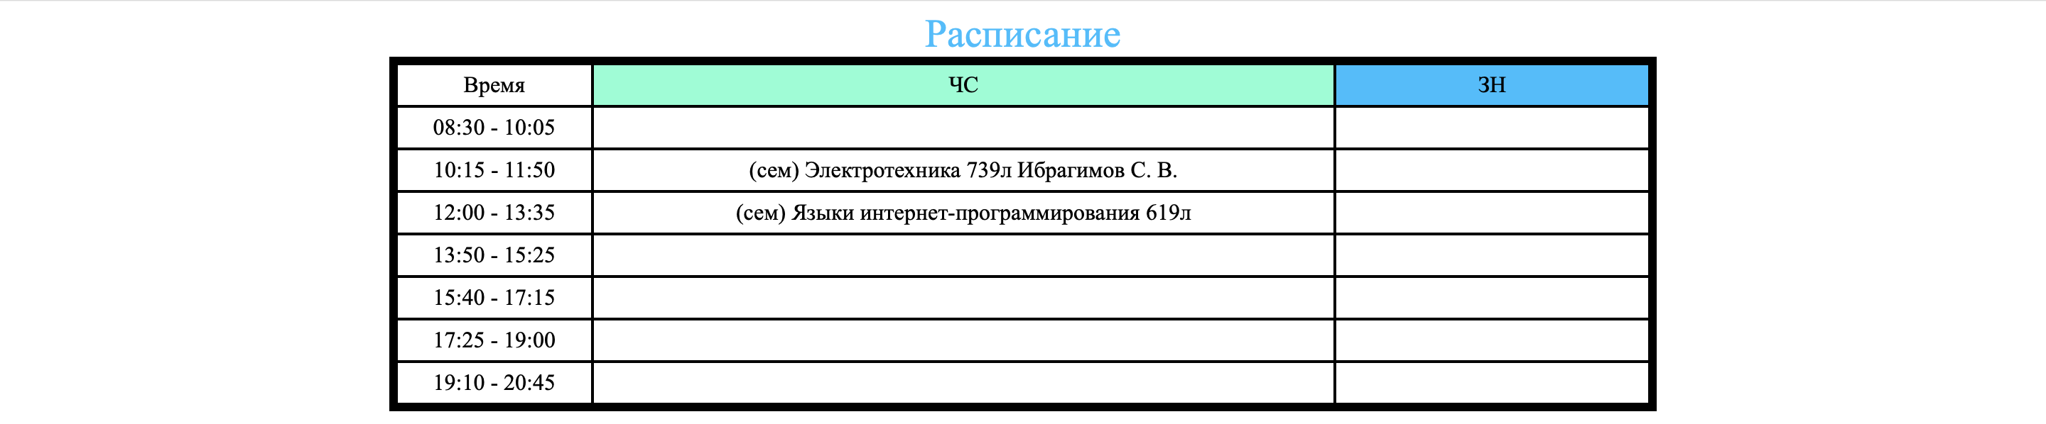

**Задание 3. Bootstrap.**

<!DOCTYPE html>

<html lang="ru">

<head>

<meta charset="utf-8">

<meta http-equiv="X-UA-Compatible" content="ie=edge">

<meta name="viewport"

content="width=device-width, initial-scale=1.0">

<title>ICS6 Bootstrap</title>

<link href="bootstrap.min.css" type="text/css" rel="stylesheet">

<style>

html {

position: relative;

min-height: 100%;

}

body {

margin-bottom: 40px;

}

main {

margin-top: 15px;

}

footer {

height: 40px;

position: absolute;

bottom: 0;

width: 100%;

}

.my-primary {

background-color: blue;

color: white;

}

p{

font-size:18px;

font-family: "Times New Roman";

}

.name{

font-style:italic;

color:blue;

}

.date{

color:red;

font-stretch: ultra-expanded;

}

.TLOU{

font-weight: 800;

}

.formula{

color:yellowgreen;

font-family: "Comic Sans MS";

}

</style>

</head>

<body>

<header>

<nav class="navbar navbar-expand-lg navbar-dark my-primary">

<a class="navbar-brand" href="#">Navbar</a>

<ul class="navbar-nav mr-auto">

<li class="nav-item active">

<a class="nav-link" href="#">Home

<span class="sr-only">(current)</span>

</a>

</li>

<li class="nav-item">

<a class="nav-link" href="#">Link</a>

</li>

</ul> </nav>

</header>

<main class="container">

<div class="row">

<div class="col-4">

<img src="avatar.jpg" alt="avatar" width="150" height="150">

</div>

</div>

<div class="row">

<div class="col-4">

<div>

<table>

<td colspan="2" align="center"><b>Регистрация</b></td>

<div class ="form-group">

<tr>

<th>Логин</th>

<td> <input type="text" class="form-control"></td>

</tr>

<tr>

<th>Почта</th>

<td> <input type="text" class="form-control"></td>

</tr>

<tr>

<th>Пароль</th>

<td> <input type="password" class="form-control"></td>

</tr>

<tr>

<th сolspan="2">Больше 16 лет?</th>

<td align="center"><input type="checkbox" class="form-check-input"></td>

</tr>

<tr>

<th colspan="2"> <button type="submit" class="btn btn-success">Принять</th>

</tr>

</div>

</table>

</div>

</div>

<div class="col-6">

<table class="table table-bordered">

<thead>

<tr>

<th scope="col">ВТ</th>

<th scope="col">Время</th>

<th scope="col">ЧС</th>

<th scope="col">ЗН</th>

</tr>

</thead>

<tbody>

<tr>

<th scope="row" rowspan="3"></th>

<td>12:00-13:35</td>

<td colspan="2">(лек) Языки интернет-программирования 501ю Самарев Р. С.</td>

</tr>

<tr>

<td>13:50-15:25</td>

<td colspan="2">(лек) Базы данных 501ю Фомин М. М.

</td>

</tr>

<tr>

<td>15:40-17:15 </td>

<td>(сем) Физика 323</td>

</tr>

</tbody>

</table>

</div>

</div>

<div class="row">

<div class="col">

<p>

&nbsp;&nbsp;&nbsp;&nbsp;When <span class="name"> Naughty Dog </span>revealed <span class="TLOU">The Last of Us Part 1</span> earlier this year,

a complete visual remake of the original <span class="TLOU">The Last of Us</span> from <span class="date">2013</span>,

we were a little surprised.

There's always a debate to be had about the timing of a re-release,

and we wondered whether the new version would be different enough from the <span class="date">2014</span> <span class="name">PS4</span> remaster

and <span class="date">2016</span> <span class="name">PS4 Pro</span> patch to justify a purchase from newcomers to the seasons and series veterans alike.

After spending some time with the final release,

we have some answers - including comparisons between the new <span class="name">PS5</span> release and the prior <span class="name">PS3</span> and <span class="name">PS4</span> versions,

the video modes available and the gameplay changes included.

</p>

<p>

&nbsp;&nbsp;&nbsp;&nbsp;First, let's rewind.

The Last of Us was the PS3's <span class="TLOU">swan song</span>,

a showpiece title released just months before the arrival of the <span class="name">PS4</span>.

The mix of storytelling, survival horror and action resonated with fans,

becoming one of <span class="name">Naughty Dog's</span> most successful games ever.

The technical challenge <span class="name">Naughty Dog's</span> created for itself was the creation of a world

almost entirely devoid of electric lights(<small>The Last of Us relies heavily on indirect lighting which,

in <span class="date">2013</span>, was still very difficult to achieve even when leaning on pre-calculated techniques).</small>

Against the odds,

Naughty Dog did manage to come up with a suitable solution to this problem - it's far from perfect,

mind you, but the world was convincingly lit and designed.

The problem was that on <span class="name">PS3</span>, the performance just didn't hold up and many larger areas exhibited severe frame-rate issues that detracted from the experience.

</p>

<p class="formula">

<var> x <sup>2</sup> </var> + <var> y <sup>2</sup> </var> = 25

</p>

<p class="formula">

H<sub>2</sub>O

</p>

</div>

</div>

</main>

<footer class="my-primary">

<div class="container">

<p class="footer-text">Footer</p>

</div>

</footer>

</body>

</html>

**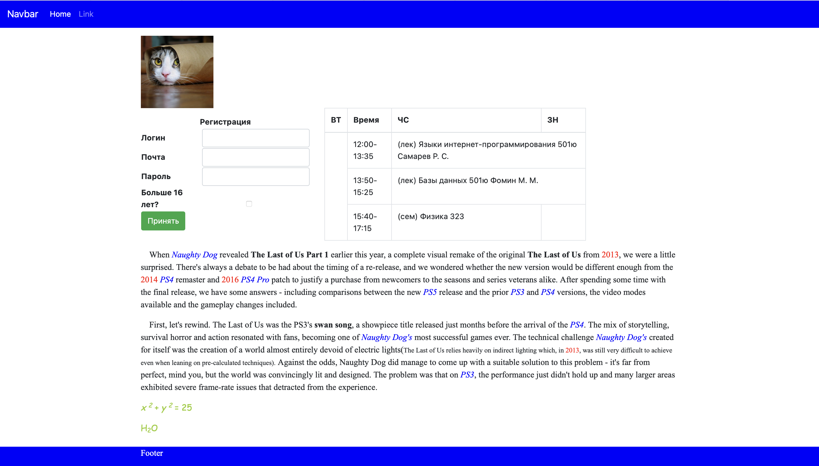**

**Задание 5. Проверка в валидаторе.**

|  |  |
| --- | --- |
| **Ошибки** | **Их проявление** |
| The character encoding was not declared. | Никак не проявляется |
| Element head is missing a required instance of child element title. | Никак не проявляется |
| Start tag div seen in table. | Никак не проявляется |
| Unclosed element button. | Никак не проявляется |