1. Data center
2. Google,
3. Bing
4. Baidu
5. Amazon
6. eBay
7. Alibaba
8. Gmail
9. Yahoo Mail
10. Facebook
11. Instagram
12. Twitter
13. WeChat
14. TIkTok
15. YouTube
16. Netflix
17. Application Programming Interface (API)
18. Transport Layer Security
19. Telnet
20. FTP
21. SIP
22. RTP
23. Skype
24. Chrome
25. Microsoft Internet Explorer
26. Apache servers
27. Microsoft servers
28. mozilla firefox
29. HTTP/2
30. Head of Line (HOL) blocking
31. HTTP/3
32. QUIC
33. SYN cookies
34. Microsoft Outlook
35. Apple Mail
36. Berkeley Internet Name Domain (BIND) software
37. SNMP
38. Github
39. Spotify
40. DNSSEC
41. random first selection (BitTorrent)
42. endgame mode
43. anti-snubbing
44. Distributed Hast Table (DHT)
45. Enter Deep
46. Bring Home
47. Akamai
48. Amazon CloudFront
49. Amazon Prime
50. Azure CDN
51. CacheFly
52. Cloudflare
53. CDN77
54. Fastly
55. Google Cloud CDN
56. StackPath
57. Verizon Media Platform
58. Linkedin
59. Upwork
60. SSH
61. NFS
62. Go-Back-N (GBN)
63. Selective Repeat (SR)
64. SYN FLOOD ATTACK
65. DDoS Attack
66. TCP Tahoe
67. Reno
68. TCP CUBIC
69. DCTCP
70. CTCP
71. BBR
72. SCTP

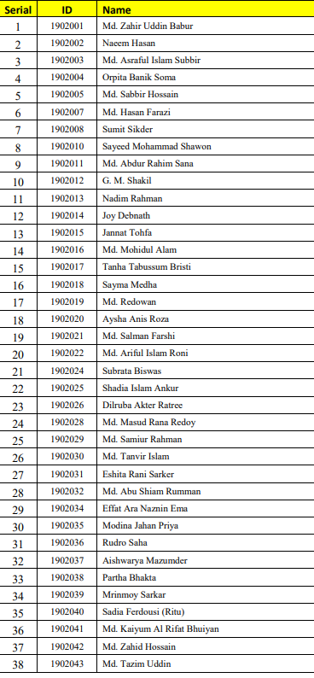

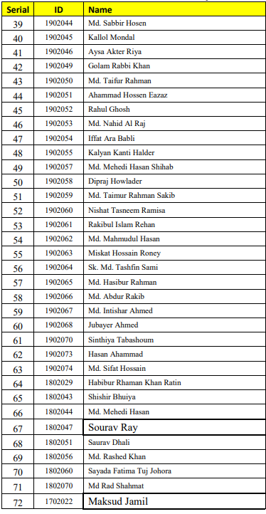

Assignment topics for CCE 313. 71 topics for 71 students. Topics should be chosen according to your id. First id gets the first topic. You should make a complete tutorial on your given topic. Assignment should contain at least 5 pages excluding the top sheet. And also the assignment should be both hand written and computer composed. Last submission date: 30th January. Thank you.