**MACHINE LEARNING FROM DATA**

**Report: Lab Session 0 – Exploratory data analysis**

**Names: Miquel Gómez I Esteve / Ricard Abril Ferreres**

**Q1. Briefly describe the conclusions of your analysis (you can insert plots)**

The previous plots, which are histograms, provide information about how the data is distributed. It provides the amount of each of the random variables being in each of the bins. We can clearly see 4 kinds of distribution: Normal (Gauisian), Uniform, Laplace and Rayleigh.

We can also analyse the probability density function (shown above for a Reilegh distribution), which is used because we are working with continuous random variables. A specific point does not represent the probability of a random variable to be exactly at that point, but instead it gives us the likelihood of being in that point related to the rest of the points in the curve. The area under the curve must always be 1.

Above we can see the histograms for the four distributions we have been talking about. Each plot shows the number of values found in each of the bins. The plot also shows a line, which is a histogram smoothing, which produces a smooth curve that tries to represent the probability density of the data.

Regarding the cumulative distribution (shown above) we can see the probability of a random number being equal or less than a defined threshold. The blue line shows us the cdf for our original data. We can compare it to the red line, which shows us what a theoretical cdf would be for the four distributions. In all cases we see that the data mostly follows the red line, however not exactly. So, in general, we can assume that our data follows the defined distributions, even if it is not perfect.

The skewness gives us information about how asymmetric a distribution is, based on the mean. The lower the skewness (using its absolute value) the more symmetric the distribution will be around the mean value and the mean and the median will be more similar.

If it is positive, the mean will be higher than median, and there will be a higher density of values on the left side. If it is negative, the mean will be lower than the median and there will be a higher density of values on the right side. This Rayleigh distribution is a clear example of a right skewed (positive) distribution.

On the other hand, kurtosis is used to analyse the tailedness of how prone a distribution is to have outliers.

* In the case of our normal distribution, the kurtosis is 0, which means that it follows a normal bell curve.
* In the case of the uniform distribution, the kurtosis is less than 0, which means that It has less tails and is flatter than the normal.
* Regarding the laplace the kurtosis is very positive. Compared to the normal distribution, the laplace has a taller peak and longer tails.
* Finally, regarding Rayleigh, the kurtosis is very similar to the normal. With that in mind, this distribution has a longer tail, compared to the ones in the normal distribution.

**Q2. For each class and each feature, analyse histograms, cdfs and normal plots. Can we assume a Gaussian distribution for any of the features?**

To see if any feature follows a normal gaussian distribution, we must check the histograms, the cumulative distribution function as well as the quantile-quantile plot shown above for each feature-class combination.

It is important to note that the amount of data is very small, so it is hard to get conclusions from it.

Analysing the histograms:

* The only histograms that mildly resemble a normal distribution are (iris-setosa, petal-length) and are (iris-setosa, sepal-length).
* The other histograms show a clear skewness or an irregular distribution in general.

Analysing the cdf plots:

* The combinations (iris-setosa, petal-width) shows a clear deviation compared to the other plots.
* The features that are closer to a normal regarding the cdf are (iris-setosa, petal-length), (iris-versicolor, petal-length) and (iris-versicolor, petal-width).

Analysing the quantile-quantile plots:

* (iris-setosa, petal-width) shows a clear deviation from the normal, but that could also be caused by the discretization of the data (nbin).
* (iris-setosa, petal-length) and (iris-versicolor, petal-length) are the plots that could be the most like the normal distribution.

In conclusion, after the analisys, we have three features which are candidates to have a normal distribution. These are (iris-setosa, sepal-length), (iris-setosa, petal-length) and (iris-versiocolor, sepal-width). However, ass mentioned above, with the dataset being so small we cannot assume a normal distribution.  
With the rest of the pairs (class, feature) we could assume that they do not follow a normal distribution.

**Q3. Analyze kurtosis and skewness values for each feature and class.**

Regarding Kurtosis:

* The kurtosis for the sepal length negative with iris setosa and versicolor, that means that the tails will be smaller, and they will have less outliers, when compared to the same sepal length with the class iris virginica. The sepal length for iris virginica is almost 0 so regarding tailedness, it is very similar to a normal distribution.
* The sepal width kurtosis is very big in both iris setosa and iris virginica, that means that the distribution has bigger tails and more outliers than the iris versicolor compared to a default normal distribution. The sepal width for the iris versicolor has less outliers and smaller tails in general when compared to a normal distribution, as the value is negative.
* The petal length kurtosis is very big for iris setosa that means that it has bigger and longer tails than the other classes and the normal distribution. The petal length for the iris versicolor class is very close to 0 so regarding tailednees, it will be very similar to a normal distribution. The petal length for the iris virginica is less than 0 so it will have less outliers and smaller tails than the normal distribution.
* Finally, regarding the petail width, for iris virginica and iris versicolor, the values for kurtosis are lower than zero, so when compared to a normal distribution, they will have less outliers and smaller tails. For the iris setosa class kurtosis is the biggest from all the features and classes so I will have more outliers and longer tails than any other class-feature pair.

Regarding Skewnees:

* For sepal length, all the values are very similar, and a bit bigger than 0, that means that the data is slightly moved to the left compared to a normal.
* Regarding sepal width for iris setosa, the data is a bit moved to the left, for iris virginica as well, but it is a bit more asimetric. For iris versicolor, the value is negative, so it is less symmetric and is moved to the right.
* For petal length and iris setosa, the value is almost 0, so it is very symmetric. For iris versicolor and iris virginica, the distribution is not that symmetric. For iris versicolor the data is more concentrated to the right, and the opposite applies to iris virginica.
* Finally, for petal width, the iris setoda distribution is very asymmetric and is hightly concentrated to the left. For iris versicolor the distribution is very close to the normal regarding symmetry because the skewness is very close to 0. For iris virginica the data is slightly concentrated in the right, but still is very close to the normal.

In conclusion:

* By checking the Kurtosis, we could assume that iris virginica-sepal length and iris versicolor-petal length would be very good candidates to follow a gauissian distribution
* By checking the Skewness, we could assume that iris setosa-petal length and iris versicolor-petal width would be very good candidates to follow a gauissian distribution.
* Knowing that most of the combinations did not appear in the other questions as candidates or that either the skewness value or the kurtosis value is not close to the normal. We cannot assume that any pair of class-feature follows a normal distribution.

**Q4. Analyze boxplots by feature. Are there ‘significant’ differences between the classes?**

In this box plot we can see that the data dispersion for iris setosa is smallest than for the other classes, the median, is almost at the midel of the box so we can say that the data is almost simetric at the intercuadratic segment.

We can see that the whiskers are really short iris setosa, so the data dispersion there is small, but we have the bigger number of outlayer too, for the rest the classes we can see that the whiskers longer so we can say that we have more data dispersion outside the intercuadratic range. We can see that longitude of the whiskers are different so we can say that the data is biased.

Finally we can conclude that te iris setosa have the minimum deviation of the 3 classes.

This data it would be useful to differentiate one class with the otter, because we dont have overlapping between the q-plots.

In this case we can see that for iris-setosa, the distribution is biased to the left, we have some outliers at the positive whisker, so the distribution is not symmetric. Inside of the intercuadratic segment the data have less dispersion than outside the intercuadratic range.

For Iris versicolors the data is biased to the left, we can see this taking a look to the median, the positive whisker is bigger than the negative one so at the end this data is going to be more symmetric than for the rest of the cases. In the intercuadratic range we can see that we have more data dispersion.

For iris virginica, we have even more data dispersion inside the intercuadratic range, the negative whisker is bigger indicating that the distribution is biased to the left, also the median is indicating us the same so the dispersion is not symmetric.

This data it would be useful to differentiate one class with the otter, because we dont have overlapping between the q-plots.

For this feature we can see that for the thre classes the distribution is symmetric or almost symmetric

the longitude of the whiskers is pretty similar and the median is situated at the middle of the box.

Iris virginica is the one with more deviation and more difference between the whiskers.

This feature is not the best to differentiate between the classes, because we have overlapping values.

For irsi setosa we can see that the data is almost symmetric, and the median is at the middle of the box

For the rest of the classes we see that the data is biased to the right and we have outliers for iris virginica

Again the data is overlapping so its not the best to diferenciate the classes.

**Q5. Analyze the scatter plot. Are features related in any way? What can you say about the separability of the classes?**

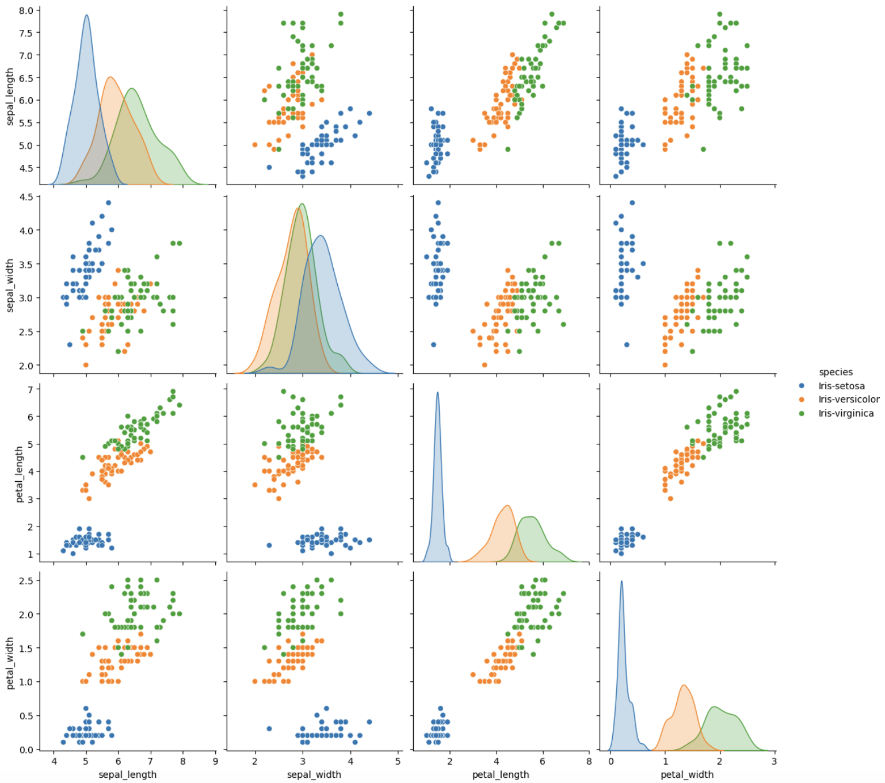

We can assume that petal length and petal width, independently of the class, are related. It means that the larger the length the larger the width as well. We can clearly see these features have a linear relationship. For the other pairs of features does not seem to be a relation with these plots.

Regarding separability of the classes, we clearly see that in all pairs of features iris setosa (blue) is clearly differentiated from the other two classes. The other two classes (iris versicolor and iris virginica) are more close to each other, however, they are not completely overlapping and we could classify data by finding a good decision boundary.