**MART MANAGEMENT SYSTEM**

Product Documentation

­­­­Prepared by

**Muhammad Danish**

**Hakeemullah**

**Rafaqat Ali**



***Department of Computer Science-UBIT***

***University of Karachi***

Table of Contents

1. Introduction 5

• Purpose of the system 5

o Scope of the system 5

• System Overview 5

2. Software Requirement Specification 6

• Functional Requirement 6

• Non-Functional Requirement 6

• System Models 7

o Scenarios 7

3. UML Diagrams 8

• Use case Diagram: 8

• UML Class Diagram 9

• UML Class Relation Diagram: 10

• Sequence Diagram 11

• Activity Diagram 12

4. Software Development Tools 13

• Analysis Tools 13

o Flowcharts: 13

o HIPO Diagram: 13

o Data Flow Diagram 14

o Structure Charts 14

5. Design Tools 15

• Designing Tools used in project: 15

• Popular Tools in Market: 15

o Microsoft Visio: 15

o Visual Paradigm: 15

o Lucidchart: 16

o UMLet 16

6. Project Management Tools 17

• Project Management Tools used in Project: 17

• Popular Management Tools in Market: 17

o Microsoft PPM: 17

o Trello: 17

o Teamwork Projects: 18

o Freedcamp: 18

o Wrike: 18

7. Database Management Tools 19

• Data Base used in Project: 19

• Popular Data Base In Market: 19

o Microsoft Access: 19

o SQL Server: 19

o MySQL: 20

o Oracle Database: 20

o MongoDB: 20

o Firebase**:** 20

8. Documentation Tools 21

• Software Documentation Tools for Gathering and Managing Requirements 21

o Jira: 21

o Trello: 21

• Software Documentation Tools for Writing Software Architecture Documentation 22

o Read The Docs: 22

o GenMyModel: 22

• Software Documentation Tools to Document Databases 22

o Dataedo: 22

o SchemaSpy: 23

• Software Documentation Tools to Create End-User Documentation 23

o Oracle UPK: 23

o StepShort Manuals: 23

9. Conclusion 24

10. Future Work 24

11. References 24

Abstract

In our daily life we need things to eat, wear, play, work, etc. and we purchase these things from market, stores, malls, etc. These businesses are increasing nowadays so quickly, there a huge demand for solution which is able to store records of customer information, data, total sale, etc. This product is not the final solution, but it need changes as requirements changes so quickly in business. We create this product with the aim of to provide solution to peoples which is easily to use, efficient and many more features which make it to deal with their problems.

The system “Data Mart Management System” mainly deals with automating the tasks of maintaining and transacting the goods. In the Warehouse System inventory management is the key process. This process includes the activities such as maintenance of stock details, maintenance of receipts and items etc. It is a tedious job to maintain all these details manually.

Hence we opted to automate the Mart Management System. It mainly includes two members. Administrator and users. The Administrator has the privileges to maintain different types of Products, Suppliers, Sub Location In charges Databases in the mart. He is concerned with registration of user, user In-charge, and Addition of Products. The Sub location Admin has privilege to maintain Products which are transformed from Administrator and registration of users.

# Introduction

## Purpose of the system

Mart Management System (MMS) is a standalone system that helps the owners of mini mart to manage the data and information of their mini mart. It provides the solution for replacing the manual work done to manage the daily records of mini marts

### Scope of the system

A full-featured management system is needed for mini marts to manage all the stored data and information systematically and efficiently. MMS application is developed for mini marts to manage inventory, staff, supplier and finance records.

## System Overview

A fully functional MMS application that featured with user friendly is provided at the end of the development process. With the developed application, users can manage the business of mini mart systematically.

Current system can be divided into two component on the bases on working. The initial component which is responsible for creating account, change password and authenticating an account with privilege access as on the bases on type of user. The final component which provide access on features on the bases of authentication type, now this component further more can be divided into two subcomponent. One subcomponent is responsible for searching, adding, deleting and finalizing customer data with slip and the other subcomponent for creating list or updating list for items present in store.

In other words:

User maybe a worker or admin and both have different privileges, when they are authenticated, they have less or full access. Worker can only insert or search customer data and admin can access all these stuff plus can change item list and other stuff.

As it has some problems and need some updates like admin access should be increase and need to be managed well which not present in currentsystem, it will be updated or evaluated as per customer demand as customer required.

# Software Requirement Specification

## Functional Requirement

* Sign Up:

The user will create account with authentication of admin key

* Sign In:

Authentication start with two different login availability user and admin

* Manage all Customer Record:

Show total price and real date time and searching option for customer record.

* Customer data inserted by code:

We have to put only specific code number and quantity in order to insert item in database with add button

* Data Item list creation:

List page contain list of the item with functions of add values, delete, update and search

* Delete Record (effective):

Delete the current mistake of insertion and delete record of the particular customer

* Manageability:

Differentiate/ Separate feature for User and Super User

* Availability:

PDF creation

## Non-Functional Requirement

* Maintainability:

Maximum efficiency, readability and safety.

* Privacy and Security
* Usability:
* User Friendly:

Mostly background process and less features on screen

* Platform capability:

Independent to machine architecture.

* Documentation:

Short and easily to understandable.

## System Models

### Scenarios

A management system which start with authentication with two different login availability user and admin.

There will be a user create account option with authentication of admin key and also contain the change account password option.

After login, there will be a sign out option for user.

There will be two tabs one for working and other one for inserting data. Working tab contain automatic customer ID, User name, Total price and date time this will show data real time and searching option for customer record, also contain add, delete, delete record and finalize option and we have to only put specific code number and quantity in order to insert item in database with add button, delete button delete the current mistake of insertion and delete record delete the whole data of particular customer finalize final the customer purchasing and create output for billing with new window with whole data with create pdf option.

The data will show real time in two different form, one will show id, username, total price and date and time, and the other one will show serial no, id, item, quantity, discount, price and discounted price.

The total number of record of both tables show bellows of the tables. The other page called item list page contain list of the item with functions of add values, delete, update and search.

Here admin key and admin name change option should be available, here table contain serial no, code, name, discount and price. Here will be update table function to work deal easily with mistakes.

It will contain at the bottom no of record. Admin user have full access to the software while user can only insert purchasing data.

# UML Diagrams

## Use case Diagram:

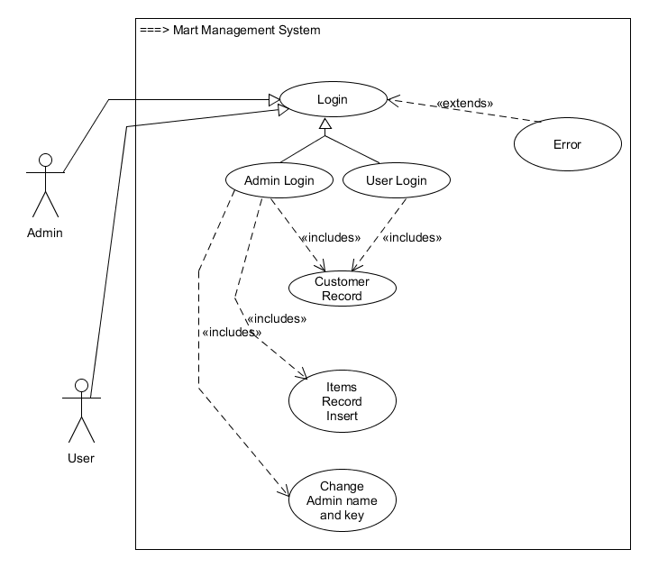

## C:\Users\Newton\Desktop\MartSeriesOneFinal\ClassDiagramcom.png UML Class Diagram

## UML Class Relation Diagram:

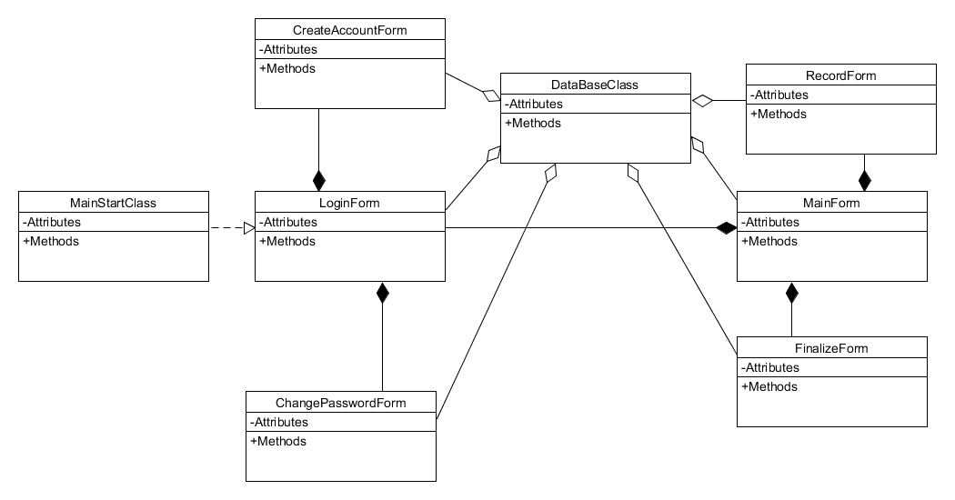

## Sequence Diagram

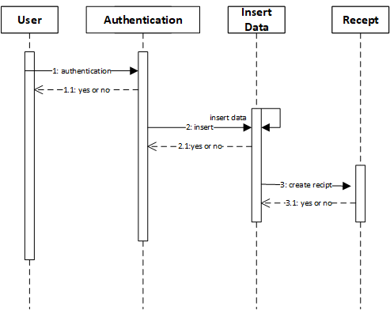

## Activity DiagramC:\Users\Newton\Downloads\Blank Diagram (1).png



# Software Development Tools

Following are the tools which is frequently used during the development process.

## Analysis Tools

Before you start writing a program, you have to understand what it's supposed to do. That usually means understanding something about the 'real world' and how it works. That something is often referred to as a 'process' or 'business rules.' In order to understand the process, programmers do something called 'analysis.' Analysis is defined as breaking something down into its inter-related components in order to understand it. The object of the analysis can be raw data, a business process, or learning how to program.

Use the following tools to collect or analyze data:

### Flowcharts:

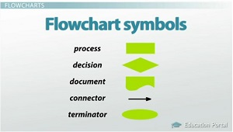Flowcharts were originally developed so programmers could map out the steps their programs needed to take to accomplish the programmed task. It turns out that they are also useful for mapping out real-world processes. There are a relatively large number of flowchart symbol

### HIPO Diagram:

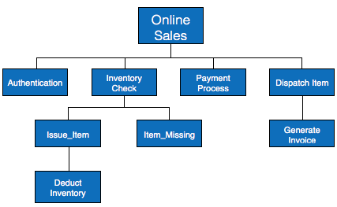HIPO (Hierarchical Input Process Output) diagram is a combination of two organized method to analyze the system and provide the means of documentation. HIPO model was developed by IBM in year 1970.

HIPO diagram represents the hierarchy of modules in the software system. Analyst uses HIPO diagram in order to obtain high-level view of system functions. It decomposes functions into sub-functions in a hierarchical manner. It depicts the functions performed by system.

HIPO diagrams are good for documentation purpose. Their graphical representation makes it easier for designers and managers to get the pictorial idea of the system structure.

### Data Flow Diagram

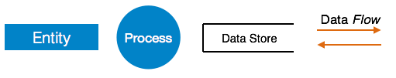In an information system, the data flow is demonstrated by data flow diagram. These diagrams are usually graphs. The flow of data that is coming in and going out and the data that is stored is represented graphically by data flow diagram.

It is to be noted that DFD is not the same as Flowchart. For program modules, the control flow is represented by flow charts and for the system the data flow is represented by DFDs.

### Structure Charts

A chart that can be prepared on the basis on Data flow diagram is known as a structure chart. The system is depicted more clearly and in more detail when compared to that of DFD. The system is split into multiple modules that function independently. For each of such modules, functions and sub-functions are represented by structure charts.

The module structure is demonstrated by the structure chart in an hierarchy. Tasks are performed at each level of hierarchy.

# Design Tools

#### Definition:

Software analysis and design includes all activities, which help the transformation of requirement specification into implementation. Requirement specifications specify all functional and non-functional expectations from the software. These requirement specifications come in the shape of human readable and understandable documents, to which a computer has nothing to do.

Software analysis and design is the intermediate stage, which helps human-readable requirements to be transformed into actual code.

## Designing Tools used in project:

Following all tools, we used in over project as per need, um-let is frequently used due to open source, free in market and less in size.

## Popular Tools in Market:

These are the most popular product in the market on which developers can rely.

### Microsoft Visio:

[Microsoft Visio](https://products.office.com/en-au/visio/flowchart-software) is one of the top diagramming tools right now, suitable for everything from flow charts to floor plans. It can be used for creating diagrams both simple and complex. It has a wide range of inbuilt shapes, stencils and objects. You can make your own shapes as well and import them.

### Visual Paradigm:

Visual Paradigm is a software tool designed for software development teams to model business information system and manage development processes. Visual Paradigm supports key industry modeling languages and standards such as Unified Modeling Language (UML), SysML, SoaML, BPMN, XMI, etc. It offers complete tool-set software companies need for requirements capturing, process analysis, system design, database design, and etc.

### Lucidchart:

Lucidchart is the best marketing documentation tool to build different types of flowcharts for your marketing processes. Starting with visualizing simple sketches of your future content campaign and ending with comprehensive user journey flow, Lucidchart will help you organize all stages and ideas in one beautiful diagram.

### UMLet

UMLet is a free, open-source UML tool with a simple user interface: draw UML diagrams fast, build sequence and activity diagrams from plain text, export diagrams to eps, pdf, jpg, svg, and clipboard, share diagrams using Eclipse, and create new, custom UML elements. UMLet runs stand-alone or as Eclipse plug-in on Windows, OS X and Linux

# Project Management Tools

#### Definition:

Project management tools are aids to assist an individual or team to effectively organize work and manage projects and tasks. The term usually refers to project management software you can purchase online or even use for free.

Despite its name, project management tools are not just for project managers. Project management tools are made to be completely customizable so they can fit the needs of teams of different sizes and with different goals.

## Project Management Tools used in Project:

Microsoft Project management tool we used in project.

## Popular Management Tools in Market:

Following are the most popular tool in the Market which are mostly used in an organization.

### Microsoft PPM:

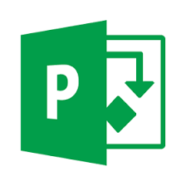Desktop application available as a simple Office 365 subscription that allows you to work from anywhere. Plan resources, manage team schedules, calculate what-ifs scenarios, and easily collaborate with all the project stakeholders.

### Trello:

Trello is the easy, free, flexible, and visual way to manage your projects and organize anything, trusted by millions of people from all over the world.

### Teamwork Projects:

Teamwork Projects combines high-performance features that build smarter workflows and close communication gaps so you can focus on getting things done. Features include task management, time tracking, milestones, Gantt charts, instant high-level reports and more. Teamwork for Enterprise provides a best in class collaboration platform to enable peak efficiency and high performing teams with additional support and security layers

### Freedcamp:

Freedcamp is free for unlimited users and projects. The company's vision is to build a truly freemium product available to all free of charge for most of its functionality. Free accounts are currently limited to 10MB file size limit with unlimited storage on all plans. Freedcamp provides paid features free to non-profits, teachers and students. You can add components you need such as Tasks, Milestones, Discussions, Time Tracking and more, when you create a project in Freedcamp.

### Wrike:

The Wrike project management software is a Software-as-a-Service (SaaS) product that enables its users to manage and track projects, deadlines, schedules, and other workflow processes. It also allows users to collaborate with one another. The application is available in English, French, Spanish, German, Portuguese, Italian, Japanese and Russian. The primary goal of the software is to help streamline workflow and allow companies to focus on core tasks. As of 2016, it was used by over 12,000 companie

# Database Management Tools

#### Definition:

Stands for "Database Management System." In short, a DBMS is a database program. Technically speaking, it is a software system that uses a standard method of cataloging, retrieving, and running queries on data. The DBMS manages incoming data, organizes it, and provides ways for the data to be modified or extracted by users or other programs.

## Data Base used in Project:

Mysql is free and popular product in the market, we used in project due to its efficiency.

## Popular Data Base In Market:

Following the popular data bases used in market.

### Microsoft Access:

Microsoft Access is a pseudo-relational database engine from Microsoft. It is part of the Microsoft Office suite of applications that also includes Word, Outlook and Excel, among others. Access is also available for purchase as a stand-alone product. Access uses the Jet Database Engine for data storage.

Access is used for both small and large database deployments. This is partly due to its easy-to-use graphical interface, as well as its interoperability with other applications and platforms such as Microsoft’s own SQL Server database engine and Visual Basic for Applications (VBA).

### SQL Server:

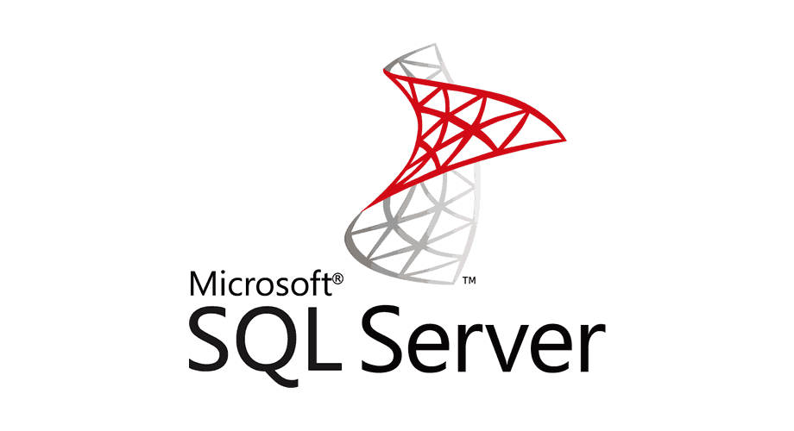A relational database management system developed by Microsoft as a database server, designed to store and retrieve different requests. Choose your preferred language and platform and build modern applications creatively. Take advantage of breakthrough performance and availability while turning raw data into meaningful reports that can be delivered to any device or platform.

### MySQL:

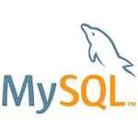MySQL Enterprise Edition includes the most comprehensive set of advanced features, management tools and technical support to achieve the highest levels of MySQL scalability, security, reliability, and uptime. It reduces the risk, cost, and complexity in developing, deploying, and managing business-critical MySQL applications.

### Oracle Database:



Leading enterprise-grade relational database that offers secure data management and transaction processing.

### MongoDB:

By offering the best of traditional databases as well as the flexibility, scale and performance todays applications require, we let innovators deploy apps as big as they can possibly dream. From startups to enterprises, for the modern and the mission-critical, MongoDB is the database for giant ideas.

### Firebase**:**

its an online platform providing back end as a services (BAAS).

Its support multiple application with real time database and its come with many more features. Just need to do, including an api in your project and here its go.

# Documentation Tools

#### Definition:

Have you guessed what all this is about? This is what software documentation is typically associated with in the man’s mind. Such an obnoxious view on documentation today is caused by people’s ignorance of powerful software documentation tools that can really streamline document creation.

Technical writing is not an easy task. Knowing that software documentation is essential, everyone still avoids taking the responsibility of it. Indeed, automatic software documentation tools can take the hassle out of writing documentation and tackle a number of your challenges at work.

## Software Documentation Tools for Gathering and Managing Requirements

### Jira:

Jira is known as popular issue tracking software, but many teams have reported that it is also an awesome tool to manage your user stories and requirements in the hassle-free format.

### Trello:

Trello is a task management application based on the Kanban system that can help you organize your requirements in a simple-to-use format. It a visual collaboration tool that helps you manage current tasks with the help of interactive boards.

## Software Documentation Tools for Writing Software Architecture Documentation

### Read The Docs:

Read the Docs is a free platform for software documentation hosting with freely available source code. It facilitates writing technical documentation by automating building, versioning, and hosting for you.

### GenMyModel:

GenMyModel can be utilized to create Unified Language Modeling (UML) diagrams and flowcharts for their further use in software architecture design and team collaboration environments.

## Software Documentation Tools to Document Databases

### Dataedo:

Dataedo is an excellent tool to document your SQL Server, Oracle, and MySQL databases. It can describe each table and column (data dictionary), procedure and function, build ER diagrams from existing schema and generate HTML, PDF or Excel documents.

### SchemaSpy:

SchemaSpyis an open source Java-based tool (requires Java 8 or higher) that analyzes the metadata of a schema in a database and generates HTML and PNG-based entity relationship diagrams.

## Software Documentation Tools to Create End-User Documentation

### Oracle UPK:

Oracle UPK is a unique platform to generate, deploy, control and maintain software training content to ensure better end user adoption. Oracle UPK delivers context-sensitive help directly within the application to walk the user through a business process reducing help desk calls.

### StepShort Manuals:

StepShort Manuals offers the best solution for large enterprises to generate user manuals and online guides just in a few clicks. With StepShot, you may bid farewell to the traditional way of documenting things and get the work done in a timely manner without switching between multiple applications.

# Conclusion

Current Mart Management system do not involve local shop for the business due to which business of the local market has gone down. To overcome this problem, we propose an efficient Local mart management system which is capable of involving local market hence enhancing/boosting the business of local market.

# Future Work

In future, it can also be used for selling of electronics product from retail shop through our available interface. This will help electronic retail shops and to boost up their business.

# References

[1] <https://afterlogic.com/mailbee-net/docs-itextsharp/>

[2] <https://dev.mysql.com/doc/connectors/en/>

[3] [http://library.utem.edu.my:8000/elmu/index.jsp?mod...](http://library.utem.edu.my:8000/elmu/index.jsp?module=webopac-d&action=fullDisplayRetriever.jsp&szMaterialNo=0000029315)

[4] Excerpted from Nancy R. Tague’s [*The Quality Toolbox*](http://asq.org/quality-press/display-item/index.html?item=H1224), Second Edition, ASQ Quality Press, 2004.

[5] https://study.com/academy/lesson/using-design-tools-and-analysis-to-solve-programming-problems.html

[6] https://www.educba.com/10-best-website-architecture-tools/

[7] <https://www.tutorialspoint.com/software_engineering/software_analysis_design_tools.htm>

[8] https://www.capterra.com/

[9] https://stepshot.net/21-software-documentation-tools-for-every-stage-of-project-implementation/