**Advance Software Engg.**

**Teacher Name: Mr. Umair Khan**

**Course no: CSSE-414**

**Class: Second year 4rd semester ( Section A)**

**Group Members**

* **Hakeemullah (B16158031)**
* **Muhammad Danish (B16158053)**
* **Rafaqat Ali (B16158075)**

**Mart Management System**

Requirements:

A management system which start with authentication with two different login availability user and admin. There will be a user create account option with authentication of admin key and also contain the change account password option.

After login, there will be a sign out option for user. There will be two tabs one for working and other one for inserting data. Working tab contain automatic customer ID, User name, Total price and date time this will show data real time and searching option for customer record, also contain add, delete, delete record and finalize option and we have to only put specific code number and quantity in order to insert item in database with add button, delete button delete the current mistake of insertion and delete record delete the whole data of particular customer finalize final the customer purchasing and create output for billing with new window with whole data with create pdf option.

The data will show real time in two different form, one will show id, username, total price and date and time, and the other one will show serial no, id, item, quantity, discount, price and discounted price. The total number of record of both tables show bellows of the tables.

The other page called item list page contain list of the item with functions of add values, delete, update and search.

Also here admin key and admin name change option should be available, here table contain serial no, code, name, discount and price. Here will be update table function to work deal easily with mistakes. Also it will contain at the bottom no of record.

Admin user have full access to the software while user can only insert purchasing data.

Use case Diagram:

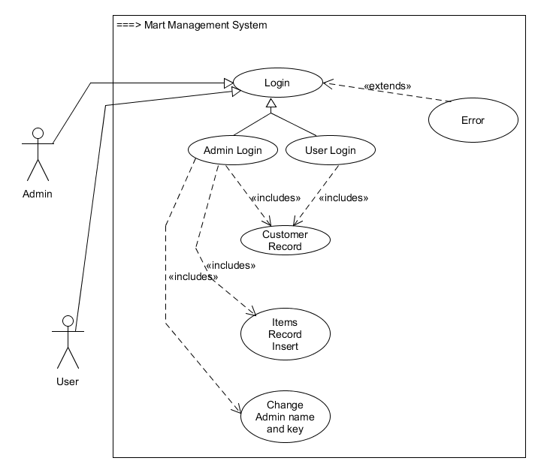

Sequence Diagram:

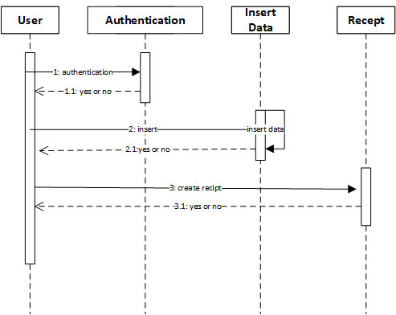

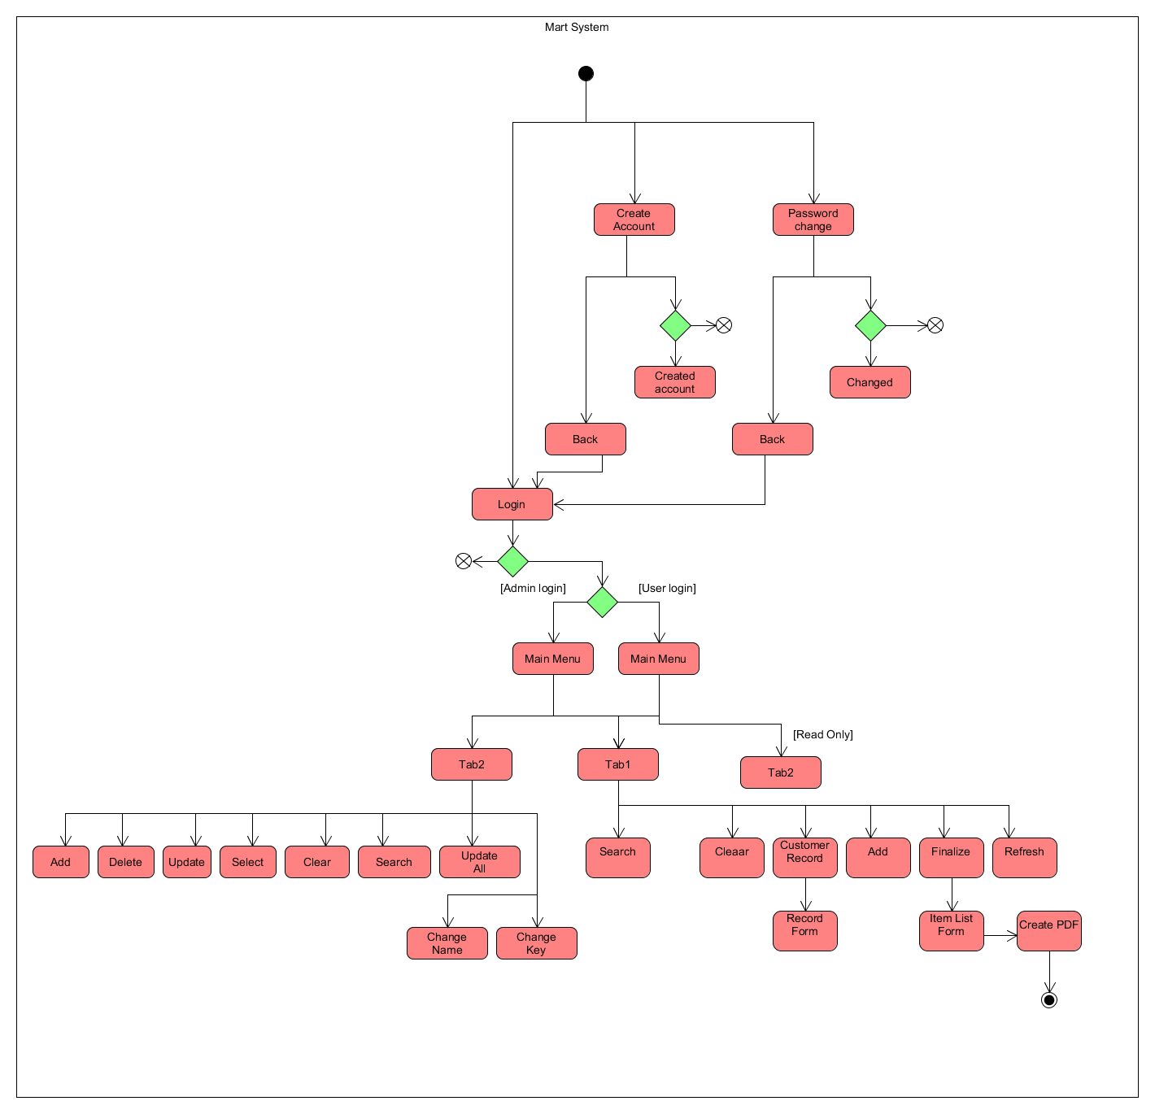Activity Diagram:

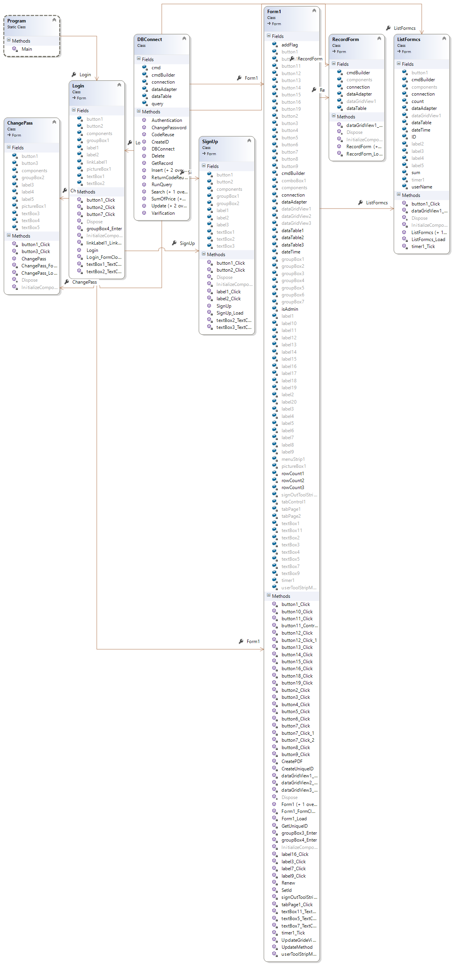UML Class Diagram:

UML Class Relation Diagram:

