

**Online School Management System**

**Submitted To**

**Submitted By**

Md. Abdul Mannan (1233270)

Md. Rafikul Islam (1236026)

Md. Zakaria Rana (1230015)

Kazi Shakhawat Hossain (1236873)

Ayesha Siddika (1236023)

BATCH: ESAD-CS/BAZL-A/33/02

**MD. Sayed Zahidul Hassan**

Consultant

IDB-BISEW IT Scholarship Project

**Online School Management System**

**Delport High School**

|  |  |
| --- | --- |
| Table of contents |  |
| Content Name | PAGE NO. |
|  |  |
| Acknowledgement ……………………………………………………………. | **3** |
|  |  |
| Introduction………………………………………………………………………. | **4** |
|  |  |
| Project Overview ……………………………………………………………… | **6** |
| Requirement……………………………………............................................... | **7** |
|  |  |
| Technology used ……………………..……………………………………….. | 8 |
|  |  |
| Data Dictionary……………………………………………………………. | 10 |
|  |  |
| Design Model …….…………………………….…………………….... | 15 |
|  |  |
| UI Design …………………………………………………………………….. | 22 |
|  |  |
| Snapshots ………….……………………………………………………………. | 26 |
|  |  |
|  |  |

**ACKNOWLEDGEMENT**

*First of all, we thank the almighty Allah for completing this project successfully and we also like to thank many people who helped us in completing this project. Foremost we would like to thank Almighty Allah who give us strength and ability to complete this project. We would like to express our gratitude to all those who gave us the possibility to complete this project. We want to thank* ***IDB-BISEW*** *and* ***BIRDS A & Z Limited*** *for providing the stage to do the project and helping us to do the necessary research. We furthermore, thank our Trainer and Instructor honorable Sir.* ***MD. Azman Ali*** *giving us complete support, advising us in the project and who taught me the basic of system development. He helped us to learn about different types of software development methodologies along with benefits. We would like to thank to our consultant honorable Sir.* ***MD. Sayed Zahidul Hassan*** *for instructing us to implement our project Plan. Finally we are really thankful to our Teammates and Course mate for the valuable suggestions and nice co-operations.*

*Thank You*

**Md. Abdul Mannan (1233270)**

**Md. Rafikul Islam (1236026)**

**Md. Zakaria Rana (1230015)**

**Kazi Shakhawat Hossain (1236873)**

**Ayesha Siddika (1236023)**

**INTRODUCTION**

*Education is the backbone of a nation. Advanced technology available today can play a crucial role in streamlining education-related processes to promote solidarity among students, teachers, parents and the school staff. School Management System consists of tasks such as registering students, producing report cards, producing official transcript and preparing timetable.*

*Handling the administration of an educational institution such as a school or college is not among the easiest of jobs as there are a lot of things that need to be taken care, which includes management of students and staff information, attendance, timetable, payroll and other things. Manually maintaining a record of all these things is quite difficult and the advent of school management system software eased the job to a great extent.*

*Our School Management System is the perfect software of this type that ensures that school owners don't face any difficulty in handling the daily routine tasks of their school. It has all the comprehensive features that are needed to effectively run and administer an educational institution. It makes the job of handling the administration quite easier and simpler. It is perfect for every kind of educational institution including schools, colleges, universities, and group of institutions, training centers and others.*

*School Management System enables school to use and operate many of integrated interrelated modules and manage the administration of school efficiently. Due to its ever growing and competitive nature, the education sector has always been in need of a quality solution to manage and serve the school resources efficiently. IT sector is giving number of solutions to schools like smart classroom, digital learning solutions and school management system to make learning easier and manage school administration effectively. Today educational institution is not limited to imparting education alone, but it is adapting latest trends in IT for improving the quality of education and handling various activities of school including admissions, class management, library management, logistics, inventory, fee management, alumni, accounts etc.*

*The School Management System is accurate and reliable and can be conveniently accessed from school intranet as well as from the public internet. It is fully browser based school management system which also includes virtual campus which can be linked with school portal and contains powerful online access to bring parents, teachers and students on a common interactive platform. Yet another advantage of this software is that it runs on minimal hardware and easily fits in the budget of schools.*

*The appearance of your student records says a lot about the quality of your school. Other educators and registrars make judgments based on student records that can permanently affect a student's life. School Management System capabilities include the basics such as transcripts, report cards, attendance, and discipline as well as many other specialized capabilities, including parental access to real time student grades on the Internet. This means that not only administrators but also parents, teachers, and students have access to real-time data. With traditional reporting methods parents may not find out how their student is performing in school until the end of the quarter or semester -- usually too late to correct a problem situation. School Management System allows parents to know how their student is doing on a continual basis by using the internet. School Management System can even send electronic progress reports to parents via email on a weekly, monthly, or even daily basis.*

**PROJECT OVERVIEW**

*We have learned a lot of about SQL server, HTML5, ASP.NET, MVC 4. Finally we have decided to complete a project about School Management System because it will require a lot of technologies and we have to apply them. Now let us tell about some main points of our objectives of this school management system application software.*

***Computerization****- All the details regarding school, whether it is small or big, will be computerized.****Automation****– The automation feature of this management system will mitigate the task of writing the papers. E.g. there is no need to write the report card of the students on the paper by the pen.  
  
It is simply can be done online on the system, and can be forwarded to the students and their parents.****Easy Interaction****– In today’s rush hour of the life, it is difficult for a parent to go to the school of his / her child every time a teacher calls.  
  
By this management system, it will easier for a parent and a teacher to be in touch every day. As a matter of fact, it will be easier for each individual person who is associated with the system to be in touch as per needed.*

**REQUIREMENT**

**User can:**

* *Apply for admission.*
* *View the Teachers in the School.*
* *View exam schedule of individual exam term and Year.*
* *View the published result sheet/mark sheet of Individual students.*

**Admin can:**

*(Admin have to provide username and password in order to prove s/he is valid)*

* *View applied students and can delete students if any erroneous information is detected.*
* *Add new students and modify them if required.*
* *Add new subject and can modify if necessary.*
* *Add new teacher and can modify them if necessary.*
* *Generate Examination schedule.*
* *Add marks and can modify them.*
* *View results by individual classes.*

**TECHNOLOGY USED**

**Software and Operating System:**

* *Microsoft Windows 10*
* *Microsoft Visual Studio 2013*
* *Microsoft SQL Server 2014*

**Technologies:**

* *ASP.NET MVC 5*
* *Odata*
* *AngularJS*
* *Web.API*
* *HTML5*
* *CSS*
* *Bootstrap*
* *JavaScript*
* *Entity Framework*

**Hardware Requirement (Minimum):**

* *Minimum Server Requirement :*

|  |  |
| --- | --- |
| Processor | *2 GHZ* |
| RAM | *2 GB* |
| Disk Space | *10 GB Of Free Space* |

* *Minimum Client Requirement :*

|  |  |
| --- | --- |
| Processor | *2 GHZ* |
| RAM | *1 GB* |
| Disk Space | *20 GB Of Free Space* |

**Software Requirement (Minimum):**

* *Server Software Requirement:*

|  |  |
| --- | --- |
| Operating System | *Windows Server 2003 R2 (32-Bit x86)* |
| Web Server | *IIS 6.0* |
| Front End | *ASP.NET MVC 4* |
| Back End | *SQL Server 2012* |

* *Client Software Requirement:*

|  |  |
| --- | --- |
| Web browser | *Internet Explorer 8.0 or Upgrade version and Google chrome Browser.* |

**Data Dictionary**

**Table Name: *Admissions***  
**Primary Key:** *AdmissionId*  
**Foreign Key:** *N/A*  
**Description:** *The information about Admission details*

|  |  |  |  |
| --- | --- | --- | --- |
| Column Name | Data Type | Constraints | Description |
| *AdmissionId* | *int* | *Primary Key* | *It stores Admission Id* |
| *Name* | *nvarchar(50)* | *Not null* | *It stores Applicant Name* |
| *FathersName* | *nvarchar(50)* | *Not null* | *It stores Applicant Father’s Name* |
| *MothersName* | *nvarchar(50)* | *Not null* | *It stores Applicant Mother’s Name* |
| *CurrentAddress* | *nvarchar(250)* | *Not null* | *It stores Applicant Current Address* |
| *PermanentAddress* | *nvarchar(250)* | *Not null* | *It stores Applicant Permanent Address* |
| *PhoneNumber* | *nvarchar(20)* | *Not null* | *It stores Applicant Phone Number* |
| *Email* | *nvarchar(50)* | *Not null* | *It stores Applicant email* |
| *DOB* | *datetime* | *Not null* | *It stores Applicant Date of birth* |
| *Gender* | *nvarchar(MAX)* | *Not null* | *It stores Applicant gender* |
| *ApplyClass* | *nvarchar(50)* | *Not null* | *It stores Applicant Apply class for* |

**Table Name: *Teachers***  
**Primary Key:** *TeacherId*  
**Foreign Key:** *N/A*  
**Description:** *The information about Teachers*

|  |  |  |  |
| --- | --- | --- | --- |
| Column Name | Data Type | Constraints | Description |
| TeacherId | *int* | *Primary Key* | *It stores Teachers Id* |
| TeacherName | *nvarchar(50)* | *Not null* | *It stores Teachers Name* |
| Photo | *nvarchar(MAX)* | *null* | *It stores Teachers Photo* |
| Designation | *nvarchar(50)* | *Not null* | *It stores Teachers Designation* |
| JoiningDate | *datetime* | *Not null* | *It stores Teachers Joining Date* |
| AcademicQualification | *nvarchar(50)* | *Not null* | *It stores Teachers Qualification* |
| CellNo | *nvarchar(50)* | *null* | *It stores Teachers Phone no.* |

**Table Name: *Classes***  
**Primary Key:** *ClassId*  
**Foreign Key:** *N/A*  
**Description:** *The information about Classes*

|  |  |  |  |
| --- | --- | --- | --- |
| Column Name | Data Type | Constraints | Description |
| ClassId | *int* | *Primary Key* | *It stores Student’s Class* |
| ClassName | *String* | *Not null* | *It stores Students class name* |

**Table Name: *Students***  
**Primary Key:** *StudentId*  
**Foreign Key:** *ClassId*  
**Description:** *The information about Students*

|  |  |  |  |
| --- | --- | --- | --- |
| Column Name | Data Type | Constraints | Description |
| StudentId | *int* | *Primary key* | *It stores Result Id* |
| StudentName | *nvarchar(50)* | *Not null* | *It stores Students Name* |
| ClassRoll | *int* | *Not null* | *It stores Classes roll* |
| ClassId | *int* | *Foreign key* | *Give reference to Classes* |

**Table Name: *Exam Terms***  
**Primary Key:** *ExamTermId*  
**Foreign Key:** *N/A*  
**Description:** *The information about Exam Terms*

|  |  |  |  |
| --- | --- | --- | --- |
| Column Name | Data Type | Constraints | Description |
| ExamTermId | *int* | *Primary key* | *It stores Exam Term Id* |
| ExamTermName | *nvarchar(50)* | *Not null* | *It stores Exam Term Name* |

**Table Name: *Exam Years***  
**Primary Key:** *ExamYearId*  
**Foreign Key:** *N/A*  
**Description:** *The information about Exam Year*

|  |  |  |  |
| --- | --- | --- | --- |
| Column Name | Data Type | Constraints | Description |
| ExamYearId | *int* | *Primary key* | *It stores Exam Year Id* |
| ExamYearDate | *int* | *Not null* | *It stores Exam Year Date* |

**Table Name: *Exams***  
 **Primary Key:** *ExamId*  
 **Foreign Key:** *ClassId, SubjectId, ExamYearId, ExamTermId*  
 **Description:** *The information about Examination*

|  |  |  |  |
| --- | --- | --- | --- |
| Column Name | Data Type | Constraints | Description |
| ExamId | *int* | *Primary key* | *It stores Exam ID* |
| ExamDate | *datetime* | *Not null* | *It stores Exam Date* |
| ClassId | *int* | *Foreign key* | *Give reference to Class* |
| SubjectId | *int* | *Foreign key* | *Give reference to Subject* |
| ExamYearId | *int* | *Foreign key* | *Give reference to Exam Year* |
| ExamTermId | *int* | *Foreign key* | *Give reference to Exam Term* |

**Table Name: *Results***  
**Primary Key:** *ResultId*  
**Foreign Key:** *ExamId, StudentId, SubjectId, ExamYearId, ExamTermId.*  
**Description:** *The information about Results*

|  |  |  |  |
| --- | --- | --- | --- |
| Column Name | Data Type | Constraints | Description |
| ResultId | *int* | *Primary key* | *It stores Result Id* |
| ExamId | *int* | *Foreign key* | *Give reference to Exam* |
| StudentId | *int* | *Foreign key* | *Give reference to Students* |
| SubjectId | *int* | *Foreign key* | *Give reference to Subjects* |
| ExamYearId | *int* | *Foreign key* | *Give reference to Exam Year* |
| ExamTermId | *int* | *Foreign key* | *Give reference to Exam Term* |
| Mark | *float* | *Not null* | *It stores Marks* |

**Table Name: *Subjects***  
 **Primary Key:** *SubjectId*  
 **Foreign Key:** *N/A*  
 **Description:** *The information about Subjects*

|  |  |  |  |
| --- | --- | --- | --- |
| Column Name | Data Type | Constraints | Description |
| SubjectId | *int* | *Primary Key* | *It stores Subject Id* |
| SubjectName | *nvarchar(50)* | *Not null* | *It stores Subject Name* |

**DESIGN MODEL**

**Data Model:**

*This is Data Model design of our database:*

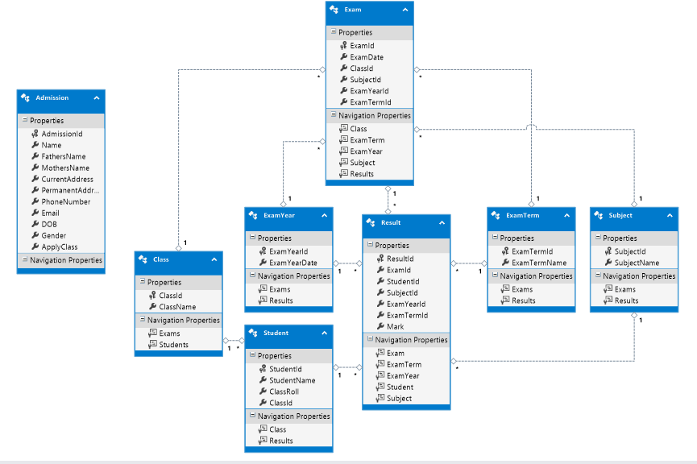

**Analysis & Design**

**Requirement model:**

*The relationship between the user and admin is presented below by using use case*

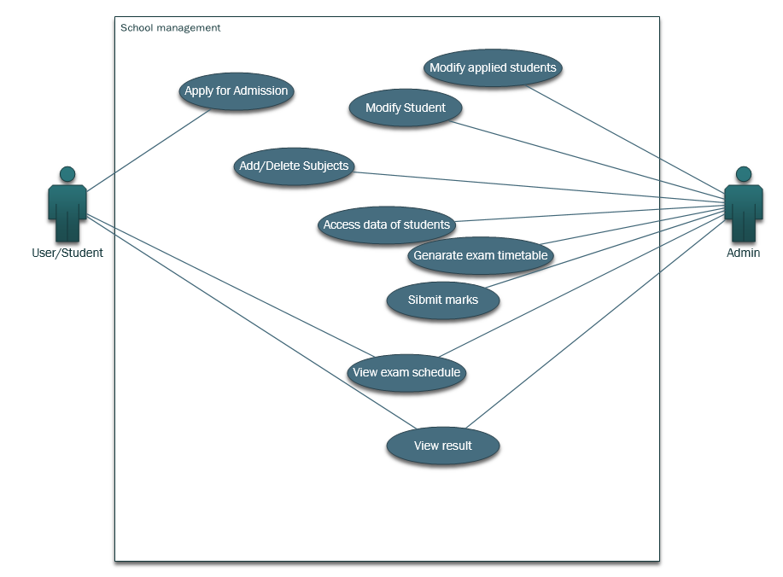

**Anonymous User/Student interaction**

*User Activity Sequence Diagram:*

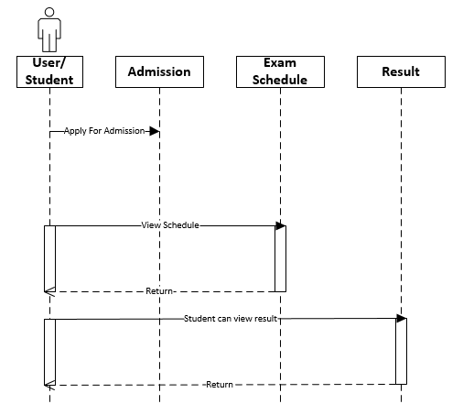

*Admin Activity Sequence Diagram***:**

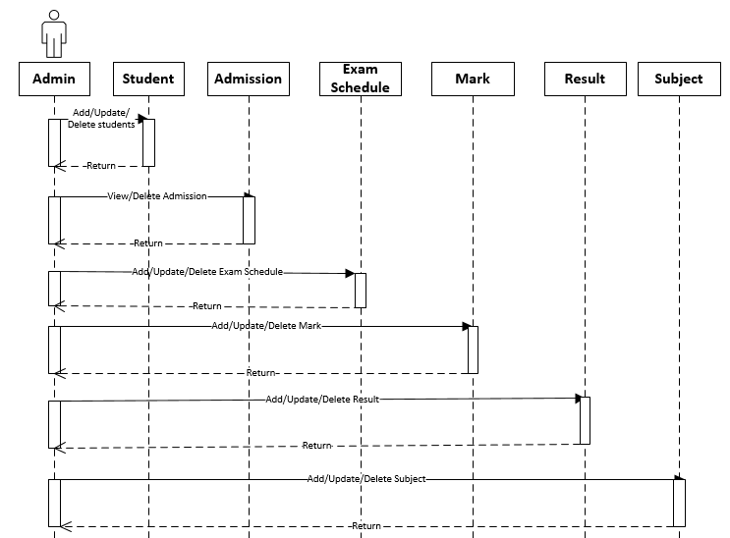

**Interaction flow:**

**User Activity Diagram:**

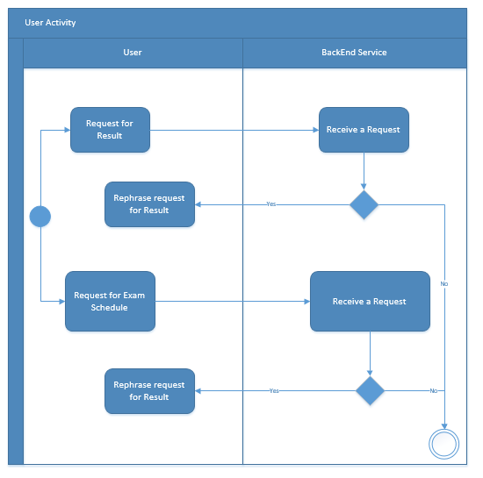

**Admin Activity Diagram:**

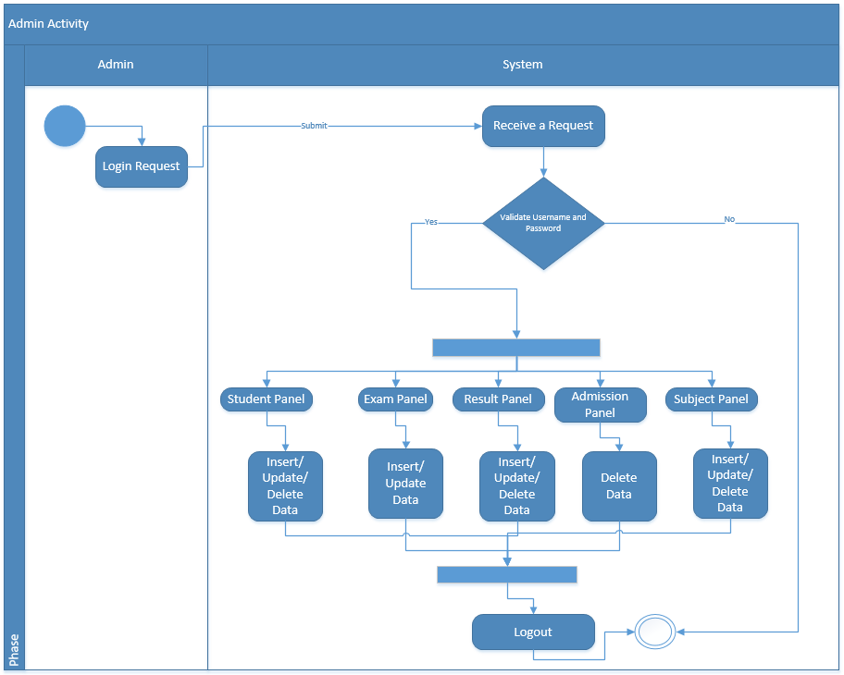

**System Architecture**

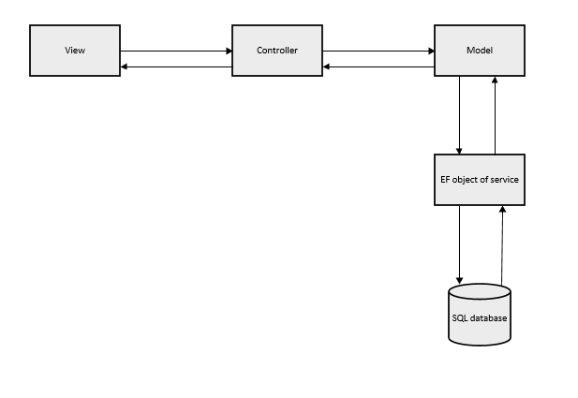

**UI Design:**

We use Single page application (SPA) to create the UI Design in this application software.

**CODE SAMPLE**

*There are given some sample code of angularJs and HTML of our project.*

***Angular Controller:***

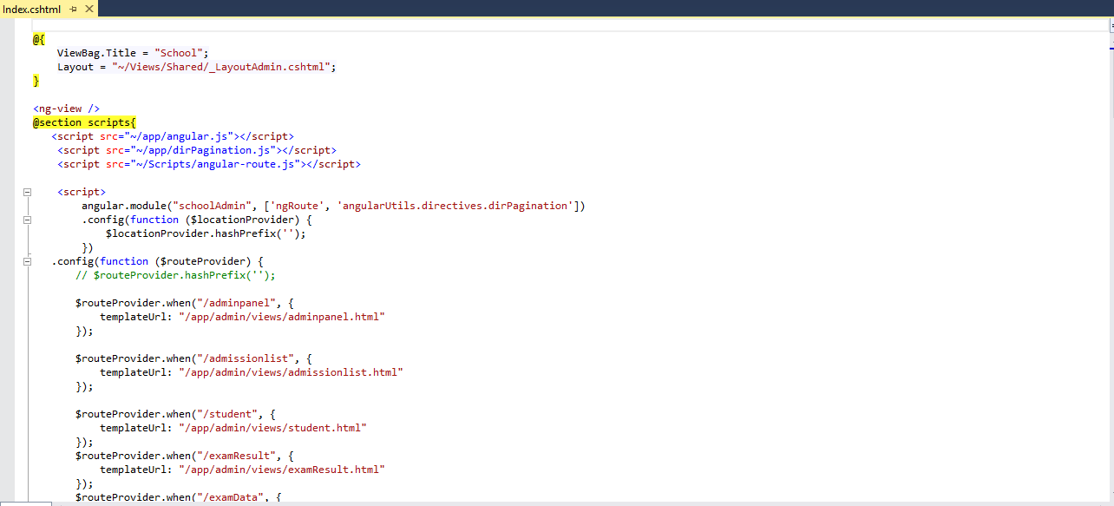

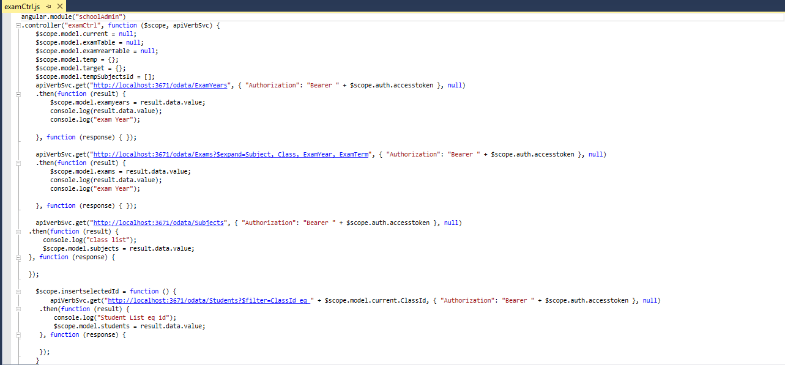

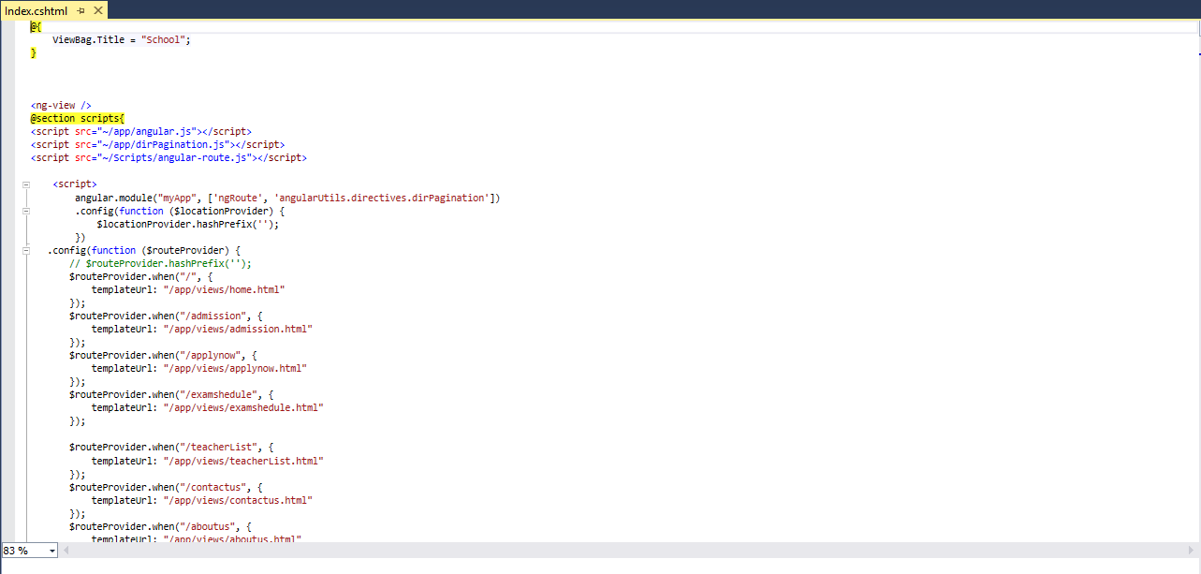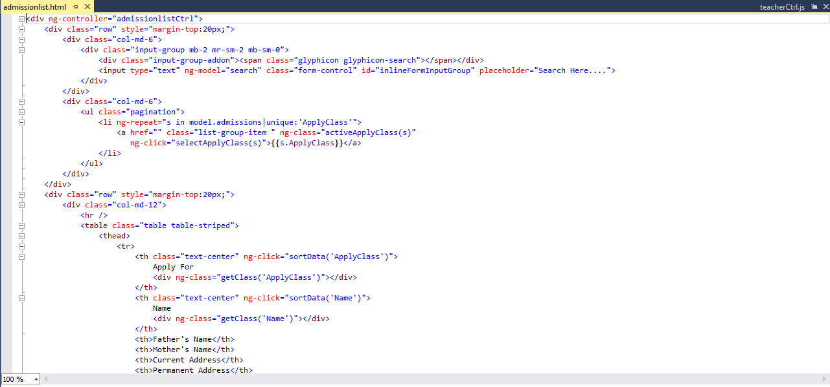***Angular View:***

***DbModel Code Sample:***

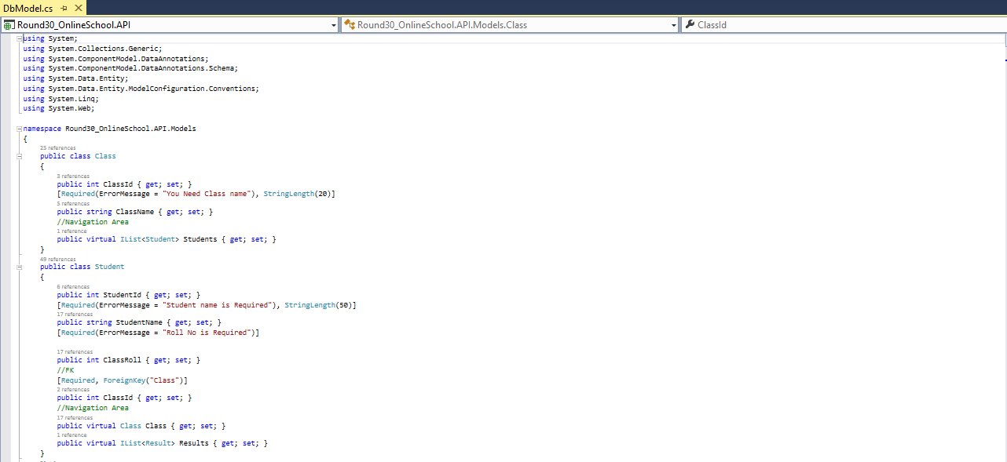

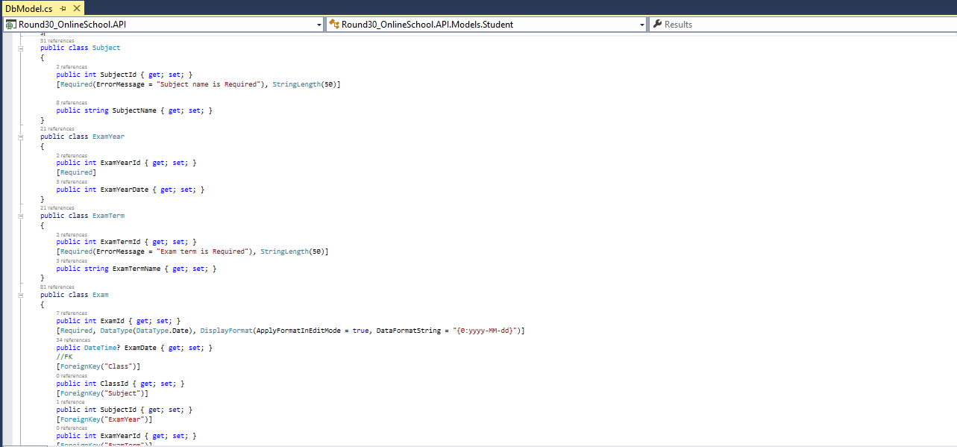

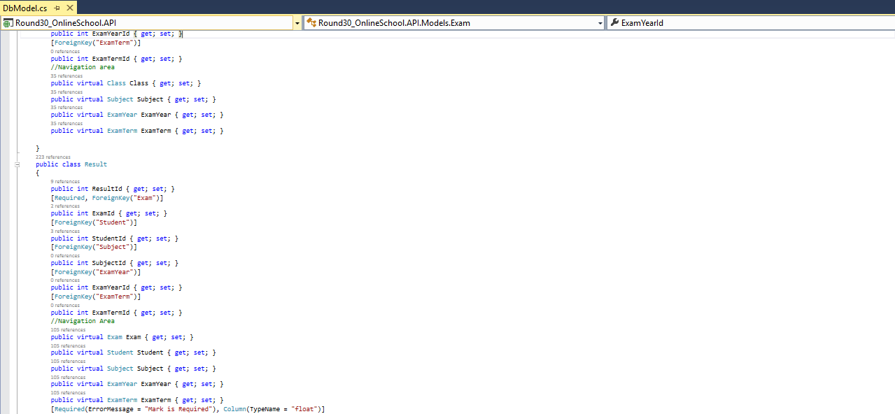

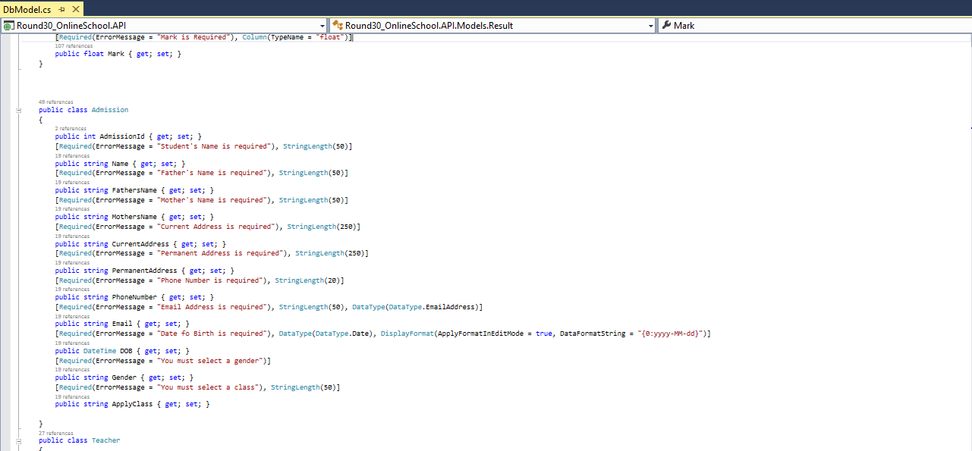

**USER INTERFACE SNAPSHOTS**

***User Interface snapshot of Admission page is given below.***

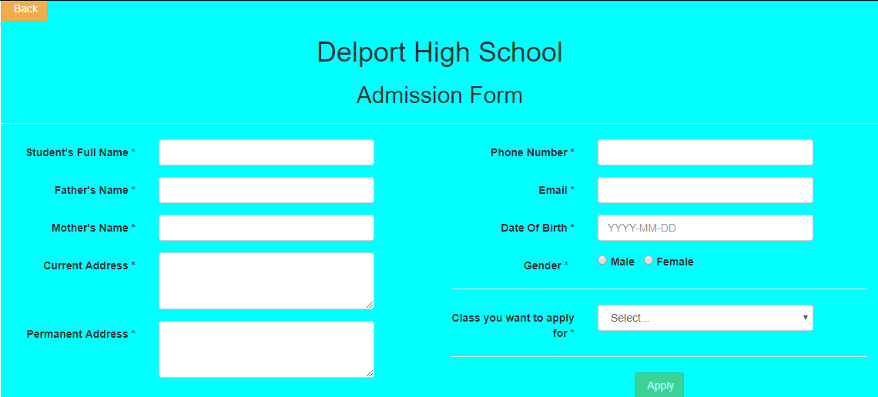

***User Interface snapshot of Exam Schedule page is given below.***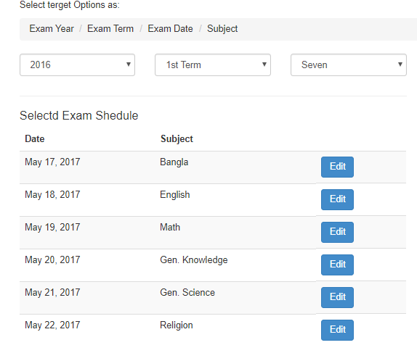

*User Interface snapshot of Mark sheet page is given below. Student also can print the mark sheet or save as PDF*.

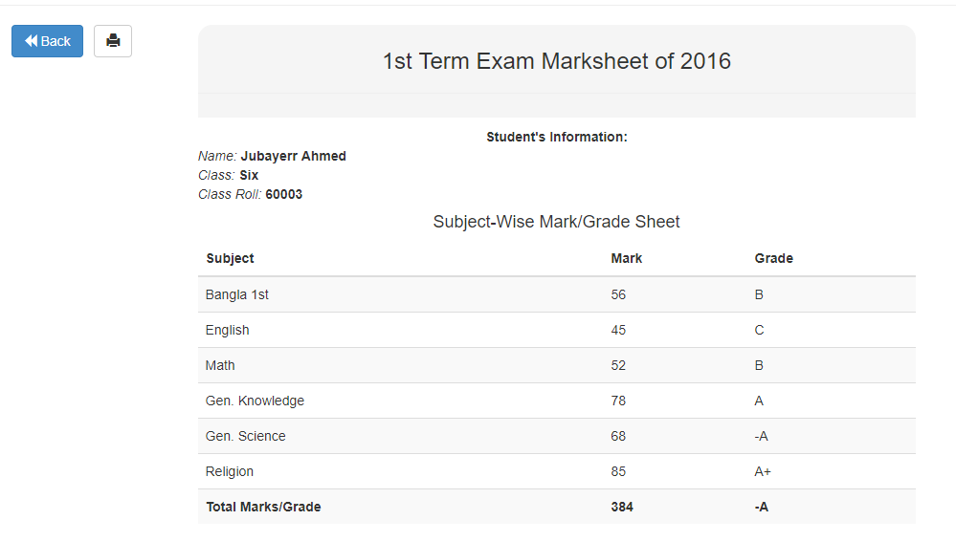

***TEST SCREEN (Admin Part):*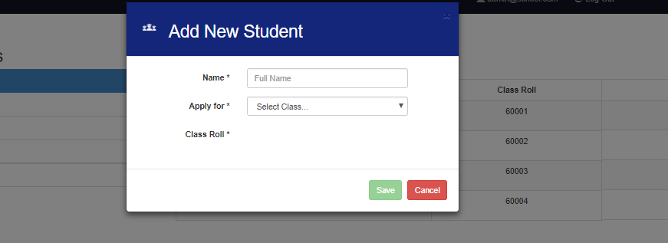**

*Admin panel test screen of Add New Student.*

***Roll will be generated automatically.***

***Admin panel test screen of student panel.***

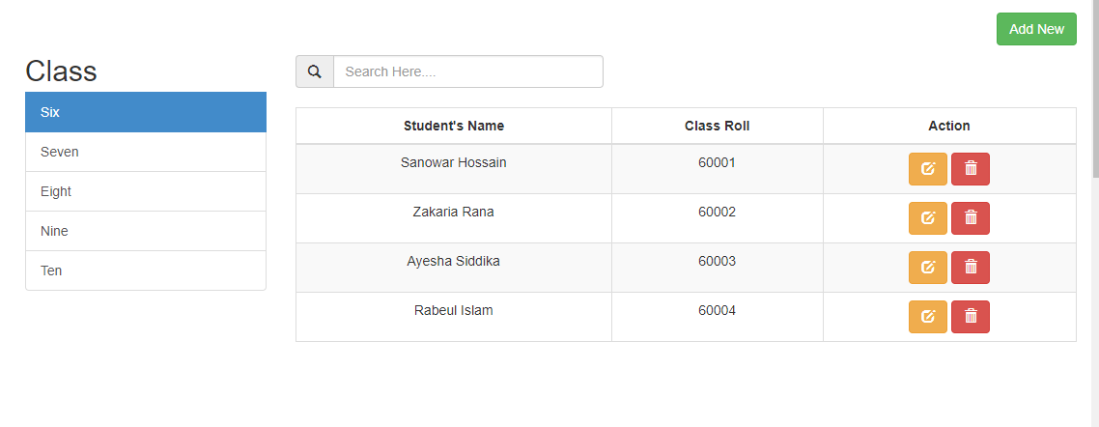

***Admin panel test screen of Exam panel.***

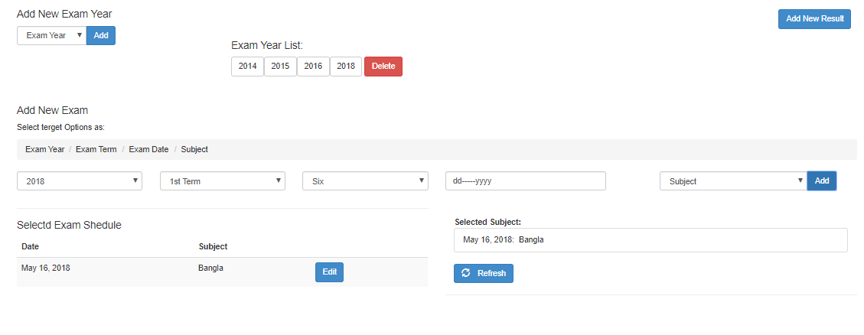

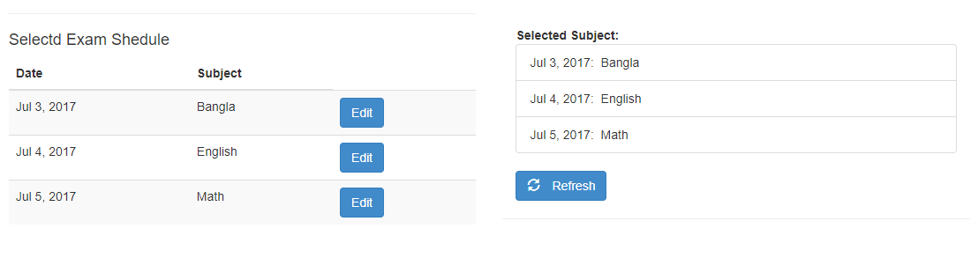

**Admin Panel for result control**

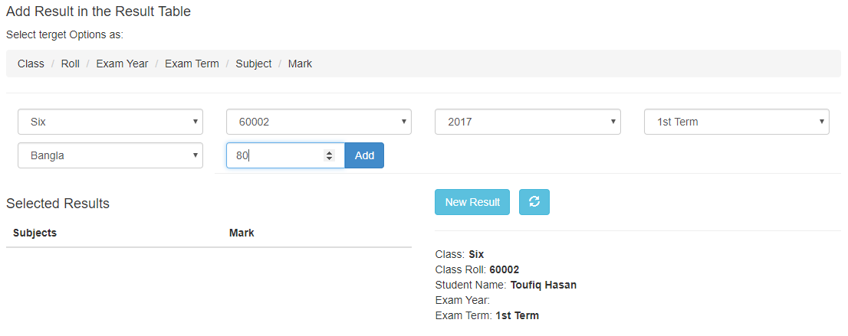

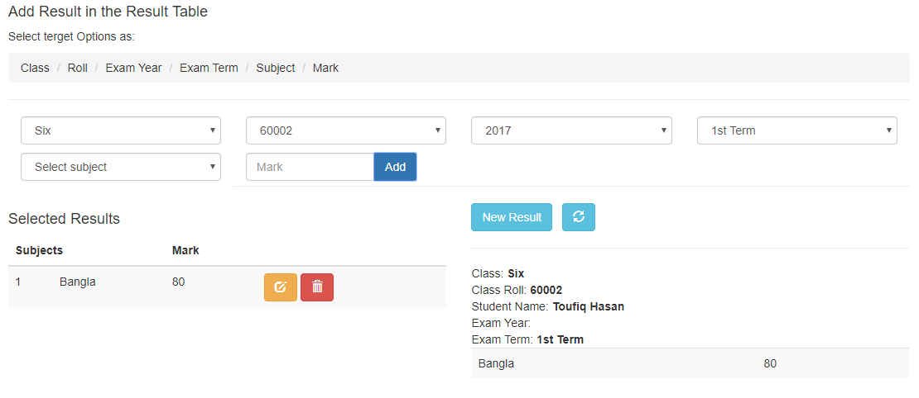

***Admin panel for Subject Modification:***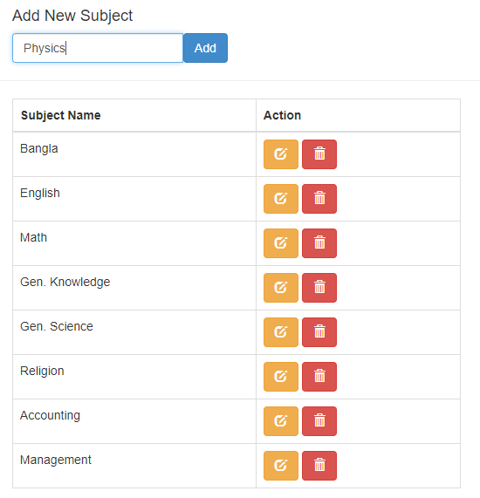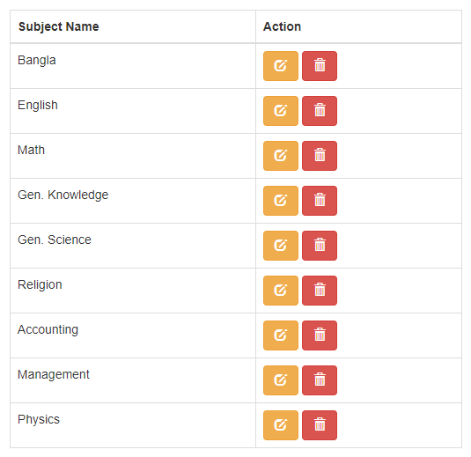

***Admin panel for Teacher Insert:***

