The Infant Mortality Rate and the American South

Richard Francais (014304743)

HDEV 300

Dr. Pamela Roberts

25 April 2018

**Abstract**

The difference in the infant mortality rate between states in the United States is immense. No better is this demonstrated than in comparing the American South with the other sub regions of the United States. The South exhibits the lowest average median household income and the highest infant mortality rates in the country. Testing shows a statistically significant negative relationship between median household income and the infant mortality rate in the South. Similar tests were done for the Gini coefficient and the number of physicians per capita but results were inconclusive.

**Introduction**

The infant mortality rate is one of the most effective indicators of quality of life in a country. Factors such as ease of access to healthcare, quality of healthcare, and income are captured in this statistic(MacDorman, 2008). The United States ranks as the country with the 57th lowest infant mortality rate in the world at 5.8, ranked between Latvia and Bosnia and Herzegovina (CIA). The infant mortality rate is calculated as the amount of infant deaths under the age of one for every 1000 live births. A ranking this low is particularly surprising for a country as wealthy as the United States. However, upon further review of the data, there is a large amount of variance in infant mortality rates between states. This is not necessarily surprising, given that there is considerable economic and political diversity within the United States itself. What is surprising are the trends that become immediately apparent, most notably the sharp difference between the traditional American South and the rest of the country. The South, a region as defined by The United States Census Bureau as shown in figure 1, has an average infant mortality rate of 7.22, landing the region between Kuwait and Puerto Rico (CIA). In this essay I will attempt to explain the gap using statistical analysis of quality of life databases to further understand the causes of this disparity.

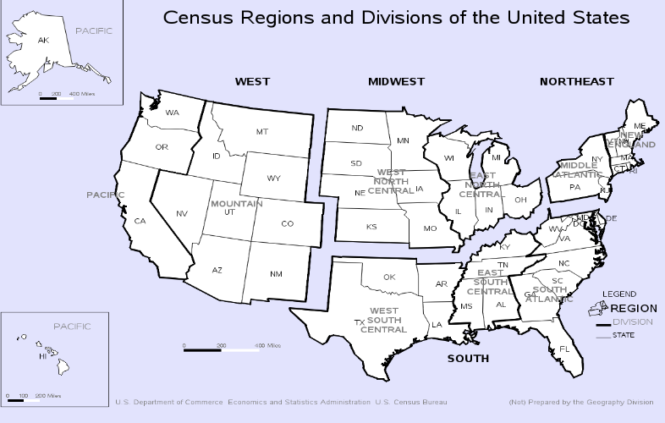

Figure 1 Census Regions (Census Bureau Regions and Divisions)

**Literature Review**

There is a wide variety of research focused on income inequality, especially in recent decades as inequality has continued to rise (Lawrence). By in large, researchers have focused on various indices that attempt to model the quality of life of citizens. By synthesizing the contributions of previous researchers, I hope to make a connection between these factors and the unusually high Infant Mortality Rate in the United States.

In “Income Distribution and Mortality: Cross Sectional Ecological Study of the Robin Hood Index in the United States” Kennedy, Kawachi, and Prothrow-Stith attempt to determine the effects that standard measures of income inequality such as the Robin Hood Index (also known as the Hoover or Schutz index) and the Gini coefficient have on general mortality in the United States. The Robin Hood Index is an estimation of the redistribution of wealth from citizens about the mean to below the mean (Kennedy, Kawachi, and Prothrow-Stith 1996, p. 1004). Similarly, the Gini coefficient also measures inequality. The results of the researchers’ tests suggested a high correlation between mortality and the Robin Hood Index, while the Gini coefficient expressed very little correlation(Kennedy et al., 1996, p. 1005**)**. Although, Kennedy does mention a study done by the OECD that showed a high correlation between the Gini coefficient and average life expectancy.

“The Wealth of Nations Revisited: Income and Quality of Life” by Ed Diener and Carol Diener sets out to answer the question, “Does economic prosperity enhance the quality of human life.” (Diener & Diener 275). To answer this question, Diener analyzed 32 indices that constituted a “diverse, representative set of human values.” (Diener & Diener p. 276). The physician per capita metric is one of these indices that is particularly relevant to the topic of this paper. The number of physicians per capita doesn’t necessarily signal the quality of healthcare, but it may represent the ease of access to health facilities. Diener also makes another relevant statement: “Wealthy nations have faults that must not be understated; the high crime rate of the U.S.A. comes readily to mind.” (Diener & Diener p. 284). Although crime rates are not explicitly relevant to the topic, the sentiment rings true that wealth does not solve all problems.

**Data**

Data was pulled from natural databases, and nearly all for the year 2016, I will touch on the two exceptions shortly. For the infant mortality rate, the CDC’s National Center for Health Statistics was used. However, the CDC’s data is strangely incorrect for Vermont. Vermont is listed as 0.0 infant mortality rate. To amend these discrepancies, I used the CDC’s 2015 data for Vermont. I considered using a different source for Vermont, but I decided against it due to possible differences in how the two sources would measure the rate. Median household income data was pulled from the United States Census Bureau’s “Household Income: 2016” paper, Gini coefficient data was also pulled from the USCB. The physician data comes from the “2017 State Physician Workforce Data Report” published by the Association of American Medical Colleges. Below are the summary statistics for the mentioned variables. Although, this doesn’t become relevant until the results section, obesity data was taken from State of Obesity.

|  |  |  |  |  |
| --- | --- | --- | --- | --- |
| Variables | Mean | Std. Dev. | Min | Max |
| Infant Mortality Rate | 6.09 | 1.25 | 3.7 | 9.1 |
| Median Household Income | 58,143 | 9,819.79 | 41,754 | 78,945 |
| Gini Coefficient | 0.47 | 0.02 | 0.41 | 0.54 |
| Physicians per 100,000 | 277.83 | 99.3 | 186.1 | 866.3 |

**Theoretical Model:**

Predicted IMRi = β0 (+/-) β1Median HH Incomei (+/-) β2GiniCoefficienti (+/-) β3PhysiciansPer100ki (+/-) β4South

IMR = The infant mortality rate per 1000 live births.

Median HH Income = Median HH Income of each state.

Gini Coefficient = The Gini coefficient value that each state possesses.

PhysiciansPer100k = The number of physicians in each state, adjusted for population.

South = 0 if the state does not fall in the region, 1 if it does

Using an ordinary least squares model, I attempt to predict the rate of infant deaths based on a few key variables from the literature that I believed would best describe the dependent variable. The first these regressors is the Median Household Income in each state. Household income is predicted to have a negative effect on the infant mortality rate, increases in income decrease the rate of infant mortality. One thing to note is the decision to keep the variable in its standard form, it would be reasonable to suggest that increased household income would only decrease the infant mortality rate up to a certain point, where the association levels off. This makes sense in theory, for example, say a state had a median income of $1,000,000.00 dollars, affording medical care would no longer be an issue, yet the state would still have infant mortalities due to unavoidable circumstances. The problem in applying this to the data is that the leveling off point is unknown, it may be outside our range of values. Ultimately, I elected towards not potentially biasing my model with a subjective decision.

The Gini coefficient is expected to have a positive effect on the infant mortality rate. This is due to the nature of the Gini coefficient. The value of the Gini coefficient is between 0 and 1, 0 representing perfect inequality and 1 representing complete inequality (Household Income p.1). As income inequality increases, the infant mortality rate is expected to rise. As for physicians, the sign is expected to be negative, for the reasons mentioned in the literature review. Finally, a dummy variable is used to account for the states in the South. The expected association should be positive if the reasoning is correct. This variable will be critical in determining if there is a statistically significant difference in mortality rates in the South.

**Results**

The results of the model are mixed. Both the Gini coefficient and physicians per capita exhibit the opposite signs that were predicted as shown in table 1 below. The Gini coefficient was shown to have a negative relationship with infant mortality, while physicians per capita has a positive correlation. This outcome suggests that some of the income inequality measure is already captured inside the differences in household income. When making this model, I used the assumption that the United States is politically and economically diverse. While that is true, it seems that diversity is overstated.

The physician result is interesting. The very slight positive relationship indicates there may be an omitted variable that is potentially skewing the results. To address this, I added in a variable representing the obesity rate in each state. The intent of this is to more accurately represent the healthcare system in America, where obesity is a major health concern. States with higher levels of obesity may serve as a signal for increased healthcare resources. In theory this might make sense, however in reality the results were even more muddled, table 3 shows this issue. While the obesity variable was shown to have an adverse impact on infant mortality; ultimately, this model simply does not do an accurate job of modeling the health care system’s effects on the infant mortality rate.

The model is not a complete disappointment however, the median household income expressed our predicted sign, and had a t-score of -4.09, a statistically significant value. This allows us to conclude that changes in household income do have a meaningful impact on the infant mortality rate. Similarly, the South dummy variable has a t-score of 4.88, suggesting that states in the South have a uniformly lower infant mortality rate than the rest of the United States.



Table 1 Original OLS model

*Figure 2 Blue series represents observed data while orange represents values predicted by the model*



Table 2 Modified OLS model with Obesity variable

**Conclusion**

The goal of this paper was to gather a greater understanding of the factors that affect the infant mortality rate and why there is so much variance in the rate within the United States, particularly in the South. Although the model was not a complete success, the effect that the health care system has remains unclear. A greater understanding of the role that a household’s income has on the well-being of the household has been reached.

References

Association of American Medical colleges. 2017 State Physician Workforce Data Report [Data file]. Retrieved from <https://members.aamc.org/eweb/upload/2017%20State%20Physician%20Workforce%20Data%20Report.pdf>

*Census Bureau Regions and Divisions with State FIPS Codes*. (n.d.). District of Columbia: U.S. Department of Commerce.

Diener, E., & Diener, C. (1995). The Wealth of Nations Revisited: Income and Quality of Life. *Social Indicators Research,* *36*, 275-286. Retrieved April 20, 2018, from https://www.jstor.org/stable/27522878?seq=1#page_scan_tab_contents.

Kennedy, B. P., Kawachi, I., & Prothrow-Stith, D. (1996). Income Distribution And Mortality: Cross Sectional Ecological Study Of The Robin Hood Index In The United States. *BMJ: British Medical Journal,* *312*, 1004-1007. Retrieved April 20, 2018, from https://www.jstor.org/stable/29731386?seq=2#page_scan_tab_contents.

Lawrence, Robert Z. [PetersonInstitute]. (2015, July 31). *Has Productivity Outstripped Wage Growth?* [Video file]. Retrieved from <https://www.youtube.com/watch?v=8sf3kt1KduY&index=1&list=PLMTpY1ixcT_Cz37OI96p-5i4gjG8kqgt5&t=0s>

MacDorman, M. F., & Mathews, T. (2008, October 9). Recent Trends in Infant Mortality in the United States. Retrieved from <https://www.cdc.gov/nchs/products/databriefs/db09.htm>

National Center for Health Statistics. (2016). *Infant Mortality Rates by State* [Data file]. Retrieved from <https://www.cdc.gov/nchs/pressroom/sosmap/infant_mortality_rates/infant_mortality.htm>

National Center for Health Statistics. (2017). *Infant Mortality Rates by State* [Data file]. Retrieved from <https://www.cdc.gov/nchs/pressroom/sosmap/infant_mortality_rates/infant_mortality.htm>

The State of Obesity. (2017). *Adult Obesity in the United States* [Data file]. Retrieved from <https://stateofobesity.org/adult-obesity/>

The World Factbook. (n.d.). Retrieved from <https://www.cia.gov/library/publications/the-world-factbook/rankorder/2091rank.html>

United States Census Bureau. (2017). *Household Income: 2016* [Data file]. Retrieved from <https://www.census.gov/content/dam/Census/library/publications/2017/acs/acsbr16-02.pdf>

United States Census Bureau FactFinder. Gini coefficient [Data file] . Available from https://factfinder.census.gov/faces/tableservices/jsf/pages/productview.xhtml?pid=ACS_10_1YR_B19083&prodType=table