**Exercise 1: Implementing the Singleton Pattern**

**Singleton Pattern :**

The Singleton Design Pattern ensures a class has only one instance throughout the application.  
It provides a global point of access to that instance.

**Code:**

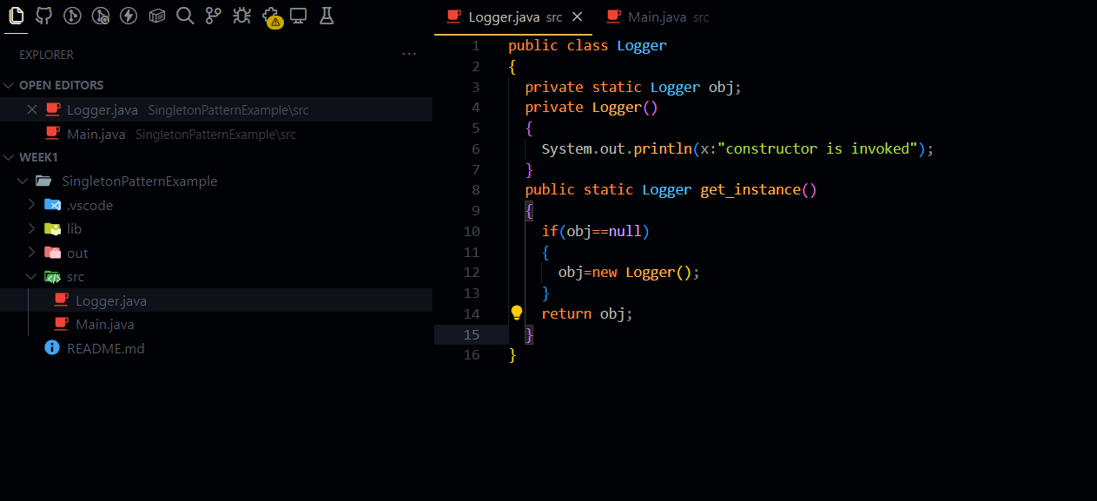

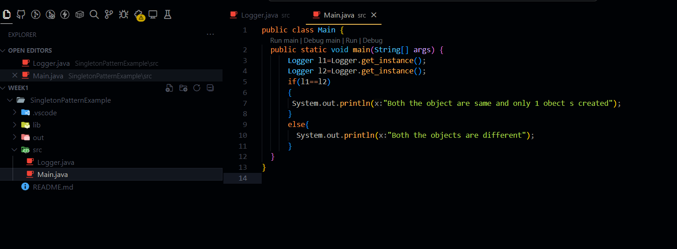

**Output:**

