Software Architecture and Design Specification (SAD)
Project: Healthcare Appointment & Patient Record System
Version: 1.0
Authors: Team 13 – P Manas Siddhardha, Prithviraj K, Parth Kale, Raghav Budur
Date: 10-10-2026
Status: Draft

Revision history
Version | Date | Author | Change summary
1.0 | 10-10-2026 | Team 13 | Initial architecture and design with diagrams

Approvals
Role | Name | Signature / Date
Course Coordinator
Project Lead | P Manas Siddhardha

1. Introduction

1.1 Purpose
This document specifies the software architecture and detailed design of the Healthcare Appointment & Patient Record System (HAPRS). It explains how the requirements in the SRS v1.0 are realised: the components and their responsibilities, the architecture pattern, the technology stack, the security architecture, the main interaction sequences and the API contracts.

1.2 Scope
The document covers the whole of version 1.0: authentication and roles, patient management, doctor schedules and slots, appointment booking with conflict prevention, medical records and prescriptions, notifications, reporting and audit logging. Billing, insurance, lab/pharmacy integration, telemedicine and HL7/FHIR interfaces are out of scope, as in the SRS.

1.3 Audience
Developers, QA engineers, security reviewers, the project team, course instructors and anyone maintaining the system later.

1.4 Definitions
Term | Meaning
HAPRS | Healthcare Appointment & Patient Record System
MRN | Medical Record Number (Patient ID)
PHI | Protected Health Information
Slot | Bookable time interval of one doctor
Care relationship | The patient has or had an appointment with the doctor
RBAC | Role-Based Access Control
JWT | JSON Web Token
STRIDE | Spoofing, Tampering, Repudiation, Information disclosure, Denial of service, Elevation of privilege
ORM | Object-Relational Mapper (SQLAlchemy)
TLS | Transport Layer Security
ADR | Architecture Decision Record

2. Document Overview

2.1 How to use this document
- Section 3 – Architecture gives the big picture: goals and constraints, stakeholders, the component and domain class diagrams, component descriptions, the chosen pattern with its rationale, the technology stack, risks, traceability to requirements and the STRIDE threat model. Read this first to understand where each requirement lives.
- Section 4 – Design goes one level deeper: the design overview, two UML sequence diagrams (appointment booking and consultation/prescription), the REST API of the Appointment Service and the Medical Record Service, error handling and logging, UX design and open issues.
- Section 5 – Appendices holds the glossary, references and tools.
Every requirement ID (HAP-F, HAP-NF, HAP-SR) refers to the SRS, and component names are used identically in all three project documents.

2.2 Related documents
Document | Version | Relationship
Software Requirements Specification (SRS) | 1.0 | Source of every requirement this design implements
Software Test Plan (STP) | 1.0 | Verifies the requirements and the design decisions described here
Requirements Traceability Matrix (RTM) | 1.0 (SRS §8) | Links each requirement to SAD sections, components and test cases
Requirements Registry | 1.0 (docs/requirements-registry.md) | Fixed list of all requirement and test case IDs

3. Architecture

3.1 Goals & Constraints
Goals
Goal | Measure | Requirement
Protect patient data | Only the patient, treating doctors and authorised staff can read records; sensitive fields encrypted at rest; every access logged | HAP-SO-1, HAP-SR-004, SR-006, SR-007
Zero double bookings | One active appointment per slot and no overlapping appointments per patient, also under concurrent requests | HAP-F-032
Responsive | 95% of API calls ≤ 2 s at 200 concurrent users; slot search ≤ 1 s | HAP-NF-001, NF-002
Available | ≥ 99.5% monthly uptime; daily backup, RPO 24 h, RTO 4 h | HAP-NF-003
Easy to use | First-time patient books in ≤ 3 minutes on a phone | HAP-NF-004
Maintainable | One package per component; ≥ 70% service-layer test coverage | HAP-NF-005
Constraints
- Personal and health data handled according to the DPDP Act 2023 principles (purpose limitation, consent, need-to-know access).
- Medical records must never be deleted (versioning only).
- Open-source stack only: React, FastAPI, PostgreSQL.
- Single clinic deployment on one server or VM; no cloud-specific services.
- Four-person student team and one semester of development time.
- Only synthetic data may be used outside production.

3.2 Stakeholders & Concerns
Stakeholder | Concerns | Addressed by
Patients | Privacy of their health data; quick and simple booking; reminders; access to their own prescriptions | RBAC + care-relationship checks (3.9), booking flow in ≤ 4 screens (4.5), Notification & Reporting Service
Doctors | Accurate schedule; no double bookings; fast access to patient history; quick note and prescription entry | Conflict-prevention transaction (3.6), chart view with allergies first, sequence diagram 2 (4.2)
Receptionists | Fast walk-in registration and check-in; booking on behalf of patients | Patient Service, Appointment Service status API (4.3)
Admin / Hospital management | Doctor utilisation, no-show rate, staff account control, reports, compliance | Dashboard and CSV export, Audit Log
Regulators / auditors | Traceability of every access to health data; records never lost | Append-only audit log, versioned records, backups
Developers | Clear module boundaries, testability, simple deployment | Layered architecture (3.5), one package per component, Docker Compose
Testers | Stable APIs, seed data, measurable acceptance criteria | API design (4.3), Test Plan, synthetic data set

3.3 Component (UML) Diagram

Component diagram
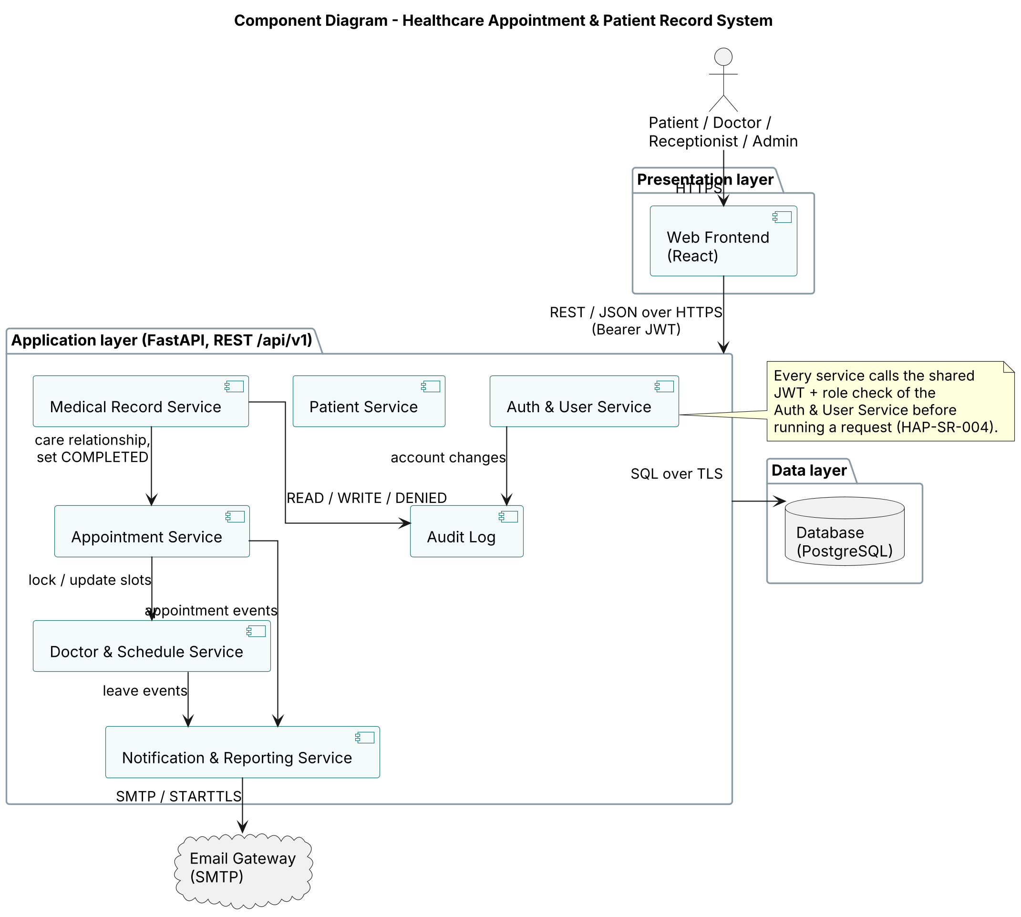
Component diagram
The system is split into three layers. The Web Frontend is the only part users touch; it calls the application layer through one REST API (/api/v1) over HTTPS with a bearer JWT. The application layer contains seven components. The Appointment Service locks and updates slots owned by the Doctor & Schedule Service and publishes appointment events to the Notification & Reporting Service. The Medical Record Service asks the Appointment Service whether a care relationship exists and marks appointments COMPLETED, and writes every access to the Audit Log. All components store data in one PostgreSQL database. The only external system is the Email Gateway (SMTP).

Domain class diagram
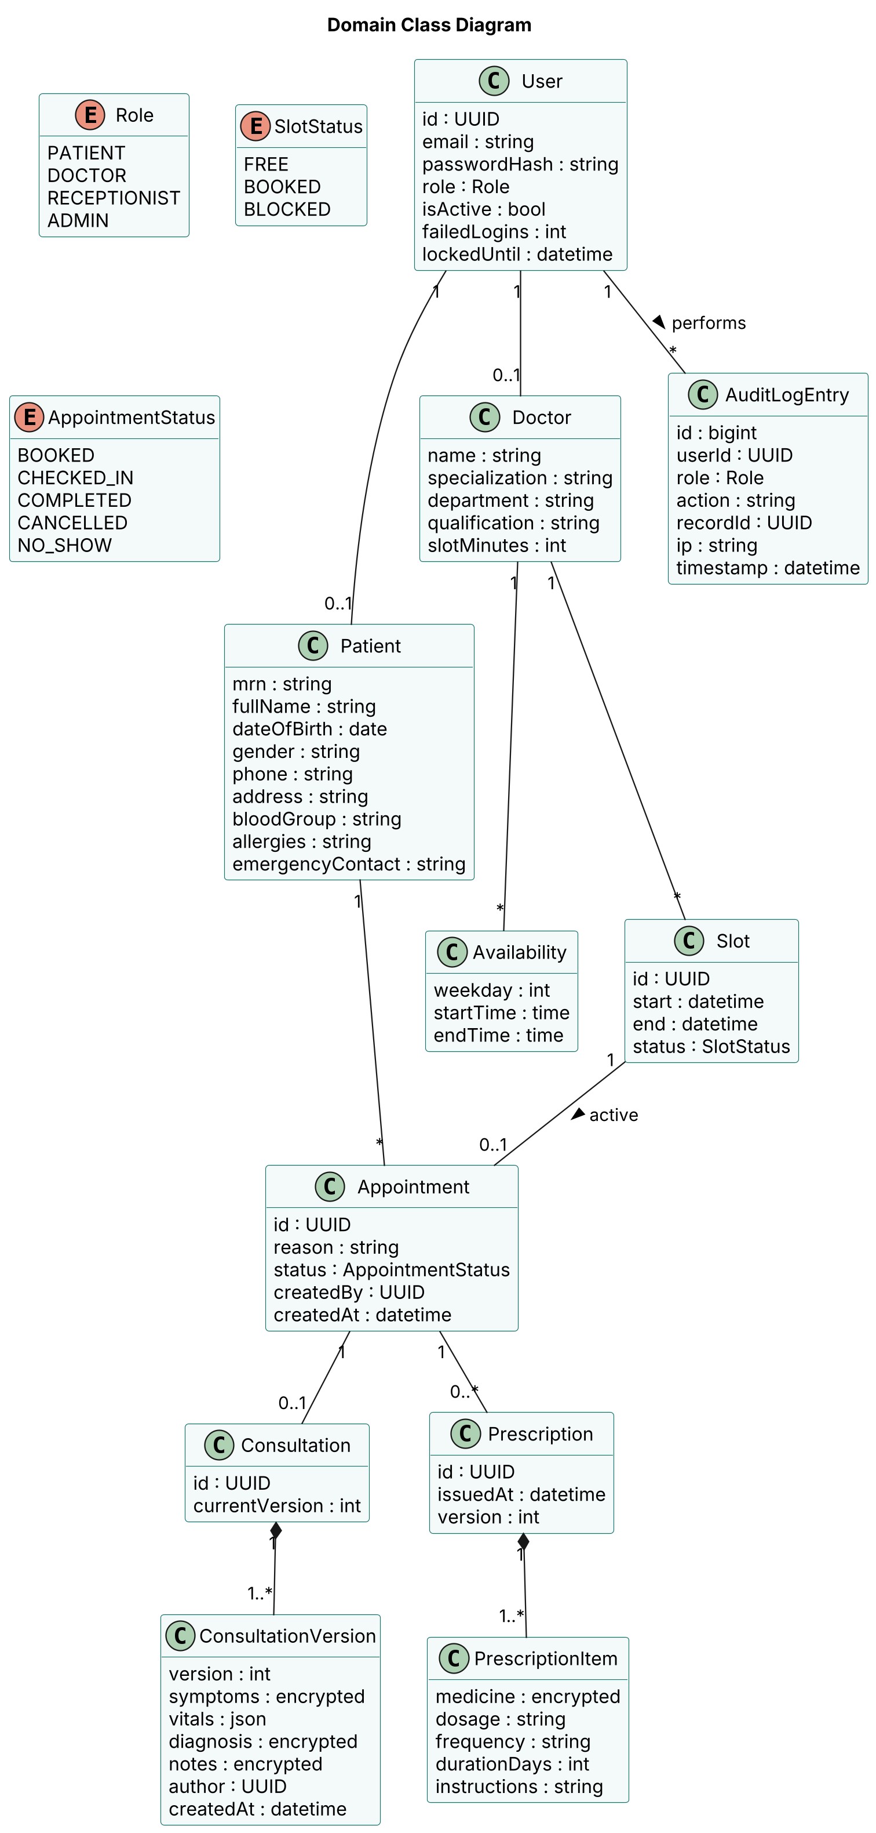
Domain class diagram
The class diagram shows the main persistent entities. A User has one role and is linked to at most one Patient or Doctor profile. A Doctor has weekly Availability rules, from which Slots are generated. A Slot can hold at most one active Appointment — this multiplicity is the conflict rule of HAP-F-032. An Appointment may have one Consultation, stored as one or more immutable ConsultationVersions (HAP-F-044), and any number of Prescriptions with their PrescriptionItems. Fields marked encrypted are encrypted at rest (HAP-SR-006). Every action is recorded as an AuditLogEntry (HAP-SR-007).

3.4 Component Descriptions
Component | Responsibility | Main data | Requirements
Web Frontend | React single-page app for all four roles. Shows only the menus of the logged-in role, validates forms before sending, and displays API error messages in plain language. Holds the JWT in memory, never in local storage. | None persistent | All FRs, HAP-NF-004
Auth & User Service | Registration, login, JWT issue and verification, password hashing, lockout, staff account creation and deactivation. Provides the shared authorisation dependency every other service calls before handling a request. | users | HAP-F-001–003, HAP-SR-001, 002, 004, 005
Patient Service | Patient profiles, MRN generation, duplicate warning, patient search for staff. | patients | HAP-F-010–013
Doctor & Schedule Service | Doctor profiles, weekly availability, nightly generation of slots for the next 30 days, leave days that block slots and trigger notifications. | doctors, availability, slots | HAP-F-020–022
Appointment Service | Free-slot search, booking, rescheduling, cancellation, check-in, status transitions and automatic NO_SHOW. Owns the conflict-prevention transaction. Answers “does this doctor have a care relationship with this patient?” for the Medical Record Service. | appointments | HAP-F-030–035, HAP-NF-002
Medical Record Service | Patient chart, consultation notes with versions, prescriptions, prescription PDFs, encryption and decryption of sensitive fields, care-relationship enforcement. | consultations, consultation_versions, prescriptions, prescription_items | HAP-F-040–044, HAP-SR-006
Notification & Reporting Service | Turns appointment and leave events into email and in-app notifications, sends 24-hour reminders, computes dashboard figures and builds CSV exports. | notifications | HAP-F-050–052
Audit Log | Append-only writer for READ, WRITE, DENIED and ADMIN events. The database role used by the application can only INSERT into this table. | audit_log | HAP-SR-007
Database (PostgreSQL) | Single relational store for all components, with daily backups. | All tables | HAP-NF-003
Email Gateway (SMTP) | External email provider reached over SMTP/STARTTLS. | – | HAP-F-050

3.5 Chosen Architecture Pattern and Rationale
Chosen pattern: Layered (3-tier) architecture — Presentation (React Web Frontend) → Application / Service layer (FastAPI services) → Data layer (PostgreSQL).
Each layer talks only to the layer directly below it. Inside the application layer, each component is a separate Python package with its own router, service logic and repository code, so it can be unit-tested on its own.
Rationale
- Separation of concerns: UI code, business rules and storage are cleanly separated, so a change to a screen never touches booking logic.
- One place for access control: every request passes through the service layer, which is where role checks and record-level checks (HAP-SR-004) are enforced, instead of trusting the browser.
- Safe conflict prevention: booking needs one database transaction that locks the slot and checks the patient’s other appointments. With all services sharing one database, this is a single ACID transaction.
- Testability: each layer and each service package can be tested separately, which supports the ≥ 70% coverage target (HAP-NF-005).
- Fits the team: four developers can each own a service package without stepping on each other’s code.
Rejected alternative: Microservices. Separate deployable services with their own databases were considered and rejected. They would add service discovery, network calls between services, distributed transactions (booking would span the slot and appointment services) and much more deployment work, all of which is out of proportion for a single clinic and a four-person team. Because the service packages already have clear boundaries, the system can be split into microservices later if load ever requires it.

3.6 Technology Stack & Data Stores
Layer | Technology | Why
Frontend | React (mobile-responsive) | Component-based UI; one codebase for desktop and phone
Backend | Python 3.11, FastAPI, SQLAlchemy ORM, Pydantic | Fast REST APIs with automatic validation and Swagger docs
Database | PostgreSQL 15 | ACID transactions, row locking, partial unique indexes
Authentication | JWT bearer tokens (30 min), bcrypt (cost 12) | Stateless sessions; slow hashes resist password cracking
Encryption | TLS 1.2+ (Nginx reverse proxy); AES-256-GCM via Python cryptography | Data protected in transit and at rest
Background jobs | APScheduler | Nightly slot generation, 24-h reminders, NO_SHOW marking
Email | SMTP (MailHog in testing) | Standard, provider-independent
PDF | ReportLab | Prescription PDFs generated on the server
Deployment | Docker Compose (frontend, backend, database, Nginx) | Same setup on every laptop and the server
Tools | GitHub + GitHub Actions, PlantUML, Swagger, Postman, Pytest, Playwright, Locust, OWASP ZAP | Version control, CI, design, testing

Data stores
Main tables: users, patients, doctors, availability, slots, appointments, consultations, consultation_versions, prescriptions, prescription_items, notifications, audit_log.
Conflict prevention in the database (HAP-F-032):
- Booking runs in one transaction: SELECT … FROM slots WHERE id = :slotId FOR UPDATE locks the slot row, so a second booking for the same slot waits until the first commits and then sees the slot as BOOKED.
- Inside the same transaction the service checks that the patient has no other appointment with status BOOKED or CHECKED_IN whose time overlaps the slot.
- A partial unique index is the final guard even if application code has a bug: CREATE UNIQUE INDEX one_active_appt_per_slot ON appointments(slot_id) WHERE status IN ('BOOKED','CHECKED_IN');
Performance (HAP-NF-001, NF-002): index on slots(doctor_id, start) for slot search; index on appointments(patient_id, status) for the overlap check; list endpoints are paginated (maximum 50 rows).
Encryption at rest (HAP-SR-006): diagnosis, symptoms, notes and medicine names are encrypted with AES-256-GCM before they are stored. The key is loaded from an environment variable / secrets file, never stored in the database.
Versioning (HAP-F-044): consultation edits insert a new row in consultation_versions; no UPDATE or DELETE is used on clinical data.
Backups (HAP-NF-003): nightly pg_dump to separate storage, kept for 30 days; a restore is tested monthly.

3.7 Risks & Mitigations
# | Risk | Impact | Likelihood | Mitigation
1 | Two users book the same slot at the same moment (race condition) | Double booking, angry patients | High | Row lock (SELECT … FOR UPDATE) in one transaction plus a partial unique index on active appointments per slot; concurrency test TC-APT-02
2 | Breach of patient data (stolen database dump, SQL injection, stolen token) | Legal and reputational damage | Medium | AES-256 encryption of sensitive fields, parameterised queries through the ORM, TLS everywhere, 30-minute tokens, RBAC and record-level checks, OWASP ZAP scans
3 | Email provider outage or emails marked as spam | Patients miss confirmations and reminders | Medium | Background retry 3 × at 5-minute intervals, in-app notifications as fallback, SPF/DKIM on the sending domain
4 | Doctor marks leave on a busy day | Many patients must be moved at once | Medium | Leave blocks free slots immediately, affected patients are notified and listed for the Receptionist to reschedule (HAP-F-022)
5 | Loss of the encryption key | Encrypted records become unreadable | Low | Key kept outside the database with an offline backup copy held by the Admin; documented restore procedure
6 | Server or database failure | System unavailable during clinic hours | Low | Docker Compose redeploy in minutes, nightly backups with monthly restore drill (RTO 4 h, RPO 24 h)
7 | Performance drops as appointment history grows | Slow slot search and charts | Medium | Indexes on slots(doctor_id, start) and appointments(patient_id, status), pagination, load test TC-PERF-01
8 | A team member becomes unavailable near a deadline | Sections or features left unfinished | Medium | One owner and one reviewer per area, small commits, shared requirement registry so anyone can pick up a section

3.8 Traceability to Requirements
Requirement(s) | Component(s) | Design section
HAP-F-001 – F-003 (accounts, roles) | Auth & User Service, Web Frontend | 3.4, 3.9
HAP-F-010 – F-013 (patients) | Patient Service | 3.4
HAP-F-020 – F-022 (doctors, availability, leave) | Doctor & Schedule Service | 3.4, 3.6
HAP-F-030 – F-035 (appointments, conflict prevention) | Appointment Service, Database | 3.6, 4.2 (diagram 1), 4.3
HAP-F-040 – F-044 (records, prescriptions, versioning) | Medical Record Service, Audit Log | 4.2 (diagram 2), 4.3
HAP-F-050 – F-052 (notifications, dashboard, CSV) | Notification & Reporting Service, Email Gateway (SMTP) | 3.4
HAP-NF-001, NF-002 (performance) | All services, Database indexes | 3.6
HAP-NF-003 (availability, backups) | Database, deployment | 3.6, 3.7
HAP-NF-004 (usability) | Web Frontend | 4.5
HAP-NF-005 (maintainability) | All services (one package each) | 3.5
HAP-SR-001, SR-002, SR-005 (passwords, tokens, lockout) | Auth & User Service | 3.9
HAP-SR-003 (TLS) | Reverse proxy in front of the backend | 3.6, 3.9
HAP-SR-004 (role and record checks) | Every service (shared authorisation dependency) | 3.9, 4.4
HAP-SR-006 (encryption at rest) | Medical Record Service, Database | 3.6, 3.9
HAP-SR-007 (audit log) | Audit Log | 3.9, 4.4

3.9 Security Architecture
Security layers
- Transport: Nginx terminates TLS 1.2/1.3; HTTP is redirected to HTTPS (HAP-SR-003).
- Identity: bcrypt-hashed passwords (cost 12), 30-minute JWTs signed with HS256 and a server secret, lockout after 5 failures (HAP-SR-001, 002, 005).
- Authorisation: a shared FastAPI dependency checks the role for every endpoint; services check record ownership and the doctor–patient care relationship (HAP-SR-004).
- Data protection: AES-256-GCM encryption of diagnoses, notes and prescription items; key outside the database (HAP-SR-006).
- Accountability: append-only audit log of record access, denied attempts and admin actions (HAP-SR-007).

Threat model (STRIDE)
STRIDE category | Example threat in our system | Mitigation | Requirement
Spoofing | Attacker guesses a doctor’s password or reuses a stolen token to pose as the doctor | bcrypt hashes; lockout after 5 failed logins for 15 min; JWT expiry 30 min; staff accounts only created by Admin | HAP-SR-001, SR-002, SR-005, HAP-F-003
Tampering | A user edits a request to change someone else’s appointment, or alters a diagnosis after the fact | Server-side validation of every field; ownership checks; clinical records are versioned, never updated in place; TLS prevents in-transit changes; ORM parameterised queries block SQL injection | HAP-SR-003, SR-004, HAP-F-044
Repudiation | A doctor denies having viewed or changed a patient’s record | Every READ, WRITE and DENIED event is written to an append-only audit log with user, role, record, time and IP; the app’s DB role cannot UPDATE or DELETE audit rows | HAP-SR-007
Information disclosure | A patient opens another patient’s prescriptions by changing the ID in the URL; a database dump leaks diagnoses; logs contain health data | Record-level checks (403); care-relationship rule for doctors; AES-256 encryption at rest; no patient data or tokens in logs; error messages never reveal whether an email exists | HAP-SR-004, SR-006
Denial of service | Bots flood the login or slot-search endpoints | Rate limiting at Nginx (10 login attempts per minute per IP, 100 requests per minute per user), pagination limits (50 rows), request size limits, lockout | HAP-SR-005, HAP-NF-001
Elevation of privilege | A patient calls an admin endpoint, or sends "role": "ADMIN" in the registration body | Role is taken only from the signed token, never from the request body; self-registration always creates a Patient; every endpoint declares its allowed roles and is covered by the RBAC test matrix | HAP-SR-004, HAP-F-001, HAP-F-002

4. Design

4.1 Design Overview
The system is designed as layered modules: a React frontend, a FastAPI backend made of seven service packages, and one PostgreSQL database.
How a request flows
- The browser sends an HTTPS request with the JWT to /api/v1/.... Nginx terminates TLS and forwards it to FastAPI.
- A shared authorisation dependency (from the Auth & User Service) validates the token’s signature and expiry and loads the user’s role. If the endpoint’s allowed roles don’t include it, the request stops with 403 FORBIDDEN.
- The router of the target service validates the request body with Pydantic models (422 VALIDATION_ERROR on failure).
- The service function applies business rules, including record-level checks: a patient may only touch their own records; a doctor may open a chart only when a care relationship exists.
- The repository layer reads and writes the database through SQLAlchemy inside a transaction. Sensitive medical fields are encrypted before writing and decrypted after reading.
- Side effects that must not slow the user down (emails, in-app notifications) are handed to the Notification & Reporting Service and run in the background. Medical-record access and admin actions are written to the Audit Log in the same transaction.
- A response is returned, or a standard error body (see 4.4).
Key design decisions
- Slots as booking inventory: availability rules are expanded into concrete slot rows, so conflict prevention becomes a simple row lock plus a unique index (see 3.6 and sequence diagram 1).
- Immutable clinical records: consultations and prescriptions are versioned instead of updated in place (HAP-F-044).
- Server-side authorisation only: the frontend hides menus for convenience, but every rule is enforced in the service layer (HAP-SR-004).
- Scheduled jobs: APScheduler generates slots nightly, sends reminders every 5 minutes for appointments 24 h away, and marks NO_SHOW 30 minutes after a slot ends.

4.2 UML Sequence Diagrams

Sequence diagram 1 – Patient books an appointment (with conflict check)
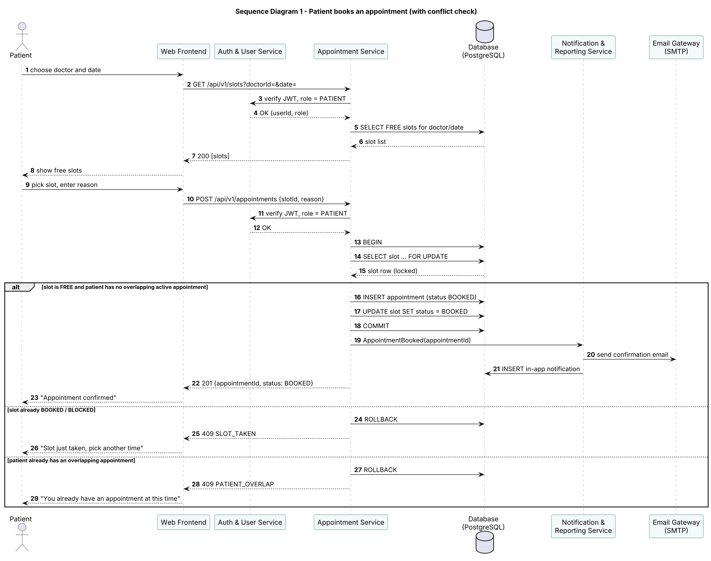
Sequence diagram – appointment booking
Walk-through
- The patient chooses a doctor and date. The Web Frontend calls GET /api/v1/slots?doctorId=&date=.
- The Appointment Service asks the Auth & User Service to verify the JWT and the PATIENT role (HAP-SR-004).
- The Appointment Service reads the FREE slots for that doctor and date and returns them (HAP-F-030, target ≤ 1 s, HAP-NF-002).
- The patient picks a slot and enters a reason. The frontend sends POST /api/v1/appointments {slotId, reason}.
- After the token check, the Appointment Service opens a transaction and locks the slot row with SELECT … FOR UPDATE. Any other booking request for the same slot now waits.
- Main path: the slot is FREE and the patient has no overlapping active appointment. The service inserts the appointment with status BOOKED, marks the slot BOOKED and commits (HAP-F-031, HAP-F-032).
- The service publishes an AppointmentBooked event. The Notification & Reporting Service sends a confirmation email through the SMTP gateway and stores an in-app notification (HAP-F-050).
- The frontend receives 201 and shows “Appointment confirmed”.
- Alternative – slot taken: if the locked slot is no longer FREE (another request committed first, or the doctor is on leave), the transaction is rolled back and 409 SLOT_TAKEN is returned. The frontend asks the patient to pick another time.
- Alternative – patient overlap: if the patient already has an active appointment at an overlapping time, the transaction is rolled back and 409 PATIENT_OVERLAP is returned.
Because the lock and the checks happen inside one transaction, and the partial unique index rejects any second active appointment for a slot, two patients can never hold the same slot.

Sequence diagram 2 – Doctor records a consultation and issues a prescription
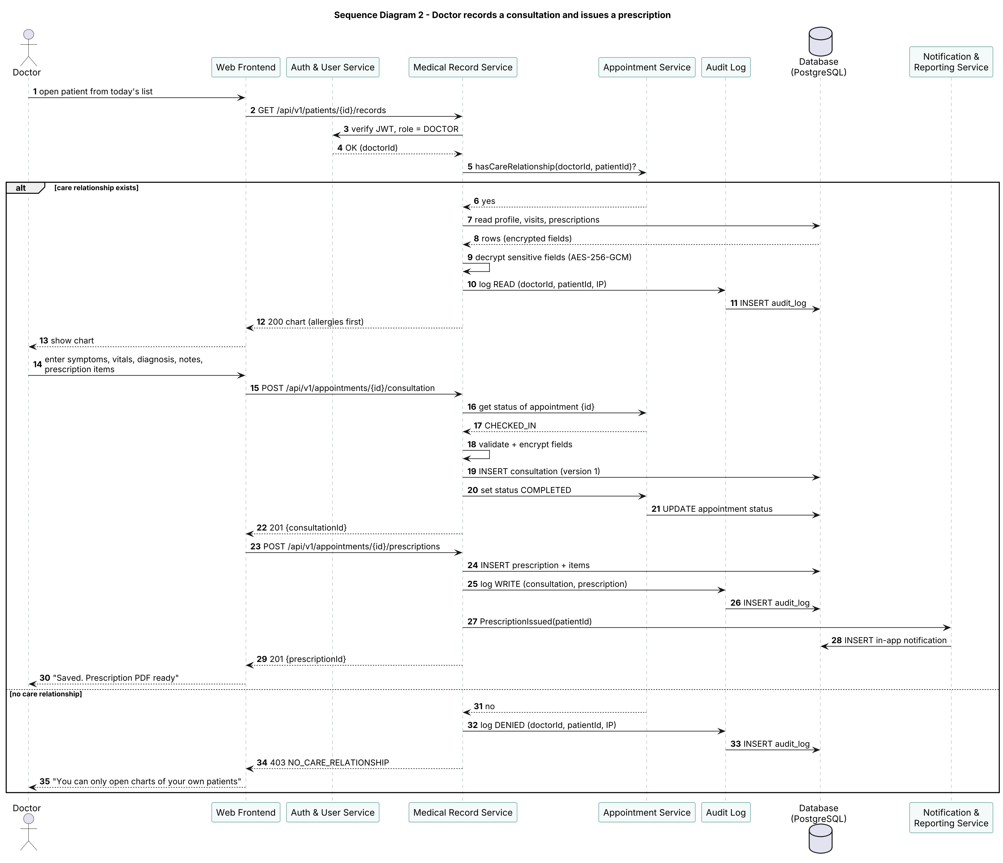
Sequence diagram – consultation and prescription
Walk-through
- The doctor opens a patient from today’s appointment list. The Web Frontend calls GET /api/v1/patients/{id}/records.
- The Medical Record Service verifies the JWT and the DOCTOR role through the Auth & User Service.
- It asks the Appointment Service whether this doctor has a care relationship with the patient, i.e. whether the patient has or had an appointment with this doctor (HAP-F-040, HAP-SR-004).
- Main path: the relationship exists. The service reads the chart, decrypts the encrypted fields (HAP-SR-006), writes a READ entry to the Audit Log (HAP-SR-007) and returns the chart with allergies first.
- The doctor enters symptoms, vitals, diagnosis and notes. POST /appointments/{id}/consultation checks that the appointment is CHECKED_IN, encrypts the sensitive fields, saves version 1 of the consultation and asks the Appointment Service to set the status to COMPLETED (HAP-F-041).
- The doctor adds the prescription items. POST /appointments/{id}/prescriptions stores the prescription and its items (HAP-F-042).
- Both writes are recorded as WRITE entries in the Audit Log. The Notification & Reporting Service creates an in-app message telling the patient a prescription is ready (the message never contains the medicine names).
- The doctor sees “Saved. Prescription PDF ready”.
- Alternative – no care relationship: the service writes a DENIED entry to the Audit Log and returns 403 NO_CARE_RELATIONSHIP; no patient data leaves the server.

4.3 API Design
All endpoints use base path /api/v1, JSON bodies and the header Authorization: Bearer <JWT>. Errors use the body { "error": { "code": "STRING_CODE", "message": "Readable message" } }. Every endpoint can also return 401 UNAUTHENTICATED / TOKEN_EXPIRED and 500 INTERNAL_ERROR; these are not repeated below.

4.3.1 Appointment Service
1. List free slots
- Endpoint: /slots?doctorId={doctorId}&date={YYYY-MM-DD}
- Method: GET
- Roles: Patient, Receptionist
- Request: query parameters only
- Response: 200 { "doctorId": "d-12", "date": "2026-10-20", "slots": [ { "slotId": "s-901", "start": "09:00", "end": "09:15" }, … ] }
- Errors: 400 VALIDATION_ERROR (date in the past or more than 30 days ahead), 404 NOT_FOUND (doctor), 403 FORBIDDEN
2. Book an appointment
- Endpoint: /appointments
- Method: POST
- Roles: Patient (books for self), Receptionist (must send patientId)
- Request: { "slotId": "s-901", "reason": "Fever for 3 days", "patientId": "p-77" }
- Response: 201 { "appointmentId": "a-5001", "status": "BOOKED", "slot": { "slotId": "s-901", "doctorId": "d-12", "start": "2026-10-20T09:00:00+05:30" } }
- Errors: 409 SLOT_TAKEN, 409 PATIENT_OVERLAP, 422 VALIDATION_ERROR (reason shorter than 5 or longer than 300 characters), 404 NOT_FOUND (slot or patient), 403 FORBIDDEN (Patient sending another patientId)
3. List appointments
- Endpoint: /appointments?date=&doctorId=&patientId=&status=&page=
- Method: GET
- Roles: Patient (own only), Doctor (own only), Receptionist, Admin
- Request: optional query filters; 50 results per page
- Response: 200 { "items": [ { "appointmentId": "a-5001", "patientMrn": "HAP-P-000077", "doctorId": "d-12", "start": "…", "status": "BOOKED" } ], "page": 1, "total": 1 }
- Errors: 403 FORBIDDEN (filtering on another patient or doctor), 422 VALIDATION_ERROR
4. Get one appointment
- Endpoint: /appointments/{id}
- Method: GET
- Roles: the appointment’s patient or doctor, Receptionist, Admin
- Response: 200 full appointment object including reason, status, createdBy, history (status changes with time)
- Errors: 404 NOT_FOUND, 403 FORBIDDEN
5. Reschedule
- Endpoint: /appointments/{id}/reschedule
- Method: PATCH
- Roles: the appointment’s patient, Receptionist
- Request: { "newSlotId": "s-950" }
- Response: 200 { "appointmentId": "a-5001", "status": "BOOKED", "slot": { "slotId": "s-950", … } } — the old slot is FREE again
- Errors: 409 CHANGE_WINDOW_CLOSED (patient, less than 2 h before start), 409 SLOT_TAKEN, 409 PATIENT_OVERLAP, 409 INVALID_STATUS_TRANSITION (not BOOKED), 404 NOT_FOUND, 403 FORBIDDEN
6. Change status
- Endpoint: /appointments/{id}/status
- Method: PATCH
- Roles: Receptionist (CHECKED_IN), Doctor (COMPLETED — normally set automatically by the Medical Record Service), system job (NO_SHOW)
- Request: { "status": "CHECKED_IN" } — one of CHECKED_IN, COMPLETED, NO_SHOW
- Response: 200 { "appointmentId": "a-5001", "status": "CHECKED_IN" }
- Errors: 409 INVALID_STATUS_TRANSITION, 422 VALIDATION_ERROR (unknown status), 403 FORBIDDEN, 404 NOT_FOUND
7. Cancel
- Endpoint: /appointments/{id}
- Method: DELETE
- Roles: the appointment’s patient, Receptionist
- Request: optional { "reason": "Travelling" }
- Response: 200 { "appointmentId": "a-5001", "status": "CANCELLED" } — the record is kept with status CANCELLED and the slot becomes FREE
- Errors: 409 CHANGE_WINDOW_CLOSED, 409 INVALID_STATUS_TRANSITION (already COMPLETED / CANCELLED / NO_SHOW), 404 NOT_FOUND, 403 FORBIDDEN

4.3.2 Medical Record Service
Same conventions as 4.3.1 (base path /api/v1, bearer JWT, standard error body; 401 and 500 apply to every endpoint). Every successful call and every denied call writes an Audit Log entry.
1. Get patient chart
- Endpoint: /patients/{id}/records
- Method: GET
- Roles: Doctor (care relationship required), Patient (own ID only)
- Request: path parameter; optional ?include=versions
- Response: 200 { "patient": { "mrn": "HAP-P-000077", "name": "Asha Rao", "age": 34, "bloodGroup": "B+", "allergies": ["Penicillin"] }, "visits": [ { "appointmentId": "a-4810", "date": "2026-09-02", "doctor": "Dr. K. Menon", "diagnosis": "Viral fever", "version": 1 } ], "prescriptions": [ { "prescriptionId": "rx-311", "date": "2026-09-02" } ] }
- Errors: 403 NO_CARE_RELATIONSHIP (doctor), 403 FORBIDDEN (patient asking for another ID), 404 NOT_FOUND
2. Record consultation
- Endpoint: /appointments/{id}/consultation
- Method: POST
- Roles: Doctor of that appointment
- Request: { "symptoms": "Fever, headache", "vitals": { "bp": "120/80", "pulse": 88, "tempC": 38.4, "weightKg": 61 }, "diagnosis": "Viral fever", "notes": "Fluids, rest; review in 5 days" }
- Response: 201 { "consultationId": "c-920", "version": 1, "appointmentStatus": "COMPLETED" }
- Errors: 409 APPOINTMENT_NOT_CHECKED_IN, 409 INVALID_STATUS_TRANSITION (consultation already exists — use PUT), 422 VALIDATION_ERROR (missing diagnosis, vitals out of range), 403 FORBIDDEN (another doctor’s appointment), 404 NOT_FOUND
3. Edit consultation (new version)
- Endpoint: /consultations/{id}
- Method: PUT
- Roles: Doctor who wrote the consultation
- Request: same body as POST plus "changeReason": "Corrected diagnosis after lab report"
- Response: 200 { "consultationId": "c-920", "version": 2, "previousVersions": [1] }
- Errors: 422 VALIDATION_ERROR (no changeReason), 403 FORBIDDEN, 404 NOT_FOUND
4. Issue prescription
- Endpoint: /appointments/{id}/prescriptions
- Method: POST
- Roles: Doctor of that appointment
- Request: { "items": [ { "medicine": "Paracetamol 650 mg", "dosage": "1 tablet", "frequency": "3 times a day", "durationDays": 5, "instructions": "After food" } ] }
- Response: 201 { "prescriptionId": "rx-312", "items": 1, "pdfUrl": "/api/v1/prescriptions/rx-312/pdf" }
- Errors: 422 VALIDATION_ERROR (no items, missing dosage or duration, durationDays < 1), 409 APPOINTMENT_NOT_CHECKED_IN (appointment is BOOKED, CANCELLED or NO_SHOW), 403 FORBIDDEN, 404 NOT_FOUND
5. Get prescription
- Endpoint: /prescriptions/{id}
- Method: GET
- Roles: the prescription’s patient; doctors with a care relationship
- Response: 200 { "prescriptionId": "rx-312", "date": "2026-10-20", "doctor": "Dr. K. Menon", "patientMrn": "HAP-P-000077", "items": [ … ], "version": 1 }
- Errors: 403 FORBIDDEN / 403 NO_CARE_RELATIONSHIP, 404 NOT_FOUND
6. Download prescription PDF
- Endpoint: /prescriptions/{id}/pdf
- Method: GET
- Roles: as for “Get prescription”
- Response: 200 with Content-Type: application/pdf and Content-Disposition: attachment; filename="rx-312.pdf"
- Errors: 403 FORBIDDEN, 404 NOT_FOUND, 500 INTERNAL_ERROR (PDF generation failed; logged without patient data)

4.4 Error Handling, Logging & Monitoring

Error handling
All errors use one JSON body:
{ "error": { "code": "SLOT_TAKEN", "message": "This slot was just booked. Please choose another time." } }
HTTP status | Error code(s) | When
400 | VALIDATION_ERROR | Malformed request or bad query parameter
401 | UNAUTHENTICATED, TOKEN_EXPIRED | No token, invalid signature, or token older than 30 minutes
403 | FORBIDDEN, NO_CARE_RELATIONSHIP | Role not allowed; record belongs to someone else; doctor has no care relationship
404 | NOT_FOUND | Resource does not exist (also used instead of 403 where revealing existence would leak data)
409 | SLOT_TAKEN, PATIENT_OVERLAP, CHANGE_WINDOW_CLOSED, INVALID_STATUS_TRANSITION, APPOINTMENT_NOT_CHECKED_IN | Business-rule conflicts
422 | VALIDATION_ERROR | Body fails field validation; the message names the field
423 | ACCOUNT_LOCKED | 5 failed logins within the lock window
429 | RATE_LIMITED | Rate limit exceeded
500 | INTERNAL_ERROR | Unexpected failure; the message is generic and includes a request ID only
Rules: messages are written for the end user and never contain stack traces, SQL, tokens or patient data; every response includes an X-Request-ID header so support staff can find the matching log line; database transactions are rolled back on any error; email failures never fail the user’s request (they are retried in the background).

Logging
- Structured JSON logs with timestamp, level, request ID, user ID, role, endpoint, status code and duration.
- Never logged: passwords, JWTs, diagnoses, notes, prescription items, allergies, phone numbers.
- Security events (failed logins, lockouts, 403s, token errors) are logged at WARNING level.
- The audit log (HAP-SR-007) is separate from application logs and stored in its own append-only table.
- Application logs are kept for 90 days.

Monitoring
Metric | Alert threshold
API p95 response time | > 2 s for 5 minutes (HAP-NF-001)
Error rate (5xx) | > 1% of requests over 5 minutes
Failed logins | > 50 per minute (possible attack)
403 / NO_CARE_RELATIONSHIP rate | Sudden spike above normal daily level
Uptime check on /health | 2 consecutive failures, 1 minute apart (HAP-NF-003)
Email queue length | > 100 unsent messages
Nightly backup job | Any failure

4.5 UX Design
Principles: few steps, plain language, safe defaults, and the same layout on desktop and phone (screens ≥ 360 px, HAP-NF-004).
Patient booking flow (≤ 4 screens, target ≤ 3 minutes):
- Find a doctor – search box plus specialization chips (General Medicine, Cardiology, Paediatrics …).
- Choose a date and slot – a 7-day strip and a grid of time buttons. Free slots are solid teal buttons; unavailable times are grey and not clickable; a legend explains the colours, and the state is also shown as text (“Free”, “Taken”) so colour is never the only cue.
- Confirm – doctor, date, time and a reason box; one “Book appointment” button.
- Done – confirmation with “Add to calendar” and “View my appointments”.
If the slot was taken meanwhile (409 SLOT_TAKEN) the patient stays on screen 2 with the message “Someone just booked this time. Please pick another slot.” and the grid refreshes.
Doctor screens: today’s schedule as a list (time, patient, status chip) with the next patient highlighted; the chart opens with an allergy banner at the top; consultation and prescription forms sit side by side on desktop and stack on phones; prescription rows can be added with one click.
Receptionist screens: a single search bar (name, MRN or phone) on the home screen; today’s arrivals list with a large Check-in button per row; “Book for patient” reuses the patient booking screens.
Admin screens: dashboard cards (today’s appointments, no-show rate, utilisation), staff account table, doctor profiles, report export with a date-range picker.
Accessibility: WCAG 2.1 AA contrast, visible keyboard focus, labelled form fields, error messages placed next to the field and announced to screen readers, body text ≥ 16 px, touch targets ≥ 44 × 44 px.
Language: English in version 1.0; all UI text is kept in one resource file so Kannada and Hindi can be added later.

4.6 Open Issues & Next Steps
Open issues
# | Issue | Proposed handling
1 | Key management for AES-256 encryption (rotation, backup of the key) | Store the key in a secrets file outside the repo for v1.0; evaluate a key vault before production
2 | Email deliverability (spam filters, provider limits) | Use a transactional email provider with SPF/DKIM; in-app notifications remain the fallback
3 | Time zones if the clinic serves patients outside IST | All times stored in UTC, displayed in the clinic’s time zone; confirm with stakeholders
4 | Doctors on emergency duty need to override the 15-minute slot grid | Allow Receptionist “urgent” bookings outside slots in a later sprint
5 | Retention period for audit logs | Keep for at least 3 years; confirm with the course/clinic policy
Future enhancements
- OTP-based login and two-factor authentication for staff
- SMS / WhatsApp appointment reminders
- Video consultations (telemedicine)
- Lab results upload and viewing
- Online payments and invoices
- HL7 / FHIR interfaces to exchange records with other hospitals
- Native Android and iOS apps

5. Appendices

5.1 Glossary
Term | Meaning
Appointment | A booking of one slot by one patient, with a status
Audit log | Append-only record of who accessed or changed what, and when
Care relationship | A patient has or had an appointment with the doctor
CHECKED_IN | Patient has arrived and been checked in by the Receptionist
Consultation | Doctor’s notes for one appointment; stored as versions
MRN | Medical Record Number, the unique Patient ID
NO_SHOW | Patient did not arrive within 30 minutes after the slot ended
PHI | Protected Health Information
Slot | A bookable time interval of one doctor
STRIDE | Threat-modelling categories: Spoofing, Tampering, Repudiation, Information disclosure, Denial of service, Elevation of privilege
ADR | Architecture Decision Record
JWT | JSON Web Token
RBAC | Role-Based Access Control
TLS | Transport Layer Security
AES-GCM | Advanced Encryption Standard in Galois/Counter Mode

5.2 References
- ISO/IEC/IEEE 42010:2011 – Systems and software engineering — Architecture description
- IEEE 830-1998 / ISO/IEC/IEEE 29148:2018 – Requirements specification
- IEEE 829 / ISO/IEC/IEEE 29119-3 – Software test documentation
- OWASP Top 10 (2021) and OWASP Application Security Verification Standard (ASVS) 4.0
- NIST SP 800-63B – Digital Identity Guidelines (authentication)
- Digital Personal Data Protection Act, 2023 (India)
- WCAG 2.1 – Web Content Accessibility Guidelines
- Team 13 – SRS v1.0 and Software Test Plan v1.0

5.3 Tools
Purpose | Tool
Diagrams | PlantUML, draw.io
API documentation | Swagger / OpenAPI (generated by FastAPI)
Version control and CI | Git, GitHub, GitHub Actions
API testing | Postman, Pytest
UI testing | Playwright
Performance testing | Locust
Security testing | OWASP ZAP, testssl.sh

