Software Requirements Specification (SRS)
Project: Healthcare Appointment & Patient Record System
Version: 1.0
Authors: Team 13 – P Manas Siddhardha, Prithviraj K, Parth Kale, Raghav Budur
Date: 10-10-2026
Status: Draft

Revision history
Version | Date | Author | Change summary | Approval
1.0 | 10-10-2026 | Team 13 | Initial draft with diagrams | Pending

Approvals
Role | Name | Signature / Email | Date
Course Coordinator
Project Lead | P Manas Siddhardha

Table of contents
- Introduction
- Overall description
- External interface requirements
- System features (detailed)
- Non-functional requirements (detailed)
- Quality attributes & acceptance tests
- UML use-case diagrams
- Requirements Traceability Matrix (RTM)

1. Introduction

1.1 Purpose
This document is the Software Requirements Specification for the Healthcare Appointment & Patient Record System (HAPRS). It defines the functional requirements, non-functional requirements, security requirements, external interfaces and acceptance criteria of the system. It is the baseline for the Software Architecture & Design document (SAD) and the Software Test Plan, and every requirement in it carries an ID that is traced to design components and test cases.

1.2 Scope
HAPRS is a web application used by a clinic or small hospital to run outpatient appointments and keep patient records.
In scope:
- Patient registration and profiles with a unique Patient ID (MRN)
- Doctor profiles, weekly availability, bookable time slots and leave
- Appointment search, booking, rescheduling, cancellation, check-in and status tracking, with automatic prevention of double bookings and overlapping appointments
- Medical records: consultation notes, diagnoses, vitals and prescriptions, with versioning and downloadable prescription PDFs
- Role-based access for four roles (Patient, Doctor, Receptionist, Admin) and record-level access rules
- Email and in-app notifications, appointment reminders, an admin dashboard and CSV reports
- An audit log of every medical-record access and every administrative action
Out of scope for version 1.0:
- Billing, payments and insurance claims
- Laboratory, radiology and pharmacy stock systems
- Video consultations (telemedicine)
- Integration with external health-record standards (HL7 / FHIR)
- Native mobile apps (the web UI is mobile-responsive instead)

1.3 Audience
- Developers who build the frontend, backend services and database
- QA engineers who design and run the tests in the Test Plan
- The project team and reviewers who check requirement coverage
- Course instructors and assessment evaluators

1.4 Definitions and acronyms
Term | Meaning
HAPRS | Healthcare Appointment & Patient Record System
MRN | Medical Record Number – the unique Patient ID, format HAP-P-000001
EHR | Electronic Health Record
PHI | Protected Health Information – any health data linked to an identifiable patient
Slot | A bookable time interval of one doctor (default 15 minutes)
Care relationship | A doctor has a care relationship with a patient when the patient has or had an appointment with that doctor
RBAC | Role-Based Access Control
JWT | JSON Web Token used as the login session token
TLS | Transport Layer Security
API | Application Programming Interface
UI | User Interface
CSV | Comma-Separated Values file
SMTP | Simple Mail Transfer Protocol (email delivery)
DPDP Act | India’s Digital Personal Data Protection Act, 2023
RTO / RPO | Recovery Time Objective / Recovery Point Objective

2. Overall description

2.1 Product perspective
HAPRS is a new, self-contained web system that replaces paper registers and phone-based booking at a clinic. It follows a three-tier design: a React web frontend used from desktop and mobile browsers, a FastAPI backend that holds all business rules (booking, conflict prevention, access control), and a PostgreSQL database. It connects to one external system, an SMTP email gateway, for notifications. All parts communicate over HTTPS.

2.2 Major product functions
- Accounts and roles: patient self-registration, staff accounts created by the Admin, login, role-based menus, account lockout
- Patient management: patient profiles, MRN generation, duplicate warning, patient search
- Doctor and schedule management: doctor profiles, weekly availability, automatic slot generation, leave days
- Appointment management: search doctors and free slots, book, reschedule, cancel, check-in, completion and no-show tracking, conflict prevention
- Medical records and prescriptions: patient chart, consultation notes, vitals, diagnoses, prescriptions, PDF download, versioned records
- Notifications and reports: confirmations, cancellations, leave alerts, 24-hour reminders, admin dashboard, CSV export
- Audit: an append-only log of record access and admin actions

2.3 User roles and characteristics
Role | Characteristics | Main goals
Patient | General public, any age; basic smartphone or computer skills; uses the system a few times a year | Book a convenient slot quickly, get reminders, see own prescriptions
Doctor | Medical professional, busy, uses the system all day during consultations | See today’s schedule, open a patient’s history in seconds, write notes and prescriptions fast
Receptionist | Front-desk staff, trained on the system, handles walk-ins and phone calls | Register patients, book on behalf of patients, check patients in
Admin (Hospital Administrator) | Trained staff member responsible for configuration and reporting | Manage staff accounts and doctor profiles, monitor utilisation, export reports

2.4 Operating environment
- Client: latest two versions of Google Chrome, Microsoft Edge and Mozilla Firefox on Windows, macOS, Android and iOS; screen width 360 px and above
- Server: Ubuntu 22.04 LTS server or Docker containers; Python 3.11; FastAPI; PostgreSQL 15
- Network: internet or clinic LAN; HTTPS only
- Email: any SMTP provider with TLS; MailHog for testing

2.5 Constraints
- Personal and health data must be handled according to the principles of India’s DPDP Act 2023: collection only for a stated purpose, consent, and access limited to people who need it. HIPAA-style safeguards (access control, audit, encryption) are used as a reference.
- Only open-source frameworks and tools may be used.
- Medical records must never be hard-deleted.
- The system is built by a four-person student team within one semester, which limits scope to the features in Section 1.2.
- Real patient data must not be used in development or testing; all test data is synthetic.

3. External interface requirements

3.1 User interfaces
The primary UI is a responsive web application. Each role sees a home screen with only its own menu:
- Patient: Find a doctor → choose date → pick a slot from a colour-coded grid (free / unavailable) → confirm; My appointments (reschedule, cancel); My records (visits, prescriptions, PDF download); Profile; Notifications.
- Doctor: Today’s schedule (time, patient, status), patient chart with allergies highlighted at the top, consultation form (symptoms, vitals, diagnosis, notes), prescription form with one row per medicine, Availability and Leave screens.
- Receptionist: Patient search and registration, booking on behalf of a patient, today’s arrivals list with a one-click Check-in button.
- Admin: Staff accounts, doctor profiles, dashboard, report export.
Accessibility: WCAG 2.1 AA colour contrast, full keyboard navigation, form labels readable by screen readers, and minimum 16 px body text. Every error message states what went wrong and how to fix it (for example “This slot was just booked by someone else. Please pick another time.”).

3.2 Hardware interfaces
No special hardware is required. Users need a desktop, laptop, tablet or smartphone with a modern browser. The front desk may use any printer supported by the operating system to print prescription PDFs. The server runs on standard x86-64 hardware or a cloud virtual machine with at least 2 vCPUs and 4 GB RAM.

3.3 Software interfaces
Interface | Purpose | Protocol / format
PostgreSQL 15 | Stores users, patients, doctors, slots, appointments, records, audit log | SQL via SQLAlchemy over TLS
SMTP email gateway | Sends confirmations, cancellation and leave notices, 24-hour reminders | SMTP with STARTTLS
ReportLab PDF library | Generates prescription PDFs on request | In-process Python library
APScheduler | Runs nightly slot generation, reminder jobs and no-show marking | In-process scheduler
Swagger / OpenAPI | Machine-readable API description generated by FastAPI | OpenAPI 3 JSON at /docs

3.4 Communications
- All client–server traffic uses HTTPS with TLS 1.2 or higher; HTTP is redirected to HTTPS (HAP-SR-003).
- The API is REST with JSON bodies under the base path /api/v1; requests carry Authorization: Bearer <JWT>.
- Errors use one body format: { "error": { "code": "STRING_CODE", "message": "Readable message" } }.
- Email is sent asynchronously; a failed send is retried 3 times at 5-minute intervals and never blocks the user’s request.

4. System features (detailed)
Each requirement below includes acceptance criteria and a reference test case. IDs follow HAP-F-###.

4.1 Authentication & Roles
Description: Let every user sign in securely with an email and password, assign each account exactly one of four roles (Patient, Doctor, Receptionist, Admin), and show each role only the features it is allowed to use.
Req ID | Requirement (The system shall…) | Type | Priority | Source/Stakeholder | Acceptance criteria / Test case ref | Comments / Dependencies
HAP-F-001 | The system shall let a Patient self-register with email, password and mobile number, and shall let any active user log in with email and password, returning a JWT access token that carries the user’s ID and role. | Functional | High | Patients, Clinic staff | AC-HAP-F-001: A valid email/password returns HTTP 200 with a JWT whose role claim matches the account; a wrong password returns 401 UNAUTHENTICATED without saying which field was wrong; Doctor, Receptionist and Admin accounts cannot be self-registered (403). Test: TC-AUTH-01 | Password rules: ≥ 8 characters with at least one letter and one digit. Depends on HAP-SR-001, HAP-SR-002, HAP-SR-005.
HAP-F-002 | The system shall restrict every screen and API endpoint to the roles listed for it, so that each role sees only its own menus and features. | Functional | High | Security, Admin | AC-HAP-F-002: For every endpoint in the role-permission matrix, a token of a non-permitted role receives 403 FORBIDDEN and the UI hides the corresponding menu items. Test: TC-AUTH-02 | Role checks run on the server (HAP-SR-004); hiding menus is only a convenience.
HAP-F-003 | The system shall let an Admin create Doctor and Receptionist accounts and deactivate or reactivate any non-Admin account; a deactivated user shall not be able to log in. | Functional | High | Admin | AC-HAP-F-003: An account created by the Admin can log in within 1 minute; after deactivation, login returns 403 and existing tokens are rejected on the next request; each change appears in the audit log. Test: covered in sprint testing | New staff receive a one-time password and must change it at first login. Logged per HAP-SR-007.

4.2 Patient Management
Description: Create and maintain one accurate record per patient, identified by a unique Patient ID (MRN), whether the patient registers online or is registered by the Receptionist at the front desk.
Req ID | Requirement (The system shall…) | Type | Priority | Source/Stakeholder | Acceptance criteria / Test case ref | Comments / Dependencies
HAP-F-010 | The system shall store for each patient: full name, date of birth, gender, mobile number, email, address, blood group, known allergies and an emergency contact (name and phone), and shall generate a unique, never-reused Patient ID (MRN) in the format HAP-P- followed by 6 digits. | Functional | High | Patients, Reception, Doctors | AC-HAP-F-010: Saving a profile with all mandatory fields (name, date of birth, gender, mobile) returns 201 with a new MRN; a missing mandatory field returns 422 VALIDATION_ERROR naming the field; a date of birth in the future is rejected; 1,000 registrations produce 1,000 distinct MRNs. Test: TC-PAT-01 | Allergies are shown on the doctor’s chart view (HAP-F-040). Mobile number: 10 digits.
HAP-F-011 | The system shall let a Patient view and edit their own contact details, address, allergies and emergency contact, but not their MRN or date of birth, and shall let a Receptionist register a walk-in patient and edit any patient’s contact details. | Functional | High | Patients, Reception | AC-HAP-F-011: A patient’s edit of their phone number is saved and visible on next login; an attempt to change MRN or date of birth via the API returns 403; a Receptionist-created patient can later be linked to a login by email verification. Test: TC-PAT-01 | Date of birth corrections are done by the Admin and are audit-logged (HAP-SR-007).
HAP-F-012 | The system shall warn the user before creating a patient whose mobile number and date of birth both match an existing patient, and shall show the matching MRN. | Functional | Medium | Reception, Medical records | AC-HAP-F-012: Registering a second patient with the same mobile number and date of birth shows a warning with the existing MRN; the record is created only if the user confirms “create anyway”. Test: covered in sprint testing | Prevents split medical histories for one person.
HAP-F-013 | The system shall let a Receptionist or Admin search patients by name (partial match, case-insensitive), MRN or mobile number, returning at most 50 results per page in ≤ 1 s. | Functional | Medium | Reception, Admin | AC-HAP-F-013: With 10,000 patients in the database, a search returns the correct matches in ≤ 1 s (95th percentile); results are paged at 50; a Patient or Doctor token receives 403. Test: covered in sprint testing | Doctors find patients through their appointment list instead (HAP-F-040).

4.3 Doctor & Schedule Management
Description: Maintain doctor profiles and turn each doctor’s weekly working hours into bookable time slots, so that patients can only book times when the doctor is actually available.
Req ID | Requirement (The system shall…) | Type | Priority | Source/Stakeholder | Acceptance criteria / Test case ref | Comments / Dependencies
HAP-F-020 | The system shall let an Admin add and edit doctor profiles with name, specialization, department, qualification and slot duration (10, 15, 20 or 30 minutes; default 15). | Functional | High | Admin, Hospital management | AC-HAP-F-020: A new doctor profile is linked to a Doctor account and appears in patient search within 1 minute; a slot duration outside the four allowed values returns 422; changes to the slot duration apply only to slots generated afterwards. Test: covered in sprint testing | Doctor account is created first (HAP-F-003). Edits are audit-logged.
HAP-F-021 | The system shall let a Doctor define weekly availability as one or more time ranges per weekday and shall generate FREE slots of the doctor’s slot duration for the next 30 days, regenerating them every night. | Functional | High | Doctors, Patients | AC-HAP-F-021: Availability Monday 09:00–12:00 with 15-minute slots produces exactly 12 slots on every Monday in the next 30 days, starting 09:00, 09:15 … 11:45; overlapping time ranges for the same day are rejected with 422; slots that already have appointments are never removed by regeneration. Test: TC-DOC-01 | Slots are the booking inventory used by the Appointment Service (HAP-F-030–032).
HAP-F-022 | The system shall let a Doctor mark full or partial leave dates; all FREE slots in that period shall become BLOCKED, and every patient already BOOKED in that period shall be notified and asked to reschedule. | Functional | High | Doctors, Patients, Reception | AC-HAP-F-022: After marking leave for a date, slot search for that doctor and date returns no FREE slots; each affected BOOKED patient receives a notification within 1 minute (HAP-F-050); affected appointments are listed for the Receptionist. Test: TC-DOC-01 | Existing appointments are not cancelled automatically, so the patient can choose a new time.

4.4 Appointment Management
Description: Let patients and receptionists find a free slot and book it, and guarantee that no doctor is ever double-booked and no patient holds two overlapping appointments, even when several people try to book the same slot at the same moment.
Req ID | Requirement (The system shall…) | Type | Priority | Source/Stakeholder | Acceptance criteria / Test case ref | Comments / Dependencies
HAP-F-030 | The system shall let a Patient search active doctors by specialization or name and show the doctor’s FREE slots for a chosen date up to 30 days ahead. | Functional | High | Patients | AC-HAP-F-030: Searching “Cardiology” lists only active cardiologists; choosing a doctor and date lists exactly the FREE slots for that day in time order; BOOKED, BLOCKED and past slots are not shown. Test: TC-APT-01 | Slots come from the Doctor & Schedule Service (HAP-F-021). Performance target HAP-NF-002.
HAP-F-031 | The system shall let a Patient book one FREE slot with a reason for visit (5–300 characters), creating an appointment with status BOOKED that appears in the doctor’s schedule. | Functional | High | Patients, Doctors | AC-HAP-F-031: Booking returns 201 with the appointment ID and status BOOKED; the slot status changes to BOOKED; the appointment appears in the doctor’s daily list within 5 s; a confirmation is sent (HAP-F-050). Test: TC-APT-01 | Reason text is visible to the doctor only.
HAP-F-032 | The system shall prevent appointment conflicts: a slot shall hold at most one active (BOOKED or CHECKED_IN) appointment, a patient shall not hold two active appointments that overlap in time, and when several bookings for the same slot arrive at the same time exactly one shall succeed and the others shall receive 409 SLOT_TAKEN. | Functional | High | Doctors, Patients, Hospital management | AC-HAP-F-032: 20 concurrent booking requests for one slot produce exactly one 201 and nineteen 409 SLOT_TAKEN, and the database holds one active appointment for that slot; booking a slot that overlaps the patient’s existing active appointment with another doctor returns 409 PATIENT_OVERLAP. Test: TC-APT-02 | Implemented with a row lock on the slot inside one transaction plus a partial unique index (SAD §3.6).
HAP-F-033 | The system shall let a Patient reschedule an appointment to another FREE slot, or cancel it, up to 2 hours before the slot start; the old slot shall become FREE immediately; later changes shall be rejected with 409 CHANGE_WINDOW_CLOSED. | Functional | High | Patients, Reception | AC-HAP-F-033: Cancelling 3 hours before start returns 200, status CANCELLED and the slot is FREE in the next search; cancelling 1 hour 59 minutes before start returns 409 CHANGE_WINDOW_CLOSED; rescheduling applies the same conflict checks as HAP-F-032. Test: TC-APT-03 | Receptionist changes inside the 2-hour window are allowed (HAP-F-035).
HAP-F-034 | The system shall track each appointment through the statuses BOOKED → CHECKED_IN → COMPLETED, or BOOKED → CANCELLED / NO_SHOW; the Receptionist shall check patients in; the system shall mark an appointment NO_SHOW 30 minutes after the slot end if it was never checked in; any other transition shall return 409 INVALID_STATUS_TRANSITION. | Functional | High | Reception, Doctors, Admin | AC-HAP-F-034: Check-in changes BOOKED to CHECKED_IN; an appointment not checked in is NO_SHOW within 31 minutes after the slot end; COMPLETED → BOOKED and CANCELLED → CHECKED_IN both return 409. Test: TC-APT-03 | COMPLETED is set by the Medical Record Service when notes are saved (HAP-F-041).
HAP-F-035 | The system shall let a Receptionist book, reschedule and cancel appointments on behalf of any registered patient, applying the same conflict rules as HAP-F-032, and shall record which staff member made the change. | Functional | Medium | Reception | AC-HAP-F-035: A Receptionist booking for a patient creates a BOOKED appointment with created_by = the receptionist’s user ID; a conflicting booking returns 409 as for patients. Test: covered in sprint testing | Supports phone and walk-in bookings.

4.5 Medical Records & Prescriptions
Description: Give doctors fast access to the history of the patients they are treating, let them record consultations and prescriptions, and give patients read-only access to their own records, while keeping every record permanent and versioned.
Req ID | Requirement (The system shall…) | Type | Priority | Source/Stakeholder | Acceptance criteria / Test case ref | Comments / Dependencies
HAP-F-040 | The system shall show a Doctor their own appointments for a chosen day in time order and shall let the Doctor open the chart (profile, allergies, past visits, consultation notes, prescriptions) only of patients who have or had an appointment with that doctor. | Functional | High | Doctors, Patients | AC-HAP-F-040: The day list shows only that doctor’s appointments, sorted by time; opening the chart of a listed patient returns 200 within 2 s with allergies at the top; requesting the chart of a patient with no appointment with that doctor returns 403 NO_CARE_RELATIONSHIP and an audit entry. Test: TC-MR-03 | Care-relationship rule implements HAP-SR-004. Every chart view is logged (HAP-SR-007).
HAP-F-041 | The system shall let a Doctor record a consultation (symptoms, vitals: blood pressure, pulse, temperature, weight; diagnosis; notes) for an appointment that is CHECKED_IN, and saving it shall set the appointment to COMPLETED. | Functional | High | Doctors | AC-HAP-F-041: Saving a consultation for a CHECKED_IN appointment returns 201 and the appointment becomes COMPLETED; saving for a BOOKED appointment returns 409 APPOINTMENT_NOT_CHECKED_IN; vitals outside physical limits (e.g. pulse > 300) return 422. Test: TC-MR-01 | Diagnosis and notes are encrypted at rest (HAP-SR-006).
HAP-F-042 | The system shall let a Doctor issue a prescription linked to the appointment, with one or more items each having medicine name, dosage, frequency, duration in days and instructions, and shall generate a prescription PDF showing clinic, doctor, patient MRN, date and items. | Functional | High | Doctors, Patients, Pharmacists | AC-HAP-F-042: A prescription with 3 items returns 201 and a PDF of 3 items is downloadable; an item without dosage or duration returns 422; the PDF is generated in ≤ 3 s. Test: TC-MR-02 | ReportLab is used for PDFs.
HAP-F-043 | The system shall let a Patient view their own visits, consultation summaries and prescriptions read-only and download any of their prescription PDFs. | Functional | High | Patients | AC-HAP-F-043: The patient sees all their own prescriptions in date order; any PUT, POST or DELETE by a Patient on records returns 403; a patient cannot open another patient’s prescription (403). Test: TC-MR-02 | Patients do not see the doctor’s private notes field.
HAP-F-044 | The system shall never delete medical records; editing a consultation or prescription shall create a new version with the editing doctor and timestamp, and all earlier versions shall remain viewable. | Functional | High | Doctors, Hospital management, Regulators | AC-HAP-F-044: Editing a consultation once produces version 2; GET returns version 2 by default and lists version 1 with its author and time; there is no DELETE endpoint for records. Test: TC-MR-01 | Supports HAP-SO-2 (integrity and accountability).

4.6 Notifications & Reports
Description: Keep patients informed about every change to their appointments and give the Admin a live view of clinic activity plus exportable reports.
Req ID | Requirement (The system shall…) | Type | Priority | Source/Stakeholder | Acceptance criteria / Test case ref | Comments / Dependencies
HAP-F-050 | The system shall notify the patient by email and in-app message within 1 minute of an appointment being booked, rescheduled or cancelled, or of the doctor marking leave on that date, and shall send a reminder 24 hours (± 5 minutes) before the appointment start. | Functional | High | Patients, Reception | AC-HAP-F-050: For each of the four events an email (captured in MailHog during testing) and an in-app notification exist within 60 s; the reminder is sent between 23 h 55 min and 24 h 05 min before the slot start; no notification contains the diagnosis or prescription text. Test: TC-NOT-01 | Uses the Email Gateway (SMTP) and APScheduler. Failed emails are retried 3 times at 5-minute intervals.
HAP-F-051 | The system shall show the Admin a dashboard with today’s appointments per doctor (by status), the no-show rate for the last 30 days and each doctor’s slot utilisation percentage for the current week. | Functional | Medium | Admin, Hospital management | AC-HAP-F-051: Dashboard figures equal the values computed directly from the database for a seeded data set; the dashboard loads in ≤ 2 s. Test: covered in sprint testing | Utilisation = booked or completed slots ÷ generated slots × 100.
HAP-F-052 | The system shall let the Admin export an appointment report for a chosen date range (maximum 366 days) as a CSV file with one row per appointment. | Functional | Low | Admin | AC-HAP-F-052: The CSV opens in a spreadsheet and has the columns date, time, doctor, department, MRN, status; the row count equals the number of appointments in the range; no clinical notes are included; the export is written to the audit log. Test: covered in sprint testing | Depends on HAP-SR-007 (export is an admin action).

5. Non-functional requirements (detailed)
NFRs below are measurable and tied to the Test Plan. IDs follow HAP-NF-###.
Req ID | Requirement | Category | Priority | Acceptance criteria / Measurement
HAP-NF-001 | 95% of API responses shall complete within 2 seconds with 200 concurrent users performing a realistic mix of logins, slot searches, bookings and chart views. | Performance | High | Locust run of 10 minutes at 200 users on the test environment: 95th-percentile response time ≤ 2 s and error rate < 1%. Test: TC-PERF-01
HAP-NF-002 | A free-slot search for one doctor and one date shall return within 1 second (95th percentile) with 500 doctors and 50,000 appointments in the database. | Performance | High | Measured during TC-PERF-01 on a seeded database of 500 doctors and 50,000 appointments: p95 ≤ 1 s for GET /slots. Test: TC-PERF-01
HAP-NF-003 | The system shall be available at least 99.5% of each month, and the database shall be backed up daily with a recovery point objective (RPO) of 24 hours and a recovery time objective (RTO) of 4 hours. | Reliability | High | Uptime monitoring shows ≥ 99.5% per month (≤ 3 h 39 min downtime); a monthly restore drill rebuilds the database from the latest backup in ≤ 4 h. Test: operations reports
HAP-NF-004 | A first-time patient shall be able to book an appointment within 3 minutes without training; the UI shall work on screens 360 px wide and above and meet WCAG 2.1 AA colour-contrast rules. | Usability | Medium | In a usability session, at least 8 of 10 first-time users complete a booking in ≤ 3 min; no horizontal scrolling at 360 px; an accessibility checker reports no contrast failures. Test: usability test (sprint testing)
HAP-NF-005 | Each service shall be a separate module with its own tests, and unit tests shall cover at least 70% of service-layer code. | Maintainability | Medium | pytest --cov report on the service layer shows ≥ 70% line coverage; each component in SAD §3.4 maps to its own package. Test: coverage report in CI

5.1 Security

5.1.1 Security Objectives
ID | Objective
HAP-SO-1 | Confidentiality of patient data: personal details and medical records (diagnoses, notes, prescriptions) can be read only by the patient, by doctors who have a care relationship with the patient, and by staff whose role requires it.
HAP-SO-2 | Integrity and accountability: medical records, prescriptions and appointments cannot be changed without detection, are never silently deleted, and every access or change can be traced to a specific user and time.

5.1.2 Security Requirements
Req ID | Requirement (shall…) | Type | Priority | Acceptance criteria / Test case ref
HAP-SR-001 | The system shall store passwords only as bcrypt hashes with a cost factor of 12 and shall never log or return a password. | Security | High | The password_hash column starts with $2b$12$ for every user; no plaintext password appears in the database, logs or API responses. Test: TC-SEC-01
HAP-SR-002 | The system shall issue JWT access tokens that expire 30 minutes after issue and shall reject expired, unsigned or tampered tokens with 401. | Security | High | A token used 31 minutes after issue returns 401 TOKEN_EXPIRED; a token with a modified payload or signature returns 401 UNAUTHENTICATED. Test: TC-SEC-02
HAP-SR-003 | The system shall serve all traffic over HTTPS using TLS 1.2 or higher and shall redirect HTTP requests to HTTPS. | Security | High | A TLS scan shows only TLS 1.2/1.3 enabled; http:// requests receive a 301 redirect to https://. Test: TLS scan in Test Plan §5.1
HAP-SR-004 | The system shall enforce role checks and record-level checks on the server for every API call: a Patient may access only their own data, a Doctor only patients with whom they have a care relationship, and staff only the functions of their role. | Security | High | Every endpoint in the role-permission matrix rejects a non-permitted role with 403; Patient A requesting Patient B’s records gets 403; a doctor without a care relationship gets 403 NO_CARE_RELATIONSHIP. Test: TC-AUTH-02, TC-SEC-02, TC-MR-03
HAP-SR-005 | The system shall lock an account for 15 minutes after 5 consecutive failed login attempts and shall reset the counter after a successful login. | Security | High | The 6th attempt within the lock period returns 423 ACCOUNT_LOCKED even with the correct password; login succeeds again after 15 minutes. Test: TC-SEC-01
HAP-SR-006 | The system shall encrypt diagnoses, consultation notes and prescription items at rest using AES-256-GCM, with the key held outside the database. | Security | High | Reading the columns directly with SQL shows ciphertext only; the API returns the correct plaintext to an authorised doctor. Test: database inspection in Test Plan §5.1
HAP-SR-007 | The system shall write every read or write of a medical record, every denied access attempt and every admin action (account changes, doctor profile edits, exports) to an append-only audit log containing user ID, role, action, record ID, timestamp and IP address. | Security | High | Opening a patient chart creates exactly one READ entry; a denied attempt creates a DENIED entry; the application database user cannot UPDATE or DELETE audit rows. Test: TC-MR-03

6. Quality attributes & Acceptance tests

6.1 Exit criteria for acceptance
- All High-priority functional requirements (HAP-F-001–003, 010, 011, 020–022, 030–034, 040–044, 050) are implemented and their test cases pass.
- No open defect of severity Critical or High.
- No failed acceptance test for any NFR (HAP-NF-001–005) or security requirement (HAP-SR-001–007).
- The RTM (Section 8) shows every requirement linked to at least one passed test case or an accepted verification method.

6.2 Acceptance test suites
Suite | Quality attribute | Measurable acceptance test
Authentication & Roles | Security, correctness | TC-AUTH-01 and TC-AUTH-02 pass; every role/endpoint pair in the permission matrix returns the expected 200 or 403.
Patients | Correctness | TC-PAT-01 passes; 1,000 registrations produce 1,000 unique MRNs.
Schedules | Correctness | TC-DOC-01 passes; generated slots match availability exactly for 30 days.
Appointments | Correctness, integrity | TC-APT-01–03 pass; 20 concurrent bookings of one slot give exactly one success.
Medical Records | Integrity, confidentiality | TC-MR-01–03 pass; every edit creates a new version; every chart view has an audit entry.
Notifications | Reliability | TC-NOT-01 passes; 100% of test events produce an email within 60 s.
Performance | Performance | TC-PERF-01 passes: API p95 ≤ 2 s at 200 users; slot search p95 ≤ 1 s.
Security | Security | TC-SEC-01 and TC-SEC-02 pass; OWASP ZAP baseline scan reports no High alerts; TLS scan shows TLS 1.2+ only.
Usability | Usability | ≥ 8 of 10 first-time users book in ≤ 3 minutes; UI usable at 360 px; no WCAG 2.1 AA contrast failures.
Maintainability | Maintainability | Service-layer unit-test coverage ≥ 70% in the CI report.
Reliability | Availability | Restore drill completes in ≤ 4 h from the last daily backup.

7. System models and diagrams

7.1 UML Use-Case diagrams
The system has four actors: Patient, Doctor, Receptionist and Admin. The use cases are split across two diagrams so each stays readable.

Diagram 1 – Appointments
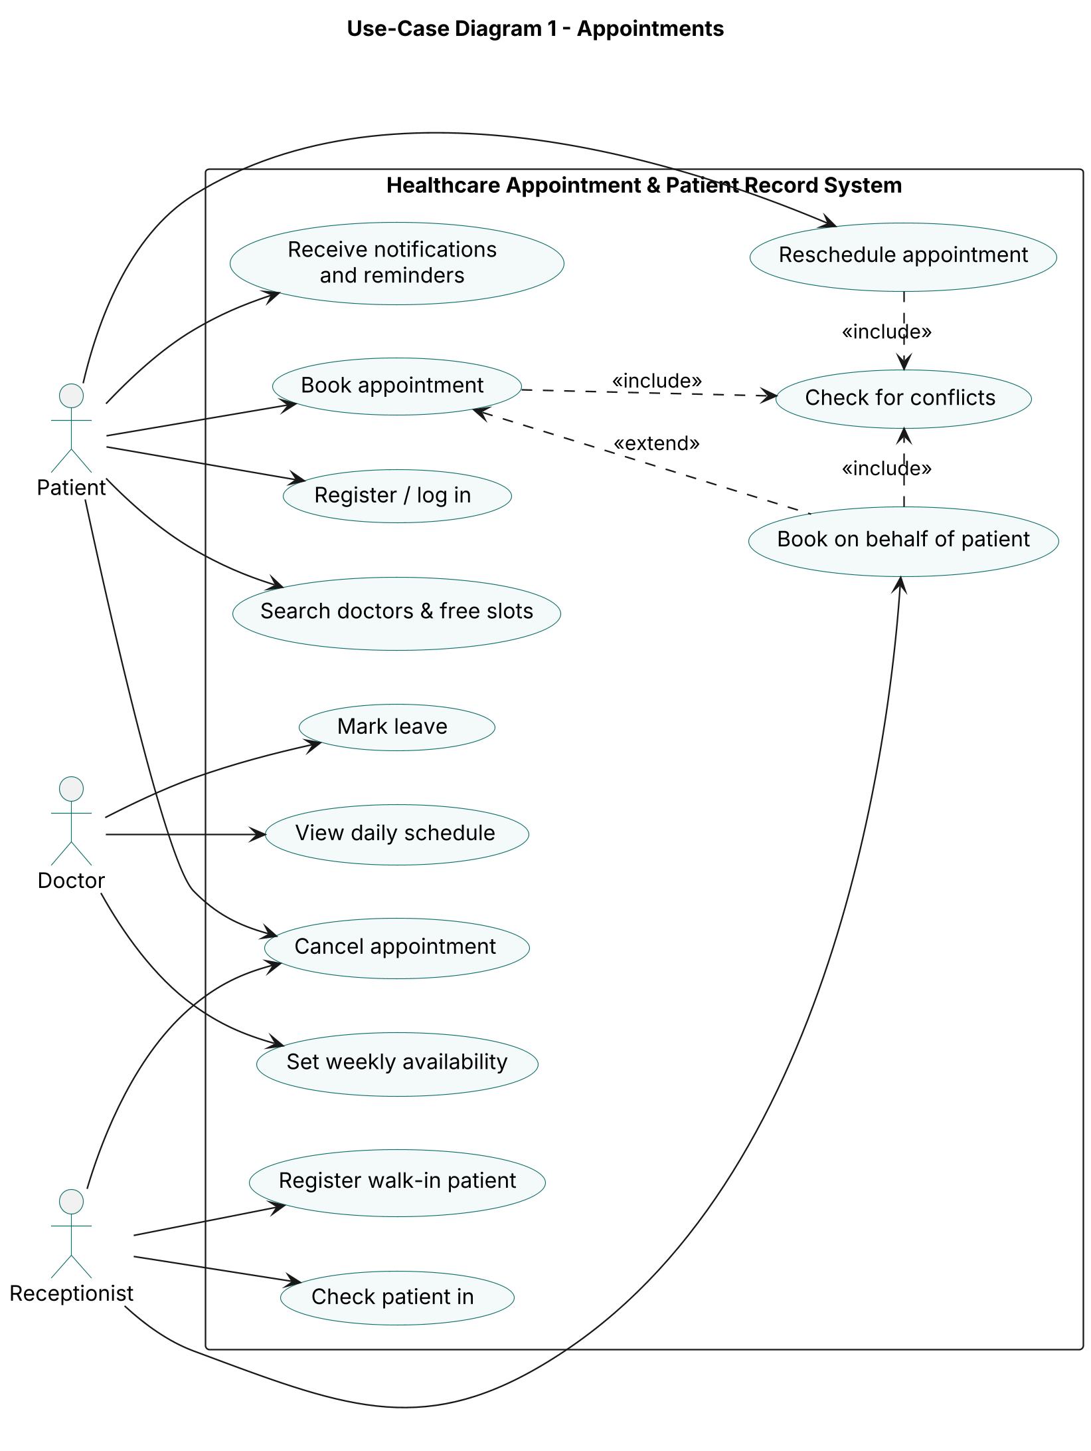
Use-case diagram 1 – Appointments
Patients register, search for doctors and free slots, and book, reschedule or cancel appointments (HAP-F-001, HAP-F-030–033); they receive notifications and reminders (HAP-F-050). The Receptionist registers walk-in patients (HAP-F-011), books on a patient’s behalf (HAP-F-035) and checks patients in (HAP-F-034). Booking, rescheduling and booking on behalf of a patient all include “Check for conflicts”, which enforces HAP-F-032. Doctors set weekly availability and leave (HAP-F-021, HAP-F-022) and view their daily schedule (HAP-F-040).

Diagram 2 – Medical Records & Administration
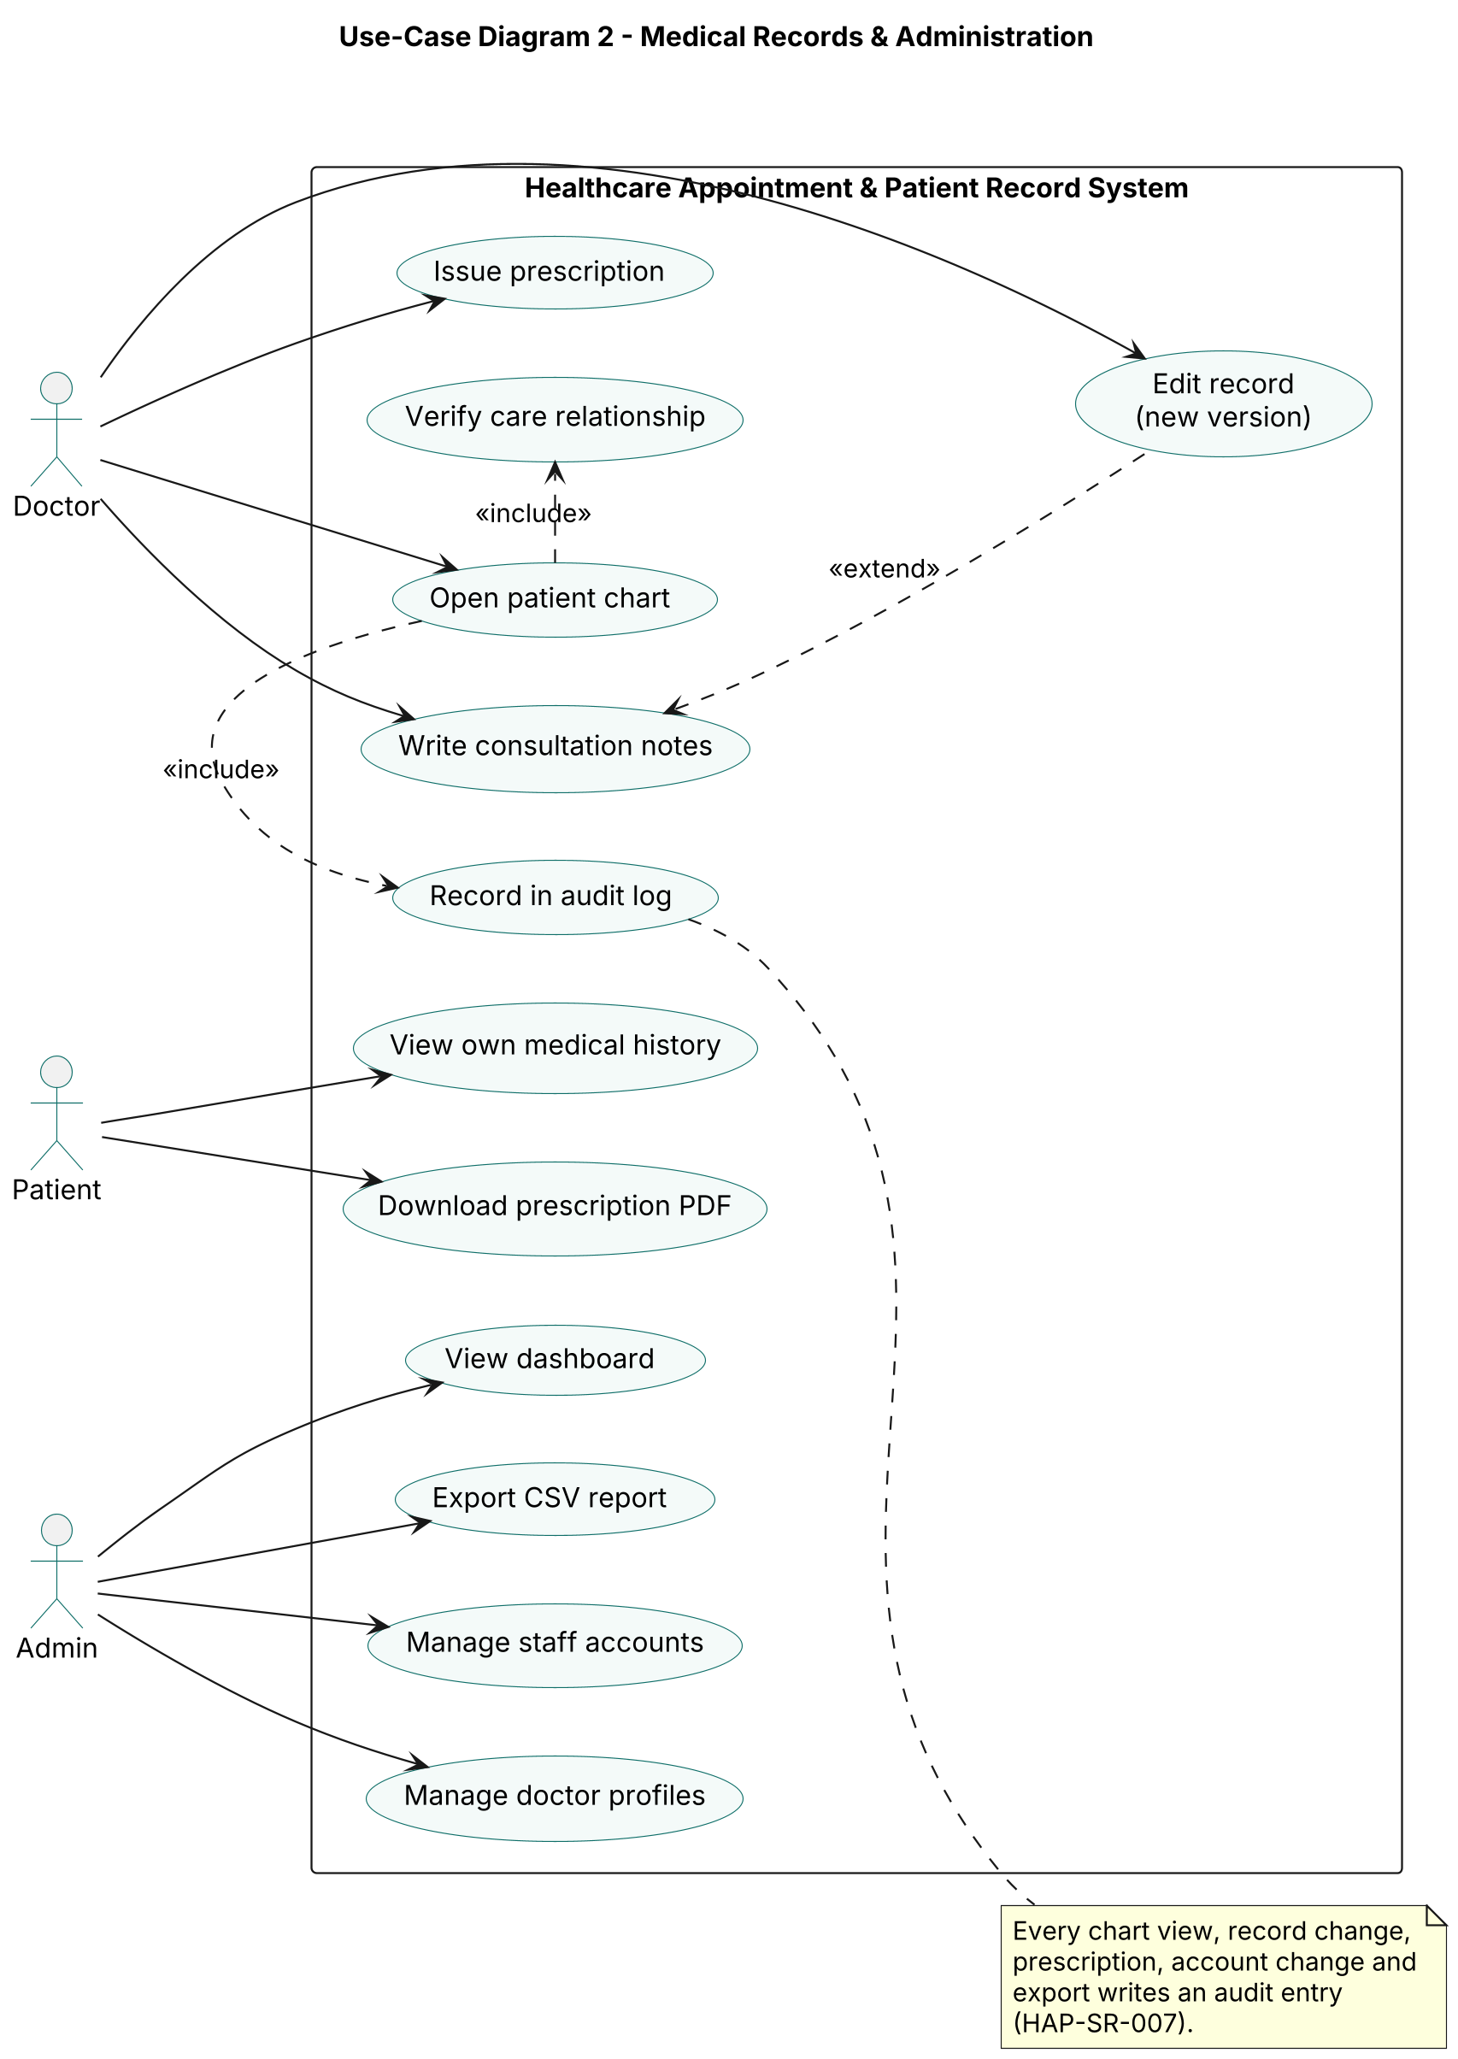
Use-case diagram 2 – Medical Records & Administration
Doctors open a patient chart, write consultation notes and issue prescriptions (HAP-F-040–042). Opening a chart includes “Verify care relationship” (HAP-SR-004) and “Record in audit log” (HAP-SR-007). Editing a record extends writing notes and always creates a new version (HAP-F-044). Patients view their own history and download prescription PDFs (HAP-F-043). The Admin manages staff accounts and doctor profiles, views the dashboard and exports CSV reports (HAP-F-003, HAP-F-020, HAP-F-051, HAP-F-052).

8. Requirements Traceability Matrix (RTM)
Status: N = not tested yet, P = passed, A = accepted. Design spec references point to sections of the SAD v1.0.
Req ID | Requirement short | Section ref / Design Spec | Module | Test case(s) | Status (N/P/A) | Comments
HAP-F-001 | Register / login, 4 roles | SRS 4.1 / SAD 3.4 | Auth & User Service | TC-AUTH-01 | N
HAP-F-002 | Role-based access | SRS 4.1 / SAD 3.4, 3.9 | Auth & User Service | TC-AUTH-02 | N
HAP-F-003 | Admin manages staff accounts | SRS 4.1 / SAD 3.4 | Auth & User Service | Sprint testing | N
HAP-F-010 | Patient registration + MRN | SRS 4.2 / SAD 3.4 | Patient Service | TC-PAT-01 | N
HAP-F-011 | Edit own profile; walk-in registration | SRS 4.2 / SAD 3.4 | Patient Service | TC-PAT-01 | N
HAP-F-012 | Duplicate patient warning | SRS 4.2 / SAD 3.4 | Patient Service | Sprint testing | N
HAP-F-013 | Patient search | SRS 4.2 / SAD 3.4 | Patient Service | Sprint testing | N
HAP-F-020 | Doctor profiles | SRS 4.3 / SAD 3.4 | Doctor & Schedule Service | Sprint testing | N
HAP-F-021 | Weekly availability → slots | SRS 4.3 / SAD 3.4 | Doctor & Schedule Service | TC-DOC-01 | N
HAP-F-022 | Doctor leave | SRS 4.3 / SAD 3.4 | Doctor & Schedule Service | TC-DOC-01 | N
HAP-F-030 | Search doctors and free slots | SRS 4.4 / SAD 4.3 Appointment API | Appointment Service | TC-APT-01 | N
HAP-F-031 | Book appointment | SRS 4.4 / SAD 4.2 diagram 1, 4.3 | Appointment Service | TC-APT-01 | N
HAP-F-032 | Conflict prevention | SRS 4.4 / SAD 3.6, 4.2 diagram 1 | Appointment Service | TC-APT-02 | N
HAP-F-033 | Reschedule / cancel ≥ 2 h | SRS 4.4 / SAD 4.3 Appointment API | Appointment Service | TC-APT-03 | N
HAP-F-034 | Status lifecycle, check-in, no-show | SRS 4.4 / SAD 4.3 Appointment API | Appointment Service | TC-APT-03 | N
HAP-F-035 | Receptionist books for patient | SRS 4.4 / SAD 4.3 Appointment API | Appointment Service | Sprint testing | N
HAP-F-040 | Doctor schedule and patient chart | SRS 4.5 / SAD 4.2 diagram 2, 4.3 | Medical Record Service | TC-MR-03 | N
HAP-F-041 | Consultation notes | SRS 4.5 / SAD 4.2 diagram 2, 4.3 | Medical Record Service | TC-MR-01 | N
HAP-F-042 | Prescriptions + PDF | SRS 4.5 / SAD 4.3 Medical Record API | Medical Record Service | TC-MR-02 | N
HAP-F-043 | Patient views own records | SRS 4.5 / SAD 4.3 Medical Record API | Medical Record Service | TC-MR-02 | N
HAP-F-044 | Versioned, never-deleted records | SRS 4.5 / SAD 3.6 | Medical Record Service | TC-MR-01 | N
HAP-F-050 | Notifications and reminders | SRS 4.6 / SAD 3.4 | Notification & Reporting Service | TC-NOT-01 | N
HAP-F-051 | Admin dashboard | SRS 4.6 / SAD 3.4 | Notification & Reporting Service | Sprint testing | N
HAP-F-052 | CSV report export | SRS 4.6 / SAD 3.4 | Notification & Reporting Service | Sprint testing | N
HAP-NF-001 | API p95 ≤ 2 s at 200 users | SRS 5 / SAD 3.1, 3.6 | All services | TC-PERF-01 | N
HAP-NF-002 | Slot search p95 ≤ 1 s | SRS 5 / SAD 3.6 | Appointment Service, Database | TC-PERF-01 | N
HAP-NF-003 | ≥ 99.5% availability, backups | SRS 5 / SAD 3.6, 3.7 | Database, deployment | Ops reports | N
HAP-NF-004 | Booking in ≤ 3 min, 360 px | SRS 5 / SAD 4.5 | Web Frontend | Usability test | N
HAP-NF-005 | ≥ 70% service-layer coverage | SRS 5 / SAD 3.5 | All services | Coverage report | N
HAP-SR-001 | bcrypt password hashes | SRS 5.1 / SAD 3.9 | Auth & User Service | TC-SEC-01 | N
HAP-SR-002 | JWT 30-minute expiry | SRS 5.1 / SAD 3.9 | Auth & User Service | TC-SEC-02 | N
HAP-SR-003 | HTTPS / TLS 1.2+ | SRS 5.1 / SAD 3.9 | Deployment (reverse proxy) | TLS scan (TP 5.1) | N
HAP-SR-004 | Server-side role and record checks | SRS 5.1 / SAD 3.9 | All services | TC-AUTH-02, TC-SEC-02, TC-MR-03 | N
HAP-SR-005 | Lockout after 5 failures | SRS 5.1 / SAD 3.9 | Auth & User Service | TC-SEC-01 | N
HAP-SR-006 | AES-256 encryption at rest | SRS 5.1 / SAD 3.6, 3.9 | Medical Record Service, Database | DB inspection (TP 5.1) | N
HAP-SR-007 | Append-only audit log | SRS 5.1 / SAD 3.9 | Audit Log | TC-MR-03 | N

