Importance of Location Selection for a Farmstead and Facilities in Farm House Design
(UPSC — IFoS Perspective)

Introduction
A farmstead is the operational nucleus of the farm business, comprising the farm house together with allied structures such as livestock sheds, storage, and machinery houses. Since the site and layout are rarely changed once established, careful location selection and functional design are essential to minimise cost, labour, and drudgery over the entire productive life of the farm.

Factors Influencing Farmstead Location — At a Glance
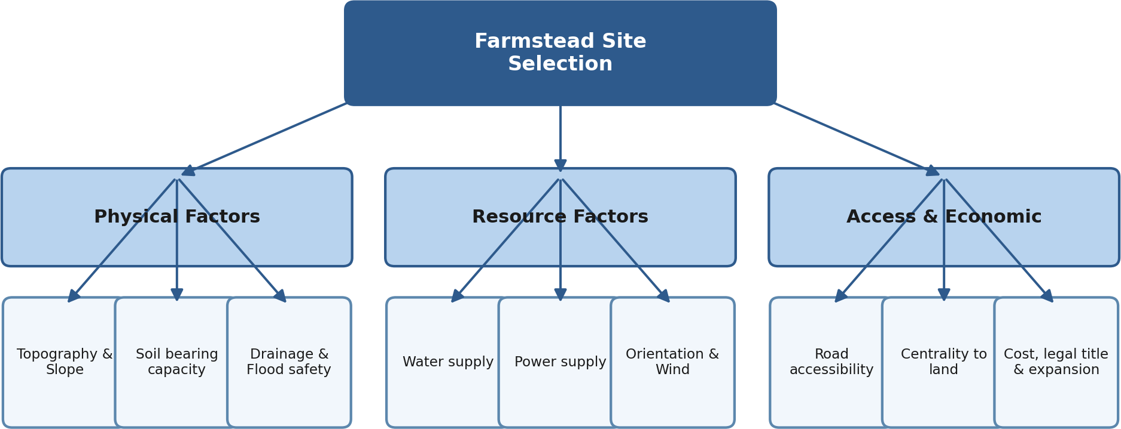

Importance of Location Selection
- Topography: Elevated, gently sloping land (1–3%) ensures natural drainage and avoids water-logging or flooding during monsoons.
- Soil conditions: Firm, well-drained soil with good bearing capacity prevents foundation cracks and seepage into wells and storage pits.
- Water supply: An assured, potable source is essential for domestic use, livestock, and farm operations; water table should be checked for well/bore-well feasibility.
- Accessibility: Proximity to an all-weather road eases transport of inputs, produce, and access to markets, schools, and health facilities.
- Centrality: A central location within the land holding reduces travel time and labour cost for workers, animals, and machinery.
- Drainage and flood safety: The site must be free from flood risk, with provision for natural or artificial drainage of rain and farm waste.
- Orientation and climate: Proper aspect ensures winter sunlight, summer shade, and ventilation; windbreaks protect against prevailing winds and soil erosion.
- Power supply: Nearness to the electricity grid supports irrigation pumps, lighting, and small-scale processing at lower cost.
- Sanitation: The site should avoid swampy or insect-infested areas and allow safe disposal of waste without contaminating water sources.
- Cost, legal status and expansion: Affordable land with clear title and sufficient surrounding space allows for future growth of the farm business.

Dimensioned Farmstead Layout Plan
A model layout on a 145 m × 105 m plot, drawn to indicate realistic building sizes and minimum sanitary separation distances (house–cattle shed ≥ 30 m; house–poultry ≥ 20 m; poultry–cattle shed > 15 m; well–manure pit >> 15 m), with the residence sited upwind of the livestock and waste zones.
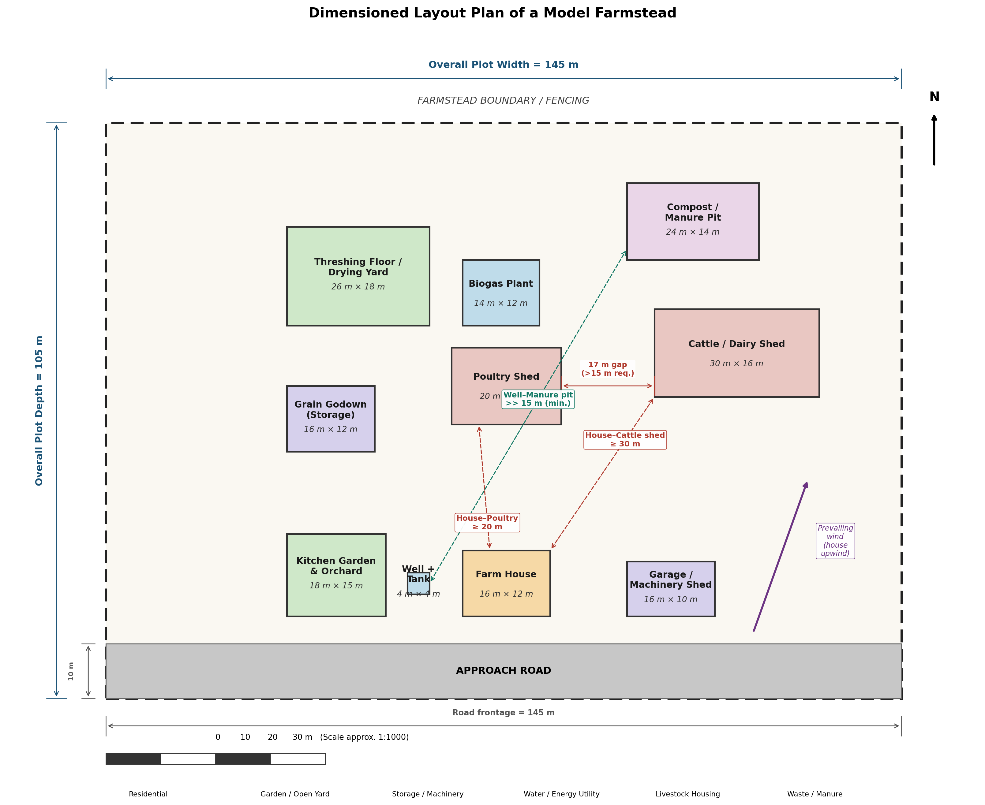

Key Facilities in Farm House Design
- Residence: Simple, durable living space built with locally available materials, with a veranda for supervising farm activities.
- Livestock housing: Well-ventilated, separate sheds for dairy animals and poultry, close enough for convenience but positioned to avoid odour and fly nuisance.
- Storage facilities: Rat-proof and moisture-proof grain godowns, a secure machinery/implement shed, and a separate lockable store for fertilizers and agro-chemicals.
- Water supply and sanitation: Piped water from a protected well or overhead tank, with proper drainage and a soak-pit/septic system for waste disposal.
- Energy facilities: Electrification for lighting and pumping, supplemented where feasible by biogas (from cattle dung) or solar units.
- Internal roads: An all-weather approach lane connecting the farm house to the public road and to different field blocks.
- Kitchen garden and orchard: A small plot near the house for growing vegetables and fruit for home consumption and nutrition.
- Processing/value-addition space: A threshing floor and drying yard, and where feasible a small shed for grading and packing produce.
- Security: Boundary fencing or hedging with adequate outdoor lighting to guard against theft and stray animals.
- Expansion space: Layout should reserve land for additional structures as the farm business diversifies over time.

Conclusion
A scientifically sited and well-designed farmstead — with assured water and power, good accessibility, and functionally zoned residential, livestock, and storage facilities — ensures efficient use of labour, capital, and time, making it a key theme in farm management and rural development.

