SIZE REDUCTION & MILLING
Detailed GATE Agricultural Engineering (AG) Notes
Section 6/7 — Agricultural Process Engineering
Compiled from lecture slides: cleaning/size-reduction principles, size-reduction laws, machinery, and rice milling

Contents at a Glance
- Milling — meaning and scope
- Size reduction — definition, objectives, advantages
- Fineness modulus and average particle size
- Factors affecting size reduction
- Mechanisms of size reduction
- Principles & crushing efficiency
- Size reduction laws — Rittinger's, Kick's, Bond's (with solved numericals)
- Size reduction machinery — crushers, grinders, cutting machines
- Oil expression and extraction
- Rice milling — parboiling, milling equipment, flow
- Quick-revision formula sheet

1. Milling — Overview
Milling is a general trade term for the reduction of food grains into end products usable for consumption or further processing.
Milling includes:
- Cleaning
- Sorting
- Polishing
- Dehusking
- Size reduction
The exact meaning of "milling" varies from crop to crop — e.g. rice milling emphasises dehusking and polishing, while wheat milling emphasises grinding into flour.

2. Size Reduction — Definition & Objectives
Definition
Size reduction is the operation of reducing bigger particles into smaller ones of desired size and shape using external forces.
- Size = physical dimensions of an object
- Reduction = process of decreasing that size
- COMMINUTION is the alternate technical term for size reduction
Objectives of Size Reduction
- Increase surface area — reaction rate for solid-particle reactions is directly proportional to contact area with the second phase
- Break material into small particles to separate valuable constituents
- Achieve intimate mixing of two or more solids
- Dispose of solid wastes easily
- Improve handling characteristics of the material
Advantages of Size Reduction
- Content uniformity
- Uniform flow
- Effective drying
- Increased surface area / increased viscosity
- Uniform mixing and drying
- Improved rate of absorption (smaller particles → greater absorption)
- Improved dissolution rate

3. Fineness Modulus (FM)
Fineness modulus indicates the uniformity of grind in the resultant product.
Determination
FM is obtained by adding the weight fractions retained above each sieve in a stack and dividing the cumulative sum by 100.
Average Particle Size
Dp = 0.135 × (1.366)^FM (Dp in mm)
GATE tip: Dp increases roughly exponentially with FM — memorize the constants 0.135 and 1.366 exactly; GATE numericals often ask you to back-calculate FM from a given Dp or vice-versa.
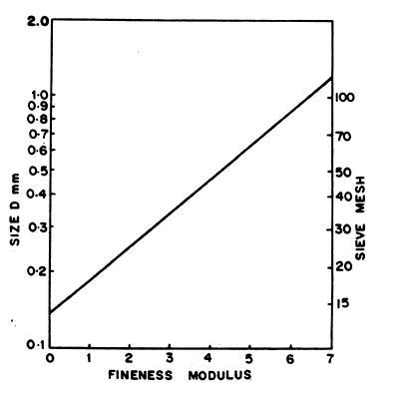
Fig. Relationship between fineness modulus and average particle size
Solved Problem — Determination of Fineness Modulus
A sieve analysis gave the following weight retained on each IS sieve. Determine the fineness modulus and average particle size.
IS Sieve No. | Wt. of material retained (g) | % retained | Fineness modulus contribution
100 | 0.0 | 0.0 | 7 × 0.0 = 0.0
70 | 1.4 | 0.56 | 6 × 0.56 = 3.36
50 | 16.7 | 6.71 | 5 × 6.71 = 33.53
40 | 36.7 | 14.45 | 4 × 14.45 = 57.80
30 | 82.2 | 33.01 | 3 × 33.01 = 99.03
20 | 96.0 | 38.55 | 2 × 38.55 = 77.10
15 | 8.0 | 3.21 | 1 × 3.21 = 3.21
Pan | 8.7 | 3.50 | 0 × 3.50 = 0.0
Total | 249.7 (≈) | 100 | 274.03

Fineness modulus, FM = 274.03 / 100 = 2.7403
Dp = 0.135 × (1.366)^2.7403 ≈ 0.317 mm

4. Factors Affecting Size Reduction
Factor | Effect / Description
Hardness | A surface property of the material; harder material is more difficult to reduce in size.
Material structure | Homogeneous substances behave uniformly; vegetables have a cellular structure often giving long, fibrous particles.
Abrasiveness | A property of hard materials; abrasive materials wear equipment faster.
Softening temperature | Heat generated during size reduction may soften some materials; controlled by cooling the mill (water jacket / air stream).
Moisture content | Materials with 5–50% moisture flow poorly and tend to cake into balls; grinding works well outside this range.
Crushing strength | Power required for crushing is almost directly proportional to the crushing strength of the material.
Friability | Tendency to fracture during normal handling; crystalline materials break along defined planes, and power required rises as particle size is reduced.
GATE tip: The 5–50% moisture "caking zone" is a favourite objective-type question — remember grinding is efficient OUTSIDE this band, not inside it.

5. Mechanisms of Size Reduction
Mechanism | Description | Typical analogy / equipment
Impact | Particle concussion by a sudden single rigid force | Hammer
Compression | Particle disintegration by two rigid forces | Nutcracker
Shear | Particle compressed between edges of two hard surfaces moving tangentially | Scissor action
Attrition | Particles scraping against one another or against a rigid surface | A file
Cutting | A sharp knife forced through the material with minimum deformation/rupture | Fruits & vegetables
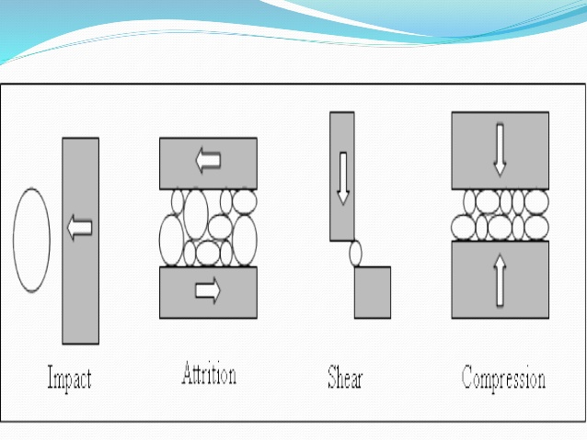
Fig. Impact, attrition, shear, and compression mechanisms

6. Principles of Size Reduction
Crushers and grinders are the equipment mostly used for size reduction. An ideal size reducer should have:
- Large capacity
- Ability to yield a pre-desired product or range of sizes
- Small power requirement per unit product handled
- Easy and trouble-free operation
Crushing Efficiency
Crushing efficiency = Surface energy created by crushing / Energy absorbed by the solid

7. Size Reduction Theories (Energy Laws)
Energy requirement for particle size reduction is a function of the input and output particle size, hardness, strength, and other properties of the solid. Three classical theories relate energy to particle size — Rittinger's Law, Kick's Law, and Bond's Law.
General differential form
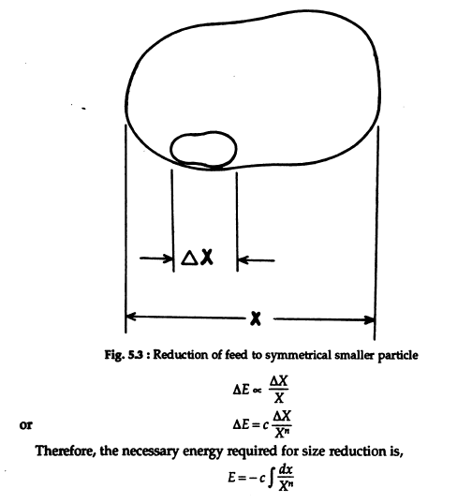
Fig. 5.3 — Reduction of feed to a symmetrical smaller particle
dE = − c · (dX / X^n)
where E = energy, X = particle size, c = constant, and n depends on the theory (n = 2 for Rittinger, n = 1 for Kick, n = 1.5 for Bond).
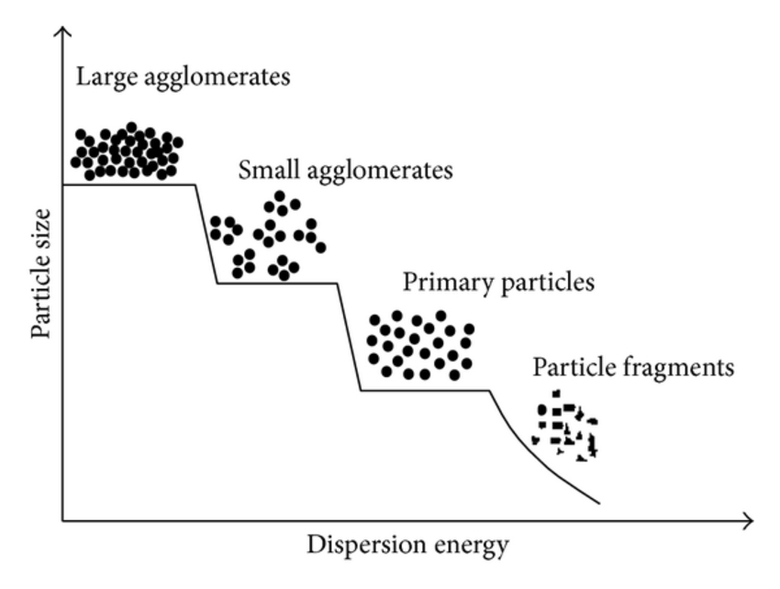
Fig. Particle size reduction stages vs dispersion energy — from large agglomerates down to particle fragments
7.1 Rittinger's Law (n = 2)
- Work required in crushing is proportional to the new surface area created
- Assumes size reduction is a shearing process
- Energy requirement is proportional to the square of the common linear dimension
E = c ( 1/Xp − 1/Xf )
where Xp and Xf = length of product and feed, respectively.
7.2 Kick's Law (n = 1)
- Based on stress analysis of plastic deformation within the elastic limit
- Assumes energy requirement is a function of the common linear dimension of the material
- Within the elastic limit, work required to crush a given quantity of material is constant for the same reduction ratio, irrespective of the original size
- Reduction ratio = ratio of feed opening to discharge opening
E = c · ln (Xf / Xp)
7.3 Bond's Law
- Estimates the power required for crushing and grinding operations
- Work required to form particles of size Dp from a very large feed is proportional to the square root of the surface-to-volume ratio of the product
P/f = 0.3162 · wi · ( 1/√Dp − 1/√Df )
where P = power (kW), f = feed rate (t/h), Dp = sieve opening through which 80% of product passes (mm), Df = sieve opening through which 80% of feed passes (mm), wi = work index.
Work index (wi): the gross energy requirement in kWh per tonne of feed needed to reduce a very large feed to a size such that 80% of the product passes through a 100 μm screen. wi is found experimentally from laboratory crushing/grinding tests.
GATE tip: Bond's Law is the most commonly examined of the three because it is closest to industrial practice — make sure the 0.3162 constant and the "80% passing" definition of Dp/Df are second nature.
Solved Problem 1 — Rittinger's and Kick's Law
In a wheat milling experiment it was found that to grind 4.33 mm sized grains to IS sieve 30 (0.351 mm opening), the power required was 8 kW. Calculate the power requirement for milling wheat grains to IS sieve 13 (0.157 mm opening) using (i) Rittinger's Law and (ii) Kick's Law. Feed rate of milling = 200 kg/hr.
(i) According to Rittinger's Law:
E = c ( 1/Xp − 1/Xf )
8/0.2 = c (1/0.351 − 1/4.33) ⇒ 40 = c (2.619) ⇒ c = 15.278
Putting the value of c for the second condition:
P/0.2 = 15.278 (1/0.157 − 1/4.33)
P = 18.75 kW
(ii) According to Kick's Law:
E = c · ln (Xf / Xp)
8/0.2 = c · ln(4.33/0.351) ⇒ 40 = c (2.5107) ⇒ c = 15.93
Putting the value of c for the second condition:
P/0.2 = 15.93 · ln(4.33/0.157)
P = 10.56 kW
Solved Problem 2 — Bond's Law
How much power is required to crush 2 t/hr of a material if 80% of the feed passes through IS sieve No. 480 (4.75 mm opening) and 80% of the product passes through IS sieve No. 50 (0.5 mm opening)? Work index of the material = 6.30.
P/f = 0.3162 · wi ( 1/√Dp − 1/√Df )
Given: wi = 6.30, f = 2 t/hr, Dp = 0.50 mm, Df = 4.75 mm
P/2 = 0.3162 × 6.30 ( 1/√0.5 − 1/√4.75 )
P = 7.129 kW

8. Size Reduction Machinery
Size reduction machinery is broadly grouped into three classes: Crushers, Grinders, and Cutting machines.
8.1 Crushers
- Squeeze the material until it breaks; break large pieces into small lumps
- Mainly used in mining-type industries
- Types: jaw crusher, gyratory crusher, crushing rolls (smooth and serrated)
- Working mechanisms: compression, impact, and shearing
8.2 Grinders
- Used to mill grains into powder
- Types: attrition mill, hammer mill, ball mill
Ball Mill — Centrifuging & Critical Speed
Centrifuging occurs beyond a critical rotational speed of the mill.
nc = (1 / 2π) × √( g / (R − r) )
where nc = critical speed (revolutions/s), g = acceleration due to gravity (9.80 m/s²), R = radius of the mill (m), r = radius of the ball (m).
GATE tip: Operating speed for ball mills is normally kept at 65–80% of critical speed — lower values are used for wet grinding in viscous suspension. This range (65–80%) is a frequently tested fact.
8.3 Cutting Machines
- Usually used for making slices of fruits and vegetables
- Types: rotary knife cutter, Reitz mill (disintegrator)

9. Oil Expression and Extraction
Used to extract oil from oilseeds such as sunflower, mustard, groundnut, etc.
Mechanical Expression
- Hydraulic press, screw press
- Chemical-free process
Solvent (Chemical) Extraction
- Uses a low-boiling-point solvent to extract oil through diffusion
- High extraction efficiency (~99%), more protein retained, better preservation quality
- Solvent is recovered from the cake by heating (evaporation)
- Low toxicity of the solvents used

10. Rice Milling
Overall flow
Paddy → Cleaner → Storage → Sheller / Husk aspirator → Paddy separator → Whitener/Polisher → Grader → Bran aspirator → Head rice, Brokens, Bran, Bagging/Storage.
Operation | Purpose
Cleaning/cleaner | Removing foreign matter from paddy
Shelling / rubber-roll sheller | Separating husk from the grain (paddy)
Husk separation / husk aspirator | Separation of husk from the product obtained from sheller
Paddy separation / paddy separator | Separation of paddy from brown rice
Bran removal / polisher-whitener | Removal of bran layers from brown rice
Bran aspiration / bran aspirator | Removal of bran adhering to the rice kernel
Grading / grader | Separation of broken rice from head rice
Handling equipment | Conveying paddy/rice to various processing units
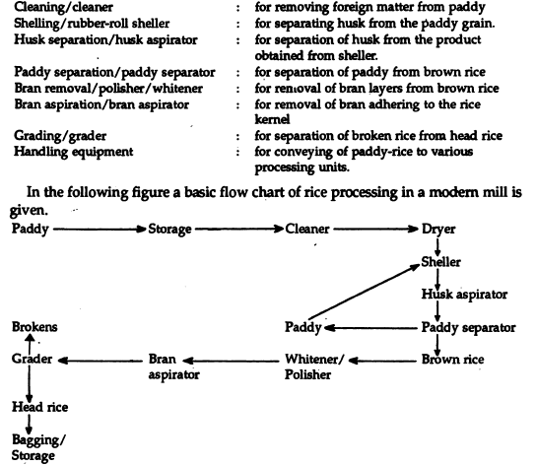
Fig. Basic flow chart of rice processing in a modern mill
Parboiling
An optional treatment given to paddy before milling. Paddy grain is composed of starch granules whose voids are filled with air/moisture.
Objective: maximize recovery of head rice and minimize breakage.
- Soaking — in normal or hot water for some time
- Steaming — temperature raised up to ~70°C
- Drying — slow drying, usually in shade or in mechanical dryers
Advantages of Parboiling
- Increases milling yield, improves quality, makes grain structure vitreous and shiny, increases shelf life
- Grains harden — greater resistance to insect attack, no germination, no atmospheric adsorption
- More oil in bran, easier shelling, more digestible
- Less sticky, swells more
- Absorbs less oil during cooking; doesn't turn rancid easily after cooking
Disadvantages of Parboiling
- Heat treatment destroys natural antioxidants; rancidity may develop during long-term storage
- Rice takes more time to cook and develops a peculiar off-flavour
- Extra capital investment (drying equipment)
- More power required during polishing
- Longer soaking time makes paddy prone to attack by spores
Parboiling Methods
Method | Procedure
Traditional | Soaking in normal water for 1–2 days; steaming under atmospheric pressure; sun drying.
CFTRI method (modern) | Water heated to 85°C by steam; paddy added and soaked for 3–4 h; followed by drying (mechanical/sun).
Pressure parboiling (modern) | Soaking for 40 min at 85°C; subjected to pressurized steam for 18 min; followed by drying. Gives rice a pleasing yellowish colour.
Head Rice vs Broken Rice
- Head rice: kernel length > 3/4 of the whole grain
- Broken rice: kernel length < 3/4 of the whole grain
Broken rice is further classified as:
  - Big brokens — 50–75% of kernel length
  - Small brokens — 12.5–50% of kernel length
  - Points — < 12.5% of kernel length
Traditional milling equipment includes hand and foot pounders.
Rice Milling / Dehusking Equipment
Equipment | Key Features
Engleberg huller | Most common equipment; ribbed cast-iron roller operating at 600–900 rpm; yields 56% to up to 64%.
Rubber roll sheller | Two rubber rolls rotate in opposite directions (10–13 m/s and 8–10 m/s, ~25% speed differential); yields up to 95% rice; subject to major wear.
Under-runner disk huller | Two horizontal cast-iron disks partly covered with an abrasive emery layer; top disk fixed, bottom disk rotates; clearance is adjustable.
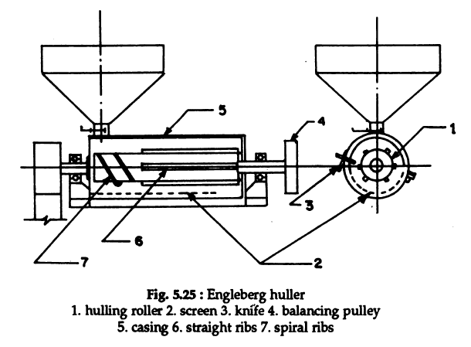
Fig. 5.25 — Engleberg huller (1. hulling roller 2. screen 3. knife 4. balancing pulley 5. casing 6. straight ribs 7. spiral ribs)
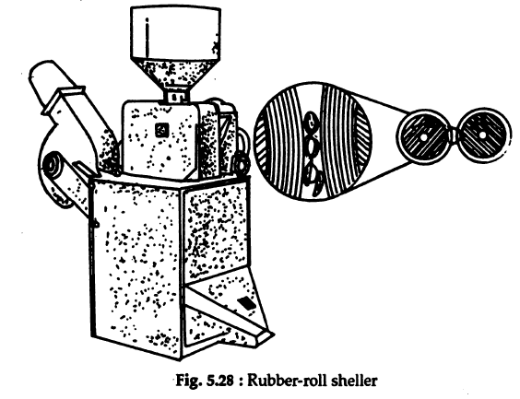
Fig. 5.28 — Rubber-roll sheller
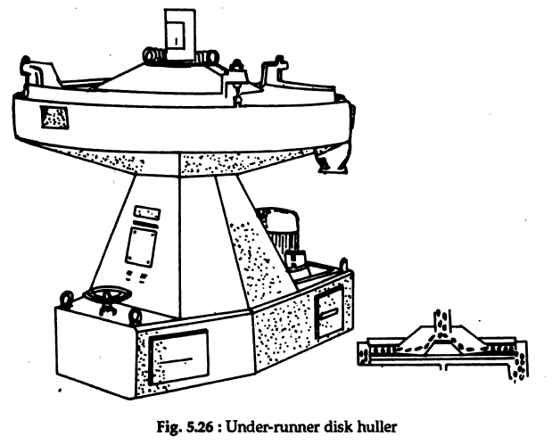
Fig. 5.26 — Under-runner disk huller
Other Milling Operations
- Husk separator
- Paddy separator (compartment type)
- Whitening — horizontal and vertical whitening cones, jet pearlers
- Glazing
- Grading — using indent-cylinder separators
GATE tip: Yield hierarchy to remember: rubber-roll sheller (~95%) > Engleberg huller (56–64%). GATE frequently tests this ranking along with the huller's rpm range (600–900 rpm).

11. Quick-Revision Formula Sheet
Concept | Formula
Average particle size from FM | Dp = 0.135 (1.366)^FM
General energy law | dE = −c (dX / X^n)
Rittinger's Law (n = 2) | E = c (1/Xp − 1/Xf)
Kick's Law (n = 1) | E = c · ln(Xf / Xp)
Bond's Law | P/f = 0.3162 · wi (1/√Dp − 1/√Df)
Ball mill critical speed | nc = (1/2π) √(g/(R−r))
Key numbers to remember
- Moisture caking range where grinding is poor: 5–50%
- Ball mill operating speed: 65–80% of critical speed (lower for wet/viscous grinding)
- Engleberg huller speed: 600–900 rpm; yield 56–64%
- Rubber roll sheller yield: up to 95%; roll speed differential ≈ 25%
- CFTRI parboiling: soak 3–4 h at 85°C water heated by steam
- Pressure parboiling: soak 40 min at 85°C + pressurized steam for 18 min
- Bond's work index (wi) definition: energy (kWh/tonne) to reduce very large feed so 80% of product passes a 100 μm screen
End of notes — Size Reduction & Milling (GATE AG).

