**1)Even Sum**

You are organizing a charity run where participants contribute a dollar for every

even-numbered kilometer they complete. Your task is to find and return an integer value representing the total amount of money raised if the race is N km long.

Input Specification:

Input1: An integer value N

Output Specification:

Return the sum of all even numbered kilometers till N they complete.

Example 1:

Input1: 10

Output: 30

**2)Product Pair**

You are given an integer array A of length N and your task is to find and return an 2009 integer value representing the count of unique pairs whose products are multiples of 3.

Note: A Unique pair means that the elements must be the same regardless of their order For instance, (1,3) and (3.1) are considered as the same pair

Input Specification:

Input1: An integer value N, representing the size of the array

input2: An integer array A

Output Specification:

Return an integer value representing the count of unique pairs whose products are multiples of 3.

Example 1:

Input1:4

input2: (3.6.5.4)

Output: 5

**3)Magical Number**

you are given a program to find the count of magical numbers from 1 to N .A magical number is defined by the following criteria

* Convert each number In the range 1 to N (inclusive) to its binary representation
* Replace ‘0’ with “1’ and ‘1’ with ‘2’ in the binary string.
* Calculate the sum of the digits in the modified binary string. If the Resultant number is odd, then it is considered a magical number.

Your task is to find and return an integer value representing the count of the magical numbers present within the given range.

Input Specification:

Input1: An integer value N representing the range of numbers.

Output Specification:

Return an integer value representing the count of magical numbers present within the range.

**4)Minimum Badness**

You are given a string S representing the colours of houses (red(R), blue(B) or white(W)). The badness value is the number of differently-coloured adjacent houses. You can paint the white houses red or blue to minimize the badness value. Your task is to find and return an integer value representing the minimum possible badness 3 value.

Input Specification:

Input1: A string value 5, representing the colours of houses.

Output Specification:

Return an integer value representing the minimum possible badness value.

Example 1:

Input1 : RRWBWBW

Output: 1

**5)Alice’s Magical Shoes!**

Alice has a pair of magical shoes that allows her to climb 3 stairs at once. In the city, there are N houses whose roofs Alice wants to reach. The number of stairs to the roof of each house is given in an array A. Alice can reach the roofs of only those houses where the number of stairs is a multiple of 3. Your task is to find and return an integer value representing the count of the number of houses whose roofs. Alice can climb up to.

Input Specification:

Input1: An integer value N representing the number of houses

Input2: An integer array A representing the number of stairs in each house

Output Specification:

Return an integer value representing the count of the number of houses whose roofs Alice can climb up to

Example 1:

Input1:4

Input2: [12.21,3,4]

**6)SUPERMARKET SALES**  
This question accounts for 25% of the total test. Please do not forget to submit your answer, timed-out tests will result in 0 points awarded.

GIVEN

Given A, the unique integer prices of N items in a supermarket. A large number of customers enter the supermarket with the target of buying a basket of items of total price B. The customers can take more than one of the same item. Given that all possible baskets of items with a total price of B have been sold exactly once, find how many baskets in which the Mth item has been sold.

NOTE

• The order of the items in the basket will not matter.

Ex: basket₁ = (item1, item2), basket2 = (item2,item₁)

then, basket1=basket2

**7)What will be the output of the given pseudo code?**

* Integer j
* Integer arr[2][2]= {{3, 1}, {1, 2}}
* arr[1][1]=(arr[0] [1]+arr[1] [0])+arr[0][0])
* if((arr[1][0]&arr[0] [0]&arr[1][0])<(4+arr[1][0]+2))

arr[1][0]=arr[1] [0]+arr[0][0]

* End if

arr[1][0]=(arr[1] [0]+arr[1][0])+arr[0][0]

* Print arr[1] [0]+arr[0] [0]

Note- &: bitwise AND – The bitwise AND operator (&) compares each bit of the first operand to the corresponding bit of the second operand. If both bits are 1, the corresponding result bit is set to 1. Otherwise, the corresponding result bit is set to 0.

Options

* 3.0
* 12.0
* 8.0
* 16.0

**8)What will be the output of the given pseudo code?**

* Integer a,b,c
* Set a = 8 b = 7 c = 9
* if( (3&a) < (c ^ 3) && 9<a)

b= (a + b) &c

* if((9 – b + c) > (c + a))
* c = a ^ a
* End if

End if

c = c + c

* Print a+b+c

Note- &&: Logical AND – The logical AND operator (&&) returns the Boolean value true (or 1) if both operands are true and returns false (or 0) otherwise.

&: bitwise AND – The bitwise AND operator (&) compares each bit of the first 20 operand to the corresponding bit of the second operand. If both bits are 1, the corresponding result bit is set to 1. Otherwise, the corresponding result bit is set to 0.

Options

* 30.0
* 34.0
* 33.0
* 43.0

**9)What will be the output of the given pseudo code?**

* Integer a,b,c
* Set a = 5 b = 3 c = 6

b =(c&b)+b

* for(each c from 2 to 4)

b = (586) ^ a

* End for
* Print a + b

Note- & bitwise AND – The bitwise AND operator (&) compares each bit of the first operand to the corresponding bit of the second operand. If both bits are 1, the corresponding result bit is set to 1. Otherwise, the corresponding result bit is set to 0.

^is the bitwise exclusive OR operator that compares each bit of its first operand to the corresponding bit of its second operand. If one bit is 0 and the other bit is 1, the Corresponding result bit is set to 1. Otherwise, the corresponding result bit is set to 0.

Options

* 24.0
* 11.0
* -12.0
* 6.0

**10)Chocolate Types**

Monica went to a confectionery shop which has N different types of chocolates. The shop displays a price chart, where column T represents the types of chocolate and column P represents their respective prices.

She was asked to pick K different types of chocolates at the minimum possible cost. Your task is to find and return an integer value representing the total amount of money she will spend. Return -1.

Note: She can buy only 1 chocolate of each type.

Input Specification:

Input1: An integer value N, representing the number of chocolate types

Input2: An integer value K. representing the number of types of chocolates to buy

Input3: An integer array representing the types of chocolates T

Input4: An integer array representing the prices P

Output Specification:

Return an integer value representing the total money she will spend. Retum -1, if K types of chocolates cannot be chosen.

**11)Repeat String**

You are given an integer N and a string S. Your task is to find and return a new string which consists of the original string repeated N times.

Input Specification:

Input1: An integer value N

Input2: A string value 5

Output Specification:

Return a new string which consists of the original string repeated N times.

Example 1:

Input1:3

Input2: abc

Output: abcabcabc

**12)What does the following pseudocode line represent?**

**While(temperature > 100)**

Options

* Execute the loop while temperature is less than 100.
* Execute the loop while temperature is greater than 100.
* Execute the loop while temperature is equal to 100.
* Execute the loop once regardless of the temperature value

**13)What is the term for a function that invokes itself?**

* Self Function
* Auto Function
* Recursive Function
* Static Function

**14)Which of the following is the default return value of functions in C++?**

Options

* Char
* Int
* void
* Float

**15)How should you position default parameters within a C++ function prototype?**

options

* To the rightmost side of the parameter list
* To the leftmost side of the parameter list
* Anywhere inside the parameter list
* Middle of the parameter list

**16)How many times “A” will be printed in the following pseudocode?**

* Integer a,b,c
* For(a = 0 to 4)
* For(b = 0 to 2)
* If(a is greater than b)
* Print “A”
* End for
* End for
* End If

Options

* 8
* 7
* 9
* 10

**17)Which logical operator does not allow us to combine two or more conditions?**

Options

* AND
* OR
* NOT
* NAND

**18)What is the term for a chart that illustrates the flow of functions or processes without displaying any actual code?**

* A fiowchart
* Structure chart
* Both A and B
* None

**19)read the flowchart given below and answer the question that flows**

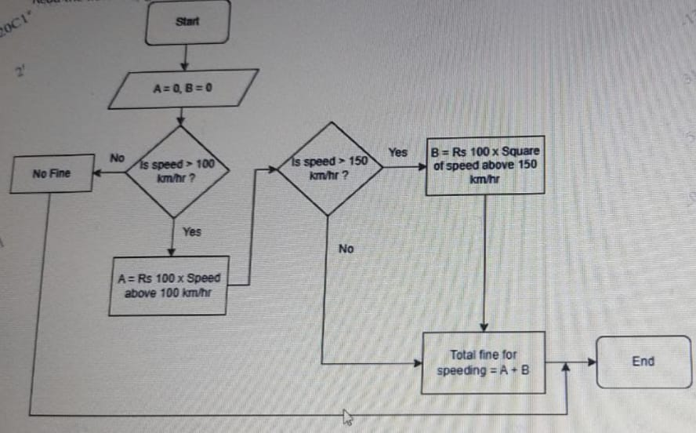

If the fine paid for speeding was Rs 14000,which of the following could have been the speed?

Options

* 128 km/hr
* 136km/hr
* 159 km/hr
* 170 km/hr

**20)A ship needs to transport a certain number of people from Point A to Point B. The capacity of the ship is denoted by an integer C. and the total number of people to be transported is denoted by an integer N. Your task is to find and return the number of rounds the ship needs to make in order to transport all the people from Point A to Point B**

Note : One round consists of the ship travelling from Poire & to Point & and then returning to Point A

Input Specification:

Input1: An integer value C representing the capacity of the ship

Input: An integer value N representing the total number of people to be transported

Output Specification

Return an integer value representing the number of rounds the ship needs to make.

Example 1:

Input: 50

Input2:200

Output:4

**Question 21**

**Stabilize the system**

In a tech startup, the team faced a software bug the zeros in their data outputs were causing their system to crash. A junior developer suggested replacing all the 0 's with 5's as a quick fix. By implementing this simple code tweak, they stabilized the system. Your task is to find and return an integer value representing the value that stabilizes the system.

**Input Specification:**

input1: An integer value

**Output Specification:**

Return an integer value representing the value that stabilizes the system

**Example 1 :**

**input1**: 100067

**Output**: 155567

**Question 3:**

int array[] = {4, 5, 8, 9, 2);

int *ptr = (int*)(&array + 1);

What is the value of *(ptr - 1) ?

4

5

2

9

**QUESTION 22**:

**For a pipelined processor architecture if the following is the time taken for each stage of every process is (5,2,4,8,3) ms respectively, what is the ratio of the turnaround time of the pipelined processor to non-pipelined processor?**

O 0.6

Ο 1/22

Ο 1.818

Ο 0.55

**QUESTION 23 :**

**What is the output of the following code?**

**#include <stdio.h>**

**#include <stdint.h>**

**int main()**

**{**

**uint8_t a, max;**

**for(a=1; a<=255; a++) {**

**max = a;**

**}**

**printf(""max = %u"", max);**

**return 0;**

**}**

1. None of the above
2. 256
3. 255
4. Infinite Loop

**QUESTION 24 :**

**Mango Distribution**

Given a number of mangoes and number of persons. Find the number

distribute identical mangoes among identical persons.

**Input Specification:**

input1: the number of mangoes

input2: the number of persons

**Output Specification**:

Return the number of ways to distribute identical mangoes amor

persons.

**Example 1:**

**input1**: 2

**input2**: 2

Output: 3

**QUESTION 25 :**

**What will be the output of the following pseudocode?**

1. Integer a,b,c

2. Set a = 6 b = 8 c = 10

3. For (each c from 2 to 4)

4. b = (2 + 5) + a

5. if ((8 + 3) < (6 + b))

6. b = b + b//16

7. a =10&&c

8.Else

9.jump out of the loop

10.End if

11. a = (b+ 7) + c

12. End for

13. Print a + b

a. 88

b. 74

C. 59

D.69

**QUESTION 26:**

**What will be the output of the given pseudo code for a=2 b=7, and c=6?**

1.Integer funn (Integer a2, Integer b7, Integer c6)

2 b=(c^8)+c//20

3 for(each c from 4 to 7)

4 b=(c+11)&b//16

5 a=11&a//2

6 End for

7 return a+b

Note- & bitwise AND- The bitwise AND operator (&) compares each bit of the first operand corresponding bit of the second operand. If both bits are Otherwise, the corresponding result bit is set to 0. 1, the 188P Corresponding result to the bit is set to 0.

is the bitwise exclusive OR operator that compares each bit of its second operand. If one bit is 0 and the other bit is 1, the corresponding result bit is set to 1. Otherwise, the corresponding result bit is set to 0.

**QUESTION 27 :**

**Alice and song**

Alice has a collection of songs represented as a string 5 where each character represents a song. A playlist is a substring of the given string with exactly K number of songs. She wants to create a playlist that contains maximum number of her favourite song which is 'a'. Your task is to find and return an integer value representing the maximum number of favourite songs that she can get in a single playlist.

**Input Specification:**

input1: A string value S representing the collection of songs.

input2: An integer value K representing the number of songs in the playlist.

**Output Specification:**

Return an integer value representing the maximum number of favourite songs that she can get in a single playlist.

**Example 1:**

**input1:** abaca

**input2** : 3

Output: 2

**Example 2:**

**input1**: bcdefgfedcb

**input2**:5

**Output**: 0

**QUESTION 28 :**

**What will be the output of the given pseudo code?**

1 Integer a,b,c

2 Set a=5, b=3, с=б

3.b-(c&b)+b

4.for(each c from 2 to 4)

5.b=(5&6)^a

6 End for

7.print a+b

Note- & bitwise AND-The bitwise AND operator compares each bit of the first operand to the corresponding bit of the second operand .If both bits are 1,the corresponding result bit is set to 1. Otherwise, the corresponding result bit is set to 0.

^ Is the bitwise exclusive OR operator that compares each bit of the first operand to the corresponding bit of its second operand. If one bit is 0 and the other bit is 1, the corresponding result bit is set to 1.Otherwise, the corresponding result bit is set to 1

**Select the correct option from the given choices**

1. 24.0
2. 11.0
3. -12.0
4. 6.0

**QUESTION 29 :**

**FIND LETTERS**

Your friend gives you a string S which contains the name of a person and asks you to find the first and last letter of their name. Your task is to find and return a string representing the first and the last letter.

**Note:**

• The output should be two capital letters with a dot separatory het

The output is case sensitive

**Input Specification:**

**input1**: A string S representing the name

**Output Specification:**

Return a string representing the first and the last letter

**Example 1:**

**Input1** : Sam Harris

**QUESTION 30**:

**ROCK,PAPER,SCISSORS**

Two players A and B, are playing the game of Rock Paper, Scissors Player A ches a move represented bya a string value M and the move can be one of the following 4765 "rock', 'paper', or 'scissors' where,

rock beats scissors

scissors beats paper

paper beats rock

Your task is to find and return a string value representing the winning move for player B

**Note**: The output a case sensitive

**Input Specification**:

**input1**: A string value M representing the move chosen by Player A

**Output Specification:**

Return a string representing the winning move for Player E