 

**Placement Empowerment Program**

***Cloud Computing and DevOps Centre***

**Use Cloud CLI Tools Install the CLI for your cloud provider (e.g., AWS CLI). Use it to list resources, upload files to storage, and manage VMs.**

Name:RAGUL GV Department: ECE



**Introduction and Overview**

Cloud CLI tools, such as AWS CLI, allow users to interact with cloud services directly from the terminal, enabling automation and efficient resource management. This task involves installing the AWS CLI, configuring it with AWS credentials, and using it to perform basic operations like listing resources, uploading files to S3, and managing EC2 instances. CLI tools offer a faster and scriptable alternative to the AWS Management Console, improving productivity. By completing this task, you 'll gain hands-on experience in cloud automation and resource control using command-line commands.

**Objective**

The goal of this project is to:

1. Learn Cloud CLI Basics – Install and configure AWS CLI to interact with cloud resources using command-line commands.
2. Manage Cloud Resources – Use AWS CLI to list cloud resources, upload files to S3, and manage EC2 instances efficiently.
3. Enhance Automation Skills – Gain hands-on experience in automating cloud tasks, improving efficiency over manual AWS Management Console operations.

**Importance of Cloud CLI**

**Hands-on Learning & Efficiency** – Cloud CLI provides direct interaction with cloud services, enabling faster and more efficient management compared to the web console.

**Automation & Scripting** – It allows users to automate repetitive tasks, such as resource provisioning and deployments, improving productivity.

**Remote Cloud Management** – With CLI tools, users can manage cloud resources from any terminal, making it ideal for DevOps, remote administration, and large-scale cloud operations.

**Step-by-Step Overview**

Step1:

Search for "AWS CLI Installer for Windows" on Google and click the first link to access the official website.

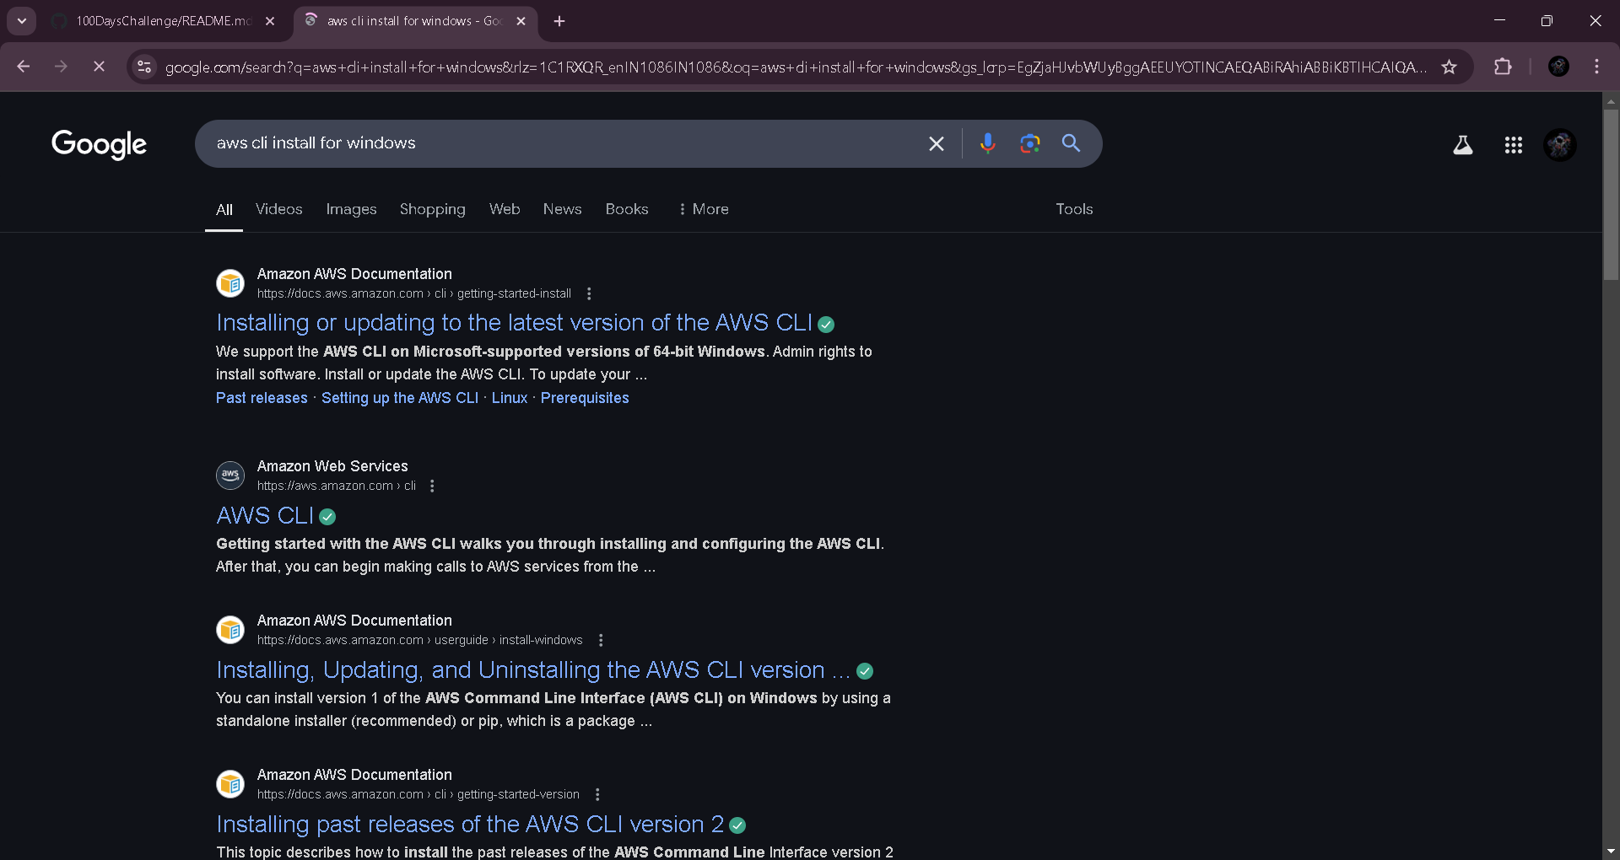

Step 2:

Click on the "Install/Update" option located on the left-hand side of the Apache Lounge website. Select the link regarding your OS, Install by using the link provided else use the ***msiexec*** command

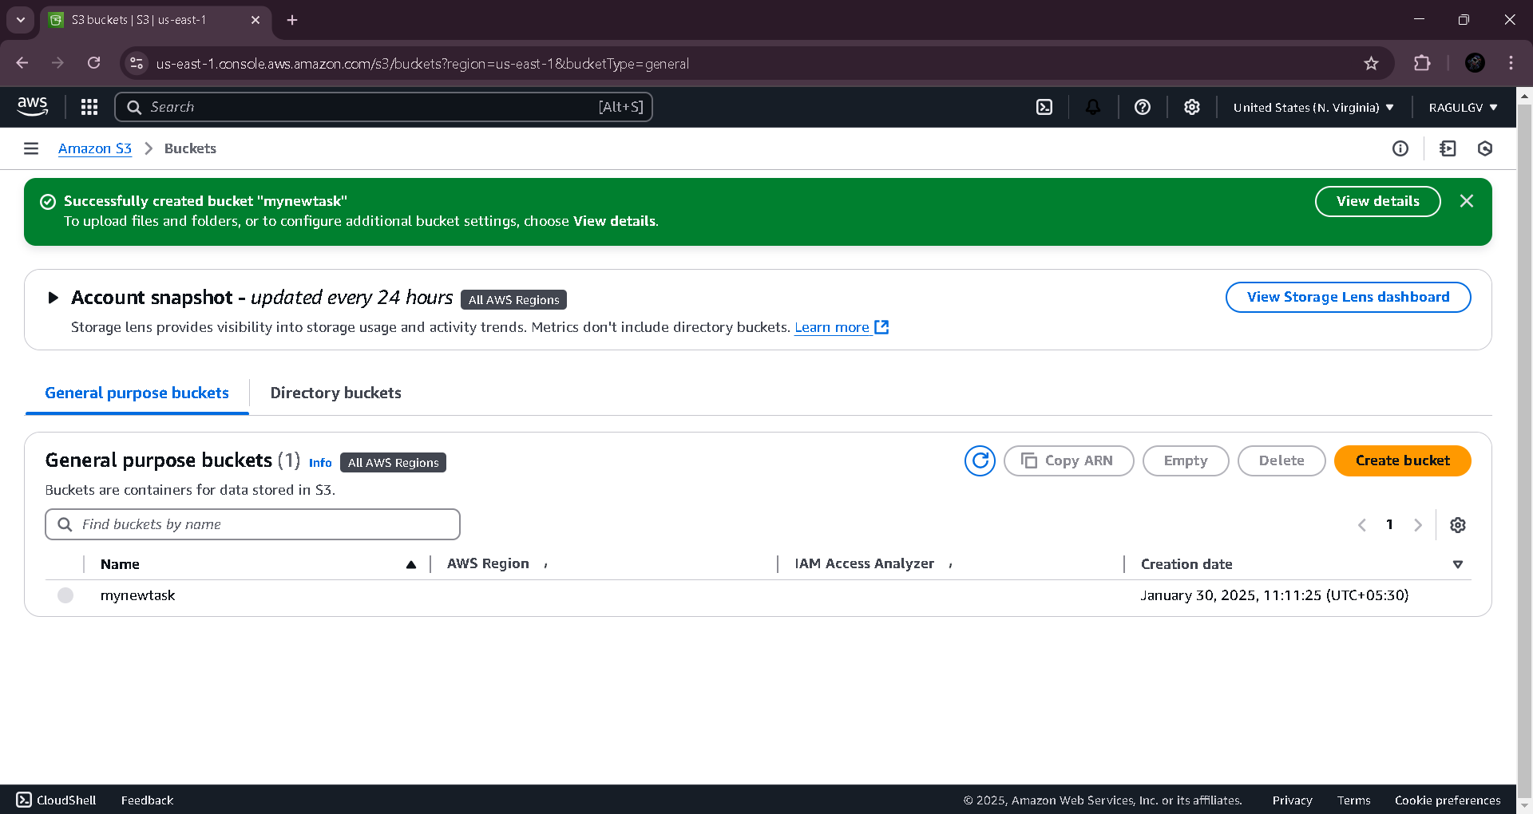

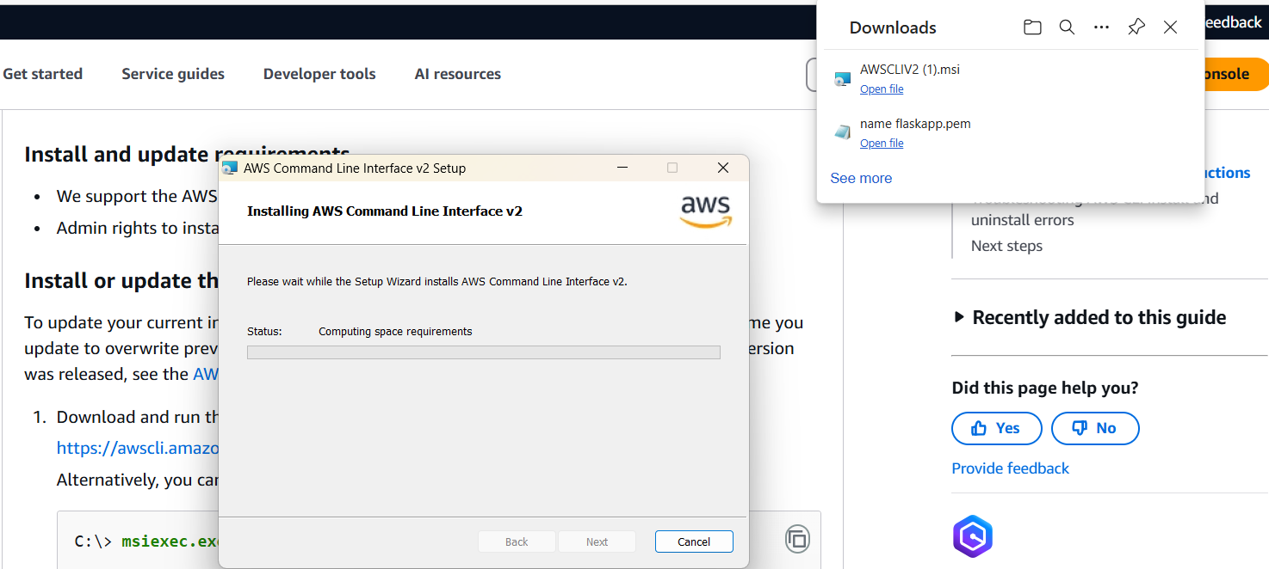

Step 3:

Once installed, verify the installation by opening Command Prompt (cmd) or PowerShell and running **aws –version**

It should return something like

aws-cli/2.x.x Python/3.x.x Windows/x86_64

Step 4:

Before using AWS CLI, you need to configure it with your AWS credentials.

Open Command Prompt and type **aws configure**

It will ask for:

AWS Access Key ID → Get it from AWS IAM > Security Credentials

AWS Secret Access Key → Get it from AWS IAM > Security Credentials

Default region name → Example: us-east-1 (Find yours in AWS Console)

Default output format → Keep it as json or press Enter for default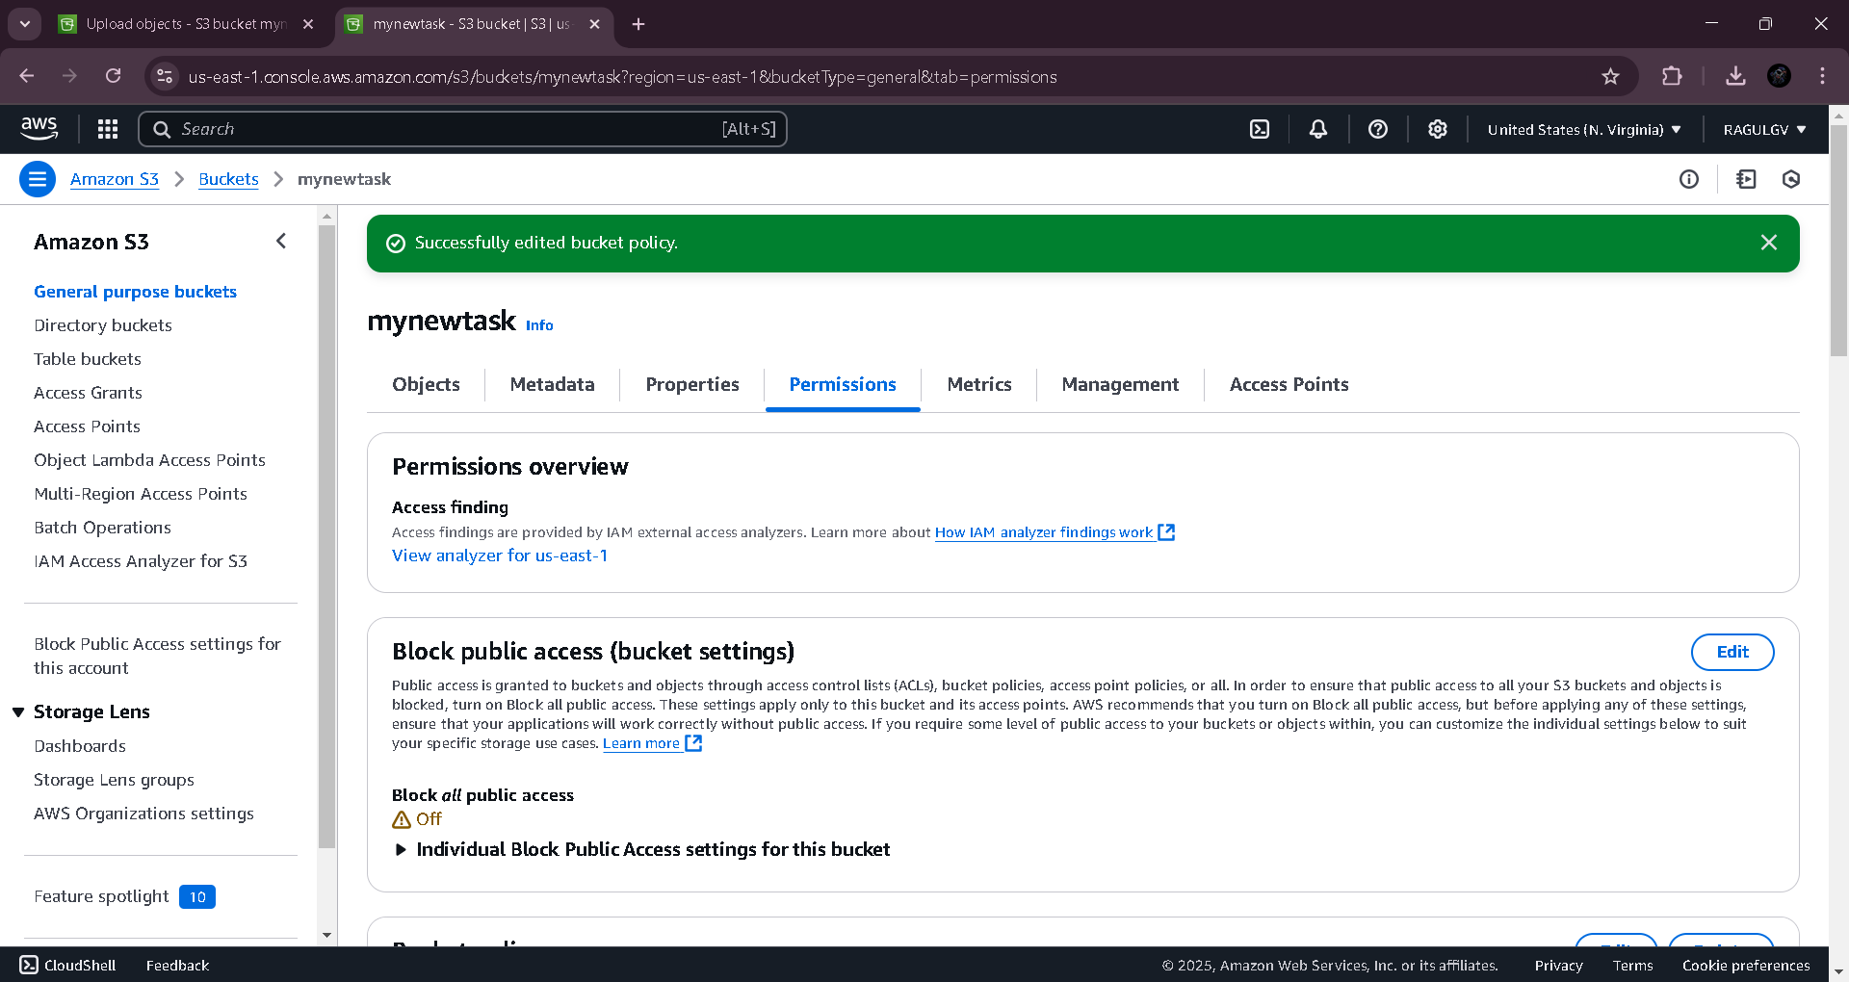

Step 5:

To see all storage buckets, Type **aws s3 ls** in cmd

To check running EC2 instances **aws ec2 describe-instances** in cmd

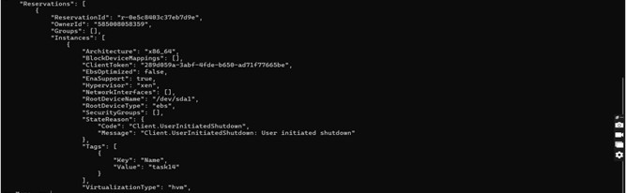

Step 6:

Create an S3 Bucket by typing **aws s3 mb s3://your-unique-bucket-name** in cmd

Upload a file to S3 Bucket by typing **aws s3 cp yourfile.txt s3://your-unique-bucket-name/** in cmd



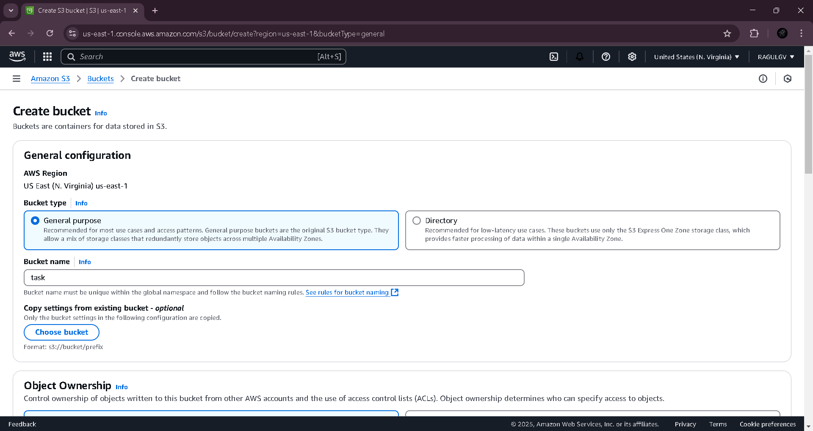

Step 7:

To Start an EC2 Instance, Type **aws ec2 start-instances --instance-ids <INSTANCE_ID>** in cmd

Replace <INSTANCE_ID> with your actual instance ID

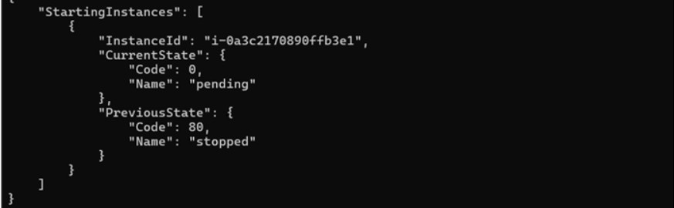

**Outcome**

By completing this POC, you will:

1. ***Successful Installation & Configuration*** – AWS CLI will be installed and configured with the correct credentials, allowing seamless interaction with AWS services.
2. ***Ability to List Cloud Resources*** – You will be able to list AWS resources such as S3 buckets, EC2 instances, and IAM users using CLI commands.
3. ***File Management in S3*** – You will gain hands-on experience in uploading, downloading, and managing files in Amazon S3 using the CLI.
4. ***EC2 Instance Control*** – You will learn how to start, stop, and reboot EC2 instances from the command line, improving your cloud management skills.
5. ***Improved Automation Skills*** – By using CLI instead of the AWS Console, you will develop automation capabilities essential for DevOps and cloud computing.