# **Placement Empowerment Program**

***Cloud Computing and DevOps Centre***

***Secure Access with a Bastion HostSet up a bastion host in a public subnet to securely access instances in a private subnet.***

Name:Ragul.G.V Department:ECE

**Introduction**

In cloud environments, securing access to private instances is crucial. A **Bastion Host** (or Jump Box) is a special-purpose instance that acts as a secure gateway to access EC2 instances in a private subnet. Instead of exposing private instances directly to the internet, users connect to the Bastion Host first and then access the private instances from there.

This setup **enhances security** by limiting direct SSH access to private instances and applying strict security controls.

**Overview**

We will set up a **Bastion Host** in a **public subnet** that provides controlled SSH access to instances inside a **private subnet**.

**What We Will Do?**

1. **Create a VPC** with a **Public and Private Subnet**.
2. **Set Up a Bastion Host** in the Public Subnet.
3. **Launch a Private EC2 Instance** in the Private Subnet.
4. **Configure Secure SSH Access** via the Bastion Host.
5. **Enhance Security** by restricting SSH access and considering AWS Systems Manager as an alternative.

**Step 1:**

**Create a VPC with Public and Private Subnets**

1.1 Create a VPC

* Go to AWS Console → VPC Dashboard.
* Click Create VPC and name it MyVPC.
* Set IPv4 CIDR Block: 10.0.0.0/16.
* Click Create VPC.

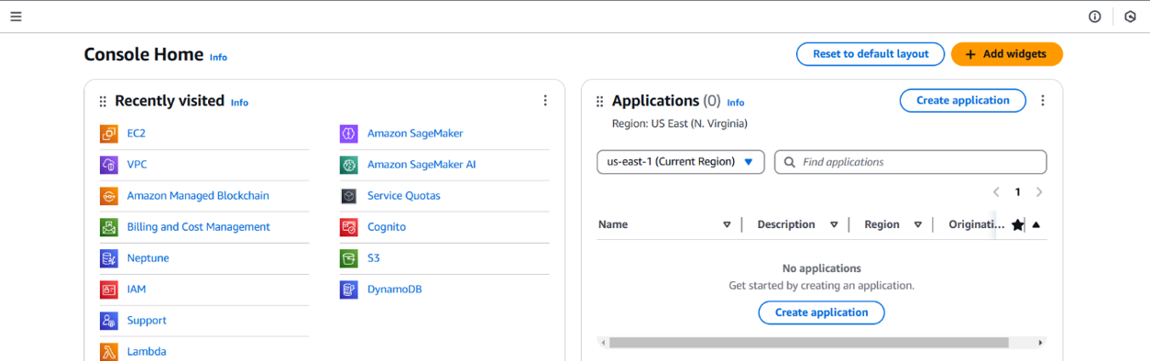

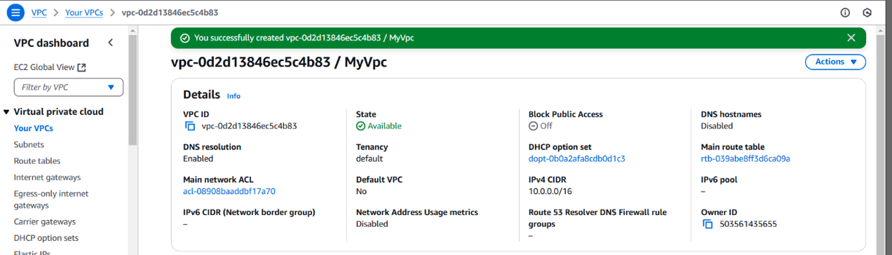

**1.2 Create a Public Subnet**

* Go to **Subnets** → **Create Subnet**.
* Select **MyVPC** and set CIDR block 10.0.1.0/24.
* Enable **Auto-Assign Public IP**.

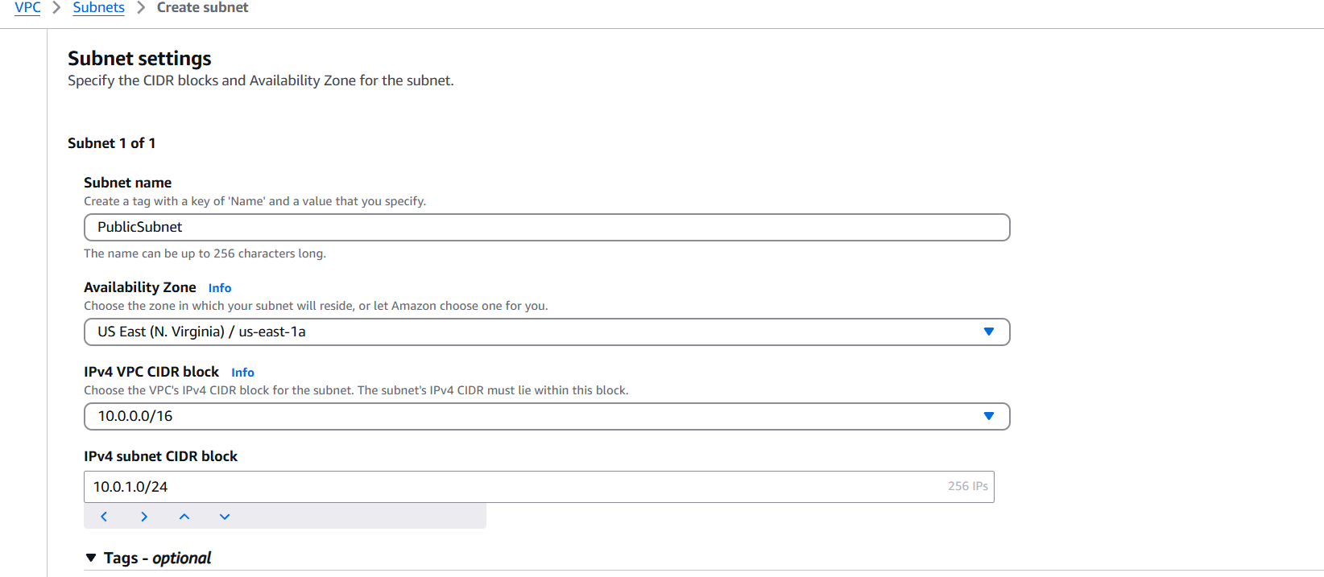

**1.3 Create a Private Subnet**

* Repeat the same process, but use CIDR block 10.0.2.0/24.
* **Do not enable** Auto-Assign Public IP.

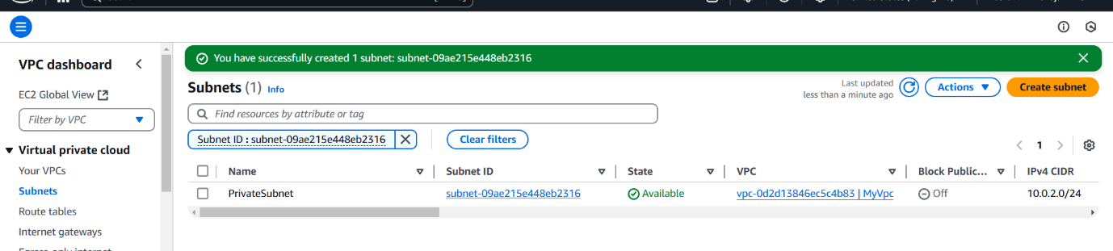

**Step 2:**

**Configure Public Subnet for Internet Access**

**2.1 Create an Internet Gateway (IGW)**

* Go to **Internet Gateways** → Click **Create Internet Gateway**.
* Name it **MyIGW**, attach it to **MyVPC**.

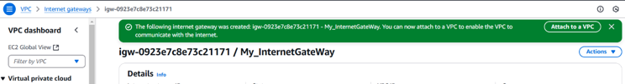

**2.2 Update Public Route Table**

* Go to **Route Tables** → **Create Route Table** → Name it **PublicRouteTable**.
* Associate it with **PublicSubnet**.
* Add a route:
  + **Destination:** 0.0.0.0/0
  + **Target:** **Internet Gateway (MyIGW)**

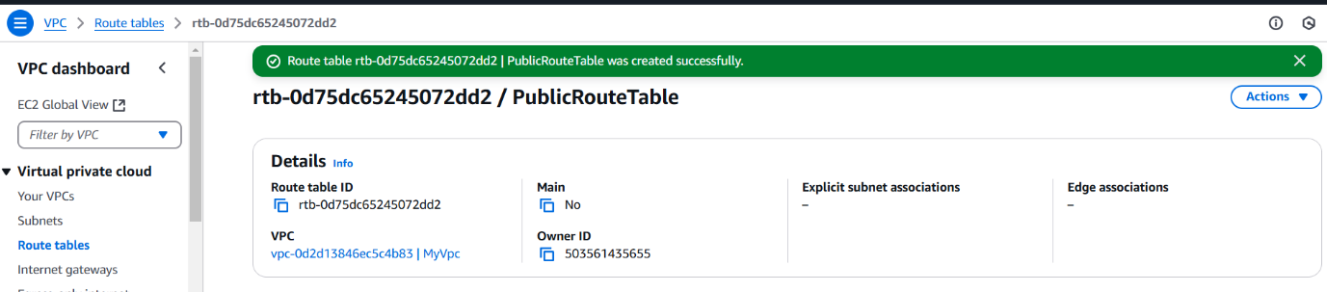

**Step 3:**

**Launch a Bastion Host (Public Subnet)**

1. Go to **EC2 Dashboard** → **Launch Instance**.
2. Select **Amazon Linux 2** (or **Ubuntu**).
3. Choose **t2.micro (Free Tier Eligible)**.
4. Place it in **PublicSubnet** with **Auto-Assign Public IP enabled**.
5. Create a **Security Group (BastionSG)**:
   * Allow **SSH (Port 22) from Your IP** (xx.xx.xx.xx/32).
6. Create or use an **existing key pair** (e.g., bastion-key.pem).
7. Click **Launch**.

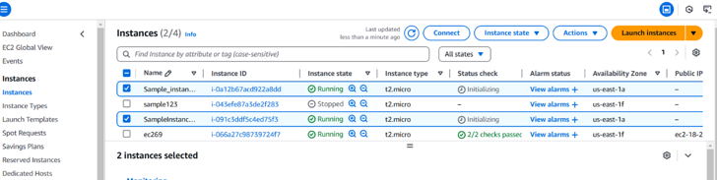

**Step 4:**

**Launch a Private EC2 Instance**

1. Go to **EC2 Dashboard** → **Launch Instance**.
2. Choose **Amazon Linux 2** (or **Ubuntu**).
3. Choose **t2.micro** and place it in **PrivateSubnet**.
4. **Disable Auto-Assign Public IP**.
5. Create a **Security Group (PrivateSG)**:
   * Allow **SSH (Port 22) only from Bastion Host’s Security Group**.
6. Use the same **key pair** (bastion-key.pem).
7. Click **Launch**.

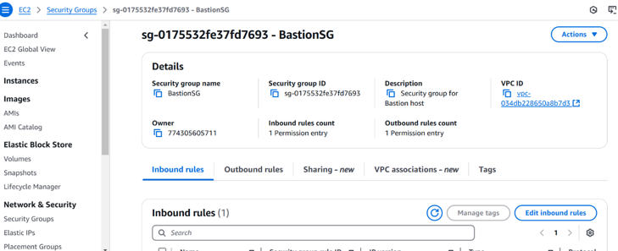

**Step 5: Connect to the Private Instance Using the Bastion Host**

**5.1 Connect to the Bastion Host**

ssh -i bastion-key.pem ec2-user@<bastion-public-ip>

*(Replace <bastion-public-ip> with the actual Bastion Host public IP.)*

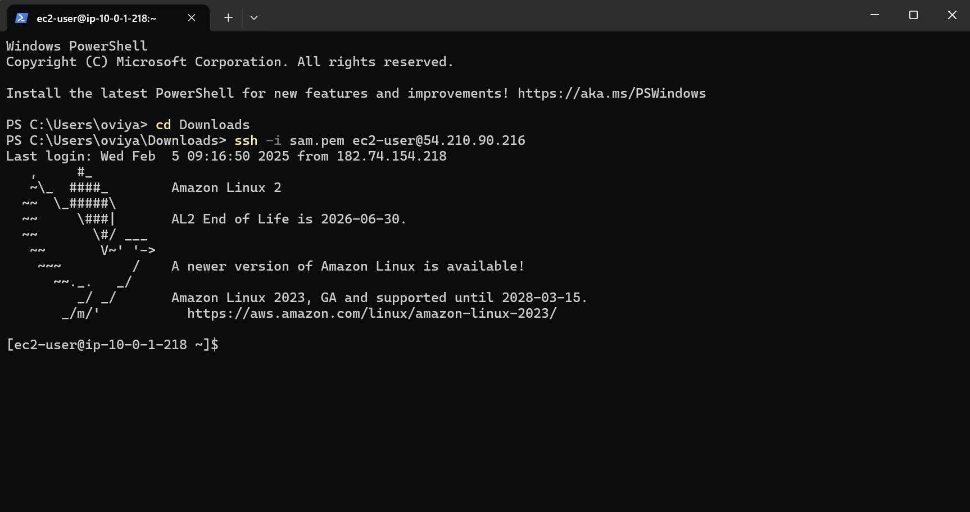

**5.2 SSH from Bastion to Private Instance**

1. Copy the bastion-key.pem file to the Bastion Host:

scp -i bastion-key.pem bastion-key.pem ec2-user@<bastion-public-ip>:~/

1. Connect to the Bastion Host:

ssh -i bastion-key.pem ec2-user@<bastion-public-ip>

1. Change permissions for the key file:

chmod 400 bastion-key.pem

1. SSH into the Private Instance from the Bastion Host:

ssh -i bastion-key.pem ec2-user@<private-instance-ip>

*(Replace <private-instance-ip> with the private IP of your instance.)*

**Step 6: Secure Your Bastion Host**

**6.1 Restrict SSH Access**

* **Go to Security Group (BastionSG)** → Edit Inbound Rules.
* **Allow SSH only from your IP address (xx.xx.xx.xx/32)** instead of allowing all (0.0.0.0/0)

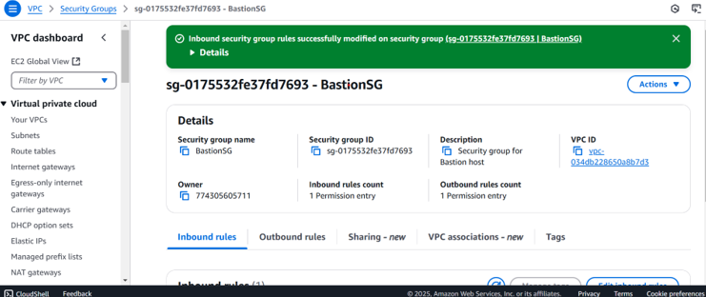

**6.2 Disable Password Authentication**

1. Edit SSH config:

sudo nano /etc/ssh/sshd_config

1. Find and update these lines:

PasswordAuthentication no

PermitRootLogin no

1. Restart SSH service:

sudo systemctl restart sshd

**Step 7:**

**Alternative - Use AWS Systems Manager (SSM) Instead of SSH**

1. **Attach SSM Managed Policy to EC2 IAM Role** (AmazonSSMManagedInstanceCore).
2. **Enable SSM Agent** (Pre-installed on Amazon Linux & Ubuntu).
3. Use **AWS Systems Manager > Session Manager** to connect to instances without SSH.

**Conclusion**

Using a Bastion Host significantly enhances security by acting as a controlled access point to private instances. This setup prevents direct internet exposure, enforces security group rules, and allows monitoring/logging of access.

For even better security, consider eliminating SSH and using AWS Systems Manager (SSM) Session Manager instead.