**DEVOPS PROJECTS**

NOTE: All instances in the same AZ and use Same Security Groups & t2.medium for nexus and sonarqube

PROJECT-1: WAR FILE DEPLOYMENT IN TOMCAT

1. Setup Jenkins on a server and connect to console.
2. Install java on slave on node/slave.
3. Manage Jenkins -- > Manage node -- > new node -- > Name -- > Permanent Agent -- > OK

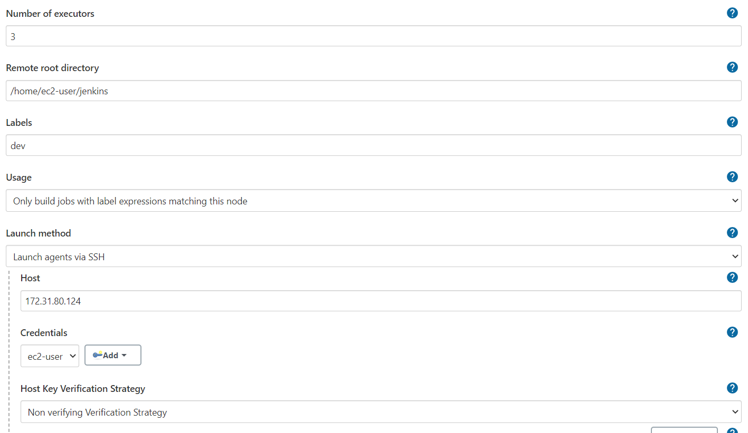

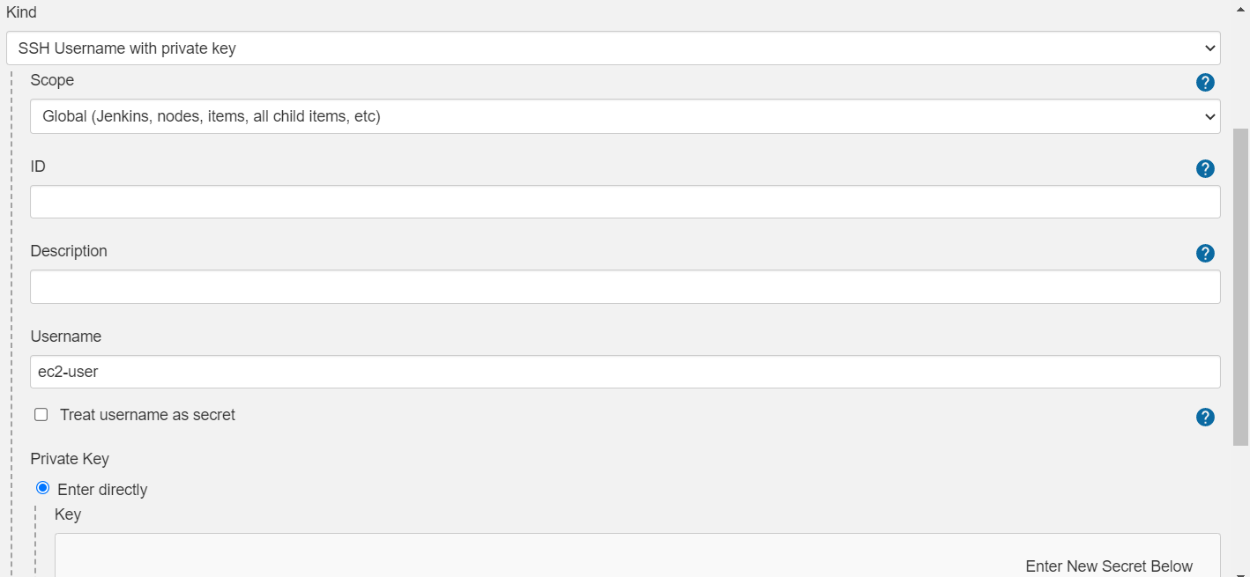

1. Now refresh the status and you will see the salve is active now.
2. Create a Job now.

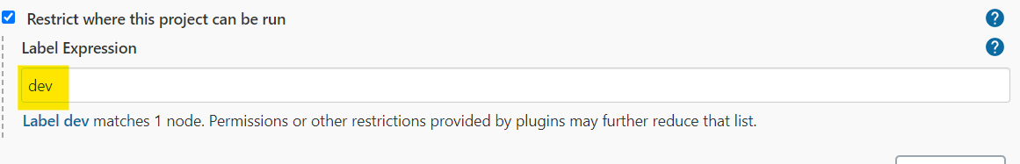

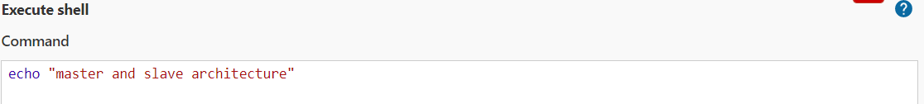

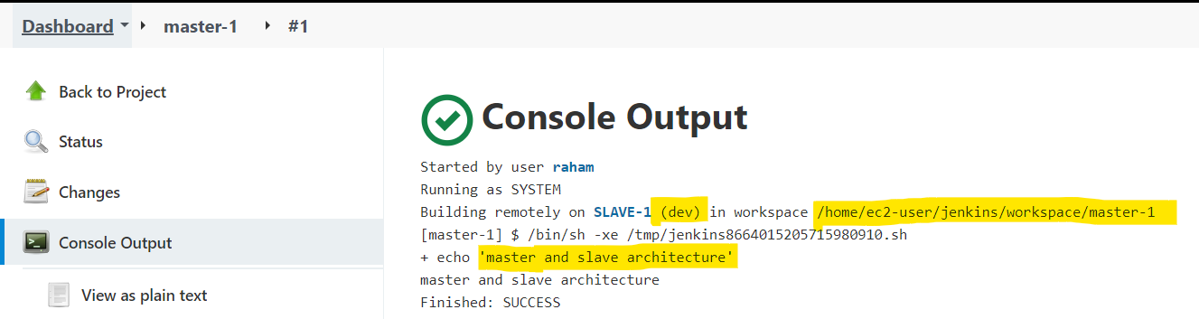

1. Now select a branch from git hub, select label and build now

(<https://github.com/RahamShaik486/mywebapp.git>)

1. Now it will be failed because we haven’t installed git in slave.
2. Install git in salve and build it now it will be success.
3. Add clean package in build -- > invoke top-level maven targets.
4. Before build install maven for it.
5. wget <https://dlcdn.apache.org/tomcat/tomcat-9/v9.0.58/bin/apache-tomcat-9.0.58.tar.gz>
6. tar -zxvf apache-tomcat-9.0.58.tar.gz
7. cd apache-tomcat-9.0.58/
8. chmod 777 webapps/ && cd webapps/manager/META-INF/ && vi context.xml
9. Delete two lines (value & allow tag lines)
10. cd ../../../ && cd conf && vi tomcatuser.xml



1. cd ../bin && ./startup.sh
2. Copy public ip of slave and paste it on browser (54.164.126.228:8080)
3. Click on manager apps give credentials.
4. Manage Jenkins -- > Manage plugins -- > Available -- > deploy to container -- > wout restart
5. Post Build Actions -- > Deploy to container -- > install -- > Restart.
6. Go to job Deploy war/ear to a container -- >

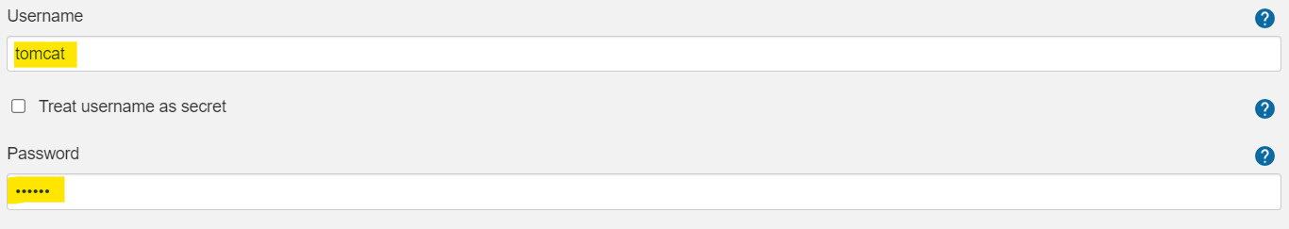

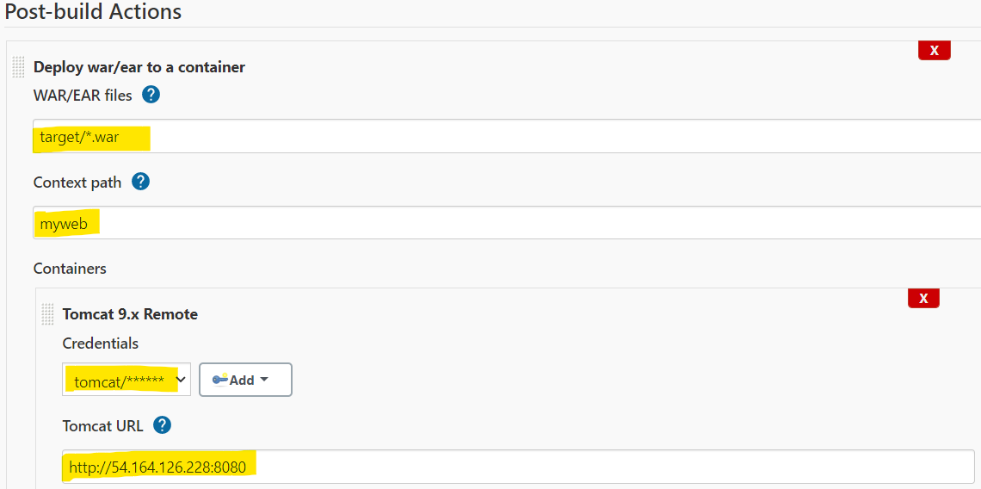

1. Now Go to browser and refresh the tomcat server you can see the deploymet.
2. Now Poll scm -- > * * * * * -- > Go to Github and /src/main/webapp/index.jsp.
3. Edit the code here and change the commits.
4. New build will be done automatically.