**LAB1 : Building a Classification Model for the Iris data set**

1. **Import libraries**

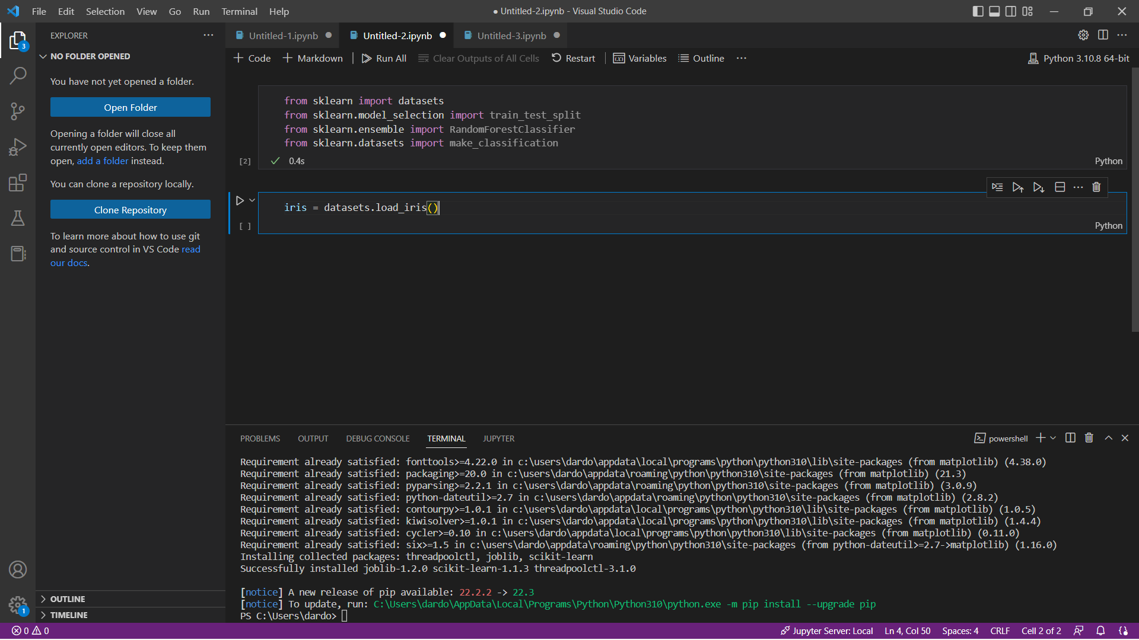

1. **Load the iris data set**

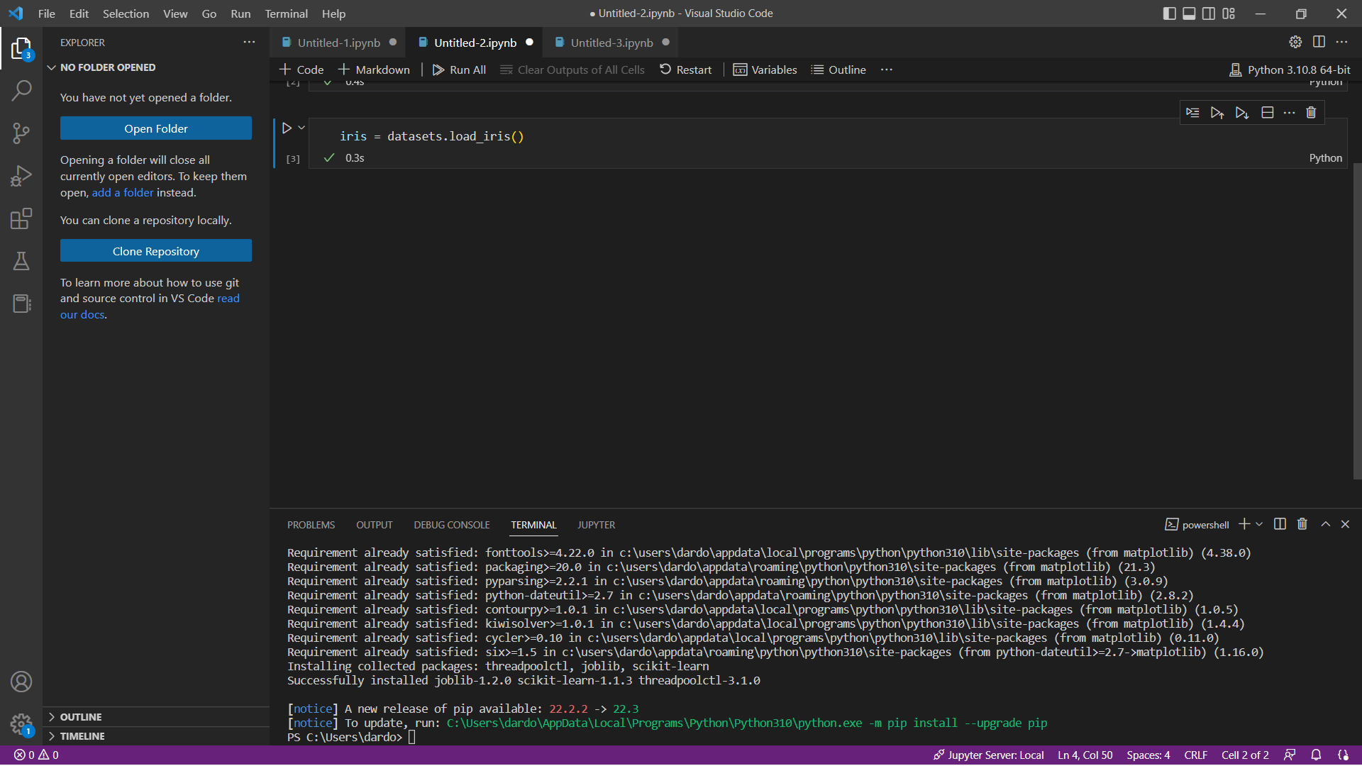

1. **Input features**
   1. **Input features**

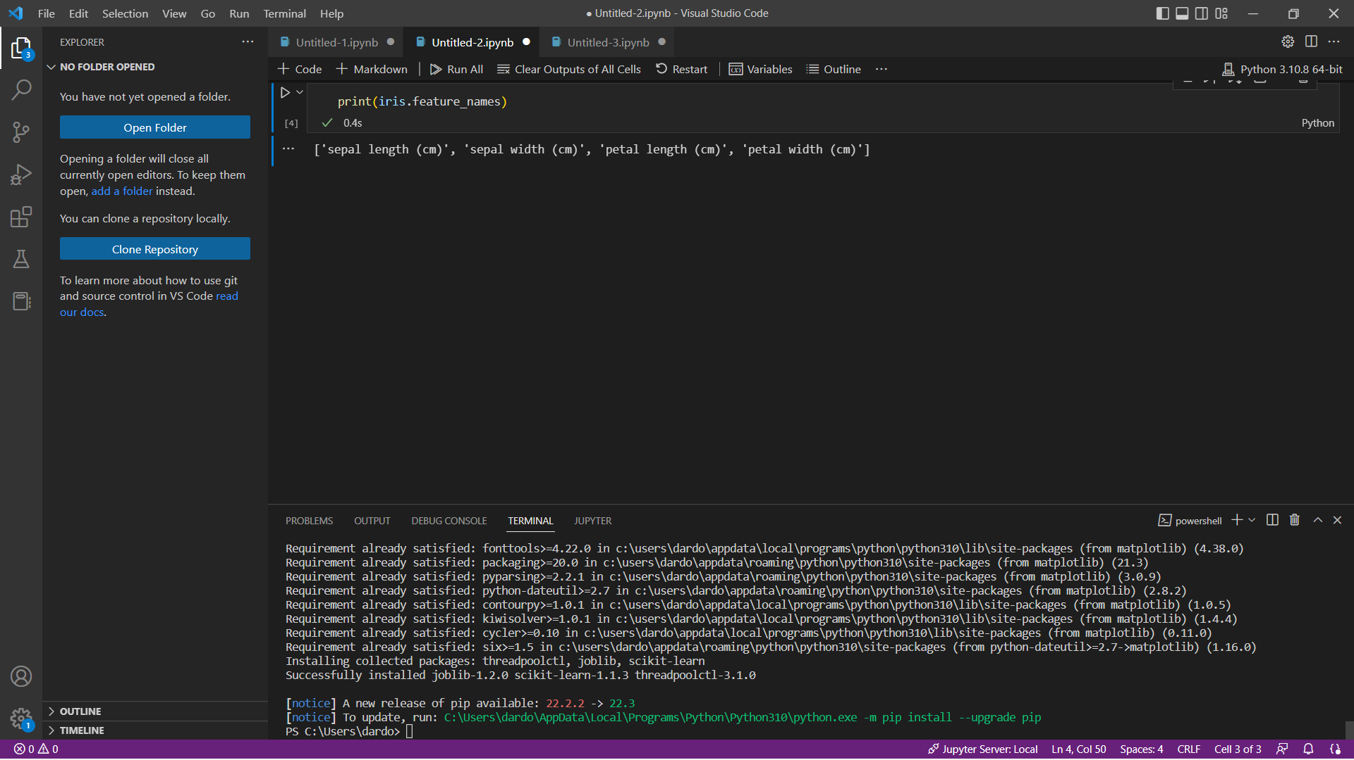

* 1. **Output features**

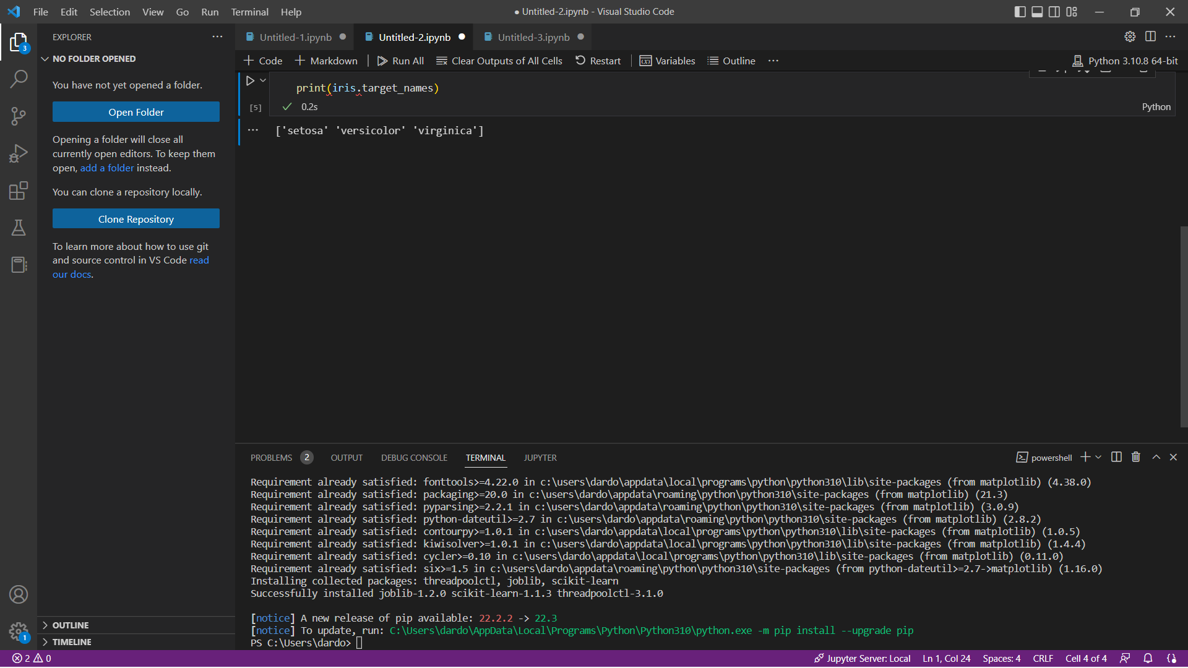

1. **Glimpse of the data**
   1. **Input features**

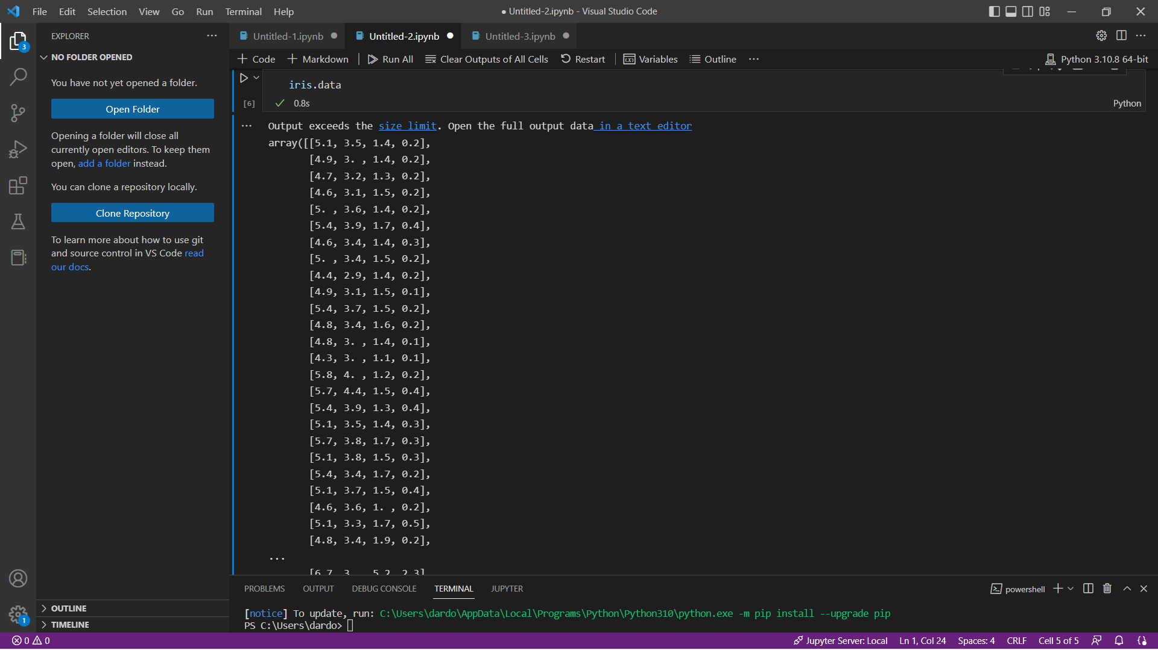

* 1. **Output variable (the Class label)**

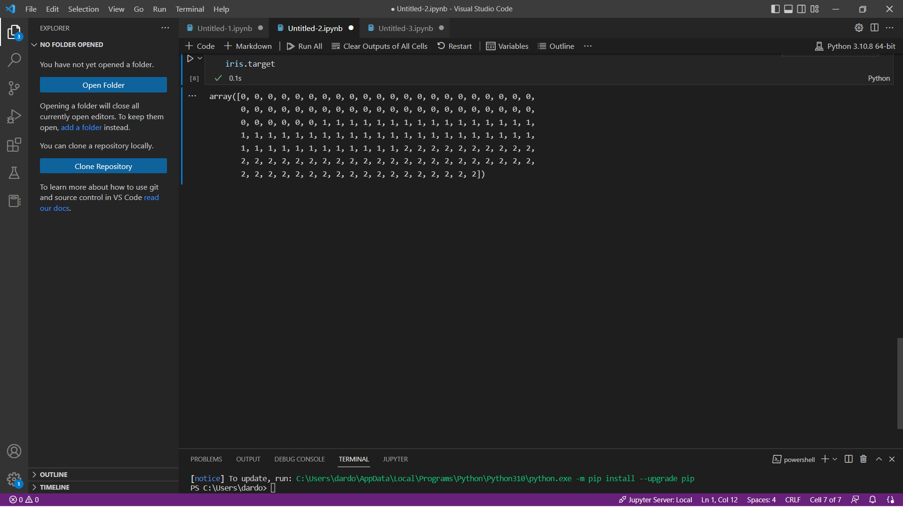

* 1. **Assigning input and output variables**

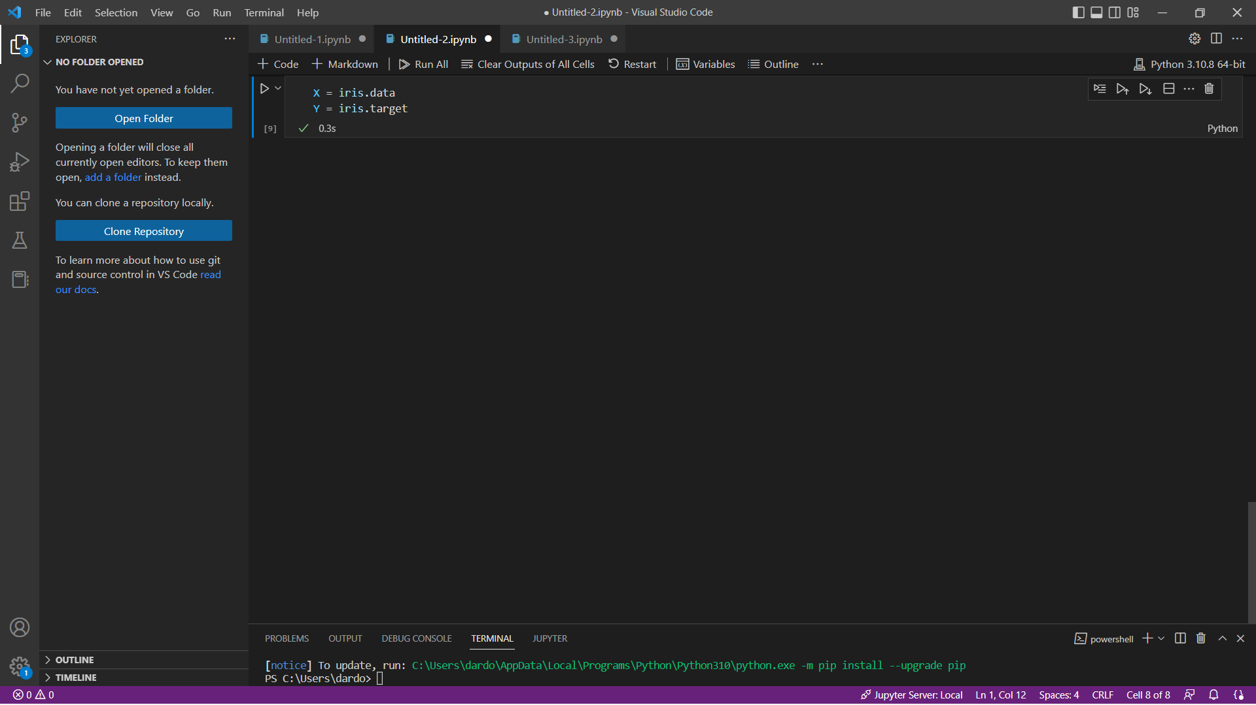

* 1. **Let's examine the data dimension**

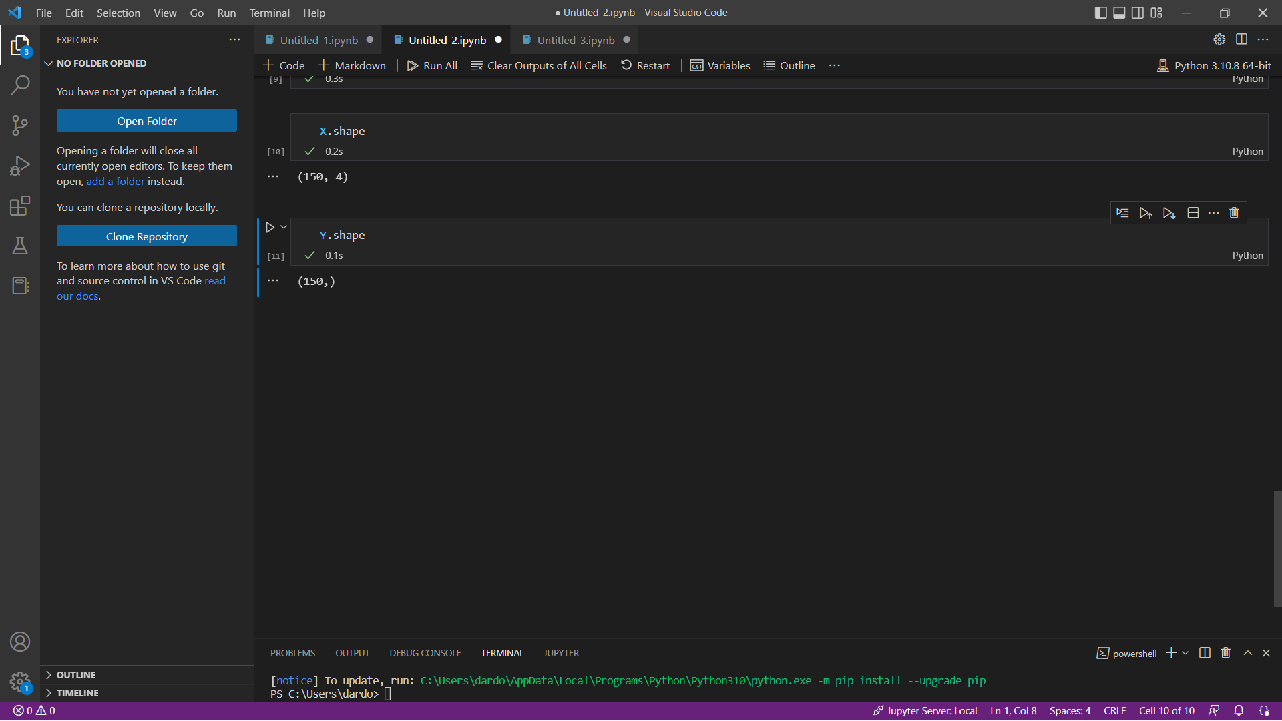

1. **Build Classification Model using Random Forest**

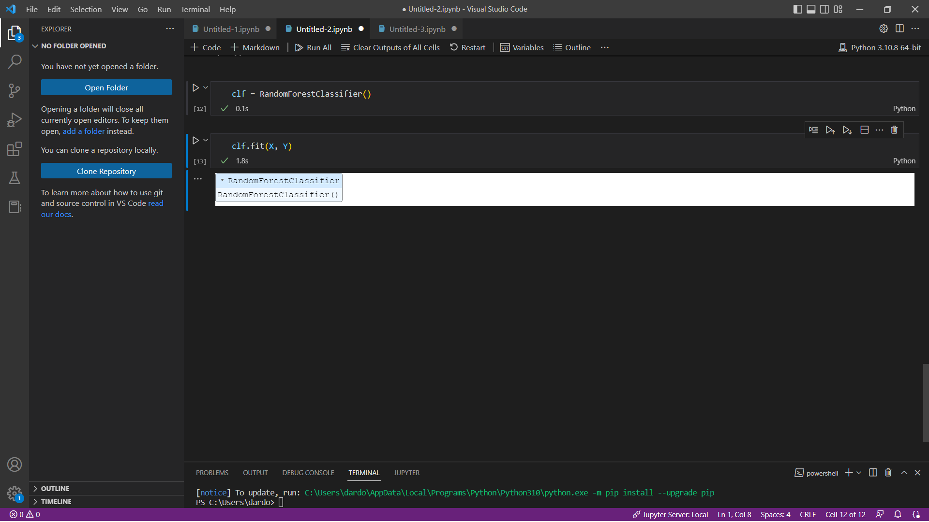

1. **Feature Importance**

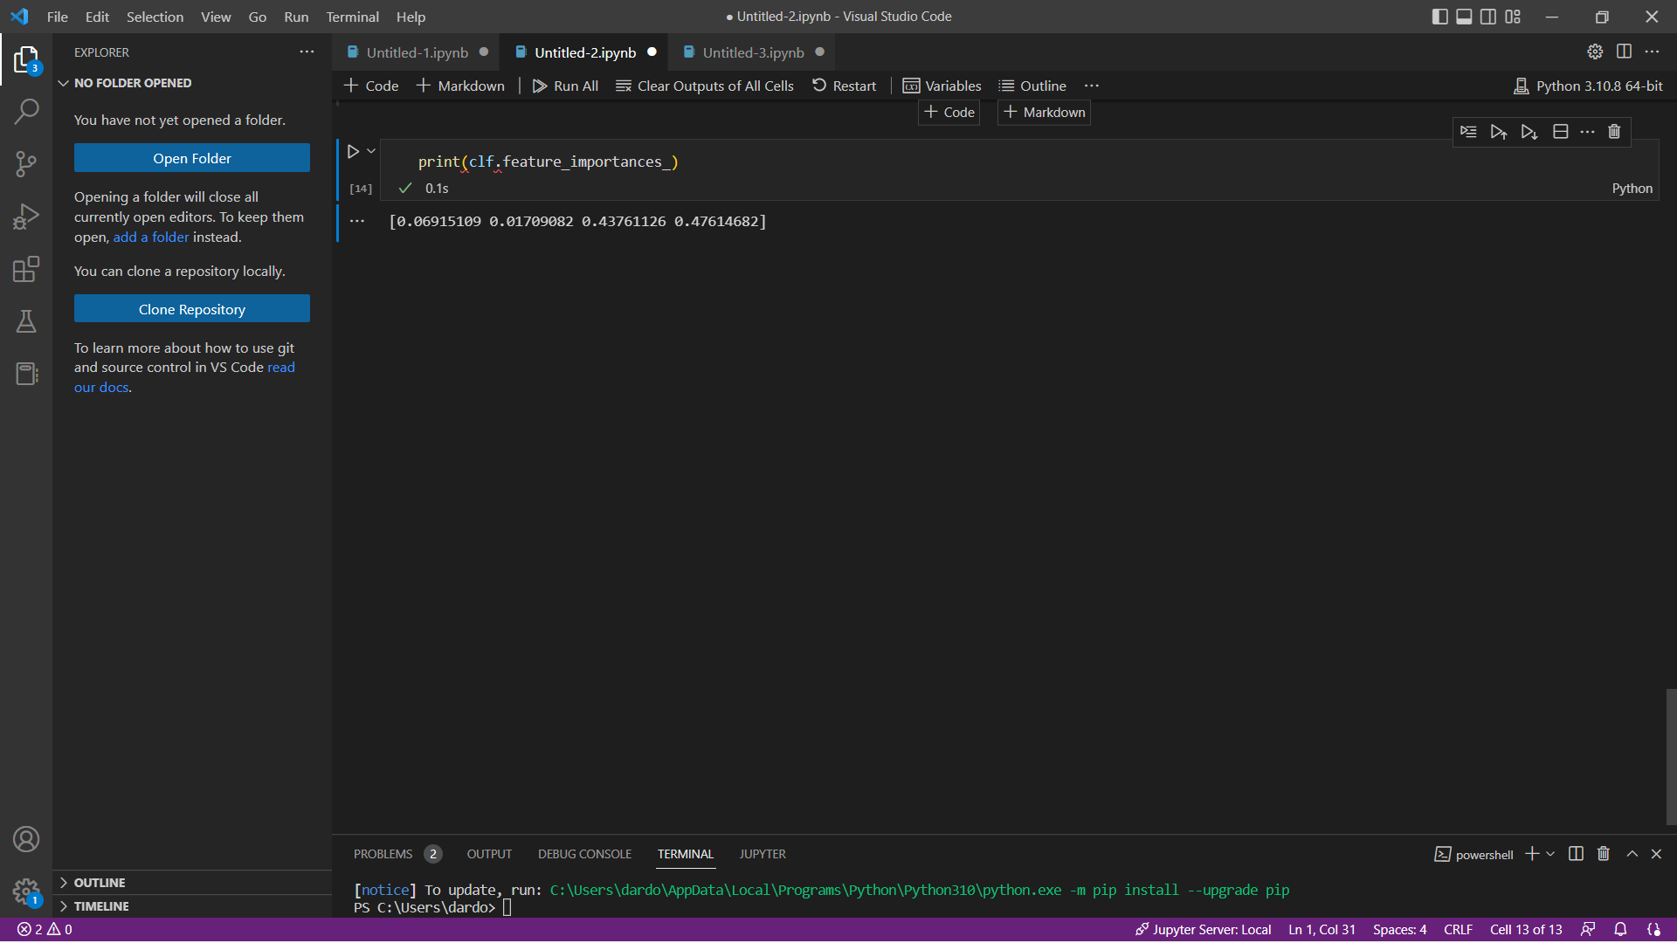

1. **Make Prediction**

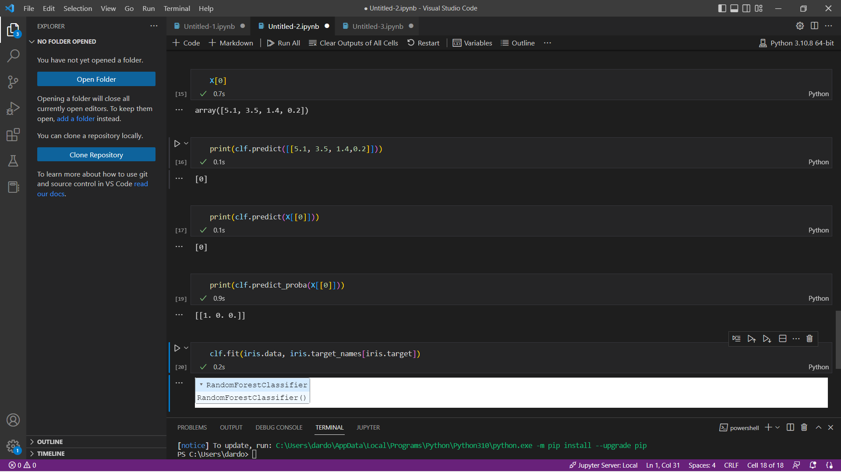

1. **Data split (80/20 ratio)**

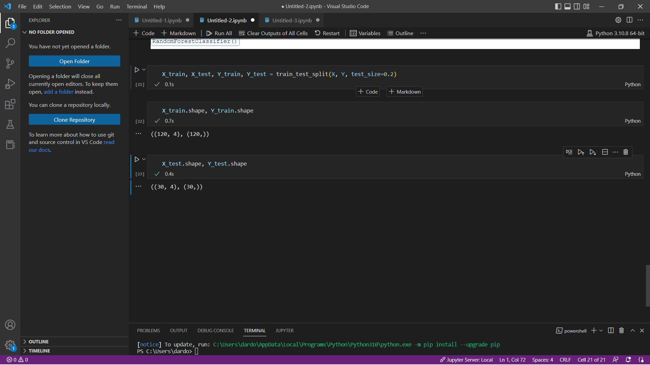

1. **Rebuild the Random Forest Model**

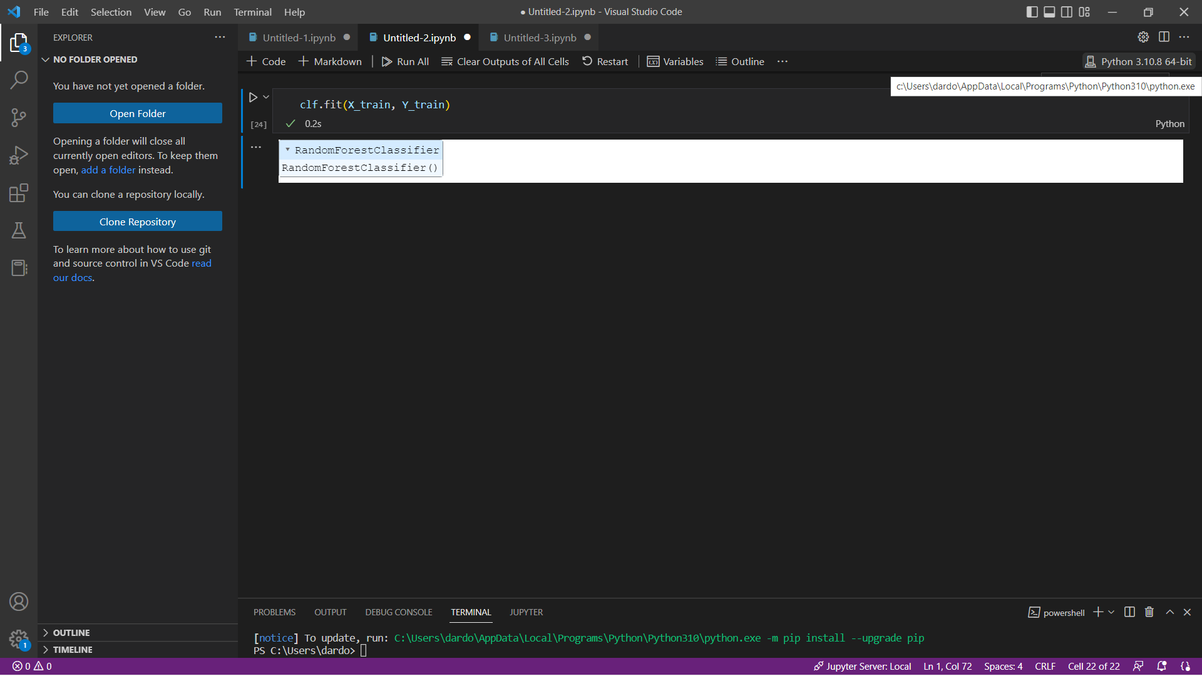

* 1. **Performs prediction on single sample from the data set**

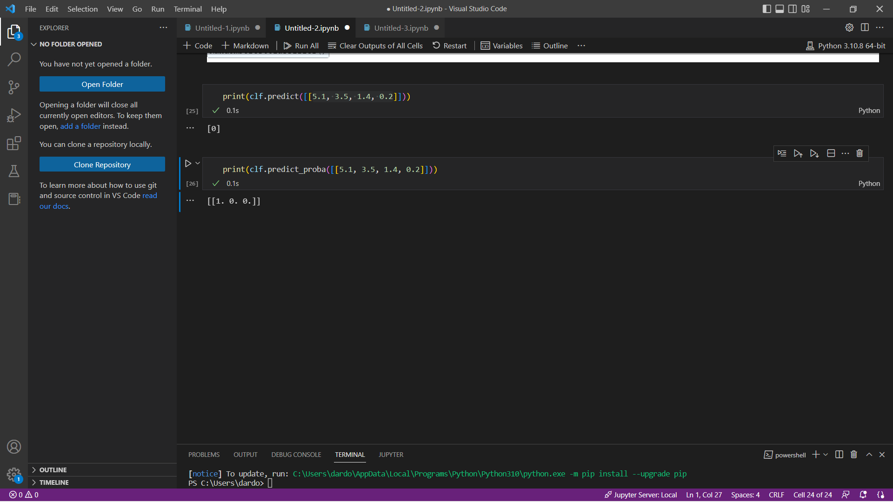

* 1. **Performs prediction on the test set**

**Predicted class labels**

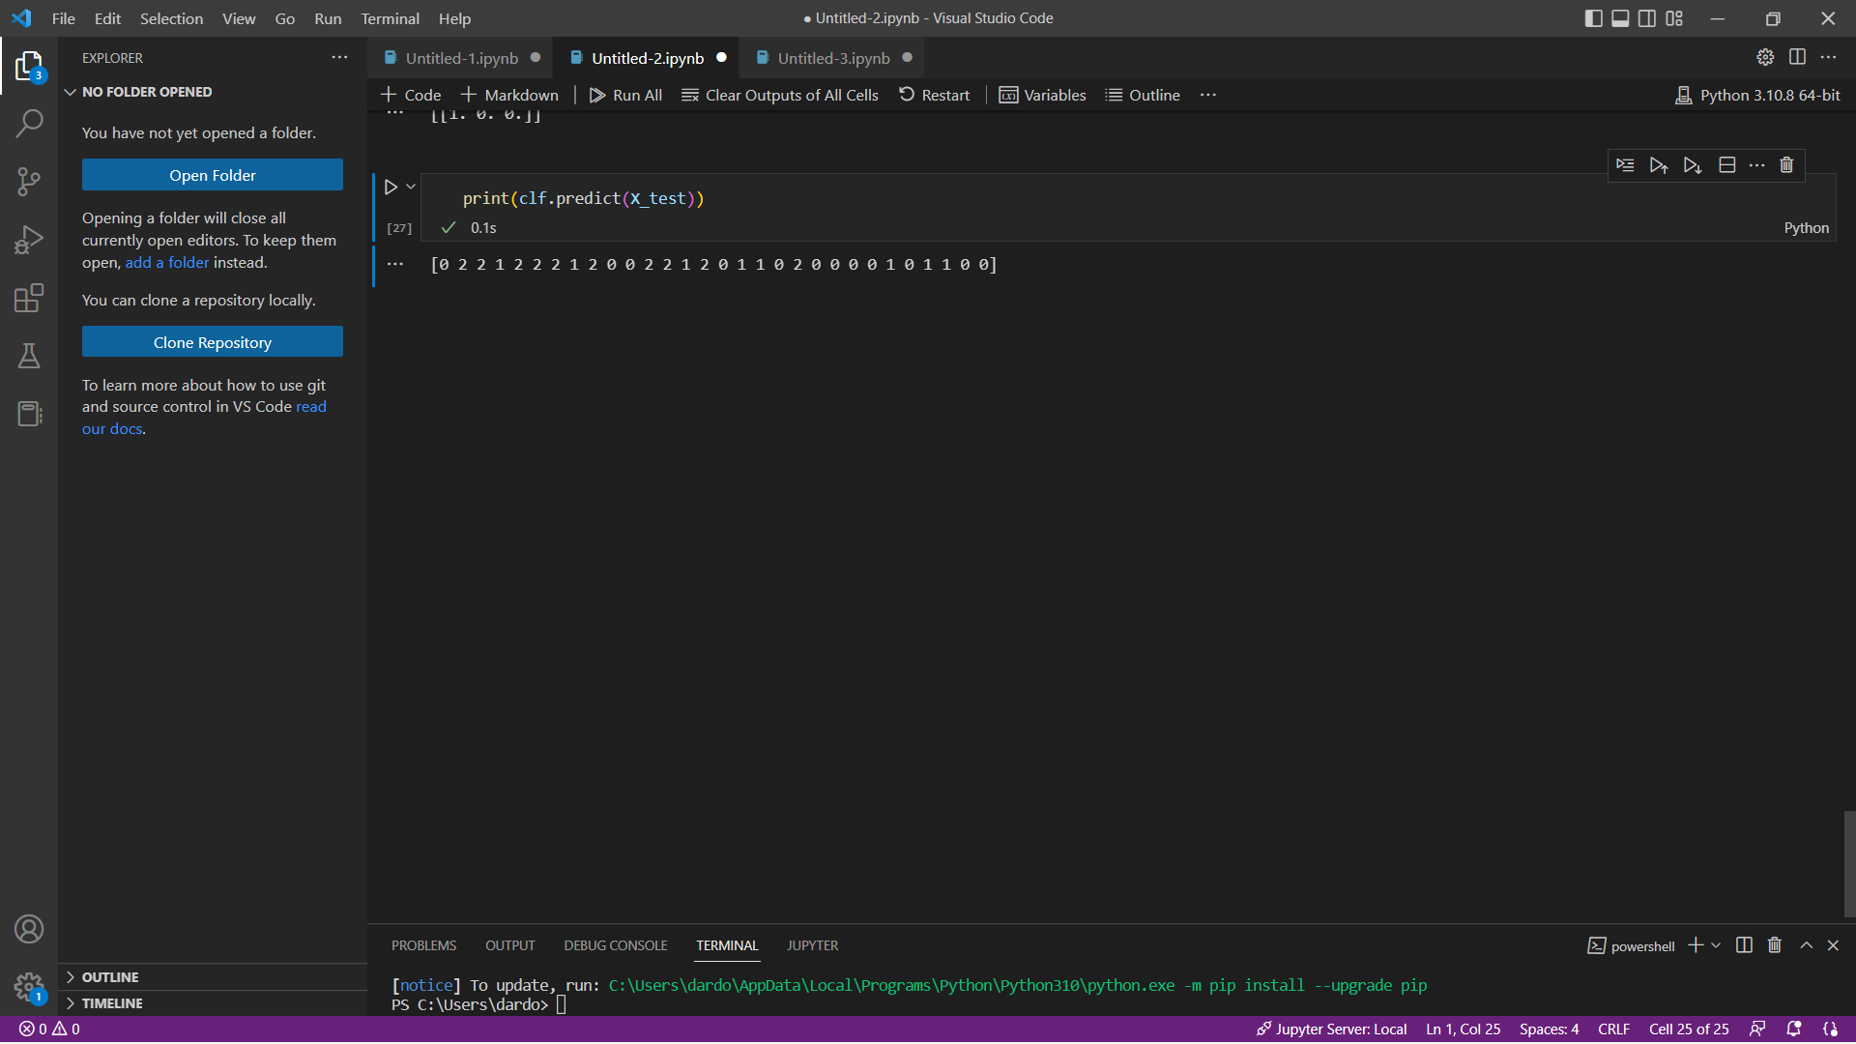

**Actual class labels**

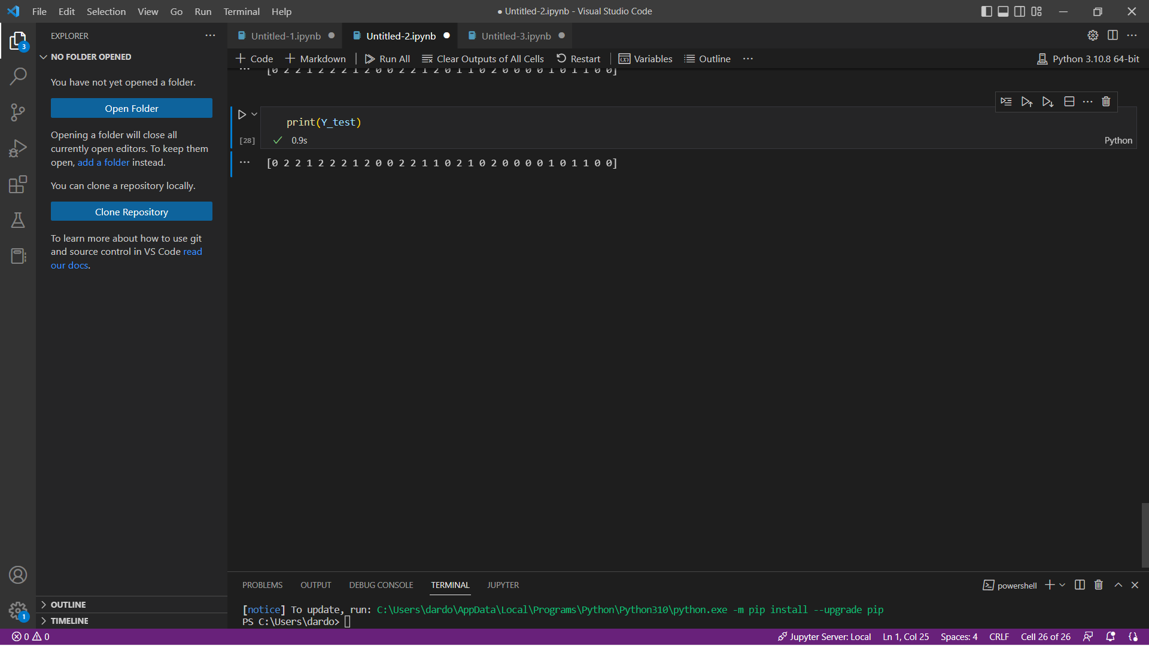

1. **Model Performance**

