**AMAZON CLONE** *A PROJECT REPORT*

*Submitted to*



**HIMACHAL PRADESH TECHNICAL UNIVERSITY, HAMIRPUR**

*by*

# RAHUL (22010203040)

*in partial fulfilment for the award of the degree of*

**BACHELOR OF TECHNOLOGY**

*in*

# COMPUTER SCIENCE & ENGINEERING



## DEPARTMENT OF COMPUTER SCIENCE & ENGINEERING

**ATAL BIHARI VAJPAYEE GOVT. INSTITUTE OFENGINEERING &**

**TECHNOLOGY**

**PRAGATINAGAR, SHIMLA, HIMACHAL PRADESH**

# NOVEMBER 2024



# CERTIFICATE

I hereby certify that the work which is being presented in the B.Tech Industrial project report entitled **“AMAZON CLONE”,** in partial fulfilment of the requirements for the award of the **Bachelor of Technology in Computer Science & Engineering** and submitted to the Department of Computer Science & Engineering of Atal Bihari Vajpayee Govt Institute of Engineering & Technology, Pragati Nagar , Shimla, HP is an authentic record of my own work carried out during a period from J u n e 2024 to J u l y 2024.

*Signature*

*RAHUL*

*22010203040*

This is to certify that the above statement made by the candidate is correct to the best of my knowledge.

## Head

Computer Science & Engineering Department

Atal Bihari Vajpayee Govt Institute of Engineering & Technology, Pragati Nagar

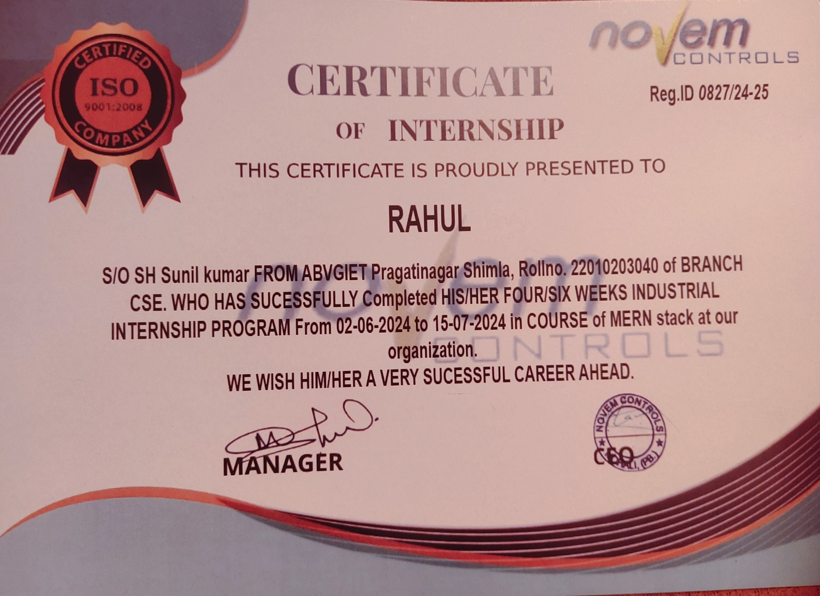

# DECLARATION

I, Rahul , a student of Bachelor of Technology (B. Tech.) Computer Science & Engineering Department,

Atal Bihari Vajpayee Government Institute of Engineering and Technology, Pragati Nagar Shimla, having Roll No. 22010203040 (session 2022-2026) hereby declare that this Industrial Training Report has been submitted to the Computer Science & Engineering Department as partial fulfilment of the requirements for the award of the degree of Bachelor of Technology. This report is an original piece of work and has not formed the basis for awarding any other degree from any other college.

RAHUL

B.TECH 5th Semester, CSE

22010203040

# ACKNOWLEDGEMENT

Firstly, I would like to thank my mentors at for their continuous support, for their patience, motivation, enthusiasm, and immense knowledge. Their guidance helped me to be able to deliver all the required tasks and be able to make valuable contributions to the project. I could not have imagined having better advisors and mentors for my internship or Industrial Besides, I would like to thank all the professors and faculty members at ABVGIET for allowing me to take this Internship opportunity and for their encouragement, insightful comments, and continuous support I am very grateful to my Industrial training project guide of **Novem training’s guider** for giving his valuable time and constructive guidance in preparing the Industrial training project. It would not have been possible to complete this Industrial training project in short period of time without his kind encouragement and valuable guidance.

RAHUL

B.TECH 5th Semester, CSE

22010203040

**Abstract**

The Amazon Clone Website is an e-commerce platform designed to provide a seamless and user-friendly online shopping experience, resembling the core features of the original Amazon website. Its primary objective is to offer a wide range of products across multiple categories, including electronics, fashion, home goods, and more, in a secure, efficient, and personalized environment. The system integrates modern technologies like machine learning for personalized recommendations and data analytics to optimize product listings and search results, ensuring users can easily find products suited to their preferences.

The website offers key features such as advanced product search filters, a secure checkout system, real-time order tracking, user reviews and ratings, and various payment gateway options. It is built to be responsive, ensuring a smooth experience across devices, from desktop computers to mobile phones. Security is a top priority, with robust measures like SSL encryption, secure payment processing, and user authentication to safeguard sensitive customer data and prevent cyber threats.

The project follows a systematic development approach, utilizing the Waterfall Model to ensure that each phase, from requirement gathering to design, implementation, testing, and maintenance, is carried out in a structured manner. This ensures the final product meets the requirements and provides a reliable, scalable e-commerce platform.

**INDEX**

|  |  |  |
| --- | --- | --- |
| **S.NO** | **TITLE** | **PAGENO** |
|  | Cover and Title Page |  |
|  | Certificate | i-ii |
|  | Declaration | iii |
|  | Acknowledgement | iv |
|  | Abstract | v |
|  | Index | vi |
|  | List of figures | vii |
| 01 | Chapter1: Introduction | 1-2 |
| 02 | Chapter2: Software and Hardware Requirement | 3-4 |
| 03 | Chapter3: System Analysis | 5-6 |
| 04 | Chapter4: Feasibility Study | 7-10 |
| 05 | Chapter5: Software Engineering Paradigm Applied: Waterfall Model | 11-12 |
| 06 | Chapter6: System Design | 13-16 |
| 07 | Chapter7: Screenshots | 17-18 |
| 08 | Chapter8: Project Code | 19-24 |
| 09 | Chapter09: Validation Check | 25-26 |
| 10 | Chapter10: Testing | 27-28 |
| 11 | Chapter11: Implementation and maintenance | 29-30 |
| 12 | Chapter12: System Security Measures | 31-32 |
| 13 | Chapter13: Future Scope | 33-34 |
| 14 | Chapter14: References | 35 |

**LIST OF FIGURES**

|  |  |  |
| --- | --- | --- |
| **SR.NO** | **FIGURE NAME** | **PAGENO** |
| **Fig 7.1** | Navbar | 7 |
| **Fig 7.2** | Homepage | 7 |
| **Fig 7.3** | Footer | 7 |