MONTHLY PROGRESS REVIEW
OCTOBER 2026
Project ID: MKCE/R&I/Consultancy/2026/001

AI-Based Egg Tray Inventory Management System (EG-Counter)

Prepared by
Rahul S (927623BCB041)
Yasvanthpalani S (927623BCB063)
Dharaneesh Kesavan (927623BCB007)
Dharani S (927623BCB008)
Mukund Balaji B (927623BCB033)

Guided by
Dr. V. Banupriya, HoD/CSBS
Mr. T. Viswanath Kani, AP/CSBS

Department of Computer Science and Business Systems
M. Kumarasamy College of Engineering
Thalavapalayam, Karur
Report prepared 3 November 2026

1. Monthly Progress Summary
October moved EG-Counter from counting single photos to counting a whole block of tray stacks from a front photo and two side photos. A block model, a guided camera, network retries, per-phone approval keys and a same-face guard were built. Version 0.4.12 of the app now runs on the farm's Redmi phone against the test (staging) server. The first test on 52 hand-labelled farm photos, and the first warehouse scans, showed close counts on close, straight-on photos and large undercounts on angled or distant photos.
Current phase: field rollout on the test server. No physical recount of trays exists yet. Every accuracy figure in this review compares the app with handwritten labels or with counts made by eye from photos, never with trays counted on site.

2. Work Completed This Month

2.1 First test on 52 hand-labelled farm photos (1-7 October)
The user sent 52 farm photos with tray totals written on them by hand. The unchanged production model (Roboflow projec-mutta/2) was run on every photo without seeing the labels: 5 of 52 were exact, the mean absolute error (MAE) was 45.1 trays, and the model counted 2,839 trays against 5,041 labelled. Straight-on photos where one face fills the frame were usually close (12 of 18 within 5%); angled, corner and distant photos all failed (0 of 16 and 0 of 5 within 5%). An experimental 3D photo-matching service on AWS matched picture points between two photos but identified no trays and gave no count.

2.2 Counting a whole block from three photos (8-14 October)
A block model combines the front photo (width and stack heights) with the side photos (depth), computes the hidden inner stacks, and draws the block in 3D on the phone. A new 'walk' layer counter was exact on 51 of 53 reference stacks (the older method: 40 of 53; these are development photos). A blind manual-count screen stores the operator's own count next to each scan. The camera screen was rebuilt, and uploads were made to survive the weak Jio connection (IPv6 lost 40-66% of packets to the server address). On the Redmi phone, a real 99-tray block was counted as 20/20/20/20/19 = 99 in 25 s.

2.3 First warehouse scans and counting fixes (13-14 October)
Seven warehouse scans arrived on 13 October, none with an on-site count. On a close 4 x 3 block the app gave 165 (105 seen + 60 computed) against 164 counted by eye from the photos. A far 5 x 4 corner block read about half the layers, and the app held its total back. On 26 October the far-block comparison was corrected: it had set assumed trays against assumed trays, so it does not measure detector misses. The counting rules were then fixed: merged face readings, a one-layer disagreement gives 'estimated', bounded gap filling, a step-closer request and one result status per scan.

2.4 Version 0.4.12: approved phones and resumable scans (15-28 October)
Each phone now creates its own key, and an administrator approves it. A scan interrupted by the network can be resumed instead of being counted again. All automated tests passed (Worker 111/111, app 167/167). An offline check of the counting rules on the labelled photos gave 10 accepted label clusters (9 exact, 1 wrong: 78 for 80) and 12 withheld, on photos the rules were tuned on. After a move to a new laptop (26 October), 0.4.12 went to the test server in observe mode, and the app was signed with a new release key.

2.5 The app on the farm phone and the same-face guard (29-31 October)
App 0.4.12 was installed on the Redmi Note 9 Pro and approved on the test server. A network test on Jio LTE passed 20 of 20 checks over IPv4 and over IPv6, and 3 of 3 photo uploads. On eight sets of earlier field photos, the server's stack counts equalled the eye count on 9 of 10 close, straight-on stacks. But three front photos of block L-100, sent as front, left and right, made the server report 500 'estimated' for a 100-tray block. A same-face guard, using the phone's turn sensor, was built and tested (Worker 122/122, app 176/176) but not yet deployed.

2.6 Photo evidence and measured counts
Measurement | Reference used | App / model result | What it shows
52 hand-labelled farm photos (7 Oct) | Handwritten totals, 5,041 trays | 2,839 trays; 5/52 exact; MAE 45.1 | Large undercount overall; not a physical recount
Straight-on photos, one face filling the frame | Handwritten totals | 12/18 within 5% (median 4.2%) | Close when the photo is good
Angled, corner or multi-block photos | Handwritten totals | 0/16 within 5% (median 70.2%) | Camera angle causes the large errors
Walk counter, 53 reference stacks (9 Oct) | Per-stack reference from labels and inspection | 51/53 exact (older method 40/53) | Development photos, not new data
Real 99-tray block on the Redmi (12 Oct) | 20/20/20/20/19 entered by hand | 20/20/20/20/19 = 99 in 25 s | One block; photos used in tuning
Close warehouse block 9b4c783e (13 Oct) | 164, counted by eye from photos | 165 (105 seen + 60 computed) | Hidden stacks assumed; a cover tray counted
Close straight-on faces, field sets (31 Oct) | Eye count by three counting agents | 9/10 stacks equal, 1 off by one | Visual reference, not physical
Block L-100 with wrong photo roles (31 Oct) | 100 (handwritten and eye count) | 500 'estimated' | Led to the same-face guard
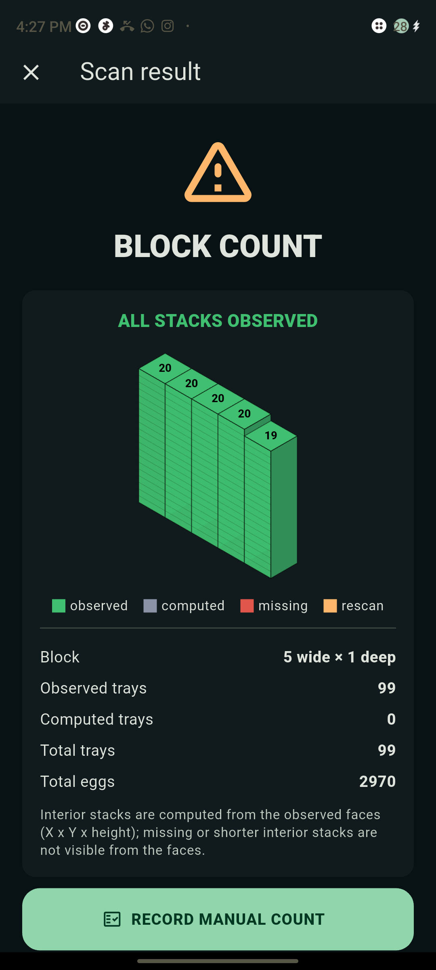 | 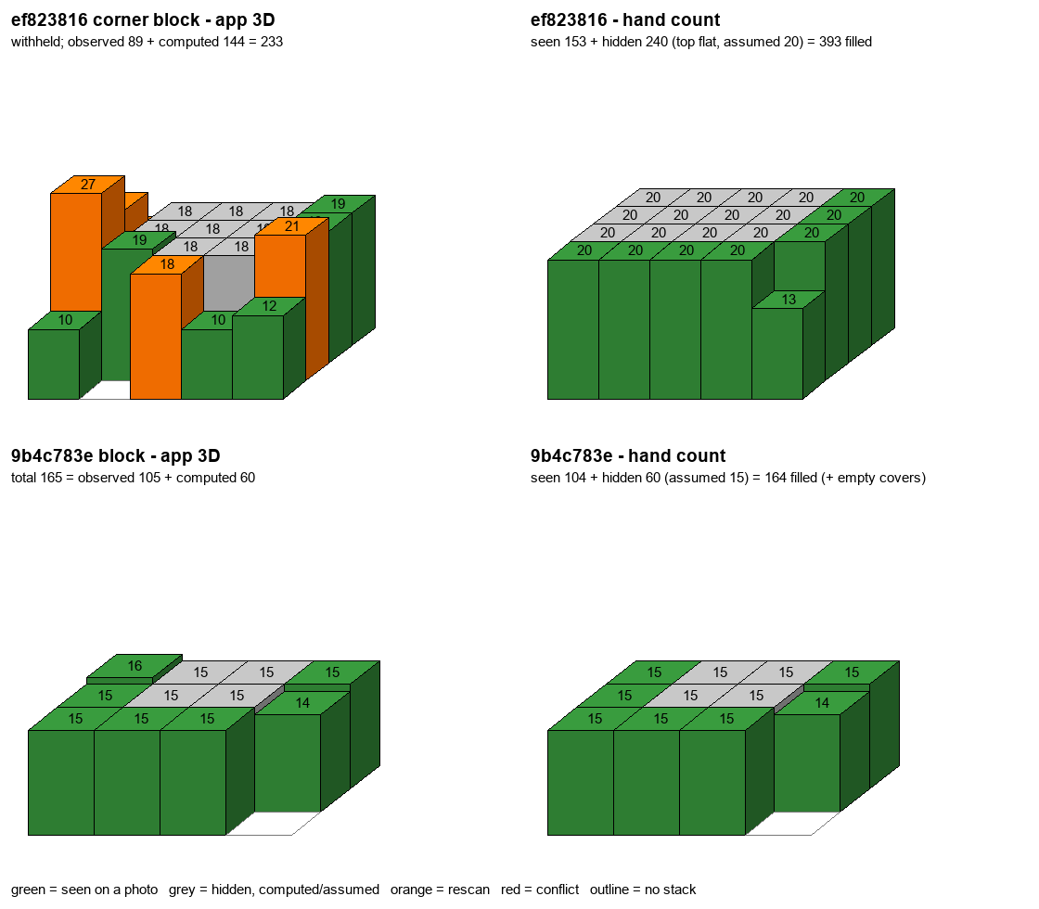
App 0.4.9 on the Redmi phone, 12 October: a real block counted as 20/20/20/20/19 = 99 trays in 25 s. | First warehouse scans, 13 October: the app's 3D block next to a count made by eye from the same photos.

3. Challenges Faced
• Angled, corner and distant photos fail badly: none of 16 angled and none of 5 distant block photos came within 5%, and far cross-stacked faces read about half the layers.
• There is no physical truth yet: 0 physical counts by 31 October. The two stored manual counts cannot serve as truth (one came from a pre-filled form, the other was entered by the assistant).
• Wrong photo roles produced a confident wrong total (500 for 100 on L-100). The same-face guard is built but not yet on the server or the phone.
• Most trays of a big block are hidden inside it (W05: 196 visible of about 1,366), and careful eye counters disagreed widely on depth (L-115: 771 / 897 / 1,455).
• The move to a new laptop lost the test server's admin token, old APKs and the signing key. The new release key meant uninstalling 0.4.11, which deleted the phone's earlier history.

4. Plan for November
• Deploy Worker 0.4.13 to the test server and install APK 0.4.13 on the Redmi; check the same-face guard with a real walk around a block.
• Photograph genuine front, left and right sets of real blocks and count their trays physically, stack by stack, with independent counters.
• Retrain the tray detector on far and cross-stacked faces, keeping some blocks aside to test it.
• Set a rule for the hidden inside of big blocks: declared by the operator, or shown as estimated with the visible share stated.
• Switch the test server from observe to enforce mode so that only approved phones are accepted.

5. Overall Project Status
Phase | Status at 31 October | Measured progress
Labelled field-photo baseline | Measured against handwritten labels | 5/52 exact; frontal 12/18 within 5%
Block (3D grid) counting | Built; running on the test server | 99-block read 20/20/20/20/19 on the phone
Android app | 0.4.12 on the Redmi, test server | Network test 20/20 on IPv4 and IPv6
Phone approval (security) | Observe mode on the test server | Requests without a key refused (401)
Same-face guard (0.4.13) | Built and tested; not deployed | Worker 122/122, app 176/176 tests
Exact warehouse inventory | Not verified | 0 physical counts

5.1 Overall Progress
October delivered the whole counting chain for a block of stacks, from guided capture to the block drawing and per-phone approval, running on the farm's phone against the test server. Accuracy on real blocks is still unmeasured, because every reference so far is a handwritten label or a count made by eye. Overall completion cannot be quantified. The next milestone is a field round with genuine front, left and right photos and independent physical per-stack counts. Work from 1 November (release 0.5.0, the photo validation and Plan 4) belongs to the November review.
Evidence: PROGRESS.md entries 1-31 October; reports/field-labelled-20261007, staging-block-20261008, network-20261012, field-scans-20261013, eval-20261015, experiment-walk-fill-20261015, mutaa-manual-vs-backend-20261031 and rollout-20261031; docs/SCAN_JOBS_AND_DEVICES.md; the weekly reports for October and october-2026-weeks.json.

