WEEKLY PROGRESS REPORT
OCTOBER 2026 • WEEK 2 (8-14 OCTOBER 2026)
Project ID: MKCE/R&I/Consultancy/2026/001

AI-Based Egg Tray Inventory Management System (EG-Counter)

Prepared by
Rahul S (927623BCB041)
Yasvanthpalani S (927623BCB063)
Dharaneesh Kesavan (927623BCB007)
Dharani S (927623BCB008)
Mukund Balaji B (927623BCB033)

Guided by
Dr. V. Banupriya, HoD/CSBS
Mr. T. Viswanath Kani, AP/CSBS

Department of Computer Science and Business Systems
M. Kumarasamy College of Engineering
Thalavapalayam, Karur
Report prepared 3 November 2026 from the project record

1. Summary of the Week
This week the team built a "block model". The app combines a front photo and the side photos of a block of tray stacks into a grid, and calculates the stacks hidden inside the block. The phone then draws the block in 3D and gives a total. The model went to the test copy of the cloud server (Cloudflare Worker, "staging") and onto the Redmi test phone. On the phone it counted a known 99-tray block exactly. Other work made the camera screen behave like a normal camera app, made uploads survive a weak mobile connection, and fixed counting rules after the first real warehouse scans of 13 October. Those scans had no on-site counts recorded with them. They were checked only against counts made by eye from the photos.
Phase: Building the block (3D grid) counting model and first field trial on the test server.

2. Work Completed This Week

2.1 Block model: front face x side face x height
On 8 October the counting of a whole block was built three times, with the same rules each time: in Python, in the cloud server (Cloudflare Worker) and in the app (version 0.4.0). Stacks seen on a photo are drawn green, and hidden interior stacks are computed and drawn grey. That evening it went to the staging server (version a012c14e). A three-photo test returned a 5 x 4 block of 400 trays in 11.5 s. This was a mechanics check only, because the three photos came from three different blocks.

2.2 In-app manual count and the first phone run
On 9 October a RECORD MANUAL COUNT screen was added. The operator types the true count of each stack, and it is stored on the server next to the scan. It is never used for counting. The full path worked on the Redmi Note 9 Pro: pick photos, upload, block result, manual count, then save on the server. Two manual counts were stored (WH-99 and MECH-DONE). The phone's own Files picker listed no files, so the app switched to the Android Photo Picker.

2.3 Better layer counting: the 'walk' counter, and a second counter left switched off
The new walk counter steps up a stack one tray at a time and adjusts to the changing spacing. It was exact on 51 of 53 reference stacks, where the older span method was exact on 40 of 53. A second counter based on tray rim edges was tried as a cross-check. It was exact on 38/53 and within 1 on 47/53, but it also disagreed on 9 of 40 stacks that were already right. So it stays off (RIM_VERIFY off).

2.4 Camera screen rebuilt like a normal camera app (0.4.3 to 0.4.8)
The viewfinder now fills the screen, and the screen never rotates. The tilt sensor decides whether a photo is upright or sideways, and the app straightens the photo before upload. On synthetic sideways phone photos made from labelled photos 01, 02 and 19, every stack was counted exactly once a 20:9 screen trim was removed (0.4.8). A new server check refused all 6 sideways frames and none of the 39 tagged photos.

2.5 Surviving a weak mobile connection (0.4.9) and a looser tilt limit
The 'backend offline' complaints were traced to the network path to the server's *.workers.dev web address, not to the server code. App 0.4.9 retries the health check 3 times and the upload 4 times, and waits longer (send 150 s, receive 90 s; was 45 s). Photos are capped at 1600 px, which makes them 138-290 KB instead of 437-669 KB with the same per-stack counts. The tilt warning limit went from 4 to 8 degrees. On the phone, the 99-tray block was counted in 25 s.

2.6 First real field scans reviewed, then the counting fixes (0.4.11)
7 scans arrived on 13 October. 3 repeated the 99-block photos and 4 were new, but none had a manual count. They were replayed on staging and counted by eye from the photos. The fixes that followed: (1) all face readings are now merged; (2) a one-layer disagreement gives an 'estimated' result; (3) at most 2 missed layers are filled per gap; (4) a face photographed from too far away asks the operator to step closer; (5) each result shows one status: exact, estimated, conflict or needs a new photo. Afterwards 51/53 reference stacks were still exact, and the Python and cloud versions gave identical results on 27 real scenes. These fixes went to staging Worker 47cb2378, and app 0.4.11 was installed on the Redmi.

3. Measured Results
Measurement | Value | What it shows
Walk counter on the reference stacks | walk exact 51/53; span exact 40/53; both 53/53 within 1 | Tray layers counted correctly per stack on 13 straight-on labelled WhatsApp photos. The reference per-stack numbers were worked out from the user's handwritten totals plus visual inspection, not a physical recount. The same photos were used to develop the rule, so this is not a test on new photos. The two misses have the bottom layer cut off in the photo.
Phone gallery scan of the real 99-tray block (app 0.4.9, staging) | 5 wide x 1 deep, 20/20/20/20/19, 99 trays, in 25 s | This matches the verified count entered by hand for this block (20/20/20/20/19). It is one block, using archived photos picked from the phone gallery, not a fresh capture. The LEFT photo was a second side photo standing in, because no genuine left photo exists.
Field scan 9b4c783e (4 x 3 block, close photos), app vs hand count | app 165 (105 observed + 60 computed) vs hand 164; observed stacks 6/7 exact, 7/7 within 1 | The hand count was made by eye from enlarged photos, not a physical recount, and the hidden stacks are assumed. The extra 1 tray is an empty cover tray counted as full.
Field scan ef823816 (5 x 4 block in a room corner, far photos), app vs hand count | app 233 (withheld) vs hand 393 filled; -160 (-41%) | The app held back this total, so no wrong number was shown as final. The hand count was made by eye from the photos, not physically, and the hidden stacks are assumed at 20. From far away the detector boxes only every other row of the cross-stacked trays, so it reads about half the layers.
Server photo-quality check (capture gate) on the 13 Oct field scans | refused 6 of 12 faces | Every refused face was really too far away or too narrow when the photos were checked by eye. This shows the check rejects bad photos. It says nothing about counting accuracy.
Phone network loss to the staging server host (Jio LTE) | IPv6 40% and 66% packet loss (12 Oct, two runs) vs Google 0%; 14 Oct: IPv6 50% loss, IPv4 0% loss | This shows the dropped scans came from the network path to the *.workers.dev address, not from the app or server code. It was measured from this one phone and one laptop only.
None of these figures is a physical recount of trays: the references are handwritten labels, counts made by eye from photos, or software checks, as each row says.

4. Photo Evidence
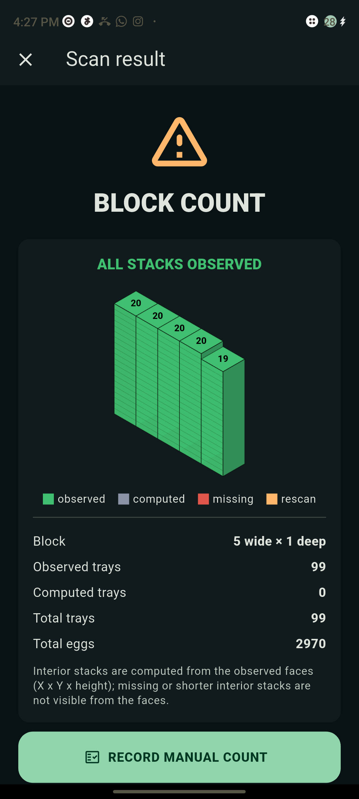 | 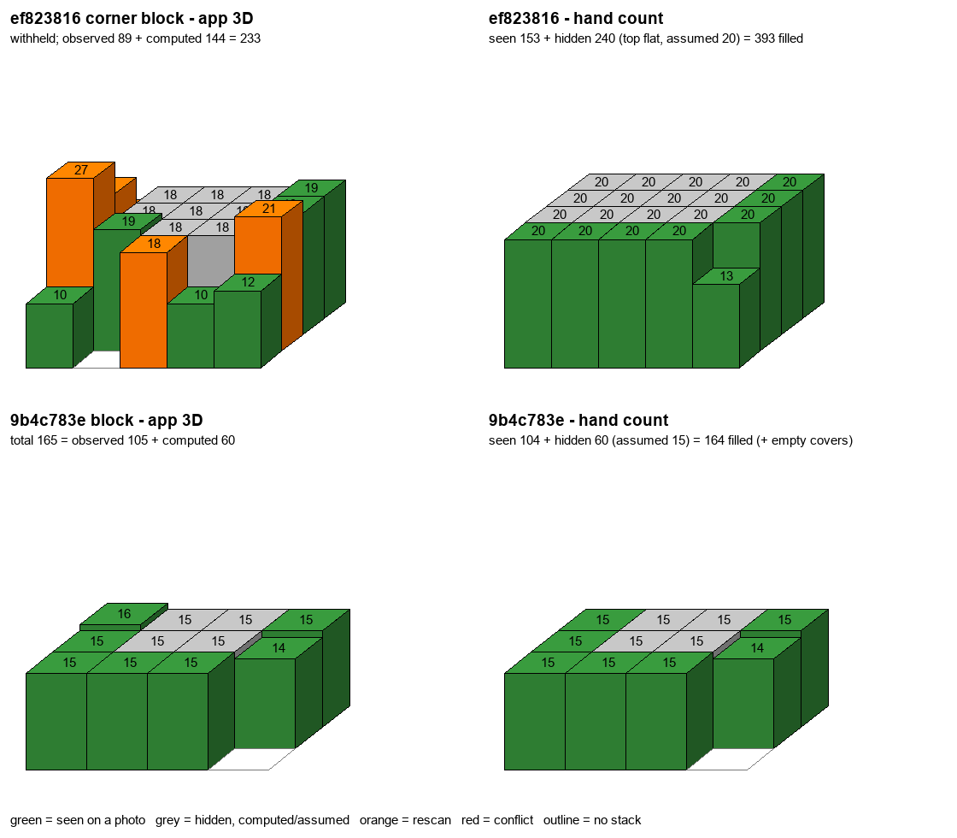
App 0.4.9 on the Redmi phone, 12 October: three saved photos of a real block counted as 5 stacks of 20/20/20/20/19 = 99 trays in 25 s, matching the hand-entered count. The orange triangle is an old warning flag; 0.4.10 shows the verified icon instead. | First real warehouse scans of 13 October: the app's 3D block (left) next to a count made by eye from the same photos (right). Close block 9b4c783e: app 165 vs 164. Far corner block ef823816: app 233, total withheld, vs 393.

5. Challenges Faced
• Weak mobile connection to the cloud server. On the phone's Jio connection, IPv6 lost 40-66% of packets to the server's *.workers.dev address. From the laptop, about a third of IPv4 connection set-ups were dropped. App retries reduce the failures, but the real fix (a custom web address on the owner's own Cloudflare domain) was proposed and not done.
• No on-site counts were recorded with the 13 October field scans. So counting accuracy on real blocks could not be scored, and the only checks were counts made by eye from the photos. The server still held only two manual counts (WH-99 and MECH-DONE).
• Real store-room conditions break the counting. Photos of cross-stacked trays taken from far away read about half the layers (ef823816: -41%). Blocks stand against walls and in corners, with little room to step back. In one scan the same side face was uploaded as both LEFT and RIGHT. Empty cover trays on top are counted as full trays.
• Phone-specific problems on the Redmi test phone. A locked camera orientation sent sideways photos to the server turned the wrong way, and the detector then found only 0-11 boxes (fixed in 0.4.6-0.4.8). The phone's Files picker listed no files (the app switched to the Android Photo Picker). A reboot on 13 Oct meant no app log covered the field scans.

6. Plan for the Next Week
• Field scans with RECORD MANUAL COUNT filled in on every block: at least 10 blocks, including a corner block and a cross-stacked block (the 14 Oct analysis set a minimum of 20 blocks)
• App 0.4.12: prefer IPv4 for the server connection, add a device key on the manual-count and listing routes, and fix the replay_field_scans.py crash on empty files
• Retrain the detector for far cross-stacked rows and add a class for empty cover trays
• Capture options: a 'side against a wall' option, a same-face-twice check, and a raised top photo
• Move the block model to the production server only after the field score

7. Status at the End of the Week
App 0.4.11 (versionCode 22, egg-tray-counter-0.4.11-block-staging.apk) installed on the Redmi test phone and pointed at the staging server. Staging Cloudflare Worker version 47cb2378-6e3e-483e-b709-b99da9960470 (block model plus the 14 Oct counting fixes). Production Worker 4c1480e6 (deployed 2026-09-23, no block model) was not touched. The 12 Oct entry named production as 0482e52c; the 14 Oct entry corrected this to 4c1480e6, as listed by wrangler.
Evidence: PROGRESS.md (entries 2026-10-08 to 2026-10-14, lines 777-1272); reports/staging-block-20261008/README.md; reports/staging-block-20261008/phone-e2e/README.md; reports/rim-count-20261009/README.md; reports/orientation-20261009/README.md; reports/network-20261012/README.md; reports/field-scans-20261013/README.md; docs/FIELD_TEST_BLOCK_20261009.md; git commits badf693, e995ea0, 97cb9cd, 266c58a, a931cd6, c6a80e7, 0eefd44, 1e8591e, fdeac4f, a3e1f89, 318eb04 (2026-10-09 to 2026-10-14).

