MONTHLY PROGRESS REVIEW
AUGUST 2026
Project ID: MKCE/R&I/Consultancy/2026/001

AI-Based Egg Tray Inventory Management System (EG-Counter)

Prepared by
Rahul S (927623BCB041)
Yasvanthpalani S (927623BCB063)
Dharaneesh Kesavan (927623BCB007)
Dharani S (927623BCB008)
Mukund Balaji B (927623BCB033)

Guided by
Dr. V. Banupriya, HoD/CSBS
Mr. T. Viswanath Kani, AP/CSBS

Department of Computer Science and Business Systems
M. Kumarasamy College of Engineering
Thalavapalayam, Karur
Report prepared 1 October 2026

1. Monthly Progress Summary
A working Android and Cloudflare/Roboflow counting route was established and measured against ten visually reviewed warehouse photos. The evaluation exposed large view-dependent errors; the app withheld a final count for an inconsistent three-view scene.
Current phase: model evaluation and mobile/backend integration. The 31 August measurements are a per-photo detection baseline, not certified egg-filled inventory.

2. Work Completed This Month

2.1 Prototype and inference integration
The Android client sent photographs to a Cloudflare Worker, which called the deployed Roboflow RF-DETR Medium model projec-mutta/2. Direct Roboflow and Worker counts matched on all ten evaluated frames. The client parsed the backend response without changing the tray count.

2.2 Ground-reference and evaluation work
Ten images received manual visible-layer references; four uncertain photos were excluded. The frozen baseline was 2/10 exact images (20.0%), 22.9 trays mean absolute error, and 58.43% mean per-image count agreement. Count agreement means 100 times (1 minus absolute count error divided by the reference); it is not detection precision or warehouse accuracy.

2.3 Photo evidence and measured counts
Saved photo / case | Manual visual reference | Model / mobile pathway | Count agreement
img05, six-stack wall | 120 | 124 | 96.67%
img04, brown two-stack scene | 32 | 29 | 90.62%
img07, single evaluated frame | 21 | 21 | 100.00%
All 10 accepted frames | 10 reviewed references | 2 exact; MAE 22.9 | 58.43% mean
The numbers above are per-photo backend counts in the mobile app path. They are not accepted three-view inventory totals. The retained photos may have been captured before August; this table dates their evaluation, not capture.
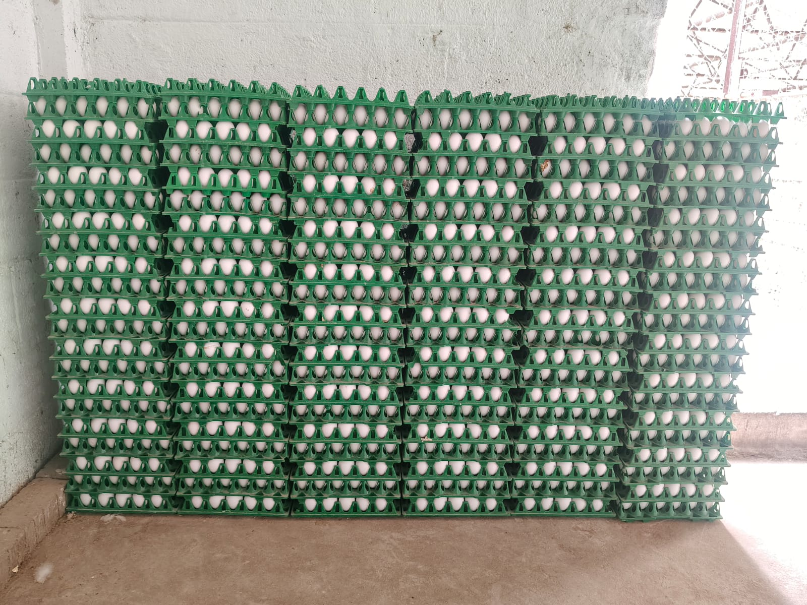 | 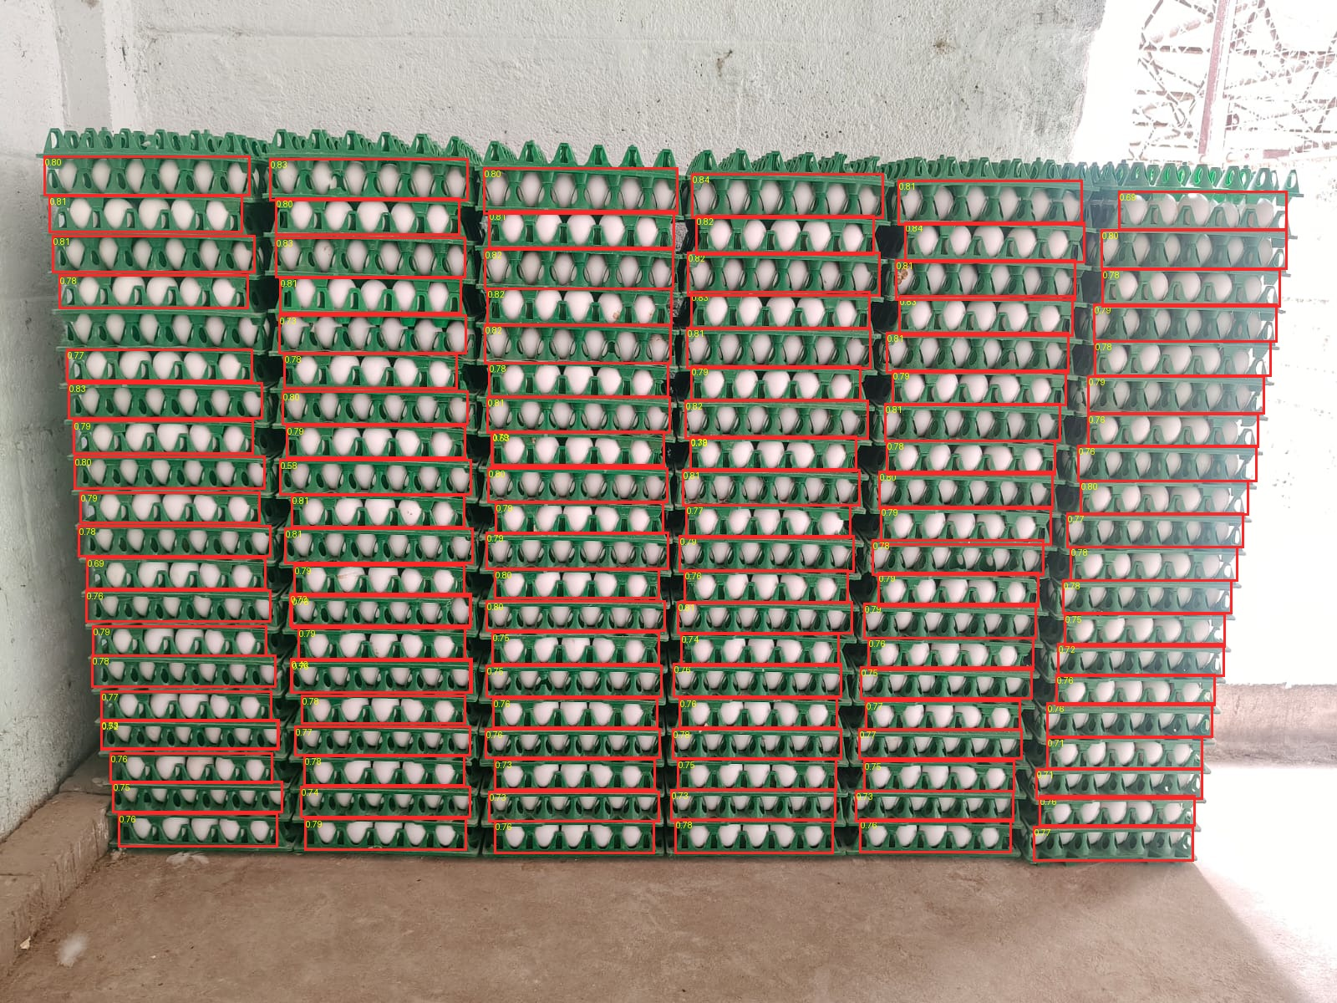
Original evaluated photo: 120 manually visible tray layers. | Saved V2 detection overlay: 124 per-photo detections.

3. Challenges Faced
• One 60-layer scene yielded 9, 12 and 93 across three views; the app withheld a final total and requested a rescan.
• Dense stacks caused duplicate boxes; distant or dim stacks caused misses.
• Visual layers do not certify concealed egg occupancy. The benchmark had no independent physical recount.

4. Plan for September
• Audit annotations and scene overlap across data splits.
• Compare angle, crop and threshold methods against per-stack references.
• Test quality prompts and multi-view counting on untouched, physically counted scenes.

5. Overall Project Status
Phase | Status at 31 August | Measured progress
Dataset and visual references | Baseline established | 10 accepted / 4 excluded
Model and backend | Integrated; inaccurate on varied views | 2/10 exact; MAE 22.9
Android integration | Prototype operational | Response parsing verified
Exact warehouse inventory | Not verified | No physical acceptance set

5.1 Overall Progress
Prototype integration and baseline evaluation were complete. Overall project completion cannot be quantified. The next milestone is an independent physical scene recount with exact stack counts and rejection coverage.
Evidence: accuracy-evaluation/report.md, summary.json, results.csv, ground-truth-exclusions.csv, and saved img05 original/overlay.

